The Mathematics Tower, Volume 3: The Upper Floors
Storeys 26–37: From Differential Equations to Abstract Algebra

by Lothar J. Musiol

Copyright © 2026 Lothar J. Musiol. All rights reserved.

Table of Contents
Table of Contents 3
About This Volume 7
On Storeys and Rooms 8
Storey 26: Differential and Integro-Differential Equations 9
Room 26.1: Ordinary Differential Equations Revisited 10
Room 26.2: Systems, Stability, and Lyapunov Functions 15
Room 26.3: Boundary-Value Problems and Sturm–Liouville Theory 19
Room 26.4: Green's Functions for ODEs 23
Room 26.5: What Integro-Differential Equations Are 26
Room 26.6: Volterra Integro-Differential Equations 30
Room 26.7: Fredholm Integro-Differential Equations and Eigenvalue Problems 34
Room 26.8: Delay Equations and Equations with Memory 38
Room 26.9: Looking Ahead: From Integro-Differential Equations to PDEs and Functional Analysis 42
Storey 27: Partial Differential Equations 46
Room 27.1: What a Partial Differential Equation Actually Is 47
Room 27.2: First-Order Equations and the Method of Characteristics 51
Room 27.3: Classification of Second-Order Equations 55
Room 27.4: The Wave Equation 59
Room 27.5: The Heat Equation 63
Room 27.6: Laplace's Equation and Harmonic Functions 67
Room 27.7: Separation of Variables and Eigenfunction Expansions 70
Room 27.8: Green's Functions, Maximum Principles, and Energy Methods 73
Room 27.9: Looking Ahead: From Classical PDEs to Modern Theory and Applications 77
Storey 28: Optimization & Calculus of Variations 82
Room 28.1: Finite-Dimensional Optimization: Unconstrained 83
Room 28.2: Constraints and Lagrange Multipliers 87
Room 28.3: Convexity and Convex Optimization 90
Room 28.4: The Calculus of Variations: The Euler–Lagrange Equation 93
Room 28.5: First Integrals, Constraints, and Variable Endpoints 96
Room 28.6: The Second Variation and Sufficient Conditions 99
Room 28.7: Hamilton's Principle and Classical Mechanics 103
Room 28.8: Classical Applications: Geodesics, Minimal Surfaces, Isoperimetry 106
Room 28.9: Looking Ahead: From Classical Variational Calculus to Optimal Control and Geometric Analysis 110
Storey 29: Numerical Methods 114
Room 29.1: What Numerical Methods Actually Are 115
Room 29.2: Root-Finding and Nonlinear Equations 119
Room 29.3: Interpolation, Approximation, and Splines 125
Room 29.4: Numerical Differentiation and Integration 130
Room 29.5: Numerical Linear Algebra 135
Room 29.6: Numerical Methods for Ordinary Differential Equations 140
Room 29.7: Numerical Methods for Partial Differential Equations 144
Room 29.8: Consistency, Stability, and Convergence 149
Room 29.9: Looking Ahead: From Elementary Numerics to High-Performance and Adaptive Methods 153
Storey 30: Optimization 158
Room 30.1: Modeling and the Landscape of Optimization Problems 159
Room 30.2: Linear Programming 163
Room 30.3: Unconstrained Nonlinear Optimization 167
Room 30.4: Constrained Nonlinear Optimization 171
Room 30.5: Convex Optimization Algorithms 176
Room 30.6: Duality in Practice 180
Room 30.7: Integer and Combinatorial Optimization 183
Room 30.8: Derivative-Free, Stochastic, and Large-Scale Methods 188
Room 30.9: Looking Ahead: From Algorithms to Advanced Optimization and Applications 192
Storey 31: Differential Geometry 196
Room 31.1: What Differential Geometry Actually Is 198
Room 31.2: Curves in the Plane and in Space 201
Room 31.3: The Frenet–Serret Apparatus 205
Room 31.4: Surfaces and the First Fundamental Form 209
Room 31.5: The Second Fundamental Form and Curvature 213
Room 31.6: Geodesics 216
Room 31.7: The Gauss–Bonnet Theorem 219
Room 31.8: Intrinsic Geometry and the Theorema Egregium 223
Room 31.9: Looking Ahead: From Surfaces to Manifolds, Riemannian Geometry, and Relativity 226
Storey 32: Topology 229
Room 32.1: What Topology Actually Is 230
Room 32.2: Metric Spaces and Continuity 234
Room 32.3: Topological Spaces and Continuous Maps 238
Room 32.4: Connectedness and Path-Connectedness 243
Room 32.5: Compactness 246
Room 32.6: Separation Axioms and Countability 250
Room 32.7: Homotopy and the Fundamental Group 254
Room 32.8: Covering Spaces and Classification of Surfaces 258
Room 32.9: Looking Ahead: From Basic Topology to Algebraic Topology and Manifolds 262
Storey 33: Integral Geometry (Advanced) 265
Room 33.1: From Classical Formulas to Modern Valuations 267
Room 33.2: Convex Bodies and Intrinsic Volumes 271
Room 33.3: Continuous Valuations and Hadwiger's Theorem 275
Room 33.4: Curvature Measures and the Normal Cycle 279
Room 33.5: The Principal Kinematic Formula and Its Relatives 283
Room 33.6: The Algebra of Valuations 287
Room 33.7: Integral Geometry on Spaces of Higher Rank 290
Room 33.8: Applications: Stereology, Tomography, and Geometric Probability 294
Room 33.9: Looking Ahead: Valuations on Manifolds and Algebraic Integral Geometry 298
Storey 34: Tensors & Manifolds 302
Room 34.1: Multilinear Algebra and Tensors 304
Room 34.2: Tensor Fields and Transformation Laws 309
Room 34.3: Smooth Manifolds 312
Room 34.4: Tangent Vectors, Vector Fields, and Flows 316
Room 34.5: Differential Forms and Exterior Calculus 320
Room 34.6: Integration on Manifolds and Stokes' Theorem 324
Room 34.7: Riemannian Metrics 327
Room 34.8: Connections, Covariant Derivatives, and Curvature 330
Room 34.9: Looking Ahead: From Manifolds to Riemannian Geometry, Gauge Theory, and Relativity 334
Storey 35: Functional Analysis 339
Room 35.1: What Functional Analysis Actually Is 340
Room 35.2: Banach Spaces and Hilbert Spaces 344
Room 35.3: Linear Operators and Duality 348
Room 35.4: The Fundamental Theorems 353
Room 35.5: Weak Topologies and Reflexivity 357
Room 35.6: Compact Operators and the Fredholm Alternative 361
Room 35.7: Spectral Theory of Compact Self-Adjoint Operators 365
Room 35.8: Unbounded Operators and Sobolev Spaces 369
Room 35.9: Looking Ahead: From Functional Analysis to Operator Algebras, Distributions, and PDEs 374
Storey 36: Measure Theory 379
Room 36.1: What Measure Theory Actually Is 381
Room 36.2: Algebras, σ-Algebras, and Measures 385
Room 36.3: Outer Measure and Lebesgue Measure 389
Room 36.4: Measurable Functions 394
Room 36.5: The Lebesgue Integral 398
Room 36.6: Convergence Theorems 402
Room 36.7: Product Measures and Fubini's Theorem 407
Room 36.8: L^p Spaces and the Radon–Nikodym Theorem 411
Storey 37: Abstract Algebra 418
Room 37.1: What Abstract Algebra Actually Is 419
Room 37.2: Groups and Homomorphisms 423
Room 37.3: Group Actions, Cosets, and Quotient Groups 427
Room 37.4: Rings, Ideals, and Quotient Rings 431
Room 37.5: Factorization in Integral Domains 435
Room 37.6: Modules over Rings 440
Room 37.7: Field Extensions 445
Room 37.8: Introduction to Galois Theory 449
Room 37.9: Looking Ahead: From Abstract Algebra to Algebraic Geometry, Number Theory, and Representation Theory 452

About This Volume
This is Volume 3 of The Mathematics Tower, the third of four volumes carrying one continuous fifty-storey mathematics book. Volume 1 (Storeys 1–12) runs from arithmetic to single-variable calculus and holds the Tower's full preface; Volume 2 (Storeys 13–25) generalizes into many variables, transforms, linear algebra, and the foundations of mathematics itself. If you are joining the climb here, ‘On Storeys and Rooms’, just after this note, explains the building's peculiar vocabulary in brief.
This volume covers Storeys 26 through 37: differential, integro-differential, and partial differential equations; optimization and the calculus of variations; numerical methods; differential geometry, topology, and integral geometry's more advanced storey; tensors and manifolds; functional analysis; measure theory; and abstract algebra. Twelve storeys, broadly, about equations that describe change and the increasingly abstract structures mathematicians built to solve, generalize, and eventually justify them.
Behind you: set theory and logic, Volume 2's final storey, quietly underwriting everything above it. Ahead, in Volume 4: category theory picks up exactly where abstract algebra leaves off, and the climb continues to the research frontier. Up we go.

On Storeys and Rooms
A brief note is owed on why perfectly good words like 'book' and 'chapter' have been evicted from this text and replaced with 'storey' and 'room', since I am aware this is the sort of decision that can look, from the outside, like whimsy that has got badly out of hand. The honest answer is that it has, rather, but let me at least make the case for the defence before you reach for a refund.
The trouble with 'book' is that this is no longer fifty of them; it is one, and a text that keeps referring to itself as 'this book' while also gesturing at 'the next book in the series' is not being quaint, it is being confused about its own word count. 'Storey' does the same job — a bounded, coherent stretch of related material — while also admitting, honestly, that the thing you are standing in only makes sense as one level of something larger. It is a small change of noun that happens to fix a structural lie, which is about as good a return as you ever get from renaming things.
'Room' replaces 'chapter' for similar reasons, but with the added benefit of matching the numbering to the metaphor rather than fighting it: Room 6.3 tells you, without further ceremony, that you are in the third room of the sixth storey, which is more information than 'Chapter 3' ever gave you and considerably more information than 'Chapter 3 of Book 6, one of a fifty-book series' gave you at roughly triple the word count. Efficiency, in the end, dressed up as a joke — which is, if I am honest, how most good jokes in mathematics arrive.
I will not pretend the metaphor is load-bearing in any technical sense; you cannot factor a polynomial faster for knowing it lives in a room rather than a chapter. But a reader climbing from arithmetic to category theory over fifty storeys deserves a mental image sturdier than 'a very long document', and a tower — with its floors resting on each other, its lift for the impatient, its occasional draughty landing — happens to be a much better description of how mathematical knowledge is actually built than a shelf of unrelated paperbacks ever was. So: storeys, rooms, and no further apology. Do come in.

Storey 26: Differential and Integro-Differential Equations
Beyond the Elementary, and the Art of Equations That Remember the Past
We have just spent an entire storey convincing ourselves that mathematics can be built, brick by suspiciously circular-looking brick, out of sets and the bare rules of logic — that even the number 2 is, if you squint hard enough and do not mind a certain amount of existential vertigo, a set containing a set containing nothing at all. It was bracing. It was also, if we are honest, the sort of storey after which one wants to go and calculate something. Anything. Preferably something that moves.
So let us go back to differential equations, which we last left in reasonably good order. Storey 17 gave us the elementary toolkit — separable equations, integrating factors, constant-coefficient linear equations solved by guessing exponentials and being smug about it. Storey 18 handed us the Laplace transform, a device for converting calculus into algebra, which is either a beautiful piece of mathematical alchemy or an elaborate way of postponing the hard part, depending on how the marking goes that week.
This storey pushes further in two directions at once. First, upward and outward: from single equations to systems, from initial-value problems to boundary-value problems, from ‘does a solution exist’ to ‘does the whole infinite family of solutions organise itself into something as orderly as a Fourier series’ (it does, and the organising principle is called Sturm–Liouville theory, which we promise is less alarming than it sounds). Second, and more interestingly, into equations that do not just react to the present but consult the past — integro-differential equations, in which the unknown function sits simultaneously under a derivative and under an integral sign, so that the instantaneous rate of change depends on the entire accumulated history of the system.
A small confession, before we start: once memory is admitted, the state of a system stops being a finite list of numbers and becomes a function — an entire curve's worth of information, carried forward at every instant. The phase space swells from ℝⁿ to something infinite-dimensional, and the theory begins to look uncannily like the dynamical systems of the future storeys. That transition, from finite bookkeeping to infinite bookkeeping, is precisely where the subject stops being homework and starts being interesting. Let's remember.

Room 26.1: Ordinary Differential Equations Revisited
In Which the Same Old Problem Turns Out to Have Sharper Teeth
Storey 17's existence theory was reassuringly generous: give the equation below a continuous, nicely-behaved f, and a solution exists near the starting point, and — because nobody mentioned otherwise — you were probably encouraged to assume it was the only one.
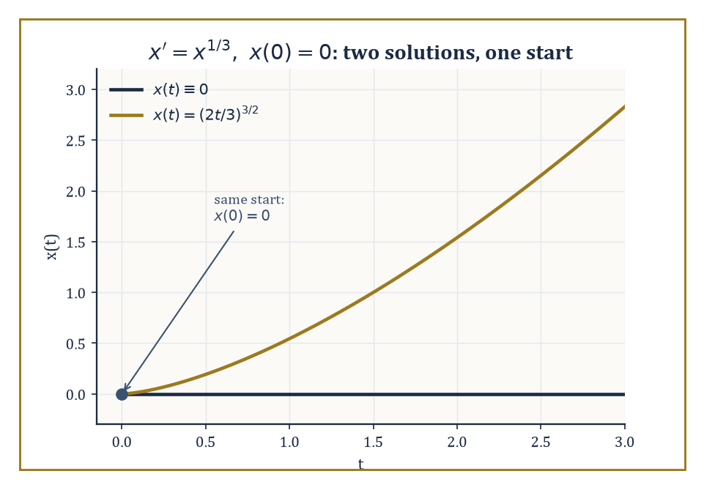
Two genuinely different solutions of x′ = x^{1/3} leaving the same starting point — Lipschitz continuity is the guard rail that was missing.
x′ = f(t, x)
It is time to be more careful. The correct statement, the Picard–Lindelöf theorem, requires f to be Lipschitz in x: there must be a constant L such that the inequality below holds for all nearby x and y.
|f(t, x) − f(t, y)| ≤ L|x − y|
Under that hypothesis, a unique solution exists locally, produced by the same Picard iteration you may recall from Storey 17, now guaranteed to converge because the Lipschitz constant stops nearby approximations from drifting apart too fast. Drop the Lipschitz condition down to mere continuity of f, and Peano's theorem still guarantees a solution exists — but no longer promises it is the only one. Continuity gets you a path through the woods; Lipschitz continuity gets you a path with guard rails.
Numeric example — Worked example — a fork in the road. Consider the initial-value problem below.
x′(t) = x(t)^{1/3}, x(0) = 0
One solution is the constant x(t) ≡ 0, since it satisfies the equation trivially.
0′ = 0 = 0^{1/3}
But try the following curve instead, for t ≥ 0.
x(t) = (2t/3)^{3/2}
Differentiating gives:
x′(t) = (3/2)·(2t/3)^{1/2}·(2/3) = (2t/3)^{1/2}
Meanwhile, raising x(t) itself to the power 1/3 gives the same expression.
x(t)^{1/3} = [(2t/3)^{3/2}]^{1/3} = (2t/3)^{1/2}
So this curve also satisfies the equation, and also starts at x(0) = 0. Two genuinely different solutions leave the same starting point. The culprit is that f(t, x) = x^{1/3} is not Lipschitz near x = 0: its x-derivative is (1/3)x^{−2/3}, which blows up to infinity as x → 0, so nearby solutions are permitted to separate arbitrarily fast — and, as we have just seen, they take the opportunity.
For linear systems of the form below, where A(t) is an n×n matrix that may vary with t, the right generalisation of 'a basis of solutions' is a fundamental matrix Φ(t).
x′(t) = A(t)x(t)
A fundamental matrix is an n×n matrix whose n columns are n linearly independent solution vectors, so that it satisfies the relation below.
Φ′(t) = A(t)Φ(t)
Its determinant W(t) = det Φ(t), the matrix analogue of the Wronskian, obeys the beautifully simple Abel–Liouville formula below.
W(t) = W(t₀)·exp(∫ₜ₀ᵗ tr A(s) ds)
The Wronskian's whole evolution is governed only by the trace of A, never by the fine detail of the solutions themselves. In particular, if W(t₀) ≠ 0 at one point, it is nonzero everywhere the solution is defined — a fundamental matrix that starts out invertible stays invertible for good.
Numeric example — Worked example — checking Abel's formula. Let A = [[0, 1], [−1, 0]] (constant). One checks by direct differentiation that the following matrix satisfies Φ′ = AΦ.
Φ(t) = [[cos t, sin t], [−sin t, cos t]]
Differentiating gives:
Φ′(t) = [[−sin t, cos t], [−cos t, −sin t]]
Meanwhile AΦ(t) has a first row that simplifies as follows.
[0·cos t + 1·(−sin t), 0·sin t + 1·cos t] = [−sin t, cos t]
And a second row that simplifies as follows.
[−1·cos t + 0·(−sin t), −1·sin t + 0·cos t] = [−cos t, −sin t]
An exact match. The Wronskian is therefore:
W(t) = cos²t + sin²t = 1
Abel's formula predicts exactly this without solving anything: the trace is tr A = 0 + 0 = 0, so
W(t) = W(0)·exp(∫₀ᵗ 0 ds) = 1·e⁰ = 1
The trace vanishing tells us, before we compute a single sine or cosine, that this fundamental matrix will never lose invertibility.
When A is constant, the fundamental matrix has a closed form: the matrix exponential e^{At}, defined by the same power series as the ordinary exponential, but now with matrices.
e^{At} = I + At + (At)²/2! + (At)³/3! + ⋯
When A is diagonalisable, A = PDP⁻¹ with D diagonal, this collapses to the formula below, where e^{Dt} is just the diagonal matrix of e^{λt} for each eigenvalue λ.
e^{At} = P·e^{Dt}·P⁻¹
This is an enormous shortcut, since it turns an infinite matrix series into ordinary scalar exponentials sandwiched between two fixed matrices.
Numeric example — Worked example — building an exponential from eigenvectors. Let A = [[1, 1], [0, 2]]. Its eigenvalues, from the upper-triangular structure, are read straight off the diagonal.
λ₁ = 1, λ₂ = 2
For λ₁ = 1, the eigenvector equation (A − I)v = 0 gives the system below, so v₂ = 0 and we may take v = (1, 0).
[[0, 1], [0, 1]]v = 0
For λ₂ = 2, the eigenvector equation (A − 2I)v = 0 gives the system below, so v₁ = v₂, and we may take v = (1, 1).
[[−1, 1], [0, 0]]v = 0
Hence P = [[1, 1], [0, 1]] and, by inspection or by the 2×2 inverse formula, P⁻¹ = [[1, −1], [0, 1]]. Then the matrix exponential is computed as follows.
e^{At} = P·diag(e^t, e^{2t})·P⁻¹ = [[1,1],[0,1]]·[[e^t, 0],[0, e^{2t}]]·[[1,−1],[0,1]] = [[1,1],[0,1]]·[[e^t, −e^t],[0, e^{2t}]] = [[e^t, e^{2t} − e^t],[0, e^{2t}]]
A sanity check: differentiating this matrix entrywise gives the matrix below.
d/dt e^{At} = [[e^t, 2e^{2t} − e^t],[0, 2e^{2t}]]
And multiplying A by our answer gives, in the first row, the following.
[1·e^t + 1·0, 1·(e^{2t}−e^t) + 1·e^{2t}] = [e^t, 2e^{2t}−e^t]
The derivative and A·e^{At} agree exactly, as the defining property demands.
Floquet theory handles the case where A(t) is periodic, A(t + T) = A(t), rather than constant — the setting of, say, a pendulum whose length is mechanically pumped up and down once a second. The key object is the monodromy matrix, defined below, which tells you how the state has transformed after exactly one period.
M = Φ(T)Φ(0)⁻¹
Its eigenvalues, the Floquet multipliers, play the role that eigenvalues of e^{AT} play for constant systems: a multiplier of modulus less than 1 means that mode shrinks over one period, greater than 1 means it grows, and stability of the periodic system is decided by whether every multiplier lies strictly inside the unit circle.
Numeric example — Worked example — stability by alternation. Consider a system that spends the first half of each period governed by A₁ = diag(1, −2) and the second half by A₂ = diag(−2, 1), so the full period is T = 2 (one unit of A₁, one of A₂). Because both matrices are diagonal, they commute with themselves trivially and the monodromy matrix is simply computed as follows.
M = e^{A₂}·e^{A₁} = diag(e^{−2}, e^{1})·diag(e^{1}, e^{−2}) = diag(e^{−2}·e^{1}, e^{1}·e^{−2}) = diag(e^{−1}, e^{−1})
Both Floquet multipliers equal e^{−1} ≈ 0.368, comfortably inside the unit circle — the periodic system is asymptotically stable. Notice the small paradox: A₁ alone has a growing direction (eigenvalue +1), and A₂ alone has a growing direction (eigenvalue +1) too — freeze the clock during either half-period and you would see one coordinate blowing up. But no coordinate gets to grow for a whole period; each direction spends half its time under the matrix that shrinks it, and the alternation nets out to overall decay. Averaging over time can rescue what a single snapshot would condemn.
The moral of this room, and the reason it earns its place before the harder material to come, is a shift in emphasis: from 'write down the closed-form solution' to 'extract the structural fact you actually need — stability, boundedness, oscillation — directly from the equation, without ever solving it.' Closed forms are lovely when they exist. They increasingly do not. Everything that follows is what mathematicians do instead.

Room 26.2: Systems, Stability, and Lyapunov Functions
Energy, Judged Without Being Measured
For an autonomous system x′ = f(x), a point x* with f(x*) = 0 is an equilibrium — a place where, once you land there, you stay forever.
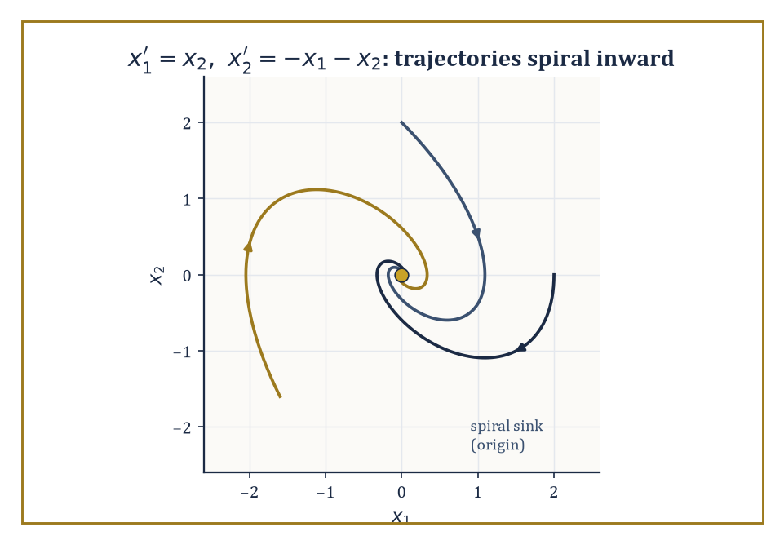
Three trajectories of the damped spring system spiral into the origin — complex eigenvalues with negative real part, drawn rather than merely asserted.
It is stable if solutions that start near x* remain near x* for all future time — formally, for every ε > 0 there is a δ > 0 such that the condition below holds for all t ≥ 0.
|x(0) − x*| < δ ⟹ |x(t) − x*| < ε
It is asymptotically stable if, in addition, nearby solutions actually converge to x* as t → ∞; and unstable if neither holds — some nearby solutions wander off no matter how close you start.
The standard first move is linearisation: replace f near x* by its Jacobian matrix Df(x*), obtaining a constant-coefficient linear system whose behaviour we settled in Room 26.1. If no eigenvalue of Df(x*) has zero real part — the hyperbolic case — the Hartman–Grobman theorem assures us the linearisation's stability verdict is also the true nonlinear verdict, at least locally.
Numeric example — Worked example — a spiral sink by eigenvalues. Take the system below (a unit mass on a spring with unit damping), with equilibrium at the origin.
x₁′ = x₂, x₂′ = −x₁ − x₂
Since the system is already linear, its Jacobian everywhere is the constant matrix below.
A = [[0, 1], [−1, −1]]
The characteristic equation is det(A − λI) = 0, which works out as follows.
(−λ)(−1−λ) − (1)(−1) = λ + λ² + 1 = 0, i.e. λ² + λ + 1 = 0
The discriminant is 1 − 4 = −3, so the roots are:
λ = (−1 ± i√3)/2 ≈ −0.5 ± 0.866i
Both eigenvalues have real part −1/2, strictly negative and nonzero, so the origin is hyperbolic and asymptotically stable — trajectories spiral inward, tracing decaying loops rather than heading straight for the origin, because the eigenvalues are complex rather than real.
Linearisation is silent whenever an eigenvalue sits exactly on the imaginary axis — the non-hyperbolic case — and this is where Lyapunov's direct method earns its keep. Choose a scalar function V(x), positive definite near x* (meaning V(x*) = 0 and V(x) > 0 elsewhere nearby), and compute its rate of change along trajectories using the chain rule, but without ever solving the differential equation.
V̇(x) = ∇V(x)·f(x)
If V̇ ≤ 0 near x*, the equilibrium is stable — V acts as a generalised energy that never increases, trapping trajectories in shrinking level sets of V. If V̇ < 0 for all x ≠ x* nearby, the equilibrium is asymptotically stable. The method converts an analytic problem (solve the ODE) into an algebraic one (find a suitable V) — often far easier, and it works precisely in the cases where linearisation gives up.
Numeric example — Worked example — succeeding where linearisation is mute. Consider x′ = −x³, equilibrium at 0. Linearising gives:
f′(x) = −3x², so f′(0) = 0
That's a zero eigenvalue, the non-hyperbolic case, and Hartman–Grobman has nothing to say. Instead take V(x) = x²/2, which is positive definite (V(0) = 0, V(x) > 0 for x ≠ 0). Then:
V̇(x) = V′(x)·x′ = x·(−x³) = −x⁴
This is strictly negative for every x ≠ 0. Hence the origin is asymptotically stable — a fact linearisation could not detect, but which one line of algebra with V confirms outright. Notice, incidentally, how slow that convergence is (x⁴ decay near zero rather than the exponential decay of a hyperbolic sink) — Lyapunov's method certifies stability without being obliged to tell you the rate.
Sometimes the best V you can find only manages V̇ ≤ 0, not strictly negative — the pendulum's energy is the standard example, since energy is conserved exactly where friction vanishes.
LaSalle's invariance principle rescues the situation: trajectories still converge, not necessarily to x* itself, but to the largest invariant set contained inside {x : V̇(x) = 0}. If that set turns out to contain nothing but the equilibrium, asymptotic stability follows after all — just via a slightly longer argument.
Abstract example — Worked example — the damped pendulum, rescued by LaSalle. Write the damped pendulum equation below as a first-order system.
θ″ + θ′ + sin θ = 0 ⟹ θ′ = ω, ω′ = −ω − sin θ
Take the mechanical energy V(θ, ω) = ω²/2 + (1 − cos θ), which is positive definite near (0, 0). Then:
V̇ = ω·ω′ + sin θ·θ′ = ω(−ω − sin θ) + sin θ·ω = −ω² − ω sin θ + ω sin θ = −ω²
This is only ≤ 0, not < 0 — it vanishes on the whole line ω = 0, not just at the origin, exactly because a pendulum that has swung all the way to θ = π with zero velocity is instantaneously not losing energy either.
LaSalle asks: within the set {ω = 0}, which points can a trajectory actually stay at forever? If ω ≡ 0 along a trajectory then ω′ ≡ 0 too, and the equation ω′ = −ω − sin θ forces sin θ = 0, so θ = 0, π, 2π, … Restricting attention to a neighbourhood of the origin, the only such point is θ = 0.
So the largest invariant subset of {V̇ = 0} near the origin is just the equilibrium itself, and LaSalle upgrades 'energy is non-increasing' to 'the pendulum, however gently it is losing energy at any given instant, is asymptotically stable at rest.'
Linearisation, Lyapunov functions, and LaSalle's principle together form the standard toolkit of nonlinear stability theory, and they underwrite the qualitative analysis of essentially every model in mechanics, population biology, chemical kinetics, and control engineering where an explicit solution formula is either unavailable or not the point.

Room 26.3: Boundary-Value Problems and Sturm–Liouville Theory
Conditions at Both Ends, and the Infinite Orthogonal Choir Between Them
An initial-value problem hands you all its conditions at one instant and asks you to march forward; a boundary-value problem (BVP) instead prescribes conditions at two or more separate points — commonly the two ends of an interval — and offers no 'march forward from here' starting gun at all.
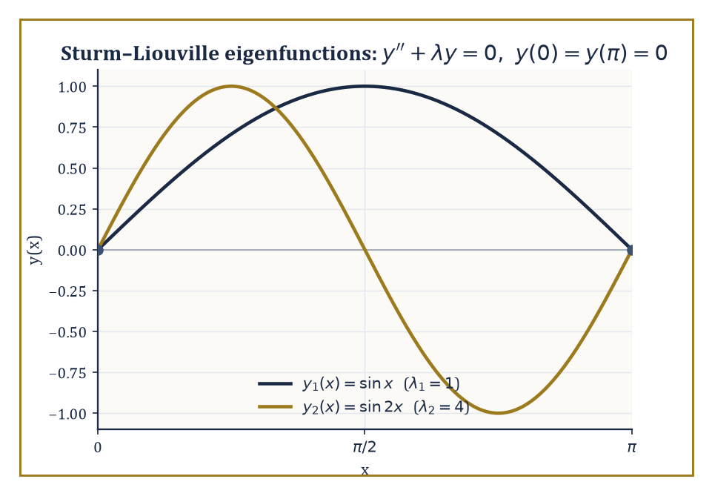
The first two eigenfunctions sin x and sin 2x, pinned to zero at both ends and — as the worked example checks by hand — exactly orthogonal on [0, π].
This changes the existence picture completely: a BVP can have no solution, exactly one solution, or infinitely many, depending on subtle interactions between the equation and the boundary conditions that an IVP never has to negotiate.
Numeric example — Worked example — a straightforward boundary-value problem. Solve the boundary-value problem below.
x″(t) = −1, x(0) = 0, x(1) = 0
Integrating twice gives:
x(t) = −t²/2 + Ct + D
The condition x(0) = 0 gives D = 0 immediately. The condition x(1) = 0 gives −1/2 + C = 0, so C = 1/2. Hence:
x(t) = t/2 − t²/2 = t(1 − t)/2
Check: x′(t) = 1/2 − t, so x″(t) = −1, as required, and x(0) = 0, x(1) = 1·0/2 = 0. Unlike an IVP, both conditions had to be satisfied simultaneously by the two free constants — here it worked out to a unique solution, but a different right-hand side or different boundary values could easily have produced no solution at all, or (as the next paragraph shows) infinitely many.
A Sturm–Liouville problem is a linear second-order boundary-value problem of the special self-adjoint form below, together with separated boundary conditions at each end, where p, q, w are given functions (w > 0 is a weight) and λ is an unknown parameter — an eigenvalue.
−(p(x)y′)′ + q(x)y = λw(x)y
Remarkably, under mild conditions on p, q, w, this equation has solutions only for a discrete increasing sequence of eigenvalues λ₁ < λ₂ < λ₃ < ⋯ → ∞, each with an essentially unique eigenfunction, and — the payoff — the eigenfunctions form an orthogonal basis of the space L²_w of square-integrable functions weighted by w. Any reasonable function can be expanded in this basis, exactly as a periodic function is expanded in sines and cosines.
Numeric example — Worked example — the simplest Sturm–Liouville problem, and orthogonality by hand. Take p = 1, q = 0, w = 1: the equation is below, with y(0) = 0, y(π) = 0.
y″ + λy = 0
Trying y = sin(√λ x) and enforcing y(π) = 0 forces √λ = n for a positive integer n, giving eigenvalues and eigenfunctions:
λₙ = n², yₙ(x) = sin(nx)
Let's verify orthogonality directly for n = 1 and n = 2, using the product-to-sum identity sin A sin B = ½[cos(A−B) − cos(A+B)].
∫₀^π sin(x) sin(2x) dx = ½∫₀^π [cos(x) − cos(3x)] dx = ½[sin(x) − sin(3x)/3]₀^π = ½[(sin π − sin 3π/3) − (sin 0 − sin 0/3)] = ½[(0 − 0) − (0 − 0)] = 0
The two eigenfunctions are exactly orthogonal on [0, π], as Sturm–Liouville theory promises for any two eigenfunctions belonging to different eigenvalues — no coincidence, a theorem.
Because the eigenfunctions form a basis, any function f on the interval can be written as an infinite sum, below, with the coefficients cₙ extracted by the same projection trick that produces ordinary Fourier coefficients — multiply by yₙ, integrate, and divide by the norm, using orthogonality to kill every other term in the sum.
f(x) = Σ cₙ yₙ(x)
This single machine both solves the homogeneous eigenvalue problem and, via variation of parameters term by term, solves the inhomogeneous problem −(py′)′ + qy = f for an arbitrary forcing f. The classical Fourier series, and the Legendre and Bessel expansions met in earlier storeys' applied excursions, are simply Sturm–Liouville expansions for particular choices of p, q, w.
Numeric example — Worked example — the first Fourier sine coefficient of a sawtooth. Expand f(x) = x on [0, π] in the basis yₙ(x) = sin(nx) from the previous example. The coefficient formula is:
bₙ = (2/π)∫₀^π x sin(nx) dx
For n = 1, integrate by parts with u = x, dv = sin x dx, so du = dx, v = −cos x.
∫₀^π x sin x dx = [−x cos x]₀^π + ∫₀^π cos x dx = (−π cos π − 0) + [sin x]₀^π = (−π·(−1)) + (0 − 0) = π
So b₁ = (2/π)·π = 2, and the leading term of the sine-series for the sawtooth f(x) = x is 2 sin x — already a recognisable, if crude, approximation to a straight line using nothing but a single sine wave.
Beyond explicit expansion, Sturm–Liouville theory supplies purely qualitative tools: oscillation theorems (the n-th eigenfunction has exactly n − 1 interior zeros — you can count the wiggles without solving anything), and comparison theorems (a 'stiffer' equation has larger eigenvalues than a 'softer' one).
It also supplies the variational, or Rayleigh-quotient, characterisation of the lowest eigenvalue, defined as a minimum over admissible trial functions y of the ratio below.
λ₁ = min_y R[y], where R[y] = [∫ p(y′)² + qy² dx] / [∫ w y² dx]
Because this is a minimum over all admissible y, plugging in any single trial function — even a bad guess — produces a guaranteed upper bound on λ₁, with no solving required.
Numeric example — Worked example — bounding an eigenvalue without solving the equation. For y″ + λy = 0 on [0, π] with y(0) = y(π) = 0 (p = 1, q = 0, w = 1), we already know the exact answer λ₁ = 1. Pretend we didn't, and try the crude parabolic trial function below, which satisfies the boundary conditions exactly (it vanishes at both ends).
y = x(π − x) = πx − x²
Then y′ = π − 2x, so the numerator of the Rayleigh quotient works out as follows.
∫₀^π (y′)² dx = ∫₀^π (π − 2x)² dx = ∫₀^π (π² − 4πx + 4x²) dx = π²·π − 4π·(π²/2) + 4·(π³/3) = π³ − 2π³ + (4/3)π³ = π³/3
And the denominator works out as follows.
∫₀^π y² dx = ∫₀^π (πx − x²)² dx = ∫₀^π (π²x² − 2πx³ + x⁴) dx = π²·(π³/3) − 2π·(π⁴/4) + π⁵/5 = π⁵/3 − π⁵/2 + π⁵/5 = (10π⁵ − 15π⁵ + 6π⁵)/30 = π⁵/30
So the Rayleigh quotient is:
R[y] = (π³/3) / (π⁵/30) = 10/π² ≈ 10/9.8696 ≈ 1.0132
The true eigenvalue is λ₁ = 1, and our lazy parabola — chosen purely because it has the right boundary behaviour, with no other cleverness — already bounds it from above by 1.0132. That's the variational method's whole appeal: even a bad guess is an honest, checkable bound.
This one-dimensional theory is the prototype for something much larger: the spectral theory of self-adjoint operators, which will reappear, considerably dressed up, when the unknown depends on several variables in the next storey, and again — dressed up further still — in the functional-analytic framework that unifies differential and integral operators as instances of the same abstract object.

Room 26.4: Green's Functions for ODEs
Delta Functions, Jump Conditions, and the Ghost of a Point Force
Given a linear differential operator L with a set of boundary conditions, the Green's function G(x, ξ) is the response of the system, at position x, to an idealised unit point-source concentrated at position ξ — physically, it is what you'd measure at x if you poked the system with a sharp unit impulse at ξ and nowhere else.
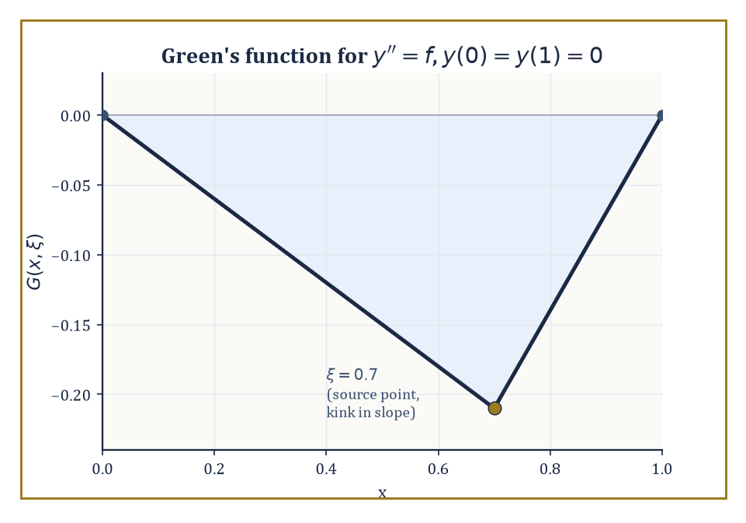
The Green's function for y″ = f on [0, 1]: continuous everywhere, but with a single polite kink in its slope at the source point ξ.
Once G is known, the solution to the full inhomogeneous problem Ly = f, with the same boundary conditions, is obtained by superposition — literally by integrating the point-response against the actual distributed source.
y(x) = ∫ G(x, ξ) f(ξ) dξ
This is the continuous analogue of solving Ax = b for a matrix A by first inverting A: G is, in a precise sense, the inverse of L.
Numeric example — Worked example — constructing and testing a Green's function. Solve Ly = y″ = f(x) on [0, 1] with y(0) = y(1) = 0.
Construction: on the left of the source point ξ, we need a homogeneous solution (y″ = 0, i.e. a straight line) satisfying the left boundary condition y(0) = 0 — take y = x, scaled by a constant depending on ξ. On the right of ξ, we need a homogeneous solution satisfying the right boundary condition y(1) = 0 — take y = x − 1, likewise rescaled.
Matching continuity of G at x = ξ and imposing the jump condition that a unit point-source in a second-order equation forces a unit jump in the first derivative there (since integrating y″ = δ(x − ξ) across the point gives exactly that), one finds:
G(x, ξ) = x(ξ − 1) for 0 ≤ x ≤ ξ, and G(x, ξ) = ξ(x − 1) for ξ ≤ x ≤ 1
Check the jump: for x < ξ, ∂G/∂x = ξ − 1; for x > ξ, ∂G/∂x = ξ; the jump at x = ξ is ξ − (ξ − 1) = 1, exactly as required. Check continuity at x = ξ: both branches give ξ(ξ − 1). Check the boundary values: G(0, ξ) = 0, and G(1, ξ) = ξ(1 − 1) = 0.
Now test the whole machine against a case we can also solve directly: take f(x) = 1. Direct solution of y″ = 1, y(0) = y(1) = 0 gives:
y(x) = x²/2 + Cx, and y(1) = 0 forces C = −1/2, so y(x) = x²/2 − x/2 = x(x − 1)/2
Via the Green's function instead:
y(x) = ∫₀^x ξ(x−1) dξ + ∫_x^1 x(ξ−1) dξ = (x−1)·(x²/2) + x·[(1/2 − 1) − (x²/2 − x)] = (x³/2 − x²/2) + (−x/2 − x³/2 + x²) = x²/2 − x/2 = x(x−1)/2
This exactly matches the direct solution. The Green's function machinery, built once and for all without knowing f in advance, reproduces the answer for this particular f without further work.
The general recipe scales up in the obvious way: solve the homogeneous equation separately on each side of the source point ξ, impose all the boundary conditions on the appropriate side, glue the two pieces together with continuity in G itself and in all but its highest derivative, and finish with a single jump condition on the highest derivative — the size of the jump being fixed by the leading coefficient of the operator at ξ.
The same construction extends to operators of any order, and to systems of equations, with more derivatives required to be continuous and only the very last one permitted to jump. It is, in short, one polite kink allowed per Green's function, and the bureaucracy of exactly which derivative gets to misbehave is entirely determined in advance.
Abstract example — Worked example — the pattern for a higher-order operator. For a general n-th order linear operator L = aₙ(x)·d^n/dx^n + ⋯ + a₀(x), the Green's function G, G′, …, G^{(n−2)} must all be continuous across x = ξ, while the (n−1)-th derivative jumps by exactly 1/aₙ(ξ).
[G^{(n−1)}]_{ξ⁻}^{ξ⁺} = 1/aₙ(ξ)
The second-order example above is the case n = 2: no lower derivatives are required to be continuous besides G itself (that's the n − 2 = 0 case, meaning only G is forced continuous), and the single jump falls on G′ = G^{(n−1)}, with a₂(ξ) = 1 giving a jump of exactly 1 — matching what we computed by hand.
A fourth-order beam equation (n = 4, governing the deflection of a loaded beam) would instead require G, G′, and G″ continuous, with the jump appearing three derivatives down, in G‴ — the same skeleton, just one storey taller.
One structural feature is worth flagging before we move on: for a self-adjoint operator (the kind Sturm–Liouville theory specialises in), the Green's function is symmetric.
G(x, ξ) = G(ξ, x)
The response measured at x to a poke at ξ is identical to the response measured at ξ to a poke at x, a mathematical statement of the physical principle of reciprocity (push here, measure there; the reading is the same as if you'd pushed there and measured here).
Numeric example — Worked example — reciprocity, checked with actual numbers. Using the Green's function constructed above, G(x, ξ) = x(ξ − 1) for x ≤ ξ and G(x, ξ) = ξ(x − 1) for x ≥ ξ, take the concrete pair x = 0.3, ξ = 0.7. Since 0.3 ≤ 0.7, we use the first branch.
G(0.3, 0.7) = 0.3·(0.7 − 1) = 0.3·(−0.3) = −0.09
Now evaluate G(0.7, 0.3) — swap the roles, so the first argument is 0.7 and the second is 0.3. Since 0.7 ≥ 0.3, we use the second branch with x = 0.7, ξ = 0.3.
G(0.7, 0.3) = 0.3·(0.7 − 1) = 0.3·(−0.3) = −0.09
The two values agree exactly, confirming G(0.3, 0.7) = G(0.7, 0.3) for this particular pair — and the same cancellation happens for any pair, since both branches reduce to the product (smaller argument)·(larger argument − 1) once you sort out which is which.
Green's functions are the hinge on which this entire storey turns: they convert a boundary-value problem, phrased purely in terms of derivatives, into an integral equation, phrased purely in terms of an integral kernel — precisely the bridge that lets Rooms 26.6 and 26.7 treat integro-differential equations as, in disguise, differential equations that have already had their Green's function applied.

Room 26.5: What Integro-Differential Equations Are
Equations That Keep a Diary
An integro-differential equation (IDE) involves both derivatives and integrals of the unknown function in the same equation. A typical form is given below.
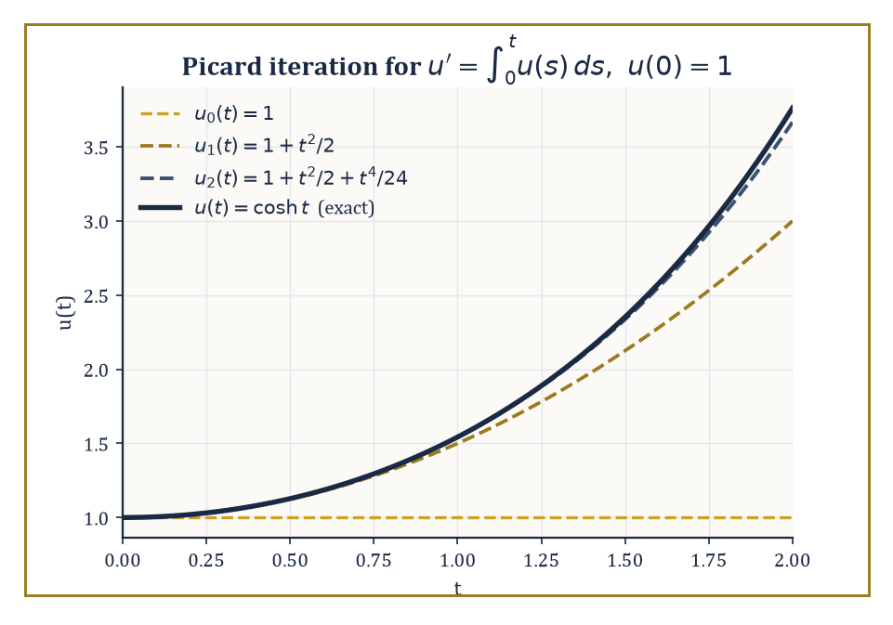
Successive Picard iterates u₀, u₁, u₂ visibly closing in on the exact solution cosh t, one more term of its Taylor series at a time.
u′(t) = f(t, u(t)) + ∫₀ᵗ K(t, s, u(s)) ds
The rate of change at time t depends not only on the current state u(t), through f, but also on the entire trajectory of u from the start up to now, through the integral term. The kernel K encodes exactly how much each past moment s contributes to the present rate: it is the mathematical embodiment of memory. An ordinary differential equation is, in this light, the special (and rather amnesiac) case where K is identically zero — the present has no idea what the past got up to.
Nature, rather inconveniently for anyone who enjoyed the tidiness of Storey 17, is stuffed with genuine hereditary effects: a viscoelastic material's stress depends on every strain it has ever experienced, not just its current one; a population's birth rate depends on its whole past age structure, not just today's headcount; a feedback controller with a sensor lag is, whether its designer intended it or not, solving a delay equation; and even classical electromagnetism, in certain formulations, has the field at a point depend on the source's behaviour at earlier retarded times.
Wherever the present genuinely depends on the accumulated past rather than merely on the instantaneous state, an ODE is the wrong tool and an IDE is the right one.
Numeric example — Worked example — an equation that remembers everything. Consider the initial-value problem below: the instantaneous rate of change is governed entirely by the accumulated total of the function's own past values.
u′(t) = ∫₀ᵗ u(s) ds, u(0) = 1
Set U(t) = ∫₀ᵗ u(s) ds, so the equation reads u′ = U, and differentiating the definition of U gives U′ = u. Differentiating the first relation again:
u″ = U′ = u
The integral has been traded for a second derivative, at the cost of needing a second condition: U(0) = ∫₀⁰ u(s) ds = 0, so u′(0) = U(0) = 0, alongside u(0) = 1. The equation u″ = u with u(0) = 1, u′(0) = 0 has solution:
u(t) = cosh t = (e^t + e^{−t})/2
Check directly against the original equation: u′(t) = sinh t, and
∫₀ᵗ u(s) ds = ∫₀ᵗ cosh s ds = [sinh s]₀ᵗ = sinh t
They agree. Notice how apt the example is: cosh t grows because it has been quietly integrating its own entire history since the beginning of time — an equation that, true to the memory theme of this storey, never forgets a thing it has done.
Existence and uniqueness for IDEs adapt the Picard contraction argument from Room 26.1, but applied to the integral formulation of the whole equation (derivative and all) rather than to the bare right-hand side.
A pleasant surprise awaits: because integration is a smoothing operation — it can only make a function better-behaved, never worse — the presence of the memory term very often improves the regularity of the solution rather than threatening it, in marked contrast to the intuition that 'more terms means more trouble.'
Numeric example — Worked example — Picard iteration building a Taylor series by hand. Return to u′(t) = ∫₀ᵗ u(s) ds, u(0) = 1, in its integral form below.
u(t) = 1 + ∫₀ᵗ ∫₀^{t′} u(s) ds dt′
Start the Picard iteration from the crudest possible guess, u₀(t) = 1. Then:
u₁(t) = 1 + ∫₀ᵗ [∫₀^{t′} 1 ds] dt′ = 1 + ∫₀ᵗ t′ dt′ = 1 + t²/2
Feed this back in:
u₂(t) = 1 + ∫₀ᵗ [∫₀^{t′} (1 + s²/2) ds] dt′ = 1 + ∫₀ᵗ [t′ + t′³/6] dt′ = 1 + t²/2 + t⁴/24
Compare with the Taylor series of the exact solution found above.
cosh t = Σₙ t^{2n}/(2n)! = 1 + t²/2! + t⁴/4! + ⋯ = 1 + t²/2 + t⁴/24 + ⋯
u₂ already matches every term up to t⁴ exactly (2! = 2, 4! = 24). The Picard iteration is not just converging in some abstract sense; it is visibly, term by term, constructing the Taylor series of cosh t from nothing but repeated integration.
One tool from Storey 18 survives this generalisation almost unscathed: whenever the kernel is of convolution type, K(t, s, u(s)) = K(t − s)·u(s), depending only on the elapsed time t − s rather than on t and s separately, the Laplace transform turns the convolution integral into an ordinary product of transforms — and the whole IDE collapses back into an algebraic equation, exactly as it did for plain linear ODEs.
This rests on the convolution theorem: the Laplace transform of a convolution is simply the product of the two individual transforms.
L{(K * u)(t)} = L{∫₀ᵗ K(t−s)u(s) ds} = K̂(s)·û(s)
This turns the messiest-looking operation in this storey into the most ordinary one in algebra.
Numeric example — Worked example — the convolution theorem, checked both ways. Let K(t) = e^{−t} and u(t) = 1 (the constant function). Directly:
(K * u)(t) = ∫₀ᵗ e^{−(t−s)}·1 ds
Substitute w = t − s (so dw = −ds, and the limits flip from s: 0→t to w: t→0, which the sign flip turns back into w: 0→t).
∫₀ᵗ e^{−w} dw = [−e^{−w}]₀ᵗ = (−e^{−t}) − (−1) = 1 − e^{−t}
So (K*u)(t) = 1 − e^{−t}. Now via transforms: K̂(s) = 1/(s+1) and û(s) = 1/s, so the theorem predicts the transform of the convolution is:
K̂(s)û(s) = 1/[s(s+1)]
Partial fractions give the decomposition below (check: common denominator gives [(s+1) − s]/[s(s+1)] = 1/[s(s+1)], correct).
1/[s(s+1)] = 1/s − 1/(s+1)
The inverse transform of 1/s is 1, and of 1/(s+1) is e^{−t}, so the inverse transform of the product is 1 − e^{−t} — exactly matching the direct computation. This is the entire justification for treating a convolution integral as 'just another algebraic factor' once Laplace-transformed, and it is what makes Room 26.6's resolvent calculations work.

Room 26.6: Volterra Integro-Differential Equations
Causality, or: Why the Future Is Not Allowed to Vote
A Volterra equation is one whose integral runs from a fixed starting point up to the variable t itself — ∫₀ᵗ, rather than over a fixed interval. This variable upper limit is precisely what makes it causal, or hereditary: the value of the integral at time t depends only on the values of u at times s ≤ t, never on the future.
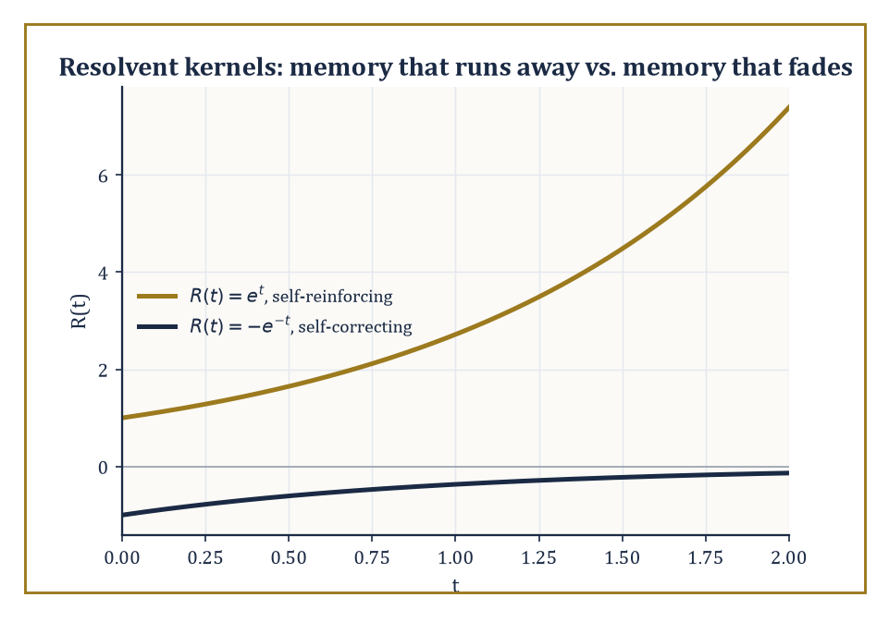
Flip the sign of one kernel and the resolvent stops exploding and starts decaying — the algebraic fingerprint of self-reinforcing versus self-correcting memory.
Linear Volterra integro-differential equations can be recast as Volterra integral equations of the second kind by the same integration trick used in Room 26.5.
u(t) = f(t) + ∫₀ᵗ K(t,s) u(s) ds
These can then be solved either by successive approximation, exactly as in Room 26.5's Picard example, or — when the kernel is of convolution type — by the Laplace transform.
Numeric example — Worked example — Laplace transform on a Volterra equation. Solve the equation below.
u′(t) = 1 + ∫₀ᵗ u(s) ds, u(0) = 0
Taking the Laplace transform of both sides (writing U(s) for the transform of u), and using that the transform of an integral from 0 to t divides by s:
sU(s) − u(0) = 1/s + U(s)/s
Since u(0) = 0, this is sU(s) − U(s)/s = 1/s. Multiplying through by s:
s²U(s) − U(s) = 1, so U(s) = 1/(s² − 1)
This is a standard transform pair: the inverse Laplace transform of 1/(s² − 1) is sinh t. So u(t) = sinh t.
Check directly: u(0) = sinh 0 = 0, correct. u′(t) = cosh t. And the right-hand side is:
1 + ∫₀ᵗ sinh s ds = 1 + [cosh s]₀ᵗ = 1 + (cosh t − 1) = cosh t
The two sides agree.
Just as a constant-coefficient linear ODE has a fundamental matrix e^{At} governing how any initial condition propagates, a linear Volterra equation has a resolvent kernel R(t, s), which satisfies its own integral equation (where * denotes convolution) and plays exactly the same organising role.
R = K + K * R
Once R is known, the solution for any forcing f is given by the variation-of-parameters-style formula below, valid for every choice of f without redoing the work.
u(t) = f(t) + ∫₀ᵗ R(t − s) f(s) ds
Numeric example — Worked example — computing a resolvent kernel. For the equation below (constant kernel K ≡ 1), take Laplace transforms of the resolvent equation.
u(t) = f(t) + ∫₀ᵗ u(s) ds
The transform of the kernel is K̂(s) = 1/s, and the resolvent satisfies:
R̂(s) = K̂(s)/(1 − K̂(s)) = (1/s)/(1 − 1/s) = (1/s)/[(s−1)/s] = 1/(s − 1)
whose inverse transform is R(t) = e^t. Test it with f(t) = 1: the formula predicts:
u(t) = 1 + ∫₀ᵗ e^{t−s}·1 ds = 1 + e^t∫₀ᵗ e^{−s} ds = 1 + e^t(1 − e^{−t}) = 1 + e^t − 1 = e^t
Direct check: does u(t) = e^t satisfy u(t) = 1 + ∫₀ᵗ u(s) ds? The right-hand side is:
1 + ∫₀ᵗ e^s ds = 1 + (e^t − 1) = e^t
It matches.
Whether the resolvent grows or decays over time is exactly what determines whether the system's memory is self-reinforcing (destabilising) or self-correcting (stabilising) — a distinction with no counterpart in ordinary differential equations, where there is no memory to reinforce or correct in the first place.
Numeric example — Worked example — a self-correcting memory. Keep the same style of equation but flip the sign of the kernel.
u(t) = f(t) − ∫₀ᵗ u(s) ds
Now K̂(s) = −1/s, and:
R̂(s) = K̂(s)/(1 − K̂(s)) = (−1/s)/(1 + 1/s) = (−1/s)/[(s+1)/s] = −1/(s+1)
whose inverse transform is R(t) = −e^{−t}. Where the previous example's resolvent e^t exploded, this one decays to zero — the negative kernel means each past contribution is subtracted back off, a built-in corrective feedback rather than a runaway reinforcement, and the resolvent's exponential decay is the algebraic fingerprint of that stability.
This machinery is not merely decorative: it is the standard language of viscoelasticity, where a material's present stress depends on its entire strain history rather than on the current strain alone; of age-structured population models, where the birth rate today depends on an integral over the whole age distribution accumulated in the past; and of control systems with delayed feedback, where a controller's present action is corrected by an integral of past tracking errors.
Three quite different disciplines, all quietly refusing to let the past go.
Worked example — Worked example — viscoelastic stress relaxation. A simple linear viscoelastic model expresses stress as the integral below, where ε′(s) is the strain rate at past time s and E(t − s) is a relaxation modulus describing how much a strain increment from s time units ago still contributes to today's stress.
σ(t) = ∫₀ᵗ E(t − s) ε′(s) ds
Take the common exponential relaxation modulus E(t − s) = E₀ e^{−(t−s)/τ} (a material that 'forgets' old strain on a timescale τ) under a constant strain rate ε′(s) = ε̇₀. Then:
σ(t) = E₀ε̇₀ ∫₀ᵗ e^{−(t−s)/τ} ds
Substituting w = t − s (so dw = −ds, and the limits flip from s: 0→t to w: t→0, which flips again on reversing the sign):
∫₀ᵗ e^{−(t−s)/τ} ds = ∫₀ᵗ e^{−w/τ} dw = τ(1 − e^{−t/τ})
So:
σ(t) = E₀ε̇₀τ(1 − e^{−t/τ})
As t → ∞, σ(t) → E₀ε̇₀τ, a finite steady-state stress, even though the strain itself is increasing without bound at constant rate ε̇₀ — the material's fading memory (governed by τ) is exactly what keeps the stress from blowing up alongside the strain.

Room 26.7: Fredholm Integro-Differential Equations and Eigenvalue Problems
No Causality Required: Every Point Consults Every Other Point at Once
A Fredholm equation, by contrast with a Volterra one, has fixed limits of integration — the whole interval, every time — and therefore no causal structure whatsoever: the kernel couples every point of the domain to every other point simultaneously, with no notion of 'past' or 'future' to keep them apart.
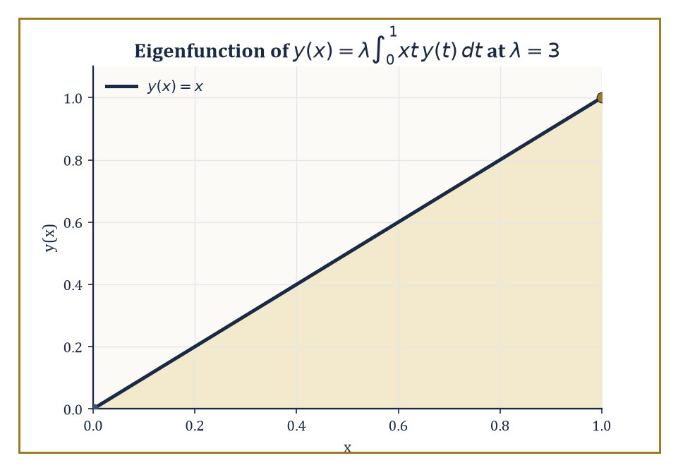
The eigenfunction y(x) = x for the degenerate kernel K(x,t) = xt, found by hand and checked to satisfy the equation exactly at λ = 3.
The Fredholm alternative governs solvability for a linear equation of the form below.
y − λ∫K(x,t)y(t)dt = f
Either the homogeneous version (f = 0) has only the trivial solution, in which case the inhomogeneous equation has a unique solution for every f, or the homogeneous version has nontrivial solutions, in which case the inhomogeneous equation is solvable only for those f that are orthogonal to every such solution — a dichotomy with no middle ground.
When the integral operator is compact (roughly: it smooths sharp features, as integration against a well-behaved kernel always does), its spectrum of eigenvalues is discrete, accumulating nowhere except possibly at zero — an infinite-dimensional operator behaving, spectrally, remarkably like a very large but ordinary matrix.
Numeric example — Worked example — an eigenvalue by hand, degenerate kernel. Solve for eigenvalue λ and eigenfunction y in the equation below.
y(x) = λ∫₀¹ xt·y(t) dt
Because the kernel K(x, t) = xt factors as a function of x times a function of t (a 'degenerate' kernel), any solution must itself be of the form y(x) = cx for some constant c — the x dependence on the right-hand side is forced to be exactly x. Substitute y(t) = ct into the equation:
cx = λ∫₀¹ xt·(ct) dt = λcx∫₀¹ t² dt = λcx·(1/3)
Cancelling x (valid for x ≠ 0) and c (assuming a nontrivial eigenfunction, c ≠ 0) leaves 1 = λ/3, so λ = 3. The eigenvalue is 3, with eigenfunction y(x) = x (up to an arbitrary overall scale, as always for eigenfunctions).
Check directly: with y(t) = t and λ = 3, the right-hand side is:
3∫₀¹ xt·t dt = 3x∫₀¹ t² dt = 3x·(1/3) = x = y(x)
It checks out exactly.
Numeric example — Worked example — the Fredholm alternative at resonance. Now perturb the previous eigenvalue problem into an inhomogeneous one, using λ = 3, precisely the eigenvalue we just found.
y(x) − 3∫₀¹ xt·y(t) dt = g(x)
Try g(x) = x. Since the kernel is degenerate, any solution must have the form y(x) = x + 3x·c, where c = ∫₀¹ t·y(t) dt is a constant to be found self-consistently. Substituting:
c = ∫₀¹ t·(t + 3ct) dt = ∫₀¹ (t² + 3ct²) dt = (1 + 3c)·∫₀¹t²dt = (1+3c)/3 = 1/3 + c
This simplifies to c = 1/3 + c, i.e. 0 = 1/3 — a flat contradiction, so no solution exists for this g.
The Fredholm alternative explains exactly why: at the eigenvalue λ = 3, the inhomogeneous equation is solvable only when g is orthogonal to the homogeneous eigenfunction y = x, meaning the condition below must hold.
∫₀¹ x·g(x) dx = 0
Here ∫₀¹ x·x dx = 1/3 ≠ 0, so the solvability condition fails, and our contradiction was the algebra dutifully reporting exactly that. This is the integral-equation cousin of mechanical resonance: forcing a system at its own natural frequency, with a forcing term that has a component along the resonant mode, produces no steady solution at all — only an amplitude that would need to grow without bound.
A Fredholm integro-differential eigenvalue problem combines a differential operator with a Fredholm integral operator in the same equation, with boundary conditions on y — for instance the equation below.
y″(x) = λ∫K(x,t)y(t)dt
Under the same compactness assumptions, the spectrum remains discrete, but an explicit formula for the eigenvalues is rarely available.
In practice one turns to numerical projection methods — collocation or Galerkin schemes — which represent the unknown eigenfunction approximately as a combination of a small, fixed set of basis functions, and in doing so reduce the entire infinite-dimensional eigenvalue problem to an ordinary matrix eigenvalue problem, solvable by the linear algebra of Storey 12.
Worked example — Worked example — what the discretised problem looks like. Suppose a Galerkin projection of some Fredholm integro-differential operator onto just two basis functions produces the symmetric matrix below as its approximate representation (a stand-in for the far messier matrix a real discretisation would produce, but structurally identical).
M = [[2, 1], [1, 2]]
Its trace is 4 and its determinant is 2·2 − 1·1 = 3, so the characteristic equation is:
λ² − 4λ + 3 = 0, factoring as (λ − 1)(λ − 3) = 0
The eigenvalues are 1 and 3.
For λ = 3:
(2−3)v₁ + v₂ = 0, i.e. v₂ = v₁, eigenvector (1, 1)
For λ = 1:
(2−1)v₁ + v₂ = 0, i.e. v₂ = −v₁, eigenvector (1, −1)
This two-line linear algebra computation is exactly the kind of thing a Galerkin or collocation scheme reduces the original, genuinely infinite-dimensional eigenvalue problem to — swap 'diagonalise a 2×2 matrix by hand' for 'diagonalise a 500×500 matrix on a computer in a fraction of a second,' and you have the entire numerical strategy in miniature.
Such combined differential-and-integral eigenvalue problems arise in the theory of loaded strings (where an integral term represents an added mass distribution, rather than the string's own uniform density), in certain formulations of neutron transport (where the integral represents scattering between all directions at once, not just neighbouring ones), and in non-local continuum mechanics (where stress at a point depends on strain throughout a whole surrounding region, not merely at that point).
A useful rule of thumb, inherited directly from the Rayleigh-quotient monotonicity of Room 26.3: adding a load — extra mass, or an extra non-local coupling — can only push the fundamental eigenvalue down, never up.
An unloaded string of length 1 satisfying y″ + λy = 0 with y(0) = y(1) = 0 has fundamental eigenvalue below (the n = 1 case of λₙ = (nπ)² on a unit interval).
λ₁ = π² ≈ 9.87
Loading it with any genuine Fredholm integral term is guaranteed, by that same variational principle, to produce a new fundamental eigenvalue strictly below 9.87 — the load makes the string want to vibrate more slowly, and the mathematics knew that before a single new number was computed.

Room 26.8: Delay Equations and Equations with Memory
The State of the System Is Not a Point, It Is a Recent Autobiography
A delay differential equation (also called a functional differential equation of retarded type) has the form below, for a fixed delay τ > 0: the rate of change depends not only on the current state but explicitly on the state at one fixed moment in the past.
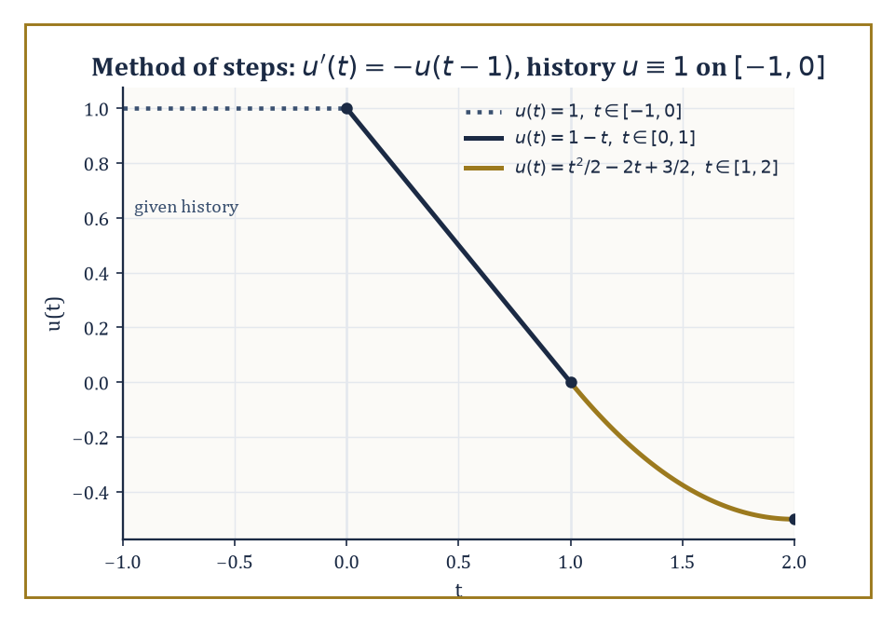
The method of steps in action: each new piece of the solution is built entirely from the piece before it, one delay-window at a time.
u′(t) = f(t, u(t), u(t − τ))
This has a striking consequence for what 'the state of the system' even means: it is no longer the single number u(t), but the entire function segment on the trailing window [t − τ, t] — an element of the infinite-dimensional space of continuous functions on that window, rather than a point of ℝ.
Existence, uniqueness, and continuous dependence on the initial data hold under Lipschitz conditions on f, exactly as in Room 26.1, but the proof proceeds by the method of steps: solve the equation as an ordinary ODE on [0, τ] using the known history to fill in u(t − τ), then repeat on [τ, 2τ] using the solution just obtained, and so on indefinitely.
Numeric example — Worked example — the method of steps. Solve u′(t) = −u(t − 1) with initial history u(t) = 1 for t ∈ [−1, 0].
On [0, 1]: here t − 1 ∈ [−1, 0], where the history says u(t−1) = 1, so the equation becomes the ordinary u′(t) = −1. Integrating from u(0) = 1 (the history's endpoint value):
u(t) = 1 − t
In particular u(1) = 0.
On [1, 2]: now t − 1 ∈ [0, 1], where we just found u(t−1) = 1 − (t−1) = 2 − t, so the equation becomes u′(t) = −(2 − t) = t − 2. Integrating from u(1) = 0:
u(t) = 0 + ∫₁ᵗ (s − 2) ds = [s²/2 − 2s]₁ᵗ = (t²/2 − 2t) − (1/2 − 2) = t²/2 − 2t + 3/2
Check continuity at the join, t = 1: t²/2 − 2t + 3/2 = 1/2 − 2 + 3/2 = 0, matching u(1) = 0 from the first piece exactly. And u(2) = 4/2 − 4 + 3/2 = 2 − 4 + 1.5 = −0.5. Each interval's solution is built entirely from the previous interval's — a genuinely constructive, computable procedure, one delay-window at a time.
For the linear autonomous case below, trying the usual exponential ansatz u(t) = e^{λt} produces a characteristic equation.
u′(t) = a·u(t) + b·u(t − τ)
The ansatz produces the characteristic equation below.
λ − a − b e^{−λτ} = 0
But now this is transcendental rather than polynomial, and it has infinitely many roots in the complex plane, not the finite handful an ODE would give.
The long-term behaviour is governed by the supremum of the real parts of all these roots (the 'rightmost root'), and as the parameters a, b, τ vary continuously, individual roots can cross the imaginary axis — switching a stable equilibrium to an unstable one, or back, often repeatedly, producing bifurcation diagrams considerably richer than anything a finite-dimensional linear ODE could manage.
Numeric example — Worked example — sitting exactly on the edge of stability. Consider u′(t) = −(π/2)·u(t − 1), so a = 0, b = −π/2, τ = 1. The characteristic equation simplifies as follows.
λ − 0 − (−π/2)e^{−λ} = 0 ⟹ λ + (π/2)e^{−λ} = 0
Let's check the purely imaginary value λ = iπ/2. We need:
e^{−iπ/2} = cos(−π/2) + i sin(−π/2) = 0 + i·(−1) = −i
So (π/2)e^{−iπ/2} = (π/2)(−i) = −iπ/2. Then:
λ + (π/2)e^{−λ} = iπ/2 + (−iπ/2) = 0
Exactly zero, confirming λ = iπ/2 is genuinely a root. This is the classical stability-boundary example of delay-equation theory: u′(t) = −a·u(t−1) is asymptotically stable for 0 < a < π/2 and unstable for a > π/2, with a = π/2 sitting exactly on the boundary, sustaining an undying oscillation of angular frequency π/2 — that is, period 2π/(π/2) = 4 time units. A vanishingly small nudge to the coefficient a is the entire difference between a system that settles down and one that oscillates forever.
Two further generalisations enlarge the family without changing its essential character. Neutral equations let the derivative itself appear with a delay, as in the equation below — the rate of change now depends on how fast the system was changing in the past, not merely on where it was.
u′(t) = f(t, u(t), u(t−τ), u′(t−τ))
Distributed-delay equations replace the single fixed lag τ with a whole spread of lags, weighted by an integral kernel, as in the equation below — a more realistic model when the 'memory' of a system fades gradually rather than cutting off sharply at one instant.
u′(t) = ∫_{−τ}^{0} u(t + θ) dη(θ)
Both are, in the end, simply particular kernels within the general integro-differential framework laid out in Room 26.5 — the delay equation was an integro-differential equation wearing a disguise all along, its kernel a single spike (a Dirac delta) at lag τ rather than something spread out.
Numeric example — Worked example — a distributed delay smoothing a jump. Take the uniform distributed-delay term below with τ = 1, acting on a step history: u(s) = 0 for s < 0, u(s) = 1 for s ≥ 0.
(1/τ)∫_{t−τ}^{t} u(s) ds
For t ∈ [0, 1], the averaging window [t−1, t] straddles the jump at s = 0: the part of the window below 0 contributes nothing (u = 0 there), so:
(1/τ)∫₀ᵗ 1 ds = t
So the distributed-delay term rises linearly from 0 at t = 0 to 1 at t = 1.
For t ≥ 1, the entire window [t−1, t] lies at or past the jump, so the average is constant thereafter.
(1/τ)∫_{t−1}^{t} 1 ds = 1
A single instantaneous jump in the underlying signal has been turned, by the act of averaging over a trailing window, into a smooth linear ramp exactly one delay-window wide — distributed memory is, quite literally, a smoothing device.

Room 26.9: Looking Ahead: From Integro-Differential Equations to PDEs and Functional Analysis
Packing for the Next Storey
We have now pushed the theory of differential equations from the elementary methods of Storey 17 through systems, stability, boundary-value problems, Green's functions, and the principal classes of integro-differential and delay equations. Two threads run through everything in this storey and both point directly at what comes next.
First, once the state of a system is a function rather than a finite list of numbers — as it becomes for a delay equation or a general integro-differential equation — we are already doing infinite-dimensional dynamics, whether we admit it or not. Second, Green's functions and integral operators turned out to be differential operators wearing a different coat, unified by the same underlying spectral theory met first in Sturm–Liouville form.
Storey 27 takes the next visible step: the unknown depends on several independent variables at once, and the operators become genuinely partial rather than ordinary — a heat equation or a wave equation is, in the right light, exactly the kind of eigenvalue problem this storey has been rehearsing, just with one more variable to keep track of.
Functional analysis, waiting a little further up the tower, supplies the fully abstract setting — Banach and Hilbert spaces of functions, with differential and integral operators alike treated as bounded or unbounded linear maps between them — in which existence, uniqueness, and spectral theory for both families are, at last, literally the same theorem.
Abstract example — Worked example — two histories, one present value. Take the delay equation u′(t) = f(u(t), u(t−1)) and compare two candidate initial histories on [−1, 0], below.
φ₁(θ) = 1 for every θ ∈ [−1, 0]
φ₂(θ) = 1 + θ for θ ∈ [−1, 0]
φ₁ is a flat history; φ₂ is a history ramping up from φ₂(−1) = 0 to φ₂(0) = 1. Both histories agree at the single point that matters for an ordinary differential equation.
u(0) = φ₁(0) = φ₂(0) = 1
For an ODE, that single shared number would be the entire initial condition, and the two systems would evolve identically forever after. But for the delay equation, φ₁ and φ₂ are different points of the phase space C([−1,0], ℝ) — different whole segments — and as soon as t exceeds 0 and the term u(t−1) starts drawing on values from θ ∈ (−1, 0), the two trajectories can diverge, because they are consulting different pasts even though they share the same present.
This is the concrete, checkable sense in which 'the state is not a point, it is a recent autobiography': agreement on the last page of the diary says nothing about agreement on the pages before it.
There is also a genuinely practical challenge lurking behind all this elegance: simulating a memory term numerically, the naive way, means storing the entire history of the solution and re-summing over all of it at every single future time step — a cost that grows without bound as the simulation runs on.
The escape route, already visible in Room 26.5's conversion of ∫₀ᵗ u(s) ds into an auxiliary variable U with its own ordinary differential equation, and in Room 26.6's exponential resolvents, is to notice that kernels built from sums or products of exponentials satisfy their own tiny system of memoryless ODEs — a trick called Markovian embedding.
Replace the ever-growing memory integral with a handful of auxiliary variables that update cheaply at every step, and the past no longer needs to be stored at all — only summarised.
Numeric example — Worked example — the price of forgetting how to forget. Suppose a simulation runs for N = 10,000 time steps, and at every step the naive approach must re-sum a memory integral over all previous steps.
N²/2 = 10,000²/2 = 100,000,000/2 = 5×10⁷ arithmetic operations
Now suppose the kernel happens to be a sum of exponential modes, and Markovian embedding replaces the memory integral with, say, 5 auxiliary variables, each updated by a cheap one-step rule independent of how far the simulation has already progressed.
5N = 5×10,000 = 50,000 = 5×10⁴ operations
The ratio is:
5×10⁷ / 5×10⁴ = 1,000
Three orders of magnitude cheaper, purely from recognising that a decaying-exponential memory, however far back it appears to reach, is secretly satisfying its own local, memoryless differential equation the whole time.
The deeper lesson of this storey, stripped of its machinery, is that a system's dependence on its entire past is both physically utterly ordinary — friction has aftereffects, materials remember old strain, populations remember their age structure, almost nothing in the physical world is quite as forgetful as the idealised ODE pretends — and, once the right function spaces and integral operators are brought to bear, mathematically manageable rather than terrifying.
It is worth noticing, too, how much of this storey's vocabulary will simply change costume rather than disappear: the resolvent kernel of Room 26.6 reappears in Storey 27 as the fundamental solution, or heat kernel, of a partial differential equation — again a function of two points, again built to be integrated against a source to produce a solution, again governing exactly how sharply, or how gently, influence spreads from one point to another.
Differential and integro-differential equations together form the core language of continuous-time dynamical modelling, from the merely elementary right up to the frontier — and very little of the language will need to be relearned from scratch.
So: the future may depend on the whole of the past, and it turns out that is a perfectly respectable thing for a future to do, provided you are willing to work in the right space of functions and stop insisting that a system's state be describable by a finite grocery list of numbers. Tenure committees, notoriously, remember only the last five years and forget everything inconvenient before that; our equations, to their credit, are considerably more honest about their memory than most of the institutions that employ the people who study them.
Storey 27 now asks the unknown function to depend on more than one variable at once — space as well as time — and turns our ordinary derivatives into partial ones. Almost nothing here is wasted: the eigenvalue expansions of Room 26.3 return as separation of variables, the Green's functions of Room 26.4 return dressed as fundamental solutions of the heat and wave equations, and the qualitative instincts of Room 26.2's stability theory return more or less unaltered, just with infinitely many directions to be stable or unstable in at once.
The tower continues upward. We have learned that the future may remember the past — now let's go and meet a function of two variables. It is about to get complicated in a whole new direction, and we would not have it any other way.

Storey 27: Partial Differential Equations
Waves, Diffusion, Equilibrium, and the Art of Equations in Several Variables
The previous storey left the unknown function in a comfortable, if occasionally chaotic, situation: it depended on one variable, usually called t, and its entire life story was a curve traced out over time. Differential and integro-differential equations, however wild their right-hand sides, were still fundamentally the story of a single point wandering through a state space. That was, in retrospect, a rather sheltered existence. We now remove the shelter.
From this storey onward the unknown function u is allowed — indeed required — to depend on several independent variables at once: on x and y, or on x, y, z and t, or on however many coordinates the problem needs to describe a string, a drum, a slab of metal, or the electromagnetic field filling a room. An equation relating u to its partial derivatives with respect to these several variables is a partial differential equation, and the extra variables are not a cosmetic generalisation. They change everything: a single number (an initial condition) is no longer enough data to pin down a solution; one now needs data along entire curves or surfaces, the shape of the domain itself becomes part of the mathematics, and the same-looking differential expression can behave like three quite different animals — elliptic, parabolic, or hyperbolic — depending on the signs of a few coefficients.
This is traditionally the point in a mathematical education at which enthusiasm and confidence part ways for a while. The repertoire of equations one can solve by a formula shrinks alarmingly, replaced by a much larger repertoire of qualitative theorems — maximum principles, energy estimates, existence proofs by pure force of functional analysis — that tell you a great deal about a solution without ever writing it down. This is not a defect of the theory; it is the theory growing up. Ordinary differential equations are, with a few exceptions, the kind of problem one can hope to finish by hand. Partial differential equations are the kind of problem the whole of twentieth-century analysis was invented to survive.
We will keep to the classical core: first-order equations solved by the method of characteristics, the three great second-order archetypes (wave, heat, Laplace), separation of variables and eigenfunction expansions, and the maximum-principle and energy-method machinery that makes the whole subject rigorous rather than merely plausible. Nonlinear equations and the full modern apparatus of Sobolev spaces are visited only at the door, in the last room, as a preview of where the tower goes next — although, as it happens, one of those maximum principles turns out to be secretly a minimisation problem, which is as good an introduction as any to the storey immediately above this one, where we finally ask what it means for a quantity to be as small (or as large) as it can possibly be. Let's add independent variables.

Room 27.1: What a Partial Differential Equation Actually Is
In which the unknown acquires several relatives to answer to
An ordinary differential equation asks a function of one variable to relate to its own derivatives — a curve, tracing out a life story in time. A partial differential equation asks more: it relates a function u of several independent variables to its partial derivatives with respect to each of them.
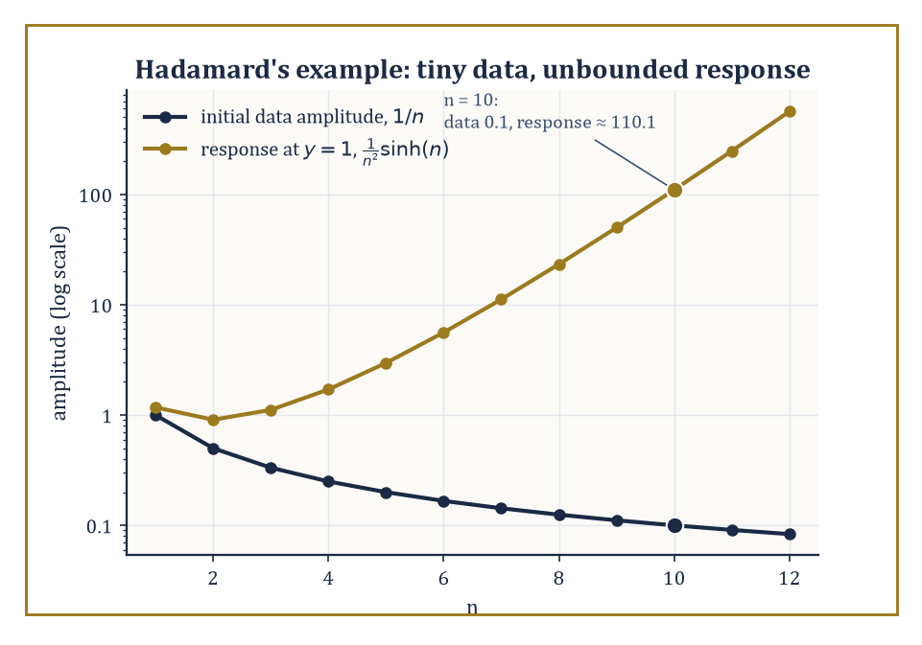
As n grows, Hadamard's initial data shrink to nothing while the corresponding solution explodes — ill-posedness made visible.
Instead of a single curve, the unknown is now a whole landscape — a temperature over a room, a displacement over a drumhead, a potential filling a volume — and the equation constrains how that landscape is allowed to look and how it is allowed to change.
The order of a PDE is, exactly as for ODEs, the order of the highest derivative appearing; a solution is a function that satisfies the equation identically at every point of some domain.
Nothing here is conceptually new so far. What is new, and what will occupy the rest of this storey, is that several variables turns out not to be a mild inconvenience but the whole story.
Numeric example — Worked example — checking a candidate solution. Consider the following candidate, proposed as a solution of the heat equation (the simplest case, with diffusion constant k = 1):
u(x, t) = e^(−t) sin x
The heat equation itself reads:
u_t = u_xx
Differentiate the candidate:
u_t = −e^(−t) sin x
u_x = e^(−t) cos x
u_xx = −e^(−t) sin x
These agree — u_t = u_xx exactly, at every (x, t) — so u is indeed a solution. Notice the order of the equation: the highest derivative present is u_xx, a second derivative in x (the equation is only first order in t), so the heat equation has order 2.
This is the standard shape of a check: propose a candidate, differentiate it exactly as many times as the equation demands, and see whether the two sides agree identically, not just at one point.
A PDE is linear if the unknown and all its derivatives occur to the first power and are not multiplied together — no u², no u·u_x, no sin(u).
Constant-coefficient linear equations, such as the heat, wave, and Laplace equations, are by far the most tractable; allow the coefficients to vary, or allow the equation to become nonlinear, and explicit formulas mostly evaporate.
The single most useful consequence of linearity is the superposition principle: if u₁ and u₂ both solve a linear homogeneous PDE, so does any combination c₁u₁ + c₂u₂. This is what makes Fourier series solve the heat and wave equations later in this storey — build the general solution by adding up simple ones.
Nonlinear equations grant no such courtesy, and the resulting loss of superposition is not a minor technical inconvenience; it is the mathematical origin of shocks, turbulence, and most of the phenomena that make fluid dynamics simultaneously fascinating and a Millennium Prize problem (a matter to which we will return, briefly and cautiously, at the end of this storey).
Numeric example — Worked example — superposition succeeds, then fails. Take Burgers' equation, the simplest genuinely nonlinear transport equation:
u_t + u u_x = 0
Both u₁ = 1 (the constant function) and u₂ = x/t solve it: for u₁, every term is zero. For u₂, compute the pieces:
u_t = −x/t², u_x = 1/t
u·u_x = (x/t)(1/t) = x/t²
u_t + u u_x = −x/t² + x/t² = 0
Good — both are bona fide solutions. Now test the sum:
w = u₁ + u₂ = 1 + x/t
Its derivatives are computed next (the constant contributes nothing to w_t):
w_t = −x/t², w_x = 1/t
w·w_x = (1 + x/t)(1/t) = 1/t + x/t²
w_t + w·w_x = −x/t² + 1/t + x/t² = 1/t
which is not zero. The sum of two solutions of a nonlinear equation is, in general, not a solution at all — superposition, the workhorse of the linear theory, simply fails.
The deepest question one can ask of a PDE, once it is written down, is whether it is well posed in Hadamard's sense: a solution should exist, it should be unique, and — crucially — it should depend continuously on the given data (initial values, boundary values, coefficients).
That third condition is not pedantry. Data in any real problem come from measurement, and measurements carry error; if an arbitrarily small change in the data can produce an arbitrarily large change in the solution, the equation is useless as a model no matter how elegant it looks on paper.
Not every equation one can write down honestly deserves to be called a description of a physical process, and Hadamard supplied the standard cautionary tale using, of all things, Laplace's equation — normally the best-behaved operator in the entire subject.
Numeric example — Worked example — Hadamard's ill-posed problem. Consider Laplace's equation on the strip {(x, y) : y ≥ 0}:
u_xx + u_yy = 0
with Cauchy data prescribed at y = 0:
u(x, 0) = 0, u_y(x, 0) = (1/n) sin(nx)
for some large integer n. One checks directly that the following function is harmonic and matches the prescribed data exactly at y = 0:
u_n(x, y) = (1/n²) sin(nx) sinh(ny)
Indeed u_xx = −sin(nx) sinh(ny) and u_yy = +sin(nx) sinh(ny), and they cancel.
As n → ∞, the initial data shrink to zero uniformly — the velocity data (1/n) sin(nx) has amplitude 1/n, vanishing.
Yet fix any y > 0, say y = 1, and take n = 10: the amplitude of the solution there is
(1/100) sinh(10) ≈ (1/100)(11013.2) ≈ 110.1
— over a thousand times larger than the initial data's amplitude of 1/10 = 0.1, and this ratio grows without bound as n increases further, since sinh(n) grows exponentially.
Arbitrarily small data, arbitrarily large response: the Cauchy problem for Laplace's equation is ill-posed, and the lesson generalises — the type of a PDE (elliptic, parabolic, hyperbolic, the subject of the next room) determines which kind of data it is willing to accept at all.

Room 27.2: First-Order Equations and the Method of Characteristics
Following information along the roads it actually travels
A first-order quasilinear PDE has the form:
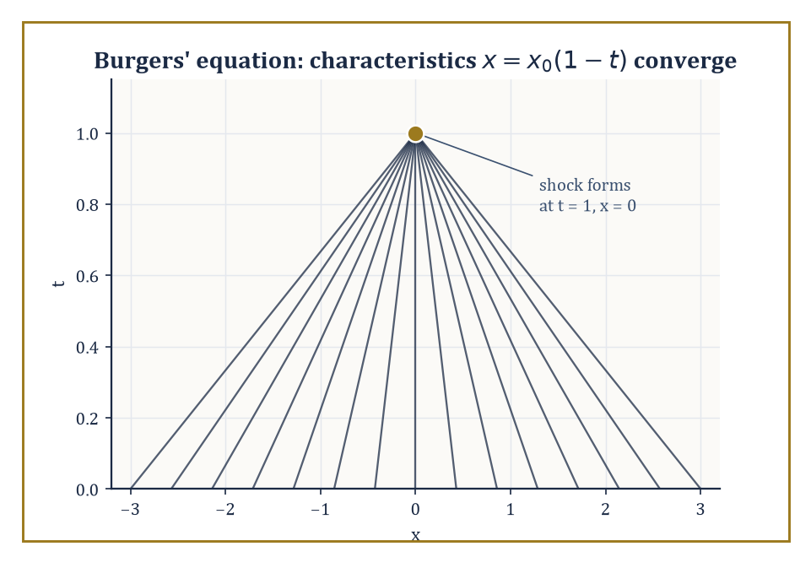
Every characteristic of the collapsing profile u(x,0) = −x arrives at the same appointment: x = 0, t = 1.
a(x, y, u) u_x + b(x, y, u) u_y = c(x, y, u)
the unknown's two first partial derivatives appear linearly, though the coefficients may depend on u itself.
The trick that unlocks such equations — the method of characteristics — is to notice that the left-hand side is a directional derivative: it is the rate of change of u along the direction (a, b) in the (x, y)-plane.
So instead of treating u_x and u_y separately, follow a curve (x(s), y(s)) whose tangent is exactly (a, b); along that curve the PDE collapses into an ordinary differential equation,
du/ds = c
Three coupled ODEs replace one PDE:
dx/ds = a, dy/ds = b, du/ds = c
This is the single most important idea in the whole first-order theory: a partial differential equation for information spread across a plane becomes an ordinary differential equation for information travelling along curves, called characteristics, and solving the PDE is reduced to solving these ODEs and then eliminating the parameter s.
Numeric example — Worked example — linear transport. The homogeneous linear transport equation is the simplest case:
u_t + c u_x = 0
here a = c, b = 1 (treating t as the second variable), and the right-hand side is zero, so u is exactly constant along each characteristic.
The characteristics themselves solve dx/dt = c, i.e.
x(t) = x₀ + ct
— straight lines of slope c in the (x, t)-plane — and:
u(x, t) = u(x₀, 0) = f(x₀) = f(x − ct)
Take c = 2 and initial data f(x) = sin x: the solution is
u(x, t) = sin(x − 2t)
a wave profile translating rigidly to the right at speed 2. Check it directly:
u_t = −2 cos(x − 2t), u_x = cos(x − 2t)
u_t + 2u_x = −2 cos(x − 2t) + 2 cos(x − 2t) = 0
exactly as required. The whole solution is nothing more than 'take the initial shape and slide it.'
Once the coefficients depend on u itself — the quasilinear case proper — the characteristic curves are no longer parallel straight lines; each one carries its own value of u, and its own consequent slope, so different characteristics can converge.
Where they do, the classical (smooth, single-valued) solution breaks down: the same point (x, t) would be asked to carry two different values of u, which is nonsense for an honest function.
Physically this is the birth of a shock — a genuine discontinuity, such as the leading edge of a traffic jam or the front of a sonic boom — and the classical method of characteristics announces its own moment of failure by telling you exactly when and where it happens.
Numeric example — Worked example — a smooth profile collapsing into a shock. Take inviscid Burgers' equation with initial data u(x, 0) = −x:
u_t + u u_x = 0
Along a characteristic starting at (x₀, 0), u stays constant (du/ds = 0) at its initial value u₀ = −x₀, and the characteristic itself moves at that constant speed:
dx/dt = u = −x₀, so x(t) = x₀ + (−x₀)t = x₀(1 − t)
Solving for x₀ (valid while t ≠ 1) gives the solution:
x₀ = x/(1 − t)
u(x, t) = −x₀ = −x/(1 − t)
Checking:
u_t = −x/(1 − t)², u_x = −1/(1 − t)
u·u_x = [−x/(1−t)]·[−1/(1−t)] = x/(1 − t)²
u_t + u u_x = −x/(1−t)² + x/(1−t)² = 0
— confirmed. But look at the characteristics:
x(t) = x₀(1 − t) = 0 at t = 1, for every single value of x₀
All the characteristics converge on the single point x = 0 simultaneously at t = 1: the solution's slope u_x = −1/(1−t) blows up as t → 1⁻, and beyond that moment no classical solution exists at all.
A perfectly smooth initial profile has focused itself into a shock in finite time, purely from the equation's own nonlinearity — nobody had to hit it with anything.
The characteristic equations also handle the case where the right-hand side is not zero — an inhomogeneous quasilinear equation still reduces to the same three coupled ODEs,
dx/ds = a, dy/ds = b, du/ds = c
only now the last equation has to be integrated rather than dismissed as du/ds = 0. This is worth seeing worked through once in full, since it is the general pattern of which the pure transport equation above is only the simplest special case.
Numeric example — Worked example — characteristics with a genuine source term. Solve the following equation, with data u(x, 0) = x prescribed along the line y = 0:
u_x + u_y = u
Here a = 1, b = 1, c = u, so the characteristic system is
dx/ds = 1, dy/ds = 1, du/ds = u
starting from (x₀, 0, x₀) at s = 0. The first two integrate to
x = x₀ + s, y = s
so s = y and x₀ = x − y. The third is a linear ODE in u alone, du/ds = u, whose solution is
u = x₀ e^s = (x − y) e^y
Check it directly:
u_x = e^y
u_y = −e^y + (x − y)e^y
(product rule on the two y-dependent factors), so:
u_x + u_y = e^y + [−e^y + (x−y)e^y] = (x − y)e^y = u
exactly matching the right-hand side of the PDE. And on y = 0,
u = (x − 0)e^0 = x
matching the prescribed data. A source term along the characteristic simply becomes an ODE to solve for how u itself grows or decays as it rides along — here it grows exponentially, at rate 1 per unit of the parameter s, which is just the elapsed distance along the characteristic since it left the data curve.
This geometric idea — that a PDE governs how information propagates along preferred curves at a finite, computable speed — does not stay confined to first-order scalar equations.
It reappears, considerably dressed up, as the theory of characteristic surfaces for hyperbolic systems and second-order hyperbolic equations (the wave equation of the next room is the flagship example), and it is the precise mathematical reason that hyperbolic problems have a finite domain of dependence: a disturbance at one point cannot be felt everywhere instantly, only within the cone swept out by the characteristics through that point.
Elliptic and parabolic equations, we will see, have no such speed limit at all — a fact that will look eccentric the first time you meet it and entirely natural the second.

Room 27.3: Classification of Second-Order Equations
Elliptic, parabolic, hyperbolic — or, conic sections get their revenge
A general second-order linear PDE in two variables can be written:
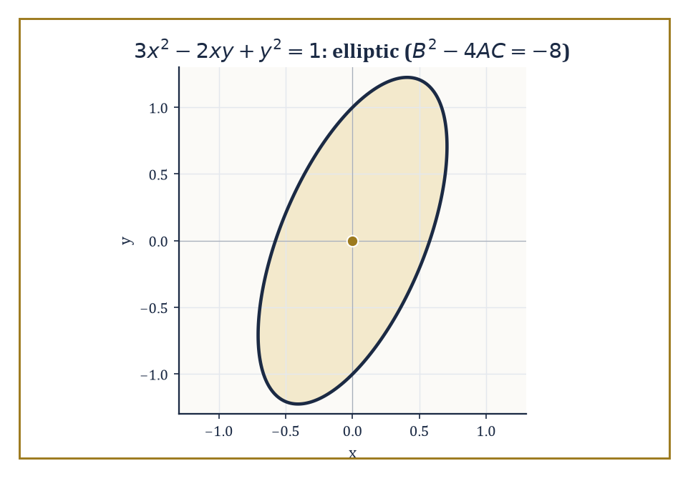
The principal symbol 3x² − 2xy + y² = 1 draws an honest ellipse — the geometric fingerprint of an elliptic operator.
A u_xx + B u_xy + C u_yy + (lower-order terms) = 0
where A, B, C may depend on x and y. Its principal part — the terms with the highest (second) derivatives — is what governs the equation's essential character, and that character is decided by a single number, the discriminant B² − 4AC, evaluated pointwise.
This is exactly the same expression that classifies a conic section:
Ax² + Bxy + Cy² = const
as an ellipse, a parabola, or a hyperbola, and the naming is not a coincidence but a direct borrowing: the equation is called elliptic where B² − 4AC < 0, parabolic where it equals 0, and hyperbolic where it is positive.
Crucially, this sign is a genuine property of the equation, not an artefact of the coordinates chosen to write it down — a smooth invertible change of variables multiplies the discriminant by the square of the transformation's Jacobian determinant, which is positive, so the sign survives unchanged.
Numeric example — Worked example — classifying the three prototypes. Classify three familiar equations by their discriminant. First:
3u_xx − 2u_xy + u_yy = 0
Here A = 3, B = −2, C = 1, so:
B² − 4AC = 4 − 12 = −8 < 0
— elliptic. Second, the wave equation (treating x and t as the two variables, with no mixed u_xt term):
u_tt − c²u_xx = 0
Here A = −c², B = 0, C = 1, so:
B² − 4AC = 0 − 4(−c²)(1) = 4c² > 0
for any nonzero wave speed c — hyperbolic. Third, the heat equation, which has no u_tt term at all and no mixed term:
u_t − k u_xx = 0
so A = −k, B = 0, C = 0, giving:
B² − 4AC = 0 − 4(−k)(0) = 0
exactly — parabolic, the boundary case between the other two, which is a rather satisfying way to discover that diffusion sits precisely on the fence between equilibrium and vibration.
The type of the equation is not an idle label; it dictates which data make the problem well posed at all, foreshadowing everything that follows in this storey.
Elliptic equations describe equilibrium states with no distinguished direction of propagation, so they are paired with boundary data prescribed all around a closed region (the Dirichlet or Neumann problem).
Hyperbolic equations propagate information at finite speed along characteristics, so they are paired with initial data — a snapshot and a velocity — on an open-ended domain.
Parabolic equations, true to their fence-sitting discriminant, need both: initial data at one moment and boundary data for all later time, because they diffuse forward but have no direction to diffuse backward into.
Prescribe the wrong kind of data for the wrong type — Cauchy data for an elliptic equation, say — and Hadamard's catastrophe from the previous room is exactly what results.
Abstract example — Abstract example — the conic-section shadow. The kinship with conic sections is not merely etymological; it is the same algebra wearing a different hat. The equation 3u_xx − 2u_xy + u_yy = 0 above has principal symbol matching the quadratic form:
3x² − 2xy + y² = 1
and this curve is, by the identical discriminant calculation (−8 < 0), an ellipse — a closed, bounded curve with no real asymptotic directions.
That absence of real asymptotic directions is the geometric shadow of the analytic fact that elliptic operators have no real characteristic curves at all: there is no direction along which information can leak out of the domain, which is exactly why elliptic problems are equilibrium problems, sealed and self-consistent once boundary values are fixed, rather than problems that evolve.
Hyperbolic operators, by contrast, correspond to actual hyperbolas, which do have real asymptotes — and those asymptotic directions are precisely the characteristic directions along which Room 27.2's information travels.
In more independent variables, or for a system of several coupled equations, the discriminant itself is replaced by something equivalent but grander: the eigenvalues of the matrix of coefficients attached to the principal part.
Elliptic still means all the eigenvalues share the same sign — no direction is special, exactly as in the plane.
Hyperbolic still means the signs split, one against the rest — a distinguished time-like direction emerges, along which information propagates, surrounded by the rest behaving as space does.
The three classical types remain, even in this generality, the organizing principle of the whole elementary theory; they simply stop being read off a single number and start being read off a spectrum.
Numeric example — Worked example — classification by eigenvalues in higher dimensions. The three-dimensional Laplacian is:
u_xx + u_yy + u_zz = 0
It has principal-part coefficient matrix equal to the 3×3 identity matrix: eigenvalues 1, 1, 1, all strictly positive, all the same sign — elliptic, in exact agreement with the two-variable discriminant test and regardless of how many spatial dimensions are added.
The 3+1-dimensional wave equation is:
u_tt − c²(u_xx + u_yy + u_zz) = 0
It has coefficient matrix diag(1, −c², −c², −c²) (one eigenvalue for the t-direction, three for the spatial directions): eigenvalues 1, −c², −c², −c² — one positive, three negative, a signature of exactly one sign flipped against the rest.
This is precisely the pattern that defines hyperbolic in the general sense, and it is no accident that physicists call this same signature pattern, dressed up as spacetime geometry, Lorentzian: the wave equation's hyperbolicity and relativity's distinction between time and space are, at the level of this one matrix of eigenvalues, the identical piece of linear algebra.

Room 27.4: The Wave Equation
d'Alembert solves everything twice, once going each way
The one-dimensional wave equation
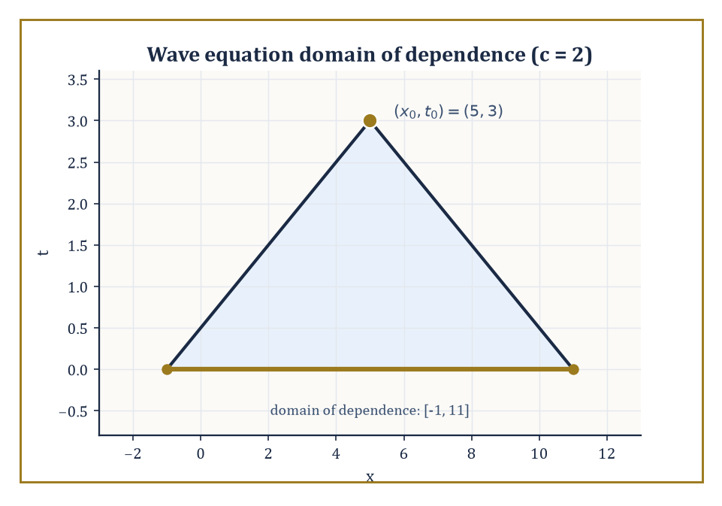
The backward light cone from (5, 3) touches the initial line at exactly [−1, 11] — everything outside is none of its business.
u_tt = c² u_xx
governs a vibrating string, and its general solution has an unreasonably clean closed form: d'Alembert's formula.
Because the equation factors — writing it as
(∂_t − c∂_x)(∂_t + c∂_x)u = 0
— the general solution is a superposition of a right-travelling wave and a left-travelling wave,
u(x, t) = φ(x − ct) + ψ(x + ct)
each moving rigidly at speed c without changing shape, in either direction.
Given initial displacement u(x, 0) = f(x) and initial velocity u_t(x, 0) = g(x), the two profiles φ and ψ are pinned down completely, and the result collapses into the single formula:
u(x, t) = ½[f(x + ct) + f(x − ct)] + (1/2c) ∫ from x−ct to x+ct of g(s) ds
On the infinite line this determines the solution everywhere and for all time from the initial data alone — no boundary conditions needed, because there is no boundary.
Numeric example — Worked example — d'Alembert in action, twice. Take c = 1, initial displacement f(x) = x², and initial velocity g(x) = 1 (the whole string starts moving upward uniformly). D'Alembert's formula gives:
u(x, t) = ½[(x+t)² + (x−t)²] + ½∫ from x−t to x+t of 1 ds = ½[2x² + 2t²] + ½(2t) = x² + t² + t
Verify the PDE:
u_tt = 2, u_xx = 2, c² = 1, so u_tt = c²u_xx holds exactly
Verify the data:
u(x, 0) = x² = f(x); u_t(x, t) = 2t + 1, so u_t(x, 0) = 1 = g(x)
As a second instance, take instead c = 2, f(x) = sin x, g(x) = 0 (no initial velocity, a plucked string released from rest). Then:
u(x, t) = ½[sin(x+2t) + sin(x−2t)]
and the sum-to-product identity
sin A + sin B = 2 sin((A+B)/2) cos((A−B)/2)
collapses this to:
u(x, t) = sin x · cos 2t
— the initial shape stays put in x but oscillates in place with angular frequency 2, a standing wave built from two travelling ones.
D'Alembert's formula also reads off, at a glance, one of the wave equation's signature features: finite propagation speed.
The value u(x₀, t₀) depends only on the initial data inside the interval [x₀ − ct₀, x₀ + ct₀] — the domain of dependence — because that is the only stretch of the initial line the two characteristic lines through (x₀, t₀) can reach.
Turn it around and a given point x₁ on the initial line can only influence the solution inside the expanding wedge |x − x₁| ≤ ct — its domain of influence. No signal, however the initial data are chosen, can travel faster than c.
This is the qualitative fingerprint of every hyperbolic equation, and it is the mathematical reason the speed of light is a hard limit rather than a suggestion.
Numeric example — Worked example — domains of dependence and influence. With wave speed c = 2, the value of the solution at the spacetime point (x₀, t₀) = (5, 3) depends only on initial data on the interval:
[5 − 2·3, 5 + 2·3] = [−1, 11]
Data given outside that interval — say, a bump in f(x) centred at x = 20 — has, mathematically, zero effect on u(5, 3); no amount of waiting changes that, since t₀ is already fixed at 3.
If instead we ask what that same bump at x = 20 can influence by time t = 3, the answer is the interval:
[20 − 6, 20 + 6] = [14, 26]
— the point x₀ = 5 is nowhere near it, consistent with the domain-of-dependence calculation above. The two notions, dependence and influence, are simply the same cone viewed from its two ends.
Energy is conserved for the free wave equation — the quantity
E(t) = ½∫(u_t² + c²u_x²) dx
summing kinetic and elastic potential energy, is constant in time, and this single fact (provable by differentiating E and integrating by parts) supplies uniqueness for the wave equation with none of d'Alembert's explicit formula required — an energy method, the first of several such arguments that will recur throughout this storey.
In more than one space dimension the story acquires an extra, almost whimsical twist: Huygens' principle.
In three (and any odd) dimension, a localized disturbance produces a sharp signal — an observer feels nothing, then feels the full disturbance, then feels nothing again, cleanly. In two (and any even) dimension, the signal never fully passes — it leaves a decaying wake behind it forever.
This is why a firework you hear cleanly click and then stop, but a stone dropped in a pond leaves ripples lingering long after the splash: sound genuinely lives in three dimensions, but the surface of a pond is stuck in two.
Abstract example — Abstract example — a sharp bang against a lingering ripple. Fix wave speed c = 1 and imagine an idealized instantaneous disturbance released at the origin at time t = 0.
An observer at distance r = 10 from the origin, in three-dimensional space, feels absolutely nothing until exactly t = 10, then experiences the disturbance, and then — this is the sharp part — feels nothing again for all t > 10: the trailing edge of the signal is as crisp as the leading edge, because the fundamental solution of the three-dimensional wave equation is supported exactly on the sphere:
|x| = ct
a set of measure zero at each instant.
Repeat the experiment with the two-dimensional wave equation (the honest model for ripples on a pond surface): the same observer still feels nothing before t = 10, begins to feel the disturbance at t = 10, but the response then decays only like:
1/√(t² − r²)
as t → ∞ rather than switching off — the disturbance rings on forever, ever more faintly.
The difference between these two outcomes is Huygens' principle, and it holds precisely in odd dimension and fails precisely in even dimension, for reasons buried in the fine structure of Bessel functions that we will only glimpse, in Room 27.7, and never fully chase down.

Room 27.5: The Heat Equation
Where yesterday's sharp corners become today's smooth curves
The heat equation
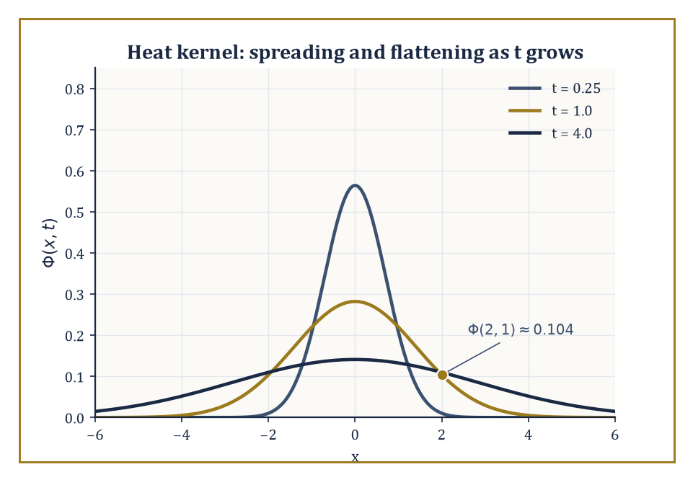
The heat kernel at t = 0.25, 1, and 4 — same total area under each curve, ever more thinly spread.
u_t = k u_xx
(with k > 0 the diffusivity) models the diffusion of temperature, of chemical concentration, or — rather more alarmingly for anyone who has just met it — of probability itself, since it is also the equation governing Brownian motion.
On the whole real line, the initial-value problem u(x, 0) = u₀(x) is solved by convolving the initial data against the heat kernel (or fundamental solution):
Φ(x, t) = (4πkt)^(−1/2) exp(−x²/4kt)
u(x, t) = ∫ over all y of Φ(x − y, t) u₀(y) dy
This formula is worth pausing over, because it encodes the equation's whole personality.
Φ(·, t) is itself a Gaussian bump that starts (as t → 0⁺) infinitely tall and infinitely thin — a mathematical idealisation of a point source of heat — and spreads out, flattening as t grows, while always integrating to exactly 1: heat is neither created nor destroyed, merely redistributed.
Numeric example — Worked example — evaluating the fundamental solution. With diffusivity k = 1, evaluate the fundamental solution at x = 2, t = 1:
Φ(2, 1) = (4π·1)^(−1/2) exp(−4/4) = (4π)^(−1/2) e^(−1)
Numerically, 4π ≈ 12.566, so (4π)^(−1/2) ≈ 0.2821, and e^(−1) ≈ 0.3679, giving:
Φ(2, 1) ≈ 0.2821 × 0.3679 ≈ 0.1038
This number is the temperature, at distance 2 from a unit point source of heat released at the origin at time 0, exactly one time unit later — compare it to the peak temperature directly above the source at the same instant:
Φ(0, 1) = (4π)^(−1/2) ≈ 0.2821
and the ratio
0.1038/0.2821 ≈ 0.368 = e^(−1)
shows the Gaussian's characteristic exponential fall-off with distance.
An immediate and rather startling consequence of the convolution formula is that the solution becomes analytic (infinitely differentiable and locally given by a convergent power series) the instant t > 0, no matter how rough — even discontinuous — the initial data u₀ were. The heat equation is the great smoother of the PDE world.
The price for this generosity is infinite propagation speed: strictly, Φ(x, t) > 0 for every x and every t > 0, however large |x| and however small t, so heating a point at the origin is felt, in principle, everywhere else in the universe instantaneously (if only by an absurdly, undetectably tiny amount).
This is physically dubious — nothing should travel faster than light — but it is a faithful feature of the idealised model, and a useful warning that every PDE is a simplification with a domain of validity.
Numeric example — Worked example — a Gaussian evolving into a wider, flatter Gaussian. Gaussian initial data evolve into Gaussian solutions, by the reproducing property of Gaussians under convolution — a fact worth checking explicitly rather than taking on faith.
Let k = 1 and u₀(x) = e^(−x²) (matching Φ's form with an effective starting time a = 1/4, since e^(−x²/(4·(1/4))) = e^(−x²)). The general Gaussian-evolves-to-Gaussian formula gives:
u(x, t) = (1 + 4t)^(−1/2) exp(−x²/(1 + 4t))
At t = 0 this reads:
(1)^(−1/2)e^(−x²) = e^(−x²) = u₀(x)
correct. At t = 2:
u(x, 2) = 9^(−1/2) exp(−x²/9) = (1/3) e^(−x²/9)
— the bump has widened (the denominator inside the exponential grew from 1 to 9) and its peak height has dropped from 1 to 1/3, exactly as diffusion should behave: same total heat, spread more thinly.
To confirm the PDE directly, set s = 1 + 4t and u = s^(−1/2)e^(−x²/s); differentiating gives:
u_x = −2x s^(−3/2) e^(−x²/s)
u_xx = e^(−x²/s)[−2s^(−3/2) + 4x²s^(−5/2)]
while:
u_t = (ds/dt)(du/ds) = 4·e^(−x²/s)[−½s^(−3/2) + x²s^(−5/2)] = e^(−x²/s)[−2s^(−3/2) + 4x²s^(−5/2)]
— identical to u_xx, term for term.
On a bounded interval, separation of variables (the subject of Room 27.7 in full generality) produces solutions as sums of exponentially decaying sine or cosine terms, each mode
e^(−λₙt) sin(nπx/L)
decaying at its own rate λₙ — the higher-frequency wiggles die out fastest, which is exactly the smoothing phenomenon from the previous example rewritten in Fourier language.
Two further facts anchor the theory rigorously. The maximum principle states that a solution of the heat equation on a bounded space-time region attains both its maximum and minimum values only on the parabolic boundary — the initial time slice together with the lateral spatial boundary, never at an interior or final-time point — which is exactly the statement that heat cannot spontaneously well up from nowhere in the middle of a rod.
And energy methods, multiplying the equation by u and integrating by parts, show that the quantity ∫u² dx is non-increasing in time, giving uniqueness and quantitative decay estimates without ever solving the equation explicitly.
Numeric example — Worked example — the maximum principle watching temperature decay. Solve u_t = u_xx on the interval [0, π] with Dirichlet boundary conditions u(0, t) = u(π, t) = 0 and initial data u(x, 0) = sin x.
This is already an eigenfunction of the spatial operator (−d²/dx² with these boundary conditions has eigenfunctions sin(nx), eigenvalue n²), so no expansion is even needed: the exact solution matches Room 27.1's very first example:
u(x, t) = e^(−t) sin x
At t = 0, the maximum over the whole closed bar is 1, attained at x = π/2 — squarely on the initial-time part of the parabolic boundary, as the maximum principle demands.
At t = 1, the profile has shrunk uniformly to e^(−1) sin x, whose maximum is e^(−1) ≈ 0.368, less than 1; at t = 5, it has shrunk further to a maximum of e^(−5) ≈ 0.0067 — the temperature is, for all practical purposes, back to the (zero) boundary value everywhere, exactly the decay-to-equilibrium behaviour the energy method predicts in general, here made completely explicit.

Room 27.6: Laplace's Equation and Harmonic Functions
The mathematics of things that have settled down
Laplace's equation:
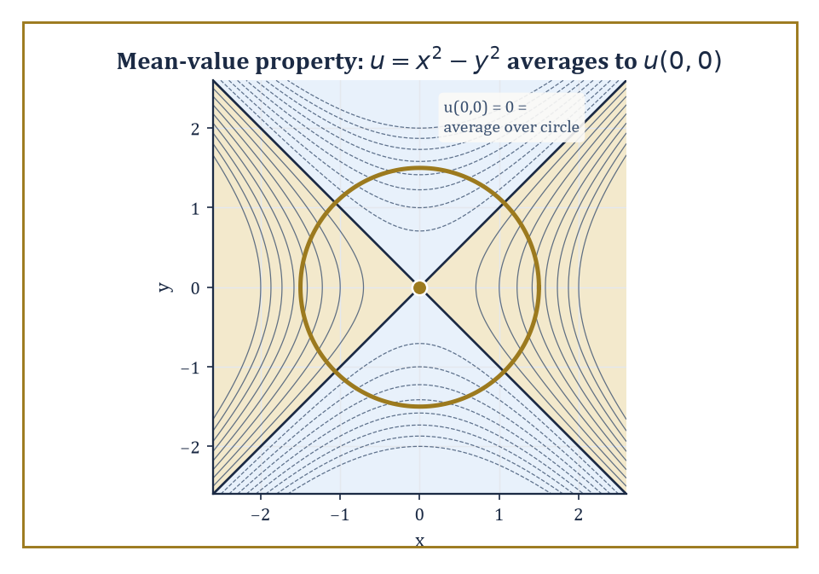
The saddle u = x² − y² refuses to disagree with its own neighbourhood: its average over any circle centred at the origin is exactly u(0,0).
Δu = u_xx + u_yy (plus u_zz, in three dimensions) = 0
describes states of equilibrium: steady temperatures, electrostatic potentials in a charge-free region, or the velocity potential of an incompressible, irrotational fluid flow.
Solutions are called harmonic functions, and they are, by a wide margin, the best-behaved functions in the whole of analysis. Three facts anchor everything else in this room.
First, the mean-value property: the value of a harmonic function at any point equals its average over any circle (or sphere) centred at that point and lying inside the domain — a harmonic function literally cannot disagree with its own neighbourhood on average.
Second, the maximum principle: a non-constant harmonic function on a bounded domain attains its maximum and minimum only on the boundary, never in the interior — an immediate corollary of the mean-value property, since an interior maximum would force the function to be constant nearby.
Third, the regularity theorem: harmonic functions are automatically real-analytic (locally a convergent power series) wherever they are merely twice differentiable — an astonishing amount of smoothness extracted from a single linear equation with no smoothing terms visibly built in.
Numeric example — Worked example — checking harmonicity directly. Check that the following function is harmonic:
u(x, y) = x³ − 3xy²
(it is, in fact, the real part of z³ where z = x + iy, and the real and imaginary parts of any holomorphic function are automatically harmonic — a fact we will not prove here but is well worth remembering as a source of endless free examples). Differentiate:
u_x = 3x² − 3y², so u_xx = 6x
u_y = −6xy, so u_yy = −6x
Then:
Δu = u_xx + u_yy = 6x + (−6x) = 0
for every (x, y) — harmonic everywhere, with no exceptions and no boundary needed to check it.
The mean-value property is not merely a curiosity; it is directly checkable and directly useful, so it is worth verifying by honest computation rather than by appeal to holomorphic functions.
Numeric example — Worked example — the mean-value property by direct integration. Take the harmonic function
u(x, y) = x² − y²
(harmonic since u_xx = 2, u_yy = −2, sum zero) and average it over the circle of radius r centred at the origin. In polar coordinates x = r cos θ, y = r sin θ, so:
u = r²(cos²θ − sin²θ) = r² cos 2θ
The average over the full circle is:
(1/2π)∫ from 0 to 2π of r² cos 2θ dθ = r² · (1/2π) · 0 = 0
since cos 2θ integrates to zero over a full period. And indeed
u(0, 0) = 0² − 0² = 0
exactly matches — the mean-value property confirmed by direct integration, for every radius r simultaneously, not just in the limit.
The Dirichlet problem seeks a harmonic function inside a domain matching prescribed values on the boundary; the Neumann problem instead prescribes the outward normal derivative there (physically: fixed temperature versus fixed heat flux).
On the unit disk, the Dirichlet problem has an explicit solution — the Poisson integral formula — built from the Poisson kernel:
P_r(θ − φ) = (1 − r²)/(1 − 2r cos(θ − φ) + r²)
which reproduces boundary data as r → 1 and smooths it into a harmonic function for r < 1.
On domains without such convenient symmetry one falls back on conformal mapping (bend the domain into a disk, solve there, bend back), Perron's method (build the solution as the supremum of all subharmonic functions staying below the boundary data), or variational methods, which — appropriately — are exactly the subject waiting one storey above this one.
Numeric example — Worked example — the Poisson kernel and a solved Dirichlet problem. Two quick illustrations of the Poisson machinery. First, the kernel value itself: with r = 0.5 and θ − φ = −π/2 (so cos(θ−φ) = 0):
P_0.5(−π/2) = (1 − 0.25)/(1 − 0 + 0.25) = 0.75/1.25 = 0.6
— a concrete number measuring how strongly the boundary value at angle φ influences the interior point at radius 0.5, angle θ.
Second, the whole Dirichlet problem in one easy case: if the boundary data are u(1, θ) = cos θ, the Poisson integral evaluates to:
u(r, θ) = r cos θ
which, converted back to Cartesian coordinates, is simply:
u(x, y) = x
Check it: Δx = 0 trivially (it's linear), and on the unit circle x = cos θ exactly matches the prescribed boundary data — the harmonic extension of cos θ into the disk is nothing more exotic than the coordinate function x itself.
Green's identities — integration by parts applied twice to the Laplacian — relate volume (or area) integrals involving harmonic functions to boundary integrals, and they are the ultimate source of representation formulas like the Poisson integral and the mean-value property alike: both can be derived as special cases of Green's second identity applied with a suitably chosen comparison function.
In this sense the mean-value property verified numerically above is not an isolated party trick but the shadow, on the very simplest possible domain (a disk with the source point at its centre), of a much more general boundary-integral machine that will resurface, in more powerful clothing, as the Green's function of Room 27.8.

Room 27.7: Separation of Variables and Eigenfunction Expansions
Divide the problem, then add the pieces back up
Separation of variables is the great workhorse of explicit PDE-solving on domains with enough symmetry to support it. The method guesses that a solution factors,
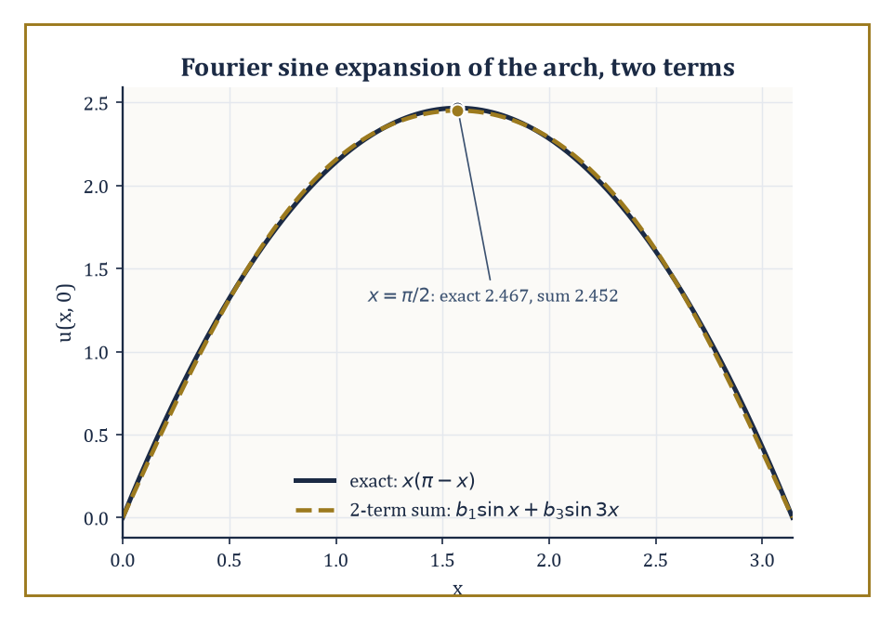
Just two terms of the sine expansion already trace the arch x(π − x) to within 0.6% at its peak.
u(x, t) = X(x)T(t)
substitutes into the PDE, and — if the equation and the geometry cooperate — finds that the two sides of the resulting equation depend on different variables and so must both equal the same constant, traditionally written −λ.
This single step converts one PDE into two ODEs: a temporal one involving λ, and a spatial one,
X'' + λX = 0
(say), that together with the boundary conditions becomes a Sturm–Liouville eigenvalue problem.
Only special values of λ — the eigenvalues — admit nonzero solutions X (the eigenfunctions), and Sturm–Liouville theory guarantees these eigenfunctions form a complete orthogonal basis for the relevant space of functions on the domain.
The full solution of the original PDE is then an infinite sum — an eigenfunction expansion — of these building blocks, each carrying its own time-dependence, with coefficients fixed by matching the initial or boundary data via the orthogonality of the basis (exactly the machinery of Fourier series, generalised).
Numeric example — Worked example — expanding a non-eigenfunction initial profile. Solve u_t = u_xx on [0, π] with Dirichlet conditions u(0,t)=u(π,t)=0 and a genuinely non-eigenfunction initial profile — a smooth arch, zero at both ends, unlike Room 27.5's convenient sin x:
u(x, 0) = x(π − x)
The eigenfunctions here are sin(nx) with eigenvalue n² (n = 1, 2, 3, …), so we need the Fourier sine coefficients:
bₙ = (2/π)∫ from 0 to π of x(π−x) sin(nx) dx
A standard integration-by-parts computation (twice, on the x² term) gives:
∫ from 0 to π of x(π−x) sin(nx) dx = 2(1 − (−1)ⁿ)/n³
which vanishes for even n and equals 4/n³ for odd n; hence:
bₙ = 8/(πn³) for odd n, and 0 for even n
Numerically,
b₁ = 8/π ≈ 2.5465, b₃ = 8/(27π) ≈ 0.0943
— already two orders of magnitude smaller, showing how fast this particular expansion converges. The full solution is:
u(x, t) = the sum over odd n of (8/(πn³)) e^(−n²t) sin(nx)
Check the initial profile at x = π/2, where the exact value is:
(π/2)(π/2) = π²/4 ≈ 2.4674
the two-term truncation gives:
b₁ sin(π/2) + b₃ sin(3π/2) = 2.5465(1) + 0.0943(−1) ≈ 2.4522
already within 0.6% of the exact arch height using only two terms — and the n = 3 mode decays, in time, nine times faster in the exponent than the n = 1 mode (e^(−9t) against e^(−t)), so the arch not only matches almost immediately but also smooths toward a pure sine shape almost immediately after.
The specific special functions that appear as eigenfunctions depend entirely on the coordinate system forced on you by the domain's geometry. Rectangular domains, as above, produce ordinary sines and cosines.
Problems with circular or cylindrical symmetry (a vibrating drum, heat flow in a cylindrical rod) produce Bessel functions in the radial variable. Problems with spherical symmetry (heat flow in a ball, the hydrogen atom's angular structure, gravitational or electrostatic potentials) produce Legendre functions and, combined with the angular sines and cosines, spherical harmonics.
In every case the underlying logic is identical — separate, reduce to a Sturm–Liouville problem, find the eigenbasis, expand — even though the resulting functions look, at first encounter, like entirely different species.
The same technique also handles non-homogeneous equations (a forcing term present): expand the forcing term itself in the same eigenbasis and solve, mode by mode, for the coefficients of the response, since the eigenbasis diagonalises the linear operator completely.
Abstract example — Abstract example — the fundamental note of a circular drum. Consider a circular drum of radius a, governed by the two-dimensional wave equation in polar coordinates.
Separation of variables in r and θ leads, for the radially symmetric modes, to Bessel's equation of order zero, whose solutions regular at the centre are J₀(kr) for a parameter k; the clamped-edge boundary condition u(a, t) = 0 forces J₀(ka) = 0, so k must be chosen so that ka is a zero of J₀.
The first positive zero of J₀ is the well-tabulated constant:
j₀,₁ ≈ 2.4048
(a distant relative, purely by coincidence, of the sinh-based blow-up constants in Room 27.1's Hadamard example — both are simply where certain classical functions happen to vanish or explode).
For a drum of radius a = 1 with wave speed c = 1, the fundamental angular frequency is therefore:
ω = c·j₀,₁/a ≈ 2.4048 rad/s
giving an ordinary frequency:
f = ω/(2π) ≈ 0.3827 Hz
— the lowest note the drum can produce, computed from nothing but the first zero of a Bessel function, exactly the same logic that gave the note e^(−n²t) sin(nx) its overtone structure on a rectangular string, wearing the costume appropriate to a round drum instead.
Separation of variables remains, after everything modern analysis has added to the subject, the single most important explicit method for solving the classical linear equations on domains with enough symmetry to support it — squares, disks, balls, cylinders, and their kin.
It is not universal (an irregularly shaped domain, in general, offers no separable coordinate system at all), but where it applies it turns an infinite-dimensional problem into a countable family of one-dimensional ones, and that reduction is, in a very real sense, the origin of the entire theory of Fourier and eigenfunction expansions that pervades the rest of analysis.

Room 27.8: Green's Functions, Maximum Principles, and Energy Methods
How to know a great deal about a solution you will never write down
The Green's function of a linear differential operator L, subject to given boundary conditions, is the integral kernel G(x, ξ) such that the solution of Lu = f is recovered as:
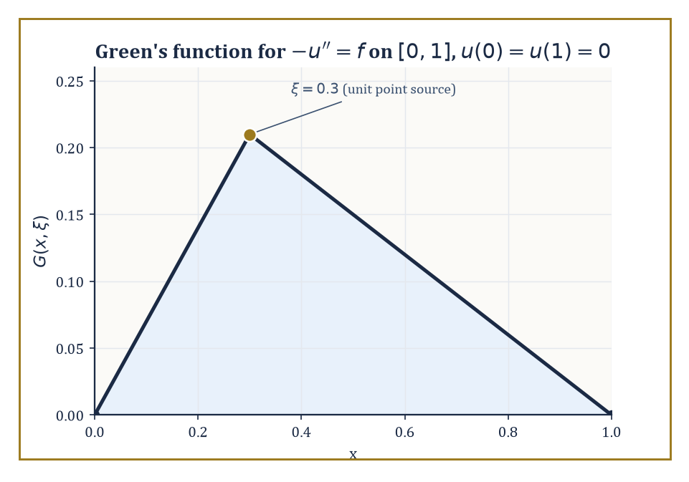
The Green's function for −u'' = f on [0,1] is a tent pitched at the source point ξ = 0.3 — the response to a single unit push.
u(x) = ∫G(x, ξ)f(ξ) dξ
Conceptually, G(x, ξ) is the response at x to a unit point source concentrated at ξ — build the solution for an arbitrary forcing f by superposing (integrating over) point-source responses, which works precisely because L is linear.
Constructing G explicitly for the Laplacian on simple domains (a disk, a half-space, a ball) is classical, typically via the method of images; for more general operators or domains one appeals instead to abstract existence theory or numerical approximation, but the interpretive idea — a solution is a weighted average of point-source responses — survives unchanged.
Numeric example — Worked example — building and using a Green's function. Construct the Green's function for −u'' = f on [0, 1] with Dirichlet conditions u(0) = u(1) = 0 — the ODE case, simplest possible setting, but the logic transfers directly to the Laplacian.
The response to a unit point source at ξ is a function linear on each side of ξ, continuous at ξ, vanishing at the two endpoints, with a unit jump in slope at ξ (from integrating −u'' = a point source once):
G(x, ξ) = x(1 − ξ) for x ≤ ξ, and ξ(1 − x) for x ≥ ξ
Use it to solve −u'' = 1 (uniform unit forcing, ξ ranging over all of [0,1]):
u(x) = ∫ from 0 to x of ξ(1−x) dξ + ∫ from x to 1 of x(1−ξ) dξ
The first integral is (1−x)·x²/2; the second, after expanding, is x/2 − x² + x³/2. Adding:
(x²/2 − x³/2) + (x/2 − x² + x³/2) = x/2 − x²/2 = x(1−x)/2
Check directly:
u = (x − x²)/2 gives u'' = −1, so −u'' = 1 = f
exactly as required, and u(0) = u(1) = 0 — the Green's function reproduces the standard textbook answer for this equation without ever solving the ODE by hand.
Maximum principles, met already for the heat equation and for harmonic functions, generalise to a wide class of elliptic and parabolic operators, and they give something ODEs rarely offer for free: pointwise control of a solution purely from control of its boundary and initial data, without solving the equation at all.
This is the direct route to uniqueness theorems (two solutions with the same data must agree, since their difference is a solution with zero data and hence, by the maximum principle, identically zero) and to comparison theorems (if one problem's data dominate another's everywhere on the boundary, its solution dominates the other's everywhere inside too).
Numeric example — Worked example — the maximum principle bounding an interior value. Take the harmonic function u(x, y) = x² − y² on the disk of radius 2 centred at the origin. On the boundary, x² + y² = 4, so y² = 4 − x², giving:
u = x² − (4 − x²) = 2x² − 4
since x² ranges over [0, 4] on this circle, the boundary values of u range over [−4, 4] (the minimum −4 at (0, ±2), the maximum 4 at (±2, 0)).
The maximum principle guarantees every interior value also lies in [−4, 4] — check the interior point (1, 1) (inside the disk since 1² + 1² = 2 < 4):
u(1,1) = 1 − 1 = 0
comfortably inside [−4, 4], as promised, and indeed inside every interior point one might try.
Energy methods take a different but complementary route: multiply the equation by the solution itself (or by a suitable test function), integrate over the domain, and integrate by parts to trade derivative-heavy terms for boundary terms plus a manifestly signed quantity — typically ∫|∇u|² or similar, which is never negative.
The resulting a priori estimate bounds the size of the solution (or of the difference of two candidate solutions) purely in terms of the data, again without needing an explicit formula, and this technique is considerably more robust than maximum principles: it survives the transition to weak solutions, to systems of equations, and to many nonlinear problems where no maximum principle is available at all.
Abstract example — Abstract example — uniqueness for Poisson's equation by the energy method. Prove uniqueness for the Dirichlet problem Δu = f on a bounded domain Ω, u = g on the boundary of Ω, by the energy method, as a template for the technique.
Suppose u₁ and u₂ both solve it; let w = u₁ − u₂. Then:
Δw = 0 in Ω, w = 0 on the boundary
Multiply Δw = 0 by w and integrate over Ω:
the integral over Ω of w·Δw equals 0
Integrate by parts (Green's first identity) on the left:
the integral over Ω of w·Δw equals the boundary integral of w times the outward normal derivative of w, minus the integral over Ω of |∇w|²
The boundary integral vanishes because w = 0 on all of the boundary, leaving:
minus the integral of |∇w|² equal to 0, so the integral of |∇w|² over Ω is 0
Since |∇w|² ≥ 0 pointwise and its integral is zero, |∇w| is identically zero throughout Ω — w is constant. And since w = 0 on the boundary, that constant is 0.
Hence u₁ ≡ u₂: uniqueness, extracted entirely from one multiplication, one integration by parts, and the simple fact that a nonnegative quantity integrating to zero must vanish everywhere — no explicit solution formula was needed, or indeed available, for a general domain Ω.

Room 27.9: Looking Ahead: From Classical PDEs to Modern Theory and Applications
Everything above was the warm-up
We have now acquired the classical core of the subject: the method of characteristics for first-order equations, the elliptic/parabolic/hyperbolic classification, the three prototype equations solved essentially by hand, separation of variables and eigenfunction expansions for domains with symmetry, and Green's functions, maximum principles, and energy methods as the analytic tools that make everything rigorous rather than merely suggestive.
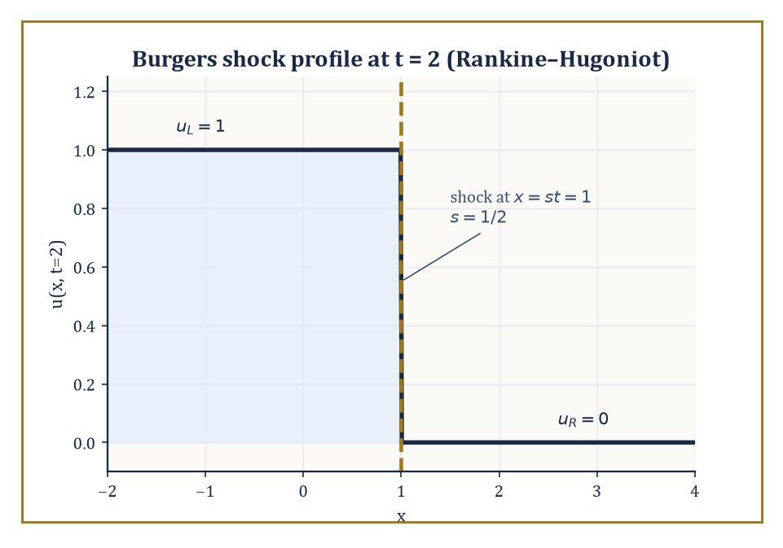
Rankine–Hugoniot names the price of admission: the jump from u = 1 to u = 0 must travel at exactly speed ½.
This is, roughly, where the subject stood at the start of the twentieth century — a formidable achievement, and also, by the standards of what came after, still comparatively tame.
The modern theory begins by admitting that classical (smooth, everywhere-differentiable) solutions are a luxury not every sensible problem can afford.
Sobolev spaces — spaces of functions whose derivatives, in a suitably generalised sense, are merely square-integrable rather than continuous — permit weak solutions: functions that satisfy the equation only after being tested against smooth functions and integrated by parts, exactly the manoeuvre used twice already in Room 27.8.
This is not a retreat from rigour but an expansion of it, since existence theorems become available for equations whose classical solutions may not exist at all — the discontinuous shocks encountered in Room 27.2, for instance, are perfectly respectable weak solutions even though no classical derivative of them exists at the discontinuity.
Numeric example — Worked example — the speed of a shock, via Rankine-Hugoniot. A weak (shock) solution of Burgers' equation:
u_t + (u²/2)_x = 0
with the discontinuous Riemann initial data u(x, 0) = 1 for x < 0 and u(x, 0) = 0 for x > 0 propagates as a single jump moving at a speed s fixed by the Rankine–Hugoniot condition:
s = [f(u_L) − f(u_R)]/[u_L − u_R]
where f(u) = u²/2 is the flux. Here u_L = 1, u_R = 0, so:
s = (1²/2 − 0²/2)/(1 − 0) = (1/2)/1 = 1/2
the jump travels rigidly to the right at speed exactly ½, with u = 1 to its left and u = 0 to its right for all time.
Unlike Room 27.2's smooth arch collapsing into a shock at t = 1, this discontinuity is present in the data from the very start — and the Rankine–Hugoniot formula is precisely what tells you, once a shock has formed by either route, how fast it subsequently travels.
Fully nonlinear equations — reaction-diffusion systems, nonlinear wave equations, and above all the Navier–Stokes equations of fluid flow — abandon superposition altogether and require an entirely different toolkit: fixed-point arguments (find a solution as the fixed point of a suitable map, rather than by formula), compactness methods (extract a convergent solution from a sequence of approximations), and, in the hardest cases, geometric measure theory.
Whether solutions of the three-dimensional Navier–Stokes equations always stay smooth, or can develop singularities in finite time from smooth data, is one of the seven Clay Millennium Prize problems — unresolved, as of this writing, and worth one million dollars to whoever settles it, which ought to put the difficulty of everything in this storey into some perspective.
Numeric example — Worked example — how large a Reynolds number gets. The nonlinearity's grip on a fluid flow is measured by the Reynolds number:
Re = UL/ν
comparing inertial effects (the troublesome u·∇u term) to viscous ones (the friendly, linear Δu term). For water (kinematic viscosity ν ≈ 1.0 × 10⁻⁶ m²/s) flowing at U = 1 m/s past an obstacle of size L = 1 m:
Re = (1)(1)/(1.0×10⁻⁶) = 1,000,000
comfortably past the threshold (of the order of a few thousand, depending on geometry) at which flows abandon smooth, orderly streamlines for turbulence.
It is exactly this regime — large Re, nonlinearity dominant, viscosity a negligible correction rather than a stabilising force — where the Millennium Prize question lives; at small Re the linear, viscosity-dominated theory is comparatively well understood.
Where no formula, weak or otherwise, is to be had, numerical methods take over: finite differences replace derivatives with difference quotients on a discrete grid, finite elements approximate the solution by piecewise polynomials tailored to complicated geometries, and spectral methods approximate it by truncated eigenfunction expansions — Room 27.7's technique, industrialised.
All three convert a PDE into a large, structured system of algebraic equations solvable on a computer, and all three carry their own analysis: does the discrete approximation converge to the true solution as the grid is refined, and how fast?
Numeric example — Worked example — one step of a finite-difference scheme, right at the edge of stability. The simplest finite-difference scheme for the heat equation u_t = u_xx (diffusivity 1) replaces derivatives by differences on a grid with spacing Δx and time step Δt, giving the explicit update:
u_i^(n+1) = u_i^n + r(u_(i+1)^n − 2u_i^n + u_(i-1)^n)
where r = Δt/Δx² is the scheme's single governing parameter. Take Δx = 0.25 (so Δx² = 0.0625) and Δt = 0.03125, giving:
r = 0.03125/0.0625 = 0.5
— exactly the classical stability limit for this scheme (von Neumann analysis shows it is stable only for r ≤ ½). Start from a spike:
u_(i-1) = 0, u_i = 1, u_(i+1) = 0, all neighbours further out also 0
One step gives:
u_i^(new) = 1 + 0.5(0 − 2 + 0) = 1 − 1 = 0
u_(i-1)^(new) = 0 + 0.5(1 − 0 + 0) = 0.5, and symmetrically u_(i+1)^(new) = 0.5
the spike has, in a single time step, collapsed to zero at its own location and jumped its neighbours up to 0.5 each — total heat conserved (still summing near 1, spread over more points, as diffusion should), but sitting right at the edge of instability, r = 0.5 is a cautionary illustration of why numerical analysts lose sleep over stability conditions that a naive implementation could violate by an innocent-looking choice of grid spacing.
We set out, at the top of this storey, to let the unknown function depend on more than one variable, and everything since has been the working-out of the consequences: characteristics carrying information along curves, a threefold classification borrowed wholesale from conic sections, three prototype equations whose behaviour — vibration, diffusion, equilibrium — covers most of continuum physics between them, separation of variables turning symmetry into explicit series, and Green's functions, maximum principles, and energy methods standing guard over the whole enterprise's rigour.
It should be said plainly, in case the steeper learning curve of this storey has been discouraging: partial differential equations are where mathematics stops being a bag of solvable tricks and becomes a genuine theory of infinite-dimensional dynamical systems, and that transition is exactly why the tools multiplied the way they did. Nobody enjoys learning to prove existence without ever seeing the solution; everybody is, eventually, grateful for a theorem that survives contact with an equation too unruly for any formula to hold it.
The next storey turns, at last, to a question this one kept nearly asking outright — the Dirichlet problem's harmonic functions, recall, are exactly the minimisers of the Dirichlet energy ∫|∇u|² among functions with the given boundary values, a fact we touched but did not chase. Optimisation and the calculus of variations pick up precisely there: what does it mean for a quantity to be as small, or as large, as it can possibly be, and what equation must its minimiser satisfy? We have learned to let the unknown depend on several variables. Next, we ask it to be the very best version of itself.

Storey 28: Optimization & Calculus of Variations
Extrema, Constraints, and the Art of Finding the Best Path or the Best Function
The previous storey left us standing before the great cathedral of partial differential equations, watching heat diffuse, waves propagate, and potentials settle into equilibrium — all of it description. Given a system and its rules, the PDE told us what happens next. It is, in its way, a profoundly passive kind of mathematics: the universe does something, and we write down the equation that reports it faithfully, like a rather diligent court stenographer. This storey asks a cheekier question. Not what does happen, but what ought to happen — of all the paths a particle could take, all the shapes a soap film could assume, all the curves joining two points, which one does nature actually pick, and why does it always seem to be the frugal one?
That question splits cleanly into two storeys' worth of mathematics that we shall, in fact, cover in a single one, because they are secretly the same idea wearing different coats. The first coat is finite-dimensional: given a function of finitely many real variables, find the point where it is smallest (or largest — minimization and maximization are the same sport played facing opposite directions, and we shall mostly talk about minimizing, partly by convention and partly because pessimism is more mathematically productive). The second coat is altogether grander: given a functional — a rule that eats an entire curve or function and spits out a single number, such as its length, its energy, or the time it takes light to traverse it — find the function that minimizes it. Note the word functional, one syllable longer than function for the very good reason that it is a function of functions, a promotion in abstraction that the calculus of variations earns by never once making it feel painful.
The remarkable fact, which this storey exists to demonstrate rather than merely assert, is that both problems are governed by the same underlying logic: at an extremum, the first-order rate of change vanishes. In finite dimensions this is the vanishing gradient, familiar since school. In the infinite-dimensional setting it becomes the Euler–Lagrange equation, and once you have seen the derivation you will never again be able to look at ∇f = 0 without hearing its infinite-dimensional cousin humming quietly in the background. We shall meet Lagrange multipliers (twice, in two disguises), convexity (the mathematician's favourite kind of good behaviour), Hamilton's principle (in which all of classical mechanics turns out to be a single sentence about laziness), and the classical trio of geodesics, minimal surfaces, and the isoperimetric problem, which between them explain why soap bubbles are round and why the shortest way to type this sentence would have been to write less of it.
One administrative note before we begin: tenure committees notwithstanding, optimization is the only branch of mathematics that is, quite literally, about doing your best. Let's minimize.

Room 28.1: Finite-Dimensional Optimization: Unconstrained
In Which the Gradient Is Asked, Politely, to Vanish
Let f: ℝⁿ → ℝ be a smooth function — think of it as a landscape, with f(x) the altitude at position x. We say f has a local minimum at a point x* if f(x*) ≤ f(x) for every x in some small neighbourhood of x*; it is nature's way of saying 'you have found the bottom of a valley, even if you cannot yet see whether it is the deepest valley on the map.'
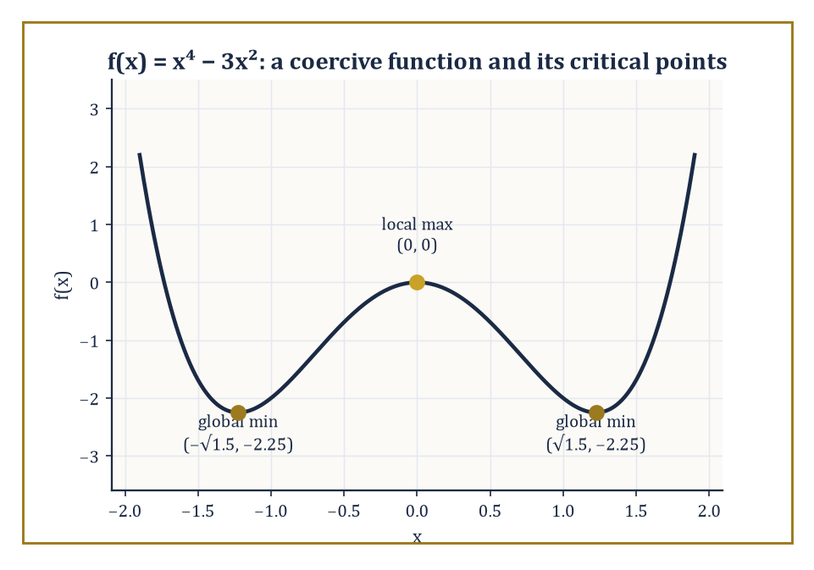
f(x) = x⁴ − 3x² is coercive: a middling local maximum at the origin flanked by two equally deep global minima, exactly as the second-derivative test predicts.
The first-order necessary condition is simply that the gradient vanishes there, because if the gradient were nonzero it would point uphill, and its negative would point downhill, meaning x* could not possibly be a local floor — you could always take a small step in the downhill direction and do better.
∇f(x*) = 0
A point where the gradient vanishes is called a critical point (or, if you enjoy sounding portentous at dinner parties, a stationary point). Not every critical point is a minimum, of course; it might be a maximum, or — the interesting case — a saddle, where the landscape rises in some directions and falls in others, rather like most compromises.
To tell these apart we look at the Hessian matrix H(x*), the n×n matrix of second partial derivatives. If H(x*) is positive definite (all its eigenvalues strictly positive), the critical point is a genuine local minimum; if it is negative definite, a local maximum; if it has eigenvalues of both signs, a saddle. This is exactly the second-derivative test from one-variable calculus, wearing a matrix for a hat.
Numeric example — Worked example — locating and classifying a critical point. Let f(x, y) = x² + 2y² − 4x − 4y. First, the gradient:
∂f/∂x = 2x − 4, ∂f/∂y = 4y − 4
Setting both to zero gives x = 2, y = 1, so the sole critical point is (2, 1). The Hessian is constant here (f is quadratic):
H = [[2, 0], [0, 4]]
A diagonal matrix, so its eigenvalues are simply its diagonal entries, 2 and 4, both strictly positive. Hence H is positive definite and (2, 1) is a local minimum; because f is a convex quadratic (more on convexity in Room 28.3) it is in fact the global minimum. Its value:
f(2, 1) = 4 + 2 − 8 − 4 = −6
So the deepest point of this particular bowl sits at height −6, and there is nowhere on the entire infinite plane that does better.
The existence of a global minimum is a separate question from locating one, and it is worth being honest about the gap: a function can have plenty of critical points and still fail to attain a minimum anywhere (f(x) = eˣ has no critical point at all and no minimum; f(x) = 1/(1+x²) has a maximum but only an infimum of 0, never attained).
Two standard guarantees rescue us. First, if the domain is compact (closed and bounded) and f is continuous, the Extreme Value Theorem guarantees a global minimum exists somewhere on it — compactness is doing all the work, by ruling out the function sneaking off to −∞ or to an unreachable boundary.
Second, on an unbounded domain like all of ℝⁿ, coercivity does the job instead: f is coercive if f(x) → +∞ as ‖x‖ → ∞, meaning the landscape eventually rises in every direction you might run off to escape it. A continuous coercive function on ℝⁿ attains a global minimum, because far enough out the function is provably worse than its value at the origin, so the search can be confined to a large-but-bounded ball, at which point compactness takes back over.
Numeric example — Worked example — coercivity guarantees a global minimum. Let f(x) = x⁴ − 3x² on ℝ. As x → ±∞, the x⁴ term dominates the −3x² term, so f(x) → +∞ in both directions: f is coercive, and a global minimum must exist somewhere finite. Differentiating:
f′(x) = 4x³ − 6x = 2x(2x² − 3)
This vanishes at x = 0 and at x = ±√1.5 ≈ ±1.2247. The second derivative is f″(x) = 12x² − 6. At x = 0, f″ = −6 < 0, a local maximum (value f(0) = 0). At x = ±√1.5, f″ = 12(1.5) − 6 = 12 > 0, a local minimum, and by the symmetry of the function both give the same value:
f(√1.5) = (1.5)² − 3(1.5) = 2.25 − 4.5 = −2.25
Since coercivity rules out anything worse lurking off at infinity, −2.25 (attained at both x = +√1.5 and x = −√1.5) is the global minimum — a rare case of a function unable to decide between two equally good answers, which is its business, not ours.
When ∇f = 0 cannot be solved in closed form — which is to say, almost always, once f stops being a textbook exercise — we fall back on iterative numerical methods. Gradient descent takes repeated steps downhill:
xₖ₊₁ = xₖ − α∇f(xₖ)
Where α > 0 is the step size (or learning rate, if you have wandered in from machine learning, where this entire storey is quietly running underneath everything). Too large a step size and you overshoot the valley and oscillate or diverge; too small and you converge with the urgency of continental drift.
Newton's method uses second-order information for a sharper step,
xₖ₊₁ = xₖ − H(xₖ)⁻¹∇f(xₖ)
Converging far faster near a minimum (quadratically, versus gradient descent's merely linear rate) at the cost of needing the Hessian, which for large n is an expensive matrix to compute and invert. Quasi-Newton methods such as BFGS split the difference, building up an approximation to the Hessian from successive gradient evaluations rather than computing it outright — a compromise, like most successful things in optimization and in life.
Numeric example — Worked example — three steps of gradient descent. Minimize f(x) = x² by gradient descent, starting at x₀ = 1 with step size α = 0.3. The derivative is f′(x) = 2x, so the update is:
xₖ₊₁ = xₖ − 0.3·(2xₖ) = xₖ(1 − 0.6) = 0.4xₖ
Starting from x₀ = 1:
x₁ = 0.4·1 = 0.4, x₂ = 0.4·0.4 = 0.16, x₃ = 0.4·0.16 = 0.064
Each step multiplies the distance to the true minimum (at x = 0) by exactly 0.4, so the iterates decay geometrically to zero — convergence, but at a rate entirely dictated by the step size: choose α = 0.5 instead and the update becomes xₖ₊₁ = 0·xₖ, landing on the exact minimum in a single step (a lucky accident of this particular quadratic); choose α = 1.1 and the multiplier 1 − 2.2 = −1.2 has magnitude greater than 1, and the iterates diverge, marching off to infinity with great confidence and no destination.

Room 28.2: Constraints and Lagrange Multipliers
Optimizing While Someone Is Watching
Unconstrained optimization assumes you may wander anywhere in ℝⁿ; life, and most interesting problems, are rarely so generous. Suppose you must minimize f(x) subject to an equality constraint g(x) = 0 — the point x is confined to some surface (a curve, in two dimensions) rather than the whole plane.
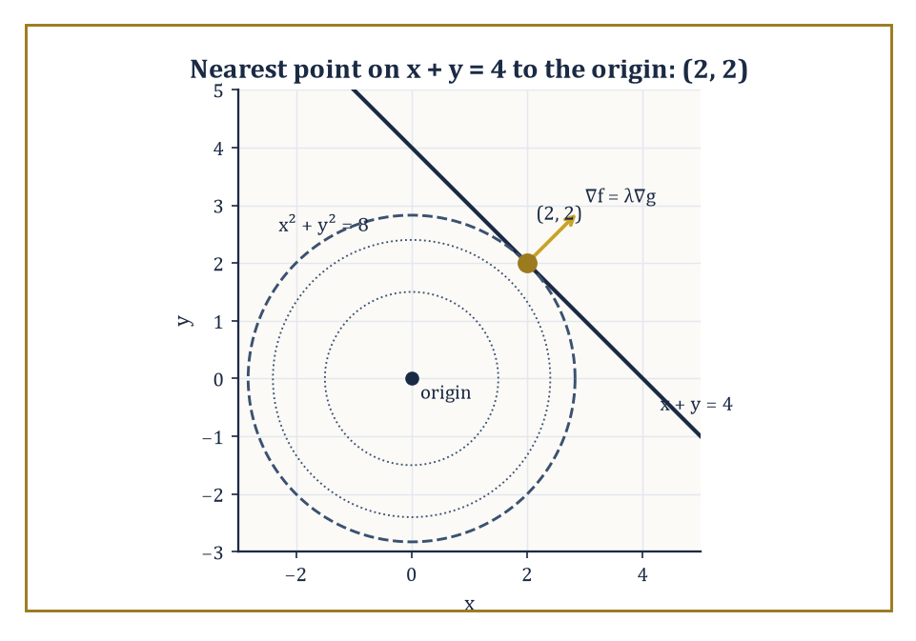
At the constrained optimum (2, 2), the level circle x² + y² = 8 sits exactly tangent to the line x + y = 4 — the geometric meaning of ∇f = λ∇g.
The method of Lagrange multipliers observes that at a constrained extremum, the gradient of f need not vanish, but it must be perpendicular to the constraint surface — equivalently, it must be parallel to ∇g, the gradient of the constraint, since ∇g is itself always perpendicular to the level surface g = 0. Parallel vectors differ only by a scalar multiple, so we demand
∇f = λ∇g
For some scalar λ, the Lagrange multiplier, alongside the constraint g(x) = 0 itself. Geometrically: if ∇f had any component along the constraint surface, you could slide along the surface in that direction and improve f, so at a true constrained extremum no such improving direction can exist — the two gradients must be aligned. With multiple constraints g₁ = g₂ = ⋯ = 0, the condition generalizes to ∇f lying in the span of ∇g₁, …, ∇gₖ, one multiplier per constraint.
Numeric example — Worked example — nearest point on a line. Minimize f(x, y) = x² + y² subject to g(x, y) = x + y − 4 = 0 (this is exactly the question: what point on the line x + y = 4 is closest to the origin, since x² + y² is the squared distance from the origin). Set up ∇f = λ∇g:
(2x, 2y) = λ(1, 1)
Giving 2x = λ and 2y = λ, so x = y. Substituting into the constraint: x + x = 4, so x = y = 2. The nearest point is (2, 2), at squared distance
f(2, 2) = 4 + 4 = 8
I.e. actual distance √8 = 2√2 ≈ 2.828. A quick sanity check: the line x + y = 4 has direction vector (1, −1), and the segment from the origin to (2, 2) has direction (1, 1) — perpendicular to the line, exactly as it should be for the shortest connecting segment.
Multiple constraints work the same way, with one multiplier apiece and the resulting gradient condition asking for ∇f to be a genuine linear combination of all the constraint gradients — not parallel to any single one, but reachable by mixing them in the right proportions.
Numeric example — Worked example — two constraints, two multipliers. Minimize f(x, y, z) = x² + y² + z² subject to g₁: x + y + z = 1 and g₂: x − y = 0. From g₂, y = x; substituting into g₁, z = 1 − 2x. So f becomes a function of x alone:
f(x) = x² + x² + (1 − 2x)² = 2x² + 1 − 4x + 4x² = 6x² − 4x + 1
Differentiating and setting to zero: 12x − 4 = 0, so x = 1/3, giving y = 1/3 and z = 1 − 2/3 = 1/3 — the constrained minimizer is (1/3, 1/3, 1/3), with f = 3·(1/9) = 1/3. Now check the Lagrange condition directly: ∇f = (2/3, 2/3, 2/3), ∇g₁ = (1, 1, 1), ∇g₂ = (1, −1, 0). We need
λ(1,1,1) + μ(1,−1,0) = (2/3, 2/3, 2/3)
The third component gives λ = 2/3 immediately; the first component then gives 2/3 + μ = 2/3, so μ = 0 — and the second component, λ − μ = 2/3 − 0 = 2/3, checks out. The two constraint gradients here happened to require no contribution from μ at all, which is a coincidence of this particular problem, not a general rule.
Inequality constraints g(x) ≥ 0 are trickier, because the constraint might or might not be 'active' at the solution — the optimum might sit comfortably in the interior of the feasible region (in which case the constraint is irrelevant there, exactly as in the unconstrained problem) or be pinned against the boundary.
The Karush–Kuhn–Tucker (KKT) conditions handle both cases in one stroke: stationarity ∇f = λ∇g, primal feasibility g(x) ≥ 0, dual feasibility λ ≥ 0, and complementary slackness
λ·g(x) = 0
That last condition is the clever bit: it forces either λ = 0 (the constraint is inactive, contributing nothing) or g(x) = 0 (the constraint is active, pressed right up against its boundary) — never both nonzero at once, since a multiplier is only 'needed' when its constraint is actually doing something. Under mild technical conditions on the constraints (constraint qualifications, ensuring the gradients behave well enough for multipliers to exist at all), the KKT conditions are necessary for optimality, and for convex problems — the subject of the next room — they are sufficient too.
Numeric example — Worked example — an active inequality constraint. Minimize f(x) = x² subject to x ≥ 1. Write the constraint as g(x) = x − 1 ≥ 0. Unconstrained, the minimum of x² sits at x = 0, which is infeasible (0 is not ≥ 1), so the constraint must be active: x = 1. Check KKT: stationarity requires f′(x) = λg′(x), i.e.
2x = λ·1, so λ = 2x
At the candidate x = 1, λ = 2, which is indeed ≥ 0 as dual feasibility demands. Complementary slackness: λ·(x − 1) = 2·0 = 0, satisfied automatically since the constraint is active. All four KKT conditions hold, so x = 1 is confirmed optimal, with minimum value f(1) = 1 — as is obvious in hindsight, since x² is increasing for x > 0 and the constraint simply will not let you go any lower than x = 1.

Room 28.3: Convexity and Convex Optimization
The Dividing Line Between Tractable and Everything Else
A function f is convex if the line segment joining any two points on its graph never dips below the graph itself — formally,
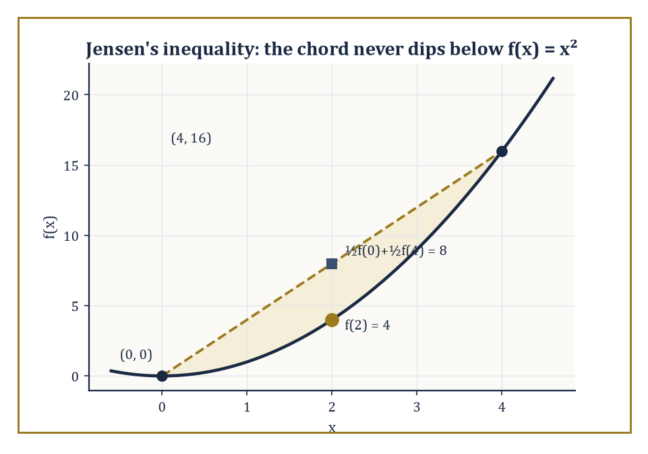
Jensen's inequality made visible: the chord from (0, 0) to (4, 16) never dips below the graph of f(x) = x², with a comfortable gap of 4 to spare at the midpoint.
f(θx + (1−θ)y) ≤ θf(x) + (1−θ)f(y) for all x, y and all θ ∈ [0,1]
A statement known as Jensen's inequality. Geometrically this says the epigraph of f (the region on or above the graph) is a convex set: pick any two points inside it, and the straight segment between them stays inside too.
For twice-differentiable functions there is a mercifully computational test: f is convex if and only if its Hessian is positive semidefinite everywhere (all eigenvalues ≥ 0), and strictly convex if the Hessian is positive definite everywhere (a slightly stronger condition that, among other things, rules out flat stretches).
Convexity is the single most consequential property in optimization, for a simple and slightly miraculous reason: for a convex function, every local minimum is automatically a global minimum, and the set of all minimizers is itself convex. There is no possibility of getting trapped in a merely-locally-good valley while a better one lurks elsewhere — convex landscapes have exactly one basin, however oddly shaped.
Numeric example — Worked example — checking Jensen's inequality. Let f(x) = x², and take x = 0, y = 4, θ = 0.5 (the midpoint). Left-hand side:
f(0.5·0 + 0.5·4) = f(2) = 4
Right-hand side:
0.5·f(0) + 0.5·f(4) = 0.5·0 + 0.5·16 = 8
Indeed 4 ≤ 8, confirming convexity at this pair of points (and the gap of 4 between the two sides is itself informative — it measures how much curvature f has between 0 and 4). The Hessian test agrees instantly: f″(x) = 2 > 0 for every x, so f is strictly convex everywhere, and its unique global minimum, x = 0, needs no further searching once convexity is established — a local check at any critical point is automatically a global certificate.
It is worth seeing what goes wrong without convexity, if only to appreciate what convexity is buying us. A non-convex function can perfectly well have a local minimum that is not global, or worse, no global minimum at all despite having plenty of local ones — the optimization landscape equivalent of confidently climbing down into the wrong valley and declaring victory.
Numeric example — Worked example — a local minimum that is not global. Let f(x) = x³ − 3x. Then f′(x) = 3x² − 3 = 0 gives x = ±1, and f″(x) = 6x. At x = 1, f″ = 6 > 0, a local minimum with value f(1) = 1 − 3 = −2. At x = −1, f″ = −6 < 0, a local maximum with value f(−1) = −1 + 3 = 2.
But as x → −∞, the x³ term dominates and f(x) → −∞: the function has no global minimum at all — it plunges without limit far to the left, quite unbothered by the tidy local minimum sitting at x = 1. This is precisely the pathology convexity forbids: f here is not convex (its second derivative 6x is negative for x < 0), and the consequence is exactly the kind of local-versus-global confusion that a convex function is structurally incapable of producing.
Convex problems also come equipped with a duality theory of startling usefulness. Every convex minimization problem (the primal) has an associated dual problem, a maximization over a different set of variables (the multipliers, now promoted to first-class citizens), and weak duality guarantees the dual's value never exceeds the primal's — the dual is always a certified lower bound, obtainable without solving the primal at all.
Under a constraint qualification (Slater's condition being the usual one: some point strictly satisfies all inequality constraints), strong duality holds and the two values coincide exactly, so solving either problem solves both. This is the engine behind interior-point methods and much of modern large-scale optimization: certify optimality by exhibiting a dual solution matching the primal, rather than trusting a first-order condition alone.
Numeric example — Worked example — a linear program and its dual. Primal: minimize 3x₁ + 2x₂ subject to x₁ + x₂ ≥ 4, x₁ ≥ 0, x₂ ≥ 0. Since x₂ is cheaper per unit than x₁ (coefficient 2 versus 3), the optimal strategy uses only x₂: set x₁ = 0, and the constraint forces x₂ ≥ 4, minimized at x₂ = 4, giving primal cost 3(0) + 2(4) = 8. (Formally: on the boundary x₁ + x₂ = 4, cost is 3x₁ + 2(4 − x₁) = x₁ + 8, minimized at x₁ = 0.)
The dual problem is: maximize 4y subject to y ≤ 3, y ≤ 2, y ≥ 0 (one dual variable y for the single primal constraint, with dual constraints built from each column of the primal). The binding restriction is y ≤ 2, so the dual optimum is y = 2, giving dual value 4·2 = 8.
Primal value 8 equals dual value 8 — strong duality holds exactly, and either number alone would have certified the other as optimal without further work.
Strict convexity is worth separating from plain convexity, because it buys something extra: uniqueness. Ordinary convexity guarantees the set of minimizers is convex — possibly a single point, but possibly an entire flat plateau of equally good answers, as happens whenever the function has a genuinely flat stretch at its lowest level. Strict convexity (Hessian positive definite, not merely semidefinite, everywhere) rules out flat stretches entirely, and with them any possibility of a tie: the minimizer, when it exists, is the only one there is.
Numeric example — Worked example — a tie for convex, no tie for strictly convex. Compare f(x, y) = x² (convex but not strict, since it ignores y entirely — the Hessian is [[2,0],[0,0]], positive semidefinite but not definite) against g(x, y) = x² + y² (strictly convex, Hessian [[2,0],[0,2]], positive definite). Both attain minimum value 0.
But f attains it along the entire line x = 0 — every point (0, y) for any y whatsoever gives f = 0, an infinite plateau of tied minimizers — while g attains it at the single point (0, 0) only, since x² + y² = 0 forces both x = 0 and y = 0 simultaneously. The extra strictness in g's curvature (curving in the y-direction, which f simply lacked) is exactly what collapses an entire line of ties down to one answer.

Room 28.4: The Calculus of Variations: The Euler–Lagrange Equation
Where the Gradient Learns to Integrate by Parts
Now for the promotion in abstraction flagged in the opening pages. A functional J[y] takes an entire function y(x) (defined on [a,b], with fixed endpoint values y(a) and y(b)) and returns a single real number, typically via an integral
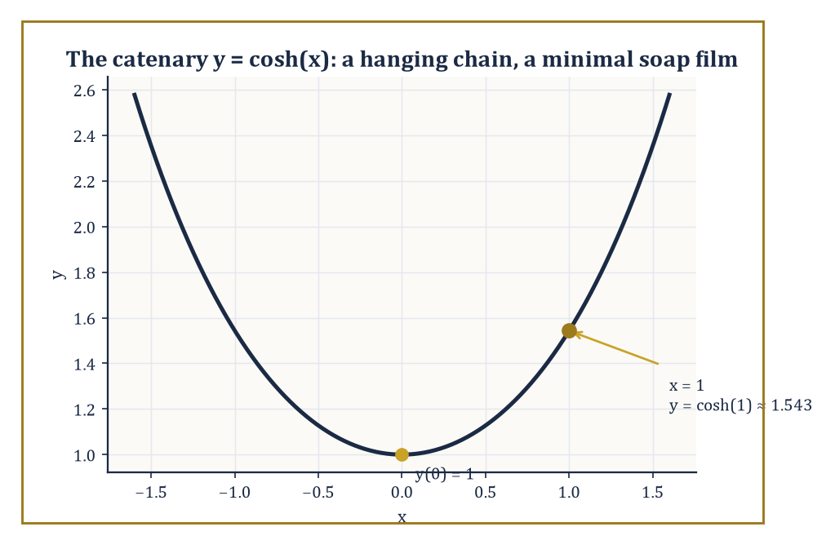
y = cosh(x): the curve the Beltrami identity hands back the moment you ask a soap film to mind its own curvature.
J[y] = ∫ₐᵇ L(x, y, y′) dx
Where L — the Lagrangian, or integrand — is some prescribed function of position x, the curve's height y, and its slope y′. The calculus of variations asks: among all admissible curves y, which one makes J[y] as small (or large) as possible?
The strategy mimics ordinary calculus with startling fidelity. Consider a one-parameter family of nearby curves y(x) + εη(x), where η is an arbitrary smooth 'variation' vanishing at both endpoints (η(a) = η(b) = 0, so every curve in the family still passes through the same fixed endpoints) and ε is a small real parameter. If y is a genuine extremal of J, then the ordinary function of one variable ε ↦ J[y + εη] must have a critical point at ε = 0, for every choice of η — because if some η made J improve by nudging ε away from 0, y could not have been extremal in the first place.
Differentiating under the integral sign and setting the derivative to zero at ε = 0 gives
∫ₐᵇ [∂L/∂y · η + ∂L/∂y′ · η′] dx = 0
Integrating the second term by parts (using η(a) = η(b) = 0 to kill the boundary contribution) converts η′ into η, leaving
∫ₐᵇ [∂L/∂y − d/dx(∂L/∂y′)] η dx = 0 for every admissible η
The fundamental lemma of the calculus of variations then says: if a continuous function multiplied against every such η integrates to zero, that function must itself be identically zero (for if it were nonzero anywhere, a cleverly bump-shaped η concentrated there would make the integral nonzero too, a contradiction). The conclusion is the Euler–Lagrange equation:
d/dx(∂L/∂y′) = ∂L/∂y
The infinite-dimensional counterpart of ∇f = 0, obtained by exactly the same logic of 'no admissible perturbation may improve things', merely with integration by parts standing in for the chain rule.
Numeric example — Worked example — the shortest path is a straight line. Minimize the arc-length functional J[y] = ∫₀¹ √(1 + y′²) dx among curves with y(0) = 0, y(1) = 1 (so L(x, y, y′) = √(1 + y′²), which happens not to depend on y at all). Then ∂L/∂y = 0, and the Euler–Lagrange equation collapses to d/dx(∂L/∂y′) = 0, meaning ∂L/∂y′ is constant along the extremal. Computing:
∂L/∂y′ = y′/√(1 + y′²)
Since the function t ↦ t/√(1+t²) is strictly increasing (its derivative is 1/(1+t²)^(3/2), always positive), the only way for y′/√(1+y′²) to stay constant is for y′ itself to be constant, say y′ = m. Integrating, y = mx + c. The boundary condition y(0) = 0 gives c = 0; the condition y(1) = 1 gives m = 1. So
y = x
The straight line joining (0,0) to (1,1), exactly as three thousand years of geometry led us to expect, now derived from first principles by an integration by parts.
Solving the Euler–Lagrange equation directly is a second-order ordinary differential equation in general, but three special structural cases let us shortcut to a first-order equation instead — a first integral, one power of differentiation cheaper. If L does not depend explicitly on y (only on x and y′), the equation reduces immediately to ∂L/∂y′ = const, exactly as in the straight-line example above.
If L does not depend explicitly on x, the relevant first integral is the Beltrami identity:
L − y′·(∂L/∂y′) = const
It is derived by noting that dL/dx = ∂L/∂y·y′ + ∂L/∂y′·y″ along any curve (chain rule), while the Euler–Lagrange equation lets us replace ∂L/∂y with d/dx(∂L/∂y′); a short rearrangement then shows d/dx[L − y′·∂L/∂y′] = 0 identically — the bracketed quantity, sometimes called the Hamiltonian of the problem, is conserved along extremals whenever the Lagrangian carries no explicit x-dependence, which is the variational shadow of energy conservation we will meet again properly in Room 28.7.
Abstract example — Worked example — the Beltrami identity derives the catenary. Consider L(y, y′) = y·√(1 + y′²) — the functional this generates, ∫L dx, computes (up to a factor of 2π) the surface area of the surface of revolution obtained by spinning the curve y(x) around the x-axis; minimizing it is the classical soap-film problem for two coaxial rings. Since L has no explicit x-dependence, the Beltrami identity applies directly:
L − y′·(∂L/∂y′) = C
First, ∂L/∂y′ = y·y′/√(1+y′²). Substituting:
y√(1+y′²) − y′·[y·y′/√(1+y′²)] = C
Putting both terms over the common denominator √(1+y′²):
y[(1+y′²) − y′²] / √(1+y′²) = C
And the bracket collapses to exactly 1, leaving
y/√(1+y′²) = C
Squaring and rearranging:
1 + y′² = y²/C², so y′² = (y² − C²)/C², i.e. y′ = (1/C)√(y² − C²)
This separates as dy/√(y² − C²) = dx/C, and the standard integral ∫dy/√(y²−C²) = cosh⁻¹(y/C) gives
cosh⁻¹(y/C) = (x − x₀)/C, or y = C·cosh((x − x₀)/C)
The catenary curve, the exact shape a hanging chain assumes under gravity, and (rotated about its axis) the exact shape of the minimal soap film spanning two coaxial rings. One equation, one identity, and an entire family of hanging chains and soap films falls out the other end.

Room 28.5: First Integrals, Constraints, and Variable Endpoints
The Same Trick, With More Furniture
Just as finite-dimensional optimization gained a constrained version via Lagrange multipliers, the calculus of variations admits constraints on the admissible curves, and the resolution is structurally identical, with one wrinkle: the multiplier can itself become a function of x.
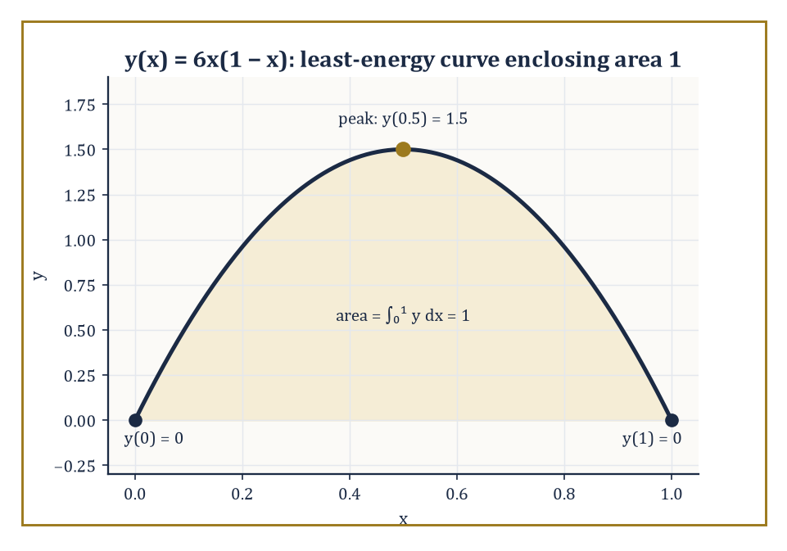
The parabola y = 6x(1 − x): the unique least-bending curve through (0,0) and (1,0) whose enclosed area is pinned at exactly 1.
Two flavours arise in practice. A pointwise (holonomic) constraint, say φ(x, y₁, y₂) = 0 relating several dependent variables at every single x, genuinely needs a multiplier λ(x) that is free to vary along the curve, since the constraint is really infinitely many constraints, one per point. An integral (isoperimetric-type) constraint, of the form ∫ₐᵇ G(x,y,y′) dx = k for some fixed number k, is a single global condition — just one number to satisfy — and so needs only a single constant multiplier λ, exactly as in Room 28.2.
In either case the recipe is the same: form the augmented Lagrangian L* = L − λ·G (or L − λ(x)·φ, for the pointwise case) and apply the ordinary Euler–Lagrange equation to L*, treating λ as fixed during the variation and solving for it afterwards using the constraint itself.
Numeric example — Worked example — minimum energy with a fixed total. Minimize J[y] = ∫₀¹ (y′)² dx subject to y(0) = y(1) = 0 and the isoperimetric constraint ∫₀¹ y dx = 1 (the curve must enclose a fixed area of 1 above the x-axis, while minimizing its total 'wiggling energy'). Form L* = (y′)² − λy, with λ a constant multiplier (this is an integral constraint, so a single λ suffices). The Euler–Lagrange equation for L* is d/dx(∂L*/∂y′) = ∂L*/∂y, i.e.
d/dx(2y′) = −λ, so 2y″ = −λ, giving y″ = −λ/2
A constant — meaning y is a parabola. Integrating twice: y′ = −(λ/2)x + b, and y = −(λ/4)x² + bx + c. The condition y(0) = 0 gives c = 0. The condition y(1) = 0 gives −λ/4 + b = 0, so b = λ/4. Hence
y = (λ/4)(x − x²) = (λ/4)·x(1−x)
Now impose the constraint:
∫₀¹ y dx = (λ/4)∫₀¹ x(1−x) dx = (λ/4)·[x²/2 − x³/3]₀¹ = (λ/4)·(1/2 − 1/3) = (λ/4)·(1/6) = λ/24
Setting this equal to 1 gives λ = 24, and so
y(x) = 6x(1 − x)
A downward parabola peaking at y(0.5) = 6·0.25 = 1.5. Checking the constraint directly: ∫₀¹ 6x(1−x) dx = 6·(1/6) = 1 ✓. This shape — not a semicircle, not a triangle, but this particular parabola — is the unique curve of least 'bending energy' that starts and ends at zero while enclosing area exactly 1.
So far every extremal problem has fixed both endpoint values in advance. Relax that, and let one endpoint — say y(b) — be free to take any value, and a subtlety appears: the derivation of the Euler–Lagrange equation used η(b) = 0 to discard a boundary term during integration by parts, but if y(b) is unconstrained, η(b) need not vanish, and that boundary term must instead be forced to zero on its own.
The result is a natural boundary condition: ∂L/∂y′ evaluated at x = b must equal zero (this is one instance of the more general transversality condition, which governs the geometry of how an extremal is allowed to meet a moving or free endpoint). It is called 'natural' because the calculus of variations imposes it automatically, with no extra input from the modeller — the curve chooses the best possible endpoint value entirely on its own.
Numeric example — Worked example — a free right endpoint. Minimize J[y] = ∫₀¹ (y′)² dx with y(0) = 0 fixed but y(1) left free. The Euler–Lagrange equation (with ∂L/∂y = 0, since L = (y′)² has no y-dependence) gives d/dx(2y′) = 0, so y″ = 0 and y = mx + c. The fixed condition y(0) = 0 gives c = 0, so y = mx. The natural boundary condition at the free end demands
∂L/∂y′|ₓ₌₁ = 0, i.e. 2y′(1) = 2m = 0, so m = 0
The extremal is therefore y ≡ 0, the flat zero function, with J[y] = ∫₀¹ 0 dx = 0. This is exactly right: freed from any obligation at x = 1, the cheapest possible curve simply refuses to move at all, achieving the absolute floor of zero energy that (y′)² can ever attain — no cleverness required, just permission to be lazy.
Abstract example — Worked example — corner conditions and Snell's law. Some variational problems have extremals with a kink — a point where y′ jumps discontinuously, as when a light ray crosses the interface between two media of different refractive indices, or a mechanical path meets an obstacle. The Weierstrass–Erdmann corner conditions govern such kinks: across any corner, both ∂L/∂y′ and L − y′·∂L/∂y′ must remain continuous, even though y′ itself is allowed to jump.
Apply this to Fermat's principle — light travels the path of least time — with a Lagrangian L = n(y)·√(1+y′²), where n is the (piecewise constant) refractive index, jumping from n₁ above an interface to n₂ below it. Continuity of ∂L/∂y′ = n·y′/√(1+y′²) across the interface, combined with the geometric fact that y′ = tan(angle from the interface normal) — more precisely, y′/√(1+y′²) = sin(angle of incidence θ, measured from the normal) — turns the continuity condition directly into
n₁ sin θ₁ = n₂ sin θ₂
Snell's law of refraction, recovered not from optics but from a single continuity requirement on a corner in an extremal curve. The bending of a pencil in a glass of water is, from this vantage point, the Weierstrass–Erdmann conditions doing their job in plain sight.

Room 28.6: The Second Variation and Sufficient Conditions
Necessary Was Never Going to Be Enough
The Euler–Lagrange equation is a first-order-variation condition: it says the derivative of J[y + εη] with respect to ε vanishes at ε = 0, which — exactly as with ∇f = 0 in finite dimensions — is necessary for an extremum but cannot by itself distinguish a minimum from a maximum or a saddle. For that we need the second variation, the functional analogue of the Hessian, obtained by differentiating J[y + εη] twice with respect to ε and evaluating at ε = 0.
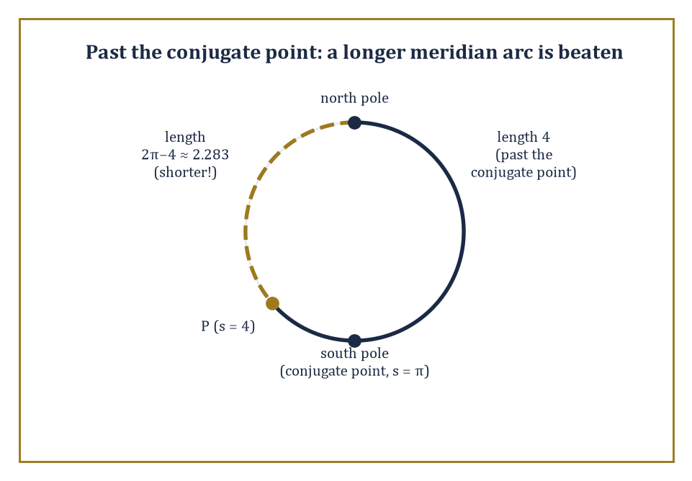
The length-4 meridian arc has already sailed past its conjugate point at the south pole — the dashed route the short way round is shorter still.
Three conditions, working together, certify a genuine local minimum. The Legendre condition asks that ∂²L/∂y′² ≥ 0 along the extremal (strengthened to strict inequality, it is the direct analogue of a positive-definite Hessian, ruling out the curve being a saddle with respect to nearby perturbations in slope).
The Jacobi condition asks that the interval [a,b] contain no conjugate point — a technical but geometrically vivid notion covered in the next paragraph, ruling out a more subtle failure where the extremal is fine locally but a nearby extremal, starting at the same point, manages to cross back and beat it globally.
The Weierstrass condition is the strongest of the three, controlling behaviour under 'strong' variations (nearby curves whose slopes may differ a great deal, not just infinitesimally) and is needed to certify a strong minimum rather than merely a weak one.
Abstract example — Worked example — checking the Legendre and Jacobi conditions for a straight line. Take L(y, y′) = (y′)² once more, the functional minimized by straight lines (Room 28.4). The Legendre condition:
∂²L/∂y′² = 2
Which is strictly positive for every value of y′ whatsoever — the strengthened Legendre condition holds everywhere, with plenty of room to spare.
For the Jacobi condition, the relevant second-order 'Jacobi equation' governing how nearby extremals spread apart is, for this particular quadratic L, simply η″ = 0 (the second variation here is exactly ∫(η′)² dx, and its own Euler–Lagrange equation is η″ = 0) — whose solutions are straight lines in η, of the form η(x) = px + q. Such a solution vanishing at x = a (as any admissible variation must) is η(x) = p(x − a), which vanishes again only at x = a itself, never at any later point.
There is therefore no conjugate point anywhere on (a, b], for any finite b: the Jacobi condition holds vacuously and completely. Both sufficient conditions confirmed, straight-line extremals of arc length are genuine (indeed strong) local minima, not mere critical curves posing as one — reassuring, since a universe in which the shortest path were only a saddle point would be an uncomfortable one to live in.
A conjugate point marks where the second variation stops being positive: it is a point along the extremal where a distinct nearby extremal, launched from the same starting point, manages to cross back and meet the original curve again. Past that crossing, the original extremal can typically be beaten by a competitor that follows the second extremal partway and switches — so a conjugate point is precisely the boundary past which an otherwise-valid critical curve stops being minimizing at all. The textbook illustration is geodesics on a sphere.
Numeric example — Worked example — conjugate points on the unit sphere. On the unit sphere (radius 1, so its great circles — the geodesics — have total circumference 2π), consider the meridian geodesic starting at the north pole and running south, parametrized by arc length s. Every meridian through the north pole reconverges at the south pole, at arc length s = π (exactly half the great-circle circumference); the south pole is therefore the conjugate point of the north pole along any meridian, and indeed along every geodesic emanating from the pole simultaneously — a famously crowded conjugate point.
Take a specific meridian arc of length s = 4 (note 4 > π ≈ 3.14159, so this arc has already passed its conjugate point). Is it still the shortest path to its endpoint? Going the other way around the same great circle instead covers a length of
2π − 4 ≈ 6.28319 − 4 = 2.28319
Which is shorter than 4. So the length-4 arc, despite satisfying the Euler–Lagrange equation (it is a perfectly genuine geodesic) and despite the Legendre condition holding trivially (as it does for arc length generally), is not the minimizing path between its endpoints — exactly because it has run past its conjugate point at s = π, and the Jacobi condition has failed. This is the precise, quantitative reason a geodesic on a sphere 'gives up' being shortest once it passes the antipode: not a vague geometric intuition, but a conjugate point sitting at a computable arc length.
The Weierstrass condition is what remains to be checked once Legendre and Jacobi have both passed. It compares the Lagrangian's value along the candidate extremal against its value for a competitor curve with a wildly different slope p at the very same point (x, y) — not an infinitesimally nearby slope, as the second variation alone examines, but any slope whatsoever, however extreme. Define the excess function
E(x, y, y′, p) = L(x, y, p) − L(x, y, y′) − (p − y′)·∂L/∂y′(x, y, y′)
The Weierstrass condition demands E ≥ 0 for every admissible p, at every point of the extremal. Passing Legendre and Jacobi certifies that no nearby wiggle can improve the curve; passing Weierstrass as well certifies that no competitor curve can improve it either, however sharply that competitor's direction departs from the original — the difference between a merely locally best route and a genuinely globally best one among all curves with comparable slopes, sharp corners included.
Abstract example — Worked example — the excess function for arc length. For L(y, y′) = √(1+y′²) (arc length once more), compute the excess function directly. ∂L/∂y′ = y′/√(1+y′²), so
E(y′, p) = √(1+p²) − √(1+y′²) − (p−y′)·y′/√(1+y′²)
Multiply through by √(1+y′²) and simplify (a short but entirely mechanical algebraic exercise): the expression reduces to
E = [√(1+p²)·√(1+y′²) − 1 − p·y′] / √(1+y′²)
And the numerator is exactly the two-dimensional Cauchy–Schwarz-style quantity √(1+p²)√(1+y′²) − (1 + py′), which is nonnegative for all real p and y′ by the Cauchy–Schwarz inequality applied to the vectors (1,p) and (1,y′) — with equality only when p = y′.
So E ≥ 0 always, confirming what geometry already told us: a straight line beats every competing curve through the same points, not merely every curve with a similar slope, which is precisely why 'the shortest distance between two points is a straight line' is a strong global fact and not merely a locally defensible opinion.

Room 28.7: Hamilton's Principle and Classical Mechanics
The Universe, It Turns Out, Is Lazy
Hamilton's principle is the single most quietly astonishing sentence in classical physics: among all the paths a mechanical system could conceivably take between a fixed initial and final configuration, the one it actually takes is a stationary point of the action,
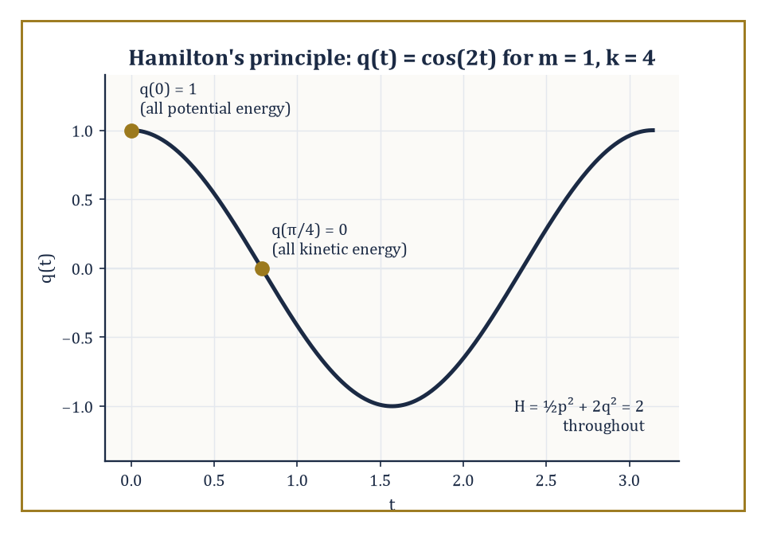
q(t) = cos(2t): the mass swaps potential energy for kinetic and back again, while H = ½p² + 2q² stands guard at 2 the entire time.
S = ∫L dt
Where the Lagrangian L = T − V is kinetic energy minus potential energy. Not the path of least energy, note, nor the fastest, nor the shortest — the one that makes the action stationary, an altogether more abstract quantity balancing how much kinetic energy is 'spent' against how much potential energy is 'owed' along the way.
Apply the Euler–Lagrange machinery of Room 28.4 to this L, with the generalized coordinate q(t) playing the role of y(x) and time t playing the role of x, and out comes
d/dt(∂L/∂q̇) = ∂L/∂q
Which, for an ordinary particle with L = ½mq̇² − V(q), reads
d/dt(mq̇) = −V′(q), i.e. mq̈ = −V′(q)
That is precisely Newton's second law, force equals mass times acceleration, with force identified as −V′(q), the negative gradient of the potential. Newtonian mechanics and Hamilton's variational principle are not two different theories that happen to agree; they are the same theory, and the calculus of variations is simply a more economical way of stating it — a single scalar functional, minimized, in place of a vector differential equation posited by fiat.
Numeric example — Worked example — the harmonic oscillator from Hamilton's principle. Take a unit mass on a spring, m = 1, spring constant k = 4, so L = ½q̇² − 2q² (using T = ½mq̇² = ½q̇² and V = ½kq² = 2q²). The Euler–Lagrange equation: d/dt(∂L/∂q̇) = ∂L/∂q gives
d/dt(q̇) = −4q, i.e. q̈ = −4q
Simple harmonic motion with angular frequency ω = √(k/m) = √4 = 2. With initial conditions q(0) = 1, q̇(0) = 0, the solution is q(t) = cos(2t): check q̇(t) = −2sin(2t), so q̇(0) = 0 ✓, and q̈(t) = −4cos(2t) = −4q(t) ✓ for all t. Hamilton's principle, applied to this specific L, has reproduced the equation of a mass bobbing on a spring exactly, with no reference to forces or Newton's laws anywhere in the derivation — only a statement about which path makes ∫L dt stationary.
Passing to the Hamiltonian formulation trades the single second-order Euler–Lagrange equation for a pair of first-order equations on phase space (position and momentum treated as independent coordinates), via the momentum p = ∂L/∂q̇ and the Hamiltonian H = pq̇ − L (a Legendre transform, in fact the very same construction that produced the Beltrami identity in Room 28.4 — no coincidence, since the Beltrami identity is precisely energy conservation in disguise).
Noether's theorem then supplies the deepest structural fact of the whole subject: every continuous symmetry of L corresponds to a conserved quantity along the extremal. Invariance of L under translations in time (L does not depend explicitly on t) yields conservation of the Hamiltonian, i.e. of energy — this is exactly the Beltrami identity applied to a Lagrangian in time rather than in x. Invariance of L under translations in space yields conservation of momentum. Symmetry, in other words, is not merely an aesthetic nicety physicists enjoy pointing out; it is mathematically equivalent to a conservation law, term for term.
Numeric example — Worked example — energy conservation via the Hamiltonian. Continue the oscillator above (m=1, k=4). The momentum is p = ∂L/∂q̇ = q̇, and the Hamiltonian is
H = pq̇ − L = p² − (½p² − 2q²) = ½p² + 2q²
Exactly kinetic plus potential energy, as it should be. At t = 0: q = 1, q̇ = 0, so p = 0, giving H = ½(0)² + 2(1)² = 2. At t = π/4 (a quarter of the period, since the period is 2π/ω = π): q(π/4) = cos(π/2) = 0, and q̇(π/4) = −2sin(π/2) = −2, so p = −2, giving
H = ½(−2)² + 2(0)² = ½(4) + 0 = 2
The Hamiltonian is exactly 2 at both instants, confirming energy conservation numerically — the oscillator has, at t = π/4, converted all of its potential energy into kinetic energy (dropping through equilibrium at maximum speed) while the total remains fixed at 2, precisely as Noether's theorem, applied to L's indifference to what time it happens to be, guarantees it must.
Abstract example — Worked example — translation symmetry conserves total momentum. Consider two particles with L = ½m₁ẋ₁² + ½m₂ẋ₂² − V(x₁ − x₂), where the potential depends only on the separation x₁ − x₂, not on the particles' absolute positions — L is invariant under simultaneously shifting both x₁ and x₂ by the same constant, a spatial translation symmetry.
The Euler–Lagrange equation for x₁: d/dt(m₁ẋ₁) = ∂L/∂x₁ = −V′(x₁−x₂). For x₂: d/dt(m₂ẋ₂) = ∂L/∂x₂ = +V′(x₁−x₂) (the chain rule contributes a sign flip, since x₂ appears as −x₂ inside V). Adding the two equations:
d/dt(m₁ẋ₁ + m₂ẋ₂) = −V′(x₁−x₂) + V′(x₁−x₂) = 0
The total momentum m₁ẋ₁ + m₂ẋ₂ is therefore constant in time — Newton's third law (equal and opposite internal forces, visible here as the two V′ terms cancelling) emerging as a direct corollary of Noether's theorem applied to the translation symmetry of the Lagrangian, rather than being assumed as a separate law of physics.

Room 28.8: Classical Applications: Geodesics, Minimal Surfaces, Isoperimetry
Straight Lines, Soap Films, and the Vindication of the Circle
A geodesic on a curved surface is, by definition, an extremal of the arc-length functional restricted to curves lying on that surface — the surface's own best attempt at a straight line, given that it is not allowed to leave the surface to take a genuine shortcut through the ambient space. Its governing equation says the geodesic curvature (the curving of the path as measured within the surface itself, ignoring any curving forced merely by the surface's own bending in space) vanishes identically.
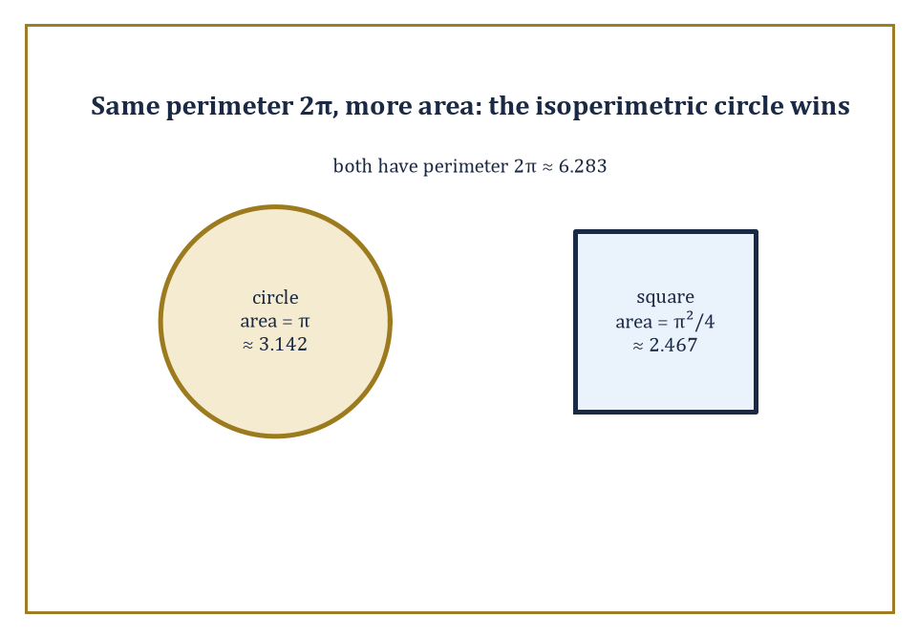
Same fencing, more pasture: a circle and a square sharing perimeter 2π, with the circle enclosing roughly 27% more area — the isoperimetric inequality in a single picture.
On a flat plane this reduces exactly to y″ = 0, straight lines, as derived in Room 28.4; on a curved surface it becomes a genuinely nontrivial second-order ODE. One of the cleanest cases is a developable surface — one that can be unrolled flat without stretching, like a cylinder or a cone — where geodesics are simply straight lines in the unrolled picture, mapped back onto the curved surface.
Numeric example — Worked example — geodesic distance on a cylinder. Take a cylinder of radius r = 1, and two points on it: one at angular coordinate θ = 0, height z = 0, the other at θ = π/2, height z = 1. Unroll the cylinder into a flat strip: the angular coordinate becomes an ordinary horizontal distance, rθ, and the height stays as it is. The two points become, in the unrolled plane,
(0, 0) and (r·π/2, 1) = (π/2, 1) ≈ (1.5708, 1)
The geodesic on the cylinder is exactly the straight line joining these points in the unrolled picture (since unrolling is a local isometry — it preserves lengths — a straight line in the flat picture is a length-minimizing curve on the actual cylinder, tracing out a helical arc once rolled back up). Its length is
√((π/2)² + 1²) = √(2.4674 + 1) = √3.4674 ≈ 1.8621
This is shorter than either travelling straight up (length 1, but not reaching the right θ) or straight around (length π/2 ≈ 1.5708, but not reaching the right z) — the helix is the genuine compromise, and its length of ≈1.8621 is provably the shortest possible route between the two points along the cylinder's surface.
A minimal surface is the higher-dimensional sibling of a geodesic: an extremal of the area functional, among surfaces spanning some fixed boundary curve (a wire frame, in the soap-film picture). The Euler–Lagrange equation for the area functional turns out to say that the mean curvature — the average of the two principal curvatures at each point — vanishes identically, which is exactly the physical balance condition for a soap film with equal air pressure on both sides (surface tension pulls the film taut everywhere in a way that, absent a curvature imbalance, has nowhere left to push it).
The catenoid derived symbolically in Room 28.4 — the surface swept out by revolving a catenary y = C·cosh(x/C) about the x-axis — is the minimal surface spanning two coaxial circular rings, and it is famously not the only story: beyond a certain critical ratio of the rings' separation to their radius, no smooth catenoid can span them at all, and the physical soap film instead collapses discontinuously into two flat disks, one across each ring (the so-called Goldschmidt solution) — a reminder that existence of a smooth extremal is never to be taken for granted, however elegant the Euler–Lagrange equation looks on paper.
Numeric example — Worked example — checking that the catenoid is genuinely minimal. For a surface of revolution generated by rotating y(x) about the x-axis, the vanishing-mean-curvature condition works out to the ODE
y·y″ = 1 + y′²
A fact worth taking on trust here rather than re-deriving (it is a short exercise in the surface-area first and second fundamental forms, and not the variational machinery this storey is otherwise built from). Take the catenary y = cosh(x) (the C = 1 case from Room 28.4) and check the condition at x = 1. First, y = cosh(1) ≈ 1.54308, y′ = sinh(1) ≈ 1.17520, and y″ = cosh(1) ≈ 1.54308 (since the catenary's second derivative is again cosh, unlike almost everything else in calculus). Left-hand side:
y·y″ = cosh(1)² ≈ 2.38110
Right-hand side:
1 + y′² = 1 + sinh(1)² ≈ 1 + 1.38110 = 2.38110
The two sides agree — unsurprisingly, since cosh²t − sinh²t = 1 is an identity for every t, so the check holds not just at x = 1 but at every point along the curve. The catenoid generated by this curve is therefore a bona fide zero-mean-curvature surface, precisely as the Beltrami-identity derivation back in Room 28.4 promised, and precisely what a soap film — which can only ever balance surface tension against itself, never against a curvature it cannot feel — is physically obliged to become.
The isoperimetric problem asks: among all closed curves of a fixed perimeter P, which one encloses the greatest area? The answer — proved rigorously via the calculus of variations, though known to intuition since antiquity — is the circle, and the same principle extends to enclosing maximal volume for fixed surface area in three dimensions (which is why soap bubbles, free to choose their own shape and answerable only to surface tension, are spheres).
Numeric example — Worked example — the circle beats the square. Take perimeter P = 2π ≈ 6.2832. A circle with this circumference has radius r = P/(2π) = 1, enclosing area πr² = π ≈ 3.1416. A square with the same perimeter has side length P/4 = 2π/4 = π/2 ≈ 1.5708, enclosing area (π/2)² = π²/4 ≈ 2.4674.
The circle's area, ≈3.1416, comfortably exceeds the square's ≈2.4674 — for the identical budget of boundary length, the circle simply does more with it, exactly as the isoperimetric inequality guarantees it must for any competing shape whatsoever, not merely the square chosen here for concreteness.
Abstract example — Worked example — the brachistochrone and the cycloid. The brachistochrone problem — posed by Johann Bernoulli in 1696 — asks for the curve down which a bead, sliding frictionlessly under gravity from rest, falls from one fixed point to another (not directly below it) in the least time. With y measured downward from the start and x horizontal, the time functional is
J[y] ∝ ∫√((1+y′²)/y) dx
Using energy conservation to write speed as √(2gy). This L has no explicit x-dependence, so the Beltrami identity of Room 28.4 applies exactly as it did for the catenary: L − y′·∂L/∂y′ = C works out (via the same algebra pattern as before, with √y in place of y in the earlier computation) to
1/(√y·√(1+y′²)) = C, i.e. y(1+y′²) = 2r for a constant 2r = 1/C²
This first-order equation is solved by the standard substitution y′ = cot(θ/2), which converts it into the parametric pair
x(θ) = r(θ − sin θ), y(θ) = r(1 − cos θ)
Precisely a cycloid, the curve traced by a point on the rim of a circle of radius r rolling along a line. That the fastest way down is not the straight line, nor any circular arc, but this specific rolling-wheel curve, is exactly the sort of counterintuitive answer the calculus of variations excels at producing and then, immediately afterward, rendering completely inevitable in hindsight.

Room 28.9: Looking Ahead: From Classical Variational Calculus to Optimal Control and Geometric Analysis
The View From the Top of This Particular Storey
We have now assembled the full classical toolkit: unconstrained and constrained critical points in finite dimensions, convexity and its duality, the Euler–Lagrange equation and its first integrals, second-variation sufficiency conditions, Hamilton's principle, and the great trio of geodesics, minimal surfaces, and isoperimetry. Each of these tools opens directly onto a modern research programme, and it is worth a moment naming where they lead, if only so that the map of the Tower stays legible from up here.
Optimal control theory extends the calculus of variations to problems where the 'curve' being chosen is constrained to obey a differential equation of its own (a state ẋ = f(x,u) driven by a control u that the modeller gets to choose), and asks for the control minimizing some cost. Pontryagin's maximum principle is the direct descendant of the Euler–Lagrange equation for this richer setting, introducing a costate variable that plays exactly the role of the multiplier function λ(x) from Room 28.5, now evolving in time according to its own differential equation.
Numeric example — Worked example — Pontryagin's maximum principle recovers an old friend. Minimize ∫₀¹ u(t)² dt subject to the state equation ẋ = u, with x(0) = 0 and x(1) = 1 fixed, over all control functions u(t) (this is the same problem as minimizing kinetic-type energy to move a particle from 0 to 1 in unit time). Form the control Hamiltonian H(x,u,p) = u² + p·u, with costate p. Pontryagin's condition requires u to minimize H pointwise:
∂H/∂u = 2u + p = 0, so u = −p/2
The costate equation is ṗ = −∂H/∂x = 0 (H has no explicit x-dependence here), so p is constant, say p = p₀, forcing u to be constant too: u ≡ −p₀/2 =: u₀. The state then evolves as x(t) = u₀t (using x(0)=0), and the terminal condition x(1) = 1 forces u₀ = 1. So the optimal control is the constant u(t) ≡ 1, giving x(t) = t and total cost ∫₀¹1² dt = 1.
Compare this to the ordinary calculus-of-variations formulation of the identical problem back in Room 28.4 and 28.5 — minimize ∫₀¹(y′)² dx with y(0)=0, y(1)=1 — whose Euler–Lagrange solution was y = x with the same cost of 1. Two formalisms, one dressed in costates and control Hamiltonians, the other in multipliers and integrands, arriving at the identical answer by what is, underneath the notation, the identical argument.
Geometric analysis takes the variational machinery of this storey and applies it to maps between curved spaces rather than curves in flat ones — harmonic maps (extremals of an energy functional generalizing both geodesics and minimal surfaces at once), and curvature functionals whose extremals include the Einstein metrics of general relativity and the Ricci flow used, famously, in the resolution of the Poincaré conjecture.
Abstract example — Worked example — harmonic maps recover two old friends as special cases. The harmonic map energy for φ: (M, g) → (N, h) is
E[φ] = ½∫_M |dφ|² dvol
A direct generalization of the kinetic-energy functional from Room 28.7. Take the domain M to be simply an interval [a, b] (a one-dimensional, flat manifold): then |dφ|² is just |φ′(t)|², and
E[φ] = ½∫ₐᵇ |φ′(t)|² dt
Exactly the free-particle Lagrangian from Room 28.7 with V ≡ 0, whose Euler–Lagrange equation forces φ to travel at constant speed along a length-minimizing curve in the target N. In other words, a harmonic map out of an interval is precisely a geodesic in the target manifold: the 'straight line' concept of Room 28.4 is the M = [a,b] case of harmonic maps and nothing more exotic.
Now take M to be a two-dimensional surface instead, and restrict attention to conformal maps φ (ones preserving angles, though not necessarily lengths). For conformal φ, a standard identity gives
E[φ] ≥ Area(φ(M))
With equality exactly when φ is also harmonic — so among conformal parametrizations of a given image surface, the energy-minimizing (harmonic) one is exactly the area-minimizing one, and minimal surfaces fall out as the M = (2-dimensional surface) case. Geodesics and minimal surfaces, which Room 28.8 introduced as two separate classical stories, are thus literally the same equation, harmonic map theory, read at two different dimensions of domain.
Direct methods in the calculus of variations sidestep the Euler–Lagrange equation altogether where it cannot be solved explicitly, instead proving a minimizer exists abstractly — via weak lower semicontinuity of the functional and compactness of minimizing sequences in a Sobolev space — and only afterward, if ever, extracting an equation the minimizer must satisfy.
The strategy, in outline: take a minimizing sequence of curves yₙ (one that drives J[yₙ] down towards the infimum value), extract a subsequence converging in a suitably weak sense to some limit y (this is the compactness step, and it is precisely why Sobolev spaces — which control a function together with a weak derivative, but only in an averaged, integral sense rather than pointwise — are the natural home for the argument), and finally argue that J itself cannot jump upward in the limit (lower semicontinuity), so J[y] ≤ liminf J[yₙ] = the infimum, forcing y to actually attain it. Not one derivative of L is differentiated in this entire argument; existence is bought with compactness and inequalities rather than with calculus.
Abstract example — Worked example — why a minimizing sequence can fail to converge to a minimizer. Consider J[y] = ∫₋₁¹ (y′)² + y²(y²−1)² dx over curves with y(−1) = −1, y(1) = 1 (a toy double-well problem — the integrand is small only where y is close to a straight interpolation and near the wells y = ±1). A minimizing sequence can, in principle, oscillate faster and faster between values near −1 and +1 across a thin transition layer, driving the well-term y²(y²−1)² arbitrarily close to zero almost everywhere while paying an ever-shrinking cost in (y′)² by making each transition steeper but rarer — the sequence's energy can approach an infimum without any single member of the sequence, nor any reasonable limit of the sequence, actually attaining that infimum cleanly.
This is exactly the phenomenon the direct method's compactness step is built to rule out or correctly diagnose: without a genuine bound controlling oscillation (an equicontinuity or Sobolev bound on the yₙ, not merely a bound on J[yₙ]), a minimizing sequence can fail to converge to anything achieving the infimum at all, and existence of a minimizer becomes a real theorem to be proved, not a formality to be waved through.
And numerical methods, the very next storey of this Tower, discretize the functional itself (replacing the continuum of admissible curves by a finite-dimensional family, and the integral by a finite sum) and hand the resulting finite-dimensional optimization problem back to the machinery of Room 28.1 — which is a pleasing closure: the infinite-dimensional theory, computationally, dissolves right back into the finite-dimensional theory it was built to generalize.
The deeper lesson of this storey, stripped of its equations, is this: an astonishing number of the shapes, paths, and configurations we observe in the world are not arbitrary. They are the configurations that minimize or maximize some quantity — length, time, energy, area — and the mathematical expression of that fact is a variational principle. Optics obeys Fermat's principle; mechanics obeys Hamilton's principle; soap films minimize area; hanging chains minimize potential energy subject to their own length. Optimization and the calculus of variations are, in the end, the mathematics of the word best — and it is a small but genuine comfort, on the many days when finding the best of anything feels impossible, that at least somewhere in the universe, physics is doing it automatically, without complaint, and without ever once applying for a grant.
We arrived at this storey already knowing how systems evolve; we leave it knowing why they evolve the way they do — because some quantity, somewhere, is being made as small (or as large) as the constraints allow, and the Euler–Lagrange equation is simply the bookkeeping that makes this precise. It is a rare thing in mathematics for a single idea — the first variation vanishes — to organize such an enormous span of material, from the placement of a single constrained point in ℝⁿ to the trajectory of a planet to the shape of a bubble, but there it is: vanish, and you have found what is best, subject to whatever the world has insisted you put up with.
What we have not done — and could not do, within one storey — is compute any of this at scale. Every worked example above was small enough to solve by hand, precisely because it needed to be checkable by hand; the moment a functional loses its convenient structure, or a constraint set gains a hundred more dimensions, closed-form answers evaporate and we are left needing an algorithm rather than an identity. That is exactly where the next storey begins: Numerical Methods takes the gradient descent and Newton's method sketched briefly in Room 28.1, and the discretized functionals gestured at in Room 28.9, and builds the machinery that turns 'in principle solvable' into 'actually solved, on a computer, this afternoon.'
The tower continues upward. We have learned to ask what is best; next, we learn how to go and find it when nobody is kind enough to hand us a closed form.

Storey 29: Numerical Methods
Approximation, Discretization, and the Art of Computing What Cannot Be Solved Exactly
You have just come down from the calculus of variations, where we spent an entire storey arguing, with great formality, about which curve — among the uncountably many candidates on offer — minimises some functional. The Euler–Lagrange equation duly arrived, stamped its authority on the problem, and handed us a differential equation that characterised the optimal curve perfectly. And then, in the overwhelming majority of cases that anyone actually cares about, that equation turned out to have no closed-form solution whatsoever. We proved existence. We proved a beautiful necessary condition. We did not, in general, get to write the answer down. This is rather like being told the exact address of buried treasure in a language nobody living can read.
Numerical methods are where the Tower stops apologising for this and starts doing something useful about it instead. The premise of this storey is disarmingly simple: if you cannot solve a problem exactly, replace it with a nearby problem you can solve — finitely, mechanically, on a machine that only knows how to add, subtract, multiply, divide, and (crucially) forget most of its digits after about sixteen of them — and then prove, rigorously, that the replacement's answer is close to the real one. That last clause is the whole discipline in miniature. Anyone can approximate; the mathematics is in knowing, in advance and with a number attached, how wrong you're allowed to be.
So this storey sits at an unusually honest floor of the Tower: it is the one where exact mathematics is required to shake hands with a machine that cannot do exact mathematics at all, and the two of them are asked to get along. We will meet the two great sources of error that haunt every numerical result — the error of replacing the infinite with the finite (truncation), and the error of the machine's own arithmetic being slightly, unavoidably, wrong (rounding) — and we will watch, in numbers, how they trade off against each other. We will find roots we cannot factor, fit curves through data that refuses to sit still, integrate functions with no elementary antiderivative, solve linear systems too large to look at, and march differential equations forward in time one careful step at a time.
One storey from now the Tower returns to optimization proper — this time without the infinite-dimensional scaffolding of variational calculus, and with the discrete, unglamorous, extremely useful machinery of gradients, constraints, and algorithms that actually terminate. Consider this storey the toolkit that makes that one possible, and indeed makes most of applied mathematics possible: nearly every equation you have solved symbolically since Storey 1 was, secretly, a lucky exception. Let's discretize.

Room 29.1: What Numerical Methods Actually Are
In which the infinite is replaced by the finite, and nobody is fooled about it
Numerical analysis is the study of algorithms for solving continuous mathematical problems approximately, together with rigorous accounting for how far the approximation is from the truth. The three concerns that govern every method in this storey are accuracy (how small is the error?), efficiency (how much arithmetic does it cost to get that error?), and stability (does the algorithm quietly amplify small errors — in the input data, or in the machine's own rounding — into large ones in the output?).
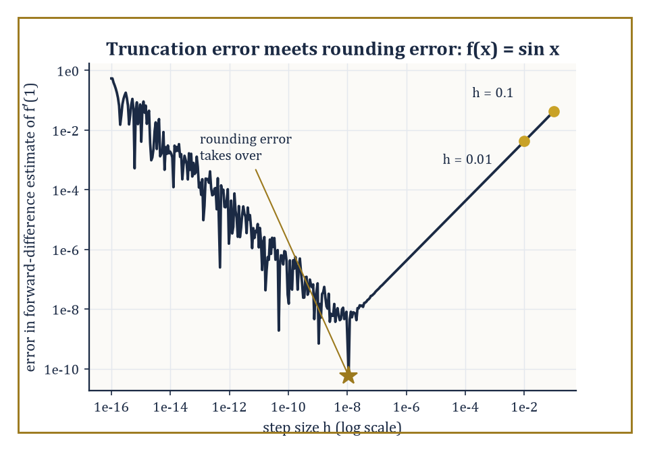
The forward-difference error for f′(1) = cos(1), plotted against step size: truncation error falling on the left, rounding error rising on the right, and the U's floor sitting right where the worked example warned it would.
It is worth dwelling on why this discipline exists at all. Most equations that arise from physics, engineering, biology, or finance have no closed-form solution: no finite combination of the functions you learned in Storeys 1 through 20 will express the answer exactly.
Even the equations that do have closed forms are sometimes numerically treacherous to evaluate — the quadratic formula, of all things, can lose most of its accuracy to catastrophic cancellation if you are not careful about which root you compute first. And for a general polynomial of degree five or higher, Galois theory (Storey 14, if memory of the Tower's floor plan serves) proved that no formula built from radicals exists at all, for reasons that have nothing to do with anyone's cleverness and everything to do with the structure of the symmetric group.
Numerical methods do not mourn this; they simply route around it.
Every numerical method works by the same trick: it replaces an infinite-dimensional object — a function, an integral, the exact solution of a differential equation — with a finite-dimensional proxy that a computer can actually hold in memory: a table of numbers, a weighted sum, a grid of values at finitely many points. This substitution introduces truncation error (sometimes called discretization error): the gap between the true infinite-dimensional answer and the best the finite-dimensional proxy could possibly achieve.
Separately, because the computer represents real numbers with only finitely many binary digits (typically about sixteen decimal digits of precision, the so-called machine epsilon, roughly 10⁻¹⁶), every arithmetic operation the machine performs introduces a further sliver of rounding error. A good numerical method is one where these two errors are both under control and, ideally, roughly balanced — driving the truncation error down further than the arithmetic can resolve is polishing a mirror in a dark room.
Numeric example — Worked example: watching truncation error shrink, forward difference. Take f(x) = sin(x) and try to approximate f′(1) = cos(1) = 0.5403023 using nothing but function values, via the forward-difference formula
f′(x) ≈ (f(x+h) − f(x)) / h
which you get by truncating the Taylor series
f(x+h) = f(x) + h f′(x) + (h²/2) f″(x) + …
after the linear term. With h = 0.1:
sin(1.1) = 0.8912074, sin(1) = 0.8414710
so the difference quotient is
(0.8912074 − 0.8414710)/0.1 = 0.4973638
The true value is 0.5403023, so the error is 0.0429385. Now halve the step to h = 0.01:
sin(1.01) = 0.8468318
(0.8468318 − 0.8414710)/0.01 = 0.5360858
giving an error of 0.0042165 — almost exactly one-tenth of the previous error, for a step ten times smaller. That is truncation error behaving exactly as the discarded Taylor term predicts: the leading error term is
−(h/2)f″(x) = (h/2) sin(1)
which evaluates to 0.0420735 at h = 0.1 and 0.0042074 at h = 0.01, matching our computed errors closely.
If you kept shrinking h past about 10⁻⁸, though, the story would reverse: sin(1+h) and sin(1) become so close together that subtracting them on a machine with sixteen digits of precision loses most of the significant digits to cancellation, and rounding error — not truncation error — starts to dominate and the total error starts climbing again.
Every numerical differentiation formula has this U-shaped error curve; the art is stopping at the bottom of the U.
The efficiency axis is usually measured, as elsewhere in the Tower, in the big-O language of algorithmic complexity: how does the cost of the method grow as the problem size n grows? This is not idle bookkeeping — the growth rate decides which methods are merely slow and which are outright impossible on real hardware, and it is the reason Room 29.5 will spend real effort distinguishing an O(n³) linear solve from an O(n) iterative one.
Numeric example — Worked example: why the exponent in big-O matters more than the constant. Gaussian elimination on a dense n×n system costs roughly n³/3 arithmetic operations (Room 29.5 derives this properly). At n = 100, that's about
100³/3 ≈ 333,333 operations
— instant on any modern machine. Scale the problem up tenfold, to n = 1000 — not an unusual size for a discretized PDE — and the cost becomes
1000³/3 ≈ 333,333,333 operations
a thousandfold increase in cost for only a tenfold increase in problem size, because the cost scales with the cube of n, and 10³ = 1000. Scale up once more to n = 10,000, typical of a modest three-dimensional grid, and the cost reaches roughly
3.3 × 10¹¹ operations
— a further thousandfold jump. This cubic wall, entirely mechanical and utterly indifferent to how cleverly the code is written, is precisely why Room 29.5 devotes so much space to iterative methods, whose cost per step scales far more gently with n, as the only realistic option once problems reach this size.
Numerical analysis therefore lives at the intersection of three subjects the Tower has already built separately: analysis (which supplies the Taylor expansions and inequalities that bound truncation error), linear algebra (which supplies the machinery for the large systems that discretization inevitably produces), and computer science (which supplies the actual floating-point arithmetic, the big-O cost accounting, and its own, entirely honest, imperfections).
It is simultaneously a branch of pure mathematics — approximation theory and stability theory are theorems, proved the way theorems are always proved — and the working engine room of scientific computing. The chapters ahead build this vocabulary one problem at a time: finding roots, fitting curves, differentiating and integrating numerically, solving huge linear systems, and marching differential equations forward through time and space.

Room 29.2: Root-Finding and Nonlinear Equations
Bisection is slow and honest; Newton is fast and occasionally reckless
The oldest and most robust root-finder is bisection: given an interval [a, b] on which a continuous function f changes sign, the Intermediate Value Theorem (Storey 9, and it has been quietly doing this job ever since) guarantees a root somewhere inside.
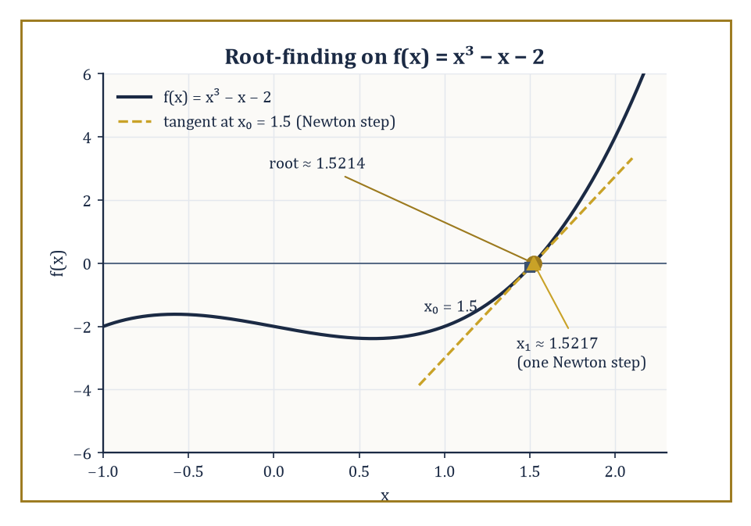
f(x) = x³ − x − 2 and its root near 1.5214, with the Newton tangent from x₀ = 1.5 landing within 0.0003 of the answer in a single step.
Evaluate f at the midpoint; whichever half still brackets the sign change becomes the new interval; repeat.
The interval halves every iteration, so the error is cut exactly in half at every step — a textbook case of linear convergence, meaning the error after n steps is proportional to (1/2)ⁿ.
It is slow, but it essentially cannot fail, provided you started with a genuine bracket.
Numeric example — Worked example: bisection on x³ − x − 2. Let f(x) = x³ − x − 2.
f(1) = 1 − 1 − 2 = −2
f(2) = 8 − 2 − 2 = 4
So a root lies in [1, 2].
Midpoint 1.5:
f(1.5) = 3.375 − 1.5 − 2 = −0.125
Still negative, so the root is in [1.5, 2].
Midpoint 1.75:
f(1.75) = 5.359375 − 1.75 − 2 = 1.609375
Positive, so the root is in [1.5, 1.75].
Midpoint 1.625:
f(1.625) = 4.291016 − 1.625 − 2 = 0.666016
Positive, root in [1.5, 1.625].
Midpoint 1.5625:
f(1.5625) = 3.814697 − 1.5625 − 2 = 0.252197
Positive, root in [1.5, 1.5625].
Midpoint 1.53125:
1.53125³ = 3.590363
f(1.53125) = 3.590363 − 1.53125 − 2 = 0.059113
Still positive, so the root is in [1.5, 1.53125].
Five steps have squeezed the bracket from width 1 down to width 0.03125 — exactly (1/2)⁵ — and the true root, 1.5213797, sits obligingly inside. Reliable, but you can see already that reaching machine precision this way would take about fifty iterations.
Newton's method trades that reliability for speed by using derivative information: given a current guess xₙ, approximate f near xₙ by its tangent line and jump to where the tangent crosses zero.
xₙ₊₁ = xₙ − f(xₙ)/f′(xₙ)
When it works, it works spectacularly — the error roughly squares at every step, so-called quadratic convergence, meaning the number of correct digits roughly doubles each iteration.
The catch, and it is a real one, is the phrase 'when it works': Newton's method has no memory of where the root actually is, and a poorly chosen starting guess, a nearby inflection point, or a flat derivative can send it wandering arbitrarily far away.
Numeric example — Worked example: Newton on the same cubic — watch the digits double. With f(x) = x³ − x − 2, f′(x) = 3x² − 1.
Start at x₀ = 1.5:
f(1.5) = −0.125
f′(1.5) = 3(2.25) − 1 = 5.75
x₁ = 1.5 − (−0.125/5.75) = 1.5 + 0.021739 = 1.521739
Compare to bisection, which after five steps had only pinned the root to within 0.03 — Newton got within 0.0003 in a single step.
Iterate again:
x₁² = 2.315690
x₁³ = 3.523876
f(x₁) = 3.523876 − 1.521739 − 2 = 0.002137
f′(x₁) = 3(2.315690) − 1 = 5.947070
x₂ = 1.521739 − 0.002137/5.947070 = 1.521739 − 0.000359 = 1.521380
The true root is 1.5213797 — x₂ is correct to six decimal places after just two iterations from a mediocre starting guess.
That is quadratic convergence made visible: the error went from about 0.02 (at x₀) to about 0.0004 (at x₁) to about 0.00000003 (at x₂), each error roughly the square of the one before.
Newton's method generalises to systems of n nonlinear equations in n unknowns by replacing the single derivative f′ with the Jacobian matrix J, the n×n matrix of all first partial derivatives, and solving the following linear system at every step for the update Δ:
J(xₙ)·Δ = −F(xₙ)
Then set:
xₙ₊₁ = xₙ + Δ
This costs an O(n³) linear solve at every iteration (Room 29.5 explains why), which for large systems is expensive enough that quasi-Newton methods — which update a cheap approximation to the Jacobian rather than recomputing and refactoring it from scratch every time — are often preferred in practice.
Numeric example — Worked example: Newton's method on a 2×2 system. Find the intersection, in the first quadrant, of the circle x² + y² = 4 and the line x − y = 1 — that is, solve:
F(x, y) = (x² + y² − 4, x − y − 1) = (0, 0)
This particular system has a closed form, by design, so we can check our work: substituting x = y + 1 gives the quadratic
2y² + 2y − 3 = 0
y = (−1 + √7)/2 = 0.8228757, x = 1.8228757
The Jacobian is:
J = [[2x, 2y], [1, −1]]
Start at (x₀, y₀) = (2, 1):
F(2,1) = (1, 0)
J(2,1) = [[4, 2], [1, −1]], determinant −6
Solving JΔ = −F gives:
Δx = Δy = −1/6
(x₁, y₁) = (1.833333, 0.833333)
Already within 0.01 of the true answer after one step.
A second iteration:
F(1.833333, 0.833333) = (3.361111 + 0.694444 − 4, 0) = (0.055556, 0)
J = [[3.666667, 1.666667], [1, −1]], determinant −5.333333
Solving gives:
Δx = Δy = −0.010417
(x₂, y₂) = (1.822917, 0.822917)
Against the exact answer (1.8228757, 0.8228757) the error is about 0.00004 in each coordinate — down from about 0.010 after the first step, the error again roughly squaring, exactly as quadratic convergence promises.
For polynomials specifically, one elegant trick converts root-finding entirely into an eigenvalue problem: the companion matrix of a monic polynomial
p(x) = xⁿ − cₙ₋₁xⁿ⁻¹ − ⋯ − c₁x − c₀
is the n×n matrix with 1s on the subdiagonal and the coefficients cᵢ down the final column, and its characteristic polynomial is exactly p(x) — so the roots of p are precisely the eigenvalues of this matrix, and can be found by the eigenvalue algorithms of Room 29.5 (this is, in fact, how MATLAB's roots function works under the hood).
Specialised algorithms — Jenkins–Traub, Aberth's method — are faster for polynomials of very high degree, but the companion-matrix trick is a beautiful illustration of one numerical problem being silently converted into another.
Abstract example — Abstract example: the companion matrix of x³ − x − 2. For p(x) = x³ − x − 2, write it as x³ − 0·x² − 1·x − 2, so c₂ = 0, c₁ = 1, c₀ = 2.
C = [[0, 0, 2], [1, 0, 1], [0, 1, 0]]
Expanding det(xI − C) along the first row recovers x³ − 0x² − x − 2, confirming the construction.
We already found one eigenvalue by Newton's method above: the real root 1.5213797.
The other two eigenvalues are complex, and Vieta's formulas pin them down exactly without any further iteration: the three roots sum to 0 (the coefficient of x² is zero) and multiply to 2 (minus the constant term), so the remaining pair sums to −1.5213797 and multiplies to:
2/1.5213797 = 1.3145962
They are therefore the roots of:
t² + 1.5213797t + 1.3145962 = 0
t = (−1.5213797 ± i√2.9437886... )/2
That is, approximately −0.7606899 ± 0.8578735i.
This is exactly what an eigenvalue algorithm applied to the companion matrix would report, and it is a useful reminder that a real cubic with one real root always hides a complex-conjugate pair, quietly, in the other two eigenvalues.
Two cautionary notes complete the picture.
First, conditioning: the roots of a polynomial can be exquisitely sensitive to tiny changes in its coefficients — Wilkinson's famous example, the degree-twenty polynomial with roots 1 through 20, has some roots that move by several units, and even leave the real line entirely to become complex-conjugate pairs, when a single coefficient is perturbed by an amount of order 10⁻⁷. Multiple or tightly clustered roots are the worst-conditioned of all.
Second, globalization: Newton's method's quadratic convergence is only a local guarantee, so practical solvers wrap it in a line search (shrink the step if it doesn't improve things) or a trust region (only trust the linear model within a ball of adaptively chosen radius) to widen the basin of initial guesses from which the method actually converges.
Numeric example — Worked example: Newton gone astray. Return to f(x) = x³ − x − 2 but start Newton's method from x₀ = 0, well away from the root near 1.52.
f(0) = −2
f′(0) = −1
x₁ = 0 − (−2/−1) = 0 − 2 = −2
Overshooting wildly to the other side of the real line.
f(−2) = −8 + 2 − 2 = −8
f′(−2) = 12 − 1 = 11
x₂ = −2 − (−8/11) = −2 + 0.727273 = −1.272727
f(−1.272727) = −2.061455 + 1.272727 − 2 = −2.788728
f′(−1.272727) = 3(1.619835) − 1 = 3.859505
x₃ = −1.272727 − (−2.788728/3.859505) = −1.272727 + 0.722461 = −0.550266
Three iterations in, and instead of approaching 1.5214 we are bouncing around the negative axis, nowhere near converging.
This is precisely the pathology that line search and trust-region methods exist to prevent — bare, unprotected Newton is a brilliant local tool and a genuinely reckless global one.

Room 29.3: Interpolation, Approximation, and Splines
Threading a curve through the data without letting it misbehave at the edges
Given n + 1 data points with distinct x-coordinates, there is exactly one polynomial of degree at most n that passes through all of them — this is the interpolation theorem, and it is worth pausing on why it is true: n + 1 unknown coefficients, n + 1 linear conditions (pass through each point), and the resulting linear system's matrix (the Vandermonde matrix) is invertible precisely because the x-coordinates are distinct.
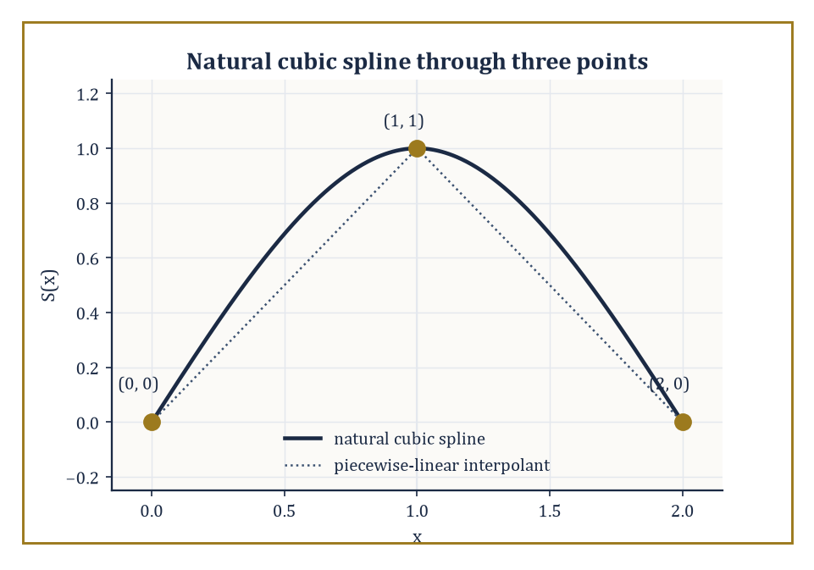
The natural cubic spline through (0,0), (1,1), (2,0), rising and falling with no kink at the knot — compared against the plain connect-the-dots path it improves on.
The Lagrange form writes this polynomial directly as a weighted sum of data values without ever solving a linear system explicitly:
P(x) = Σᵢ yᵢ Lᵢ(x)
Here Lᵢ(x) is the unique degree-n polynomial that equals 1 at xᵢ and 0 at every other node, built by construction as a product of factors (x − xⱼ)/(xᵢ − xⱼ).
Numeric example — Worked example: Lagrange interpolation through three points. Interpolate the points (0, 1), (1, 2), (3, 10) with a quadratic. The Lagrange basis polynomials are as follows.
L₀(x) = (x−1)(x−3)/((0−1)(0−3)) = (x−1)(x−3)/3
L₁(x) = x(x−3)/((1)(1−3)) = x(x−3)/(−2)
L₂(x) = x(x−1)/((3)(3−1)) = x(x−1)/6
The interpolant is P(x) = 1·L₀(x) + 2·L₁(x) + 10·L₂(x). Expanding each term over a common denominator of 6, L₀ contributes (2x² − 8x + 6)/6, 2L₁ contributes (−6x² + 18x)/6, and 10L₂ contributes (10x² − 10x)/6.
(2 − 6 + 10)x² + (−8 + 18 − 10)x + 6 = 6x² + 0x + 6
P(x) = (6x² + 6)/6 = x² + 1
Check: P(0) = 1 ✓, P(1) = 2 ✓, P(3) = 10 ✓ — and indeed those three data points were secretly sampled from f(x) = x² + 1, so the unique quadratic interpolant has exactly and exhaustively reconstructed the function that generated the data, as the interpolation theorem promised it would for any three points of a quadratic.
The error formula for polynomial interpolation is equally instructive: if f is n + 1 times differentiable, the interpolation error at any point x is given below, for some ξ in the interval.
f(x) − P(x) = f⁽ⁿ⁺¹⁾(ξ)/(n+1)! · ∏ᵢ(x − xᵢ)
The product term — the nodal polynomial — depends only on where you placed your nodes, not on f. This is where Runge's phenomenon lurks: for equally spaced nodes on an interval, the nodal polynomial's peaks near the endpoints grow so large, so fast, as the degree increases that for functions with a sharp enough peak (the classic villain is f(x) = 1/(1 + 25x²) on [−1, 1]), the interpolation error near the endpoints grows without bound as more equally spaced nodes are added — more data makes the fit worse.
Chebyshev nodes cluster near the endpoints exactly where equally spaced nodes are weakest, shrinking the nodal polynomial's peak there and taming the divergence. They are defined, for k = 1, …, n, by:
xₖ = cos((2k−1)π/(2n))
Numeric example — Worked example: five Chebyshev nodes. For n = 5 nodes on [−1, 1], the formula xₖ = cos((2k−1)π/10) gives the following values.
x₁ = cos(π/10) = cos 18° = 0.9510565
x₂ = cos(3π/10) = cos 54° = 0.5877853
x₃ = cos(5π/10) = cos 90° = 0
x₄ = cos(7π/10) = cos 126° = −0.5877853
x₅ = cos(9π/10) = cos 162° = −0.9510565
Compare five equally spaced nodes on the same interval: −1, −0.5, 0, 0.5, 1.
The Chebyshev nodes visibly bunch up near ±1 — the gap from the boundary x=1 to the nearest node is a mere 0.049, while the gap between the two nodes flanking the centre (x₂ to x₃) is 0.588, more than ten times as wide — and thin out near the middle accordingly, precisely the opposite spacing of the equally spaced set, and precisely what is needed to suppress the endpoint blow-up that ruins high-degree interpolation on a uniform grid.
When there are more data points than you want polynomial coefficients — or when the data is noisy and passing exactly through every point would be actively undesirable — least-squares approximation finds the polynomial (or, more generally, the member of whatever basis you choose) that minimises the sum of squared residuals given below.
Σᵢ(yᵢ − P(xᵢ))²
Setting the gradient of this sum to zero produces the normal equations, a small linear system in the unknown coefficients.
Numeric example — Worked example: least-squares line through four points. Fit y = a + bx to (1,2), (2,3), (3,5), (4,6).
n = 4, Σx = 10, Σy = 16, Σx² = 1+4+9+16 = 30, Σxy = 2+6+15+24 = 47
The normal equations for simple linear regression give the slope and intercept.
b = (nΣxy − ΣxΣy)/(nΣx² − (Σx)²) = (4·47 − 10·16)/(4·30 − 100) = (188 − 160)/(120 − 100) = 28/20 = 1.4
a = (Σy − bΣx)/n = (16 − 14)/4 = 0.5
The fitted line is y = 0.5 + 1.4x. Its predictions are 1.9, 3.3, 4.7, 6.1 against actual values 2, 3, 5, 6, giving residuals +0.1, −0.3, +0.3, −0.1 — which sum to exactly zero, as they always must for a least-squares fit with an intercept term, a handy self-check.
Splines take a different tack: rather than one global polynomial, use a different low-degree polynomial on each subinterval between data points, and require enough of the derivatives to match at the joints (the 'knots') that the whole curve looks smooth to the eye.
Cubic splines — piecewise cubics matching value, first, and second derivative at every interior knot — are the workhorse of computer-aided design precisely because they combine local flexibility (wiggling one data point only disturbs the curve nearby) with global smoothness (no visible kinks), unlike a single high-degree interpolating polynomial, which Runge's phenomenon shows can wiggle catastrophically everywhere in response to one troublesome data point.
Numeric example — Worked example: a natural cubic spline through three points. Interpolate (0,0), (1,1), (2,0) with a natural cubic spline (second derivative zero at both endpoints). With equal spacing h = 1 and second-derivative unknowns M₀, M₁, M₂, the interior smoothness condition for uniform spacing reads:
Mᵢ₋₁ + 4Mᵢ + Mᵢ₊₁ = (6/h²)(yᵢ₋₁ − 2yᵢ + yᵢ₊₁)
Naturalness forces M₀ = M₂ = 0, leaving:
4M₁ = 6(0 − 2 + 0) = −12, so M₁ = −3
Standard cubic-spline formulas then give, on [0,1] and on [1,2] respectively:
S₀(x) = −0.5x³ + 1.5x
S₁(x) = −0.5(2−x)³ + 1.5(2−x)
Check the joins:
S₀(0) = 0 ✓, S₀(1) = −0.5+1.5 = 1 ✓, S₁(1) = −0.5+1.5 = 1 ✓, S₁(2) = 0 ✓
First derivatives:
S₀′(x) = −1.5x²+1.5 gives S₀′(1) = 0; S₁′(x) = 1.5(2−x)²−1.5 gives S₁′(1) = 0
They agree, so the curve has no kink at x = 1.
Second derivatives:
S₀″(x) = −3x gives S₀″(0) = 0 (natural, as required) and S₀″(1) = −3 = M₁ ✓; S₁″(1) = −3 = M₁ ✓ and S₁″(2) = 0 (natural) ✓
Every condition checks out by hand, and the spline rises smoothly to its peak at x = 1 and falls away again, with no trace of the overshoot a degree-2 global interpolant would already be capable of avoiding here, but which a higher-degree global fit through many such points would not.
Approximation theory asks a sharper question than 'how well does this particular method do?' — it asks how well any method built from a given class of approximants (degree-n polynomials, say) could possibly do, for a given class of functions.
The Weierstrass approximation theorem (any continuous function on a closed interval can be approximated arbitrarily well by polynomials) has a wonderfully constructive proof due to Bernstein, using the Bernstein polynomials defined below.
Bₙ(f; x) = Σₖ f(k/n) C(n,k) xᵏ(1−x)ⁿ⁻ᵏ
The rate at which Bₙ(f) converges to f, along with the matching rate given by Jackson's theorem for the best possible polynomial approximation, quantifies exactly how much accuracy a given approximation budget can buy.
Abstract example — Abstract example: Bernstein polynomials converging to x². For f(x) = x², the Bernstein polynomial has the closed form given below (a standard identity, easily checked for n = 2).
Bₙ(x²; x) = x² + x(1−x)/n
With f(0)=0, f(0.5)=0.25, f(1)=1, the check for n = 2 proceeds as follows.
B₂(x) = 0.25·2x(1−x) + x² = 0.5x(1−x) + x² = 0.5x + 0.5x²
x² + x(1−x)/2 = x² + 0.5x − 0.5x² = 0.5x² + 0.5x
The two match exactly. At x = 0.5, B₂(0.25; 0.5)... rather, the evaluation is:
B₂(x²; 0.5) = 0.5(0.25)+0.5(0.5) = 0.125+0.25 = 0.375
That is against the true value 0.25 — an error of 0.125. Bump n to 10:
B₁₀(x²; 0.5) = 0.25 + 0.5(0.5)/10 = 0.25 + 0.025 = 0.275
That gives an error of 0.025 — exactly a fivefold reduction for a fivefold increase in n, consistent with the general O(1/n) convergence rate that both the Bernstein construction and Jackson's theorem predict for this class of function. It is not a fast rate, by the standards of later chapters, but it is a completely explicit and constructive one — you can write down, in closed form, the very polynomial that does the approximating.

Room 29.4: Numerical Differentiation and Integration
Differentiation punishes noise; integration, mercifully, forgives it
Finite-difference formulas approximate derivatives from sampled function values, and their order of accuracy — how fast the error shrinks as the step h shrinks — is read directly off the Taylor expansion term that the formula fails to cancel.
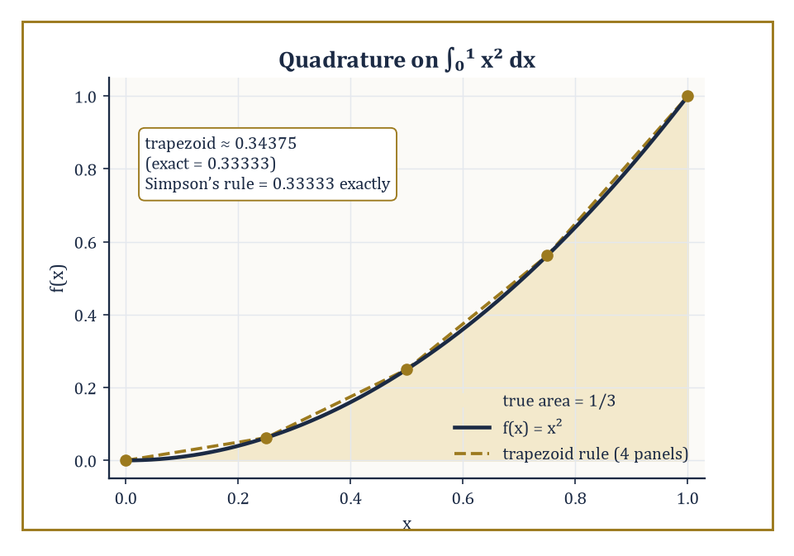
∫₀¹ x² dx: the trapezoid rule's straight segments overshoot the curve's true area, while Simpson's parabola-fitting gets the exact answer, 1/3, from the same five points.
The forward-difference formula met in Room 29.1 is first order, O(h); the central-difference formula cancels the next Taylor term for free by symmetry and is second order, O(h²):
(f(x+h) − f(x−h))/(2h)
Halving h quarters the error rather than merely halving it.
Numeric example — Worked example: central difference beats forward difference. Return to f(x) = sin(x), f′(1) = cos(1) = 0.5403023, with h = 0.1.
sin(1.1) = 0.8912074, sin(0.9) = 0.7833269
central difference = (0.8912074 − 0.7833269)/0.2 = 0.5394023
This gives an error of just 0.0009000 — about 48 times smaller than the forward-difference error of 0.0429385 computed in Room 29.1 at the very same step size. Theory explains why exactly: the central-difference leading error term is
(h²/6)f‴(ξ) ≈ (0.01/6)cos(1) = 0.0009005
which matches the observed error to five decimal places. Halve the step to h = 0.05:
sin(1.05) = 0.8674233, sin(0.95) = 0.8134156
central difference = (0.8674233 − 0.8134156)/0.1 = 0.5400772, error 0.0002251
And 0.0002251/0.0009000 ≈ 0.25, exactly the quartering that O(h²) accuracy predicts.
Richardson extrapolation squeezes yet more accuracy out of a known order of convergence for free, by combining two estimates at different step sizes to cancel the leading error term algebraically. If a method is O(h²), then the following combination cancels the h² term and leaves an O(h⁴) result:
D_extrap = (4·D(h/2) − D(h)) / 3
No new function evaluations beyond the ones you already had are required.
Numeric example — Worked example: Richardson extrapolation on the central difference. Using the two central-difference values just computed, D(0.1) = 0.5394023 and D(0.05) = 0.5400772:
D_extrap = (4·0.5400772 − 0.5394023)/3 = (2.1603088 − 0.5394023)/3 = 1.6209065/3 = 0.5403022
The true value is cos(1) = 0.5403023 — the extrapolated estimate is correct to six decimal places, an error of about 10⁻⁷, roughly two thousand times smaller than the better of the two central-difference estimates that went into it. This is the general phenomenon: extrapolation converts an O(h²) method into an O(h⁴) one using arithmetic alone, no extra sampling of the function required.
Numerical integration, or quadrature, replaces the integral of f(x) by a weighted sum:
∫f(x)dx ≈ Σwᵢf(xᵢ)
The Newton–Cotes family uses equally spaced nodes: the trapezoid rule fits a straight line between consecutive points, while Simpson's rule fits a parabola through each group of three, and is exact for any cubic — not merely any quadratic — because the error term happens to involve a fourth derivative that vanishes identically for cubics, a small piece of good luck baked into the formula's derivation.
Numeric example — Worked example: trapezoid vs Simpson on ∫₀¹ x² dx. The exact value is 1/3 = 0.333333. Using five equally spaced nodes (h = 0.25): x = 0, 0.25, 0.5, 0.75, 1 with f-values 0, 0.0625, 0.25, 0.5625, 1.
Trapezoid: (h/2)[f₀ + 2f₁ + 2f₂ + 2f₃ + f₄] = 0.125[0 + 0.125 + 0.5 + 1.125 + 1] = 0.125 × 2.75 = 0.34375
This gives an error of 0.01042.
Simpson's rule: (h/3)[f₀ + 4f₁ + 2f₂ + 4f₃ + f₄] = (0.25/3)[0 + 0.25 + 0.5 + 2.25 + 1] = 0.083333 × 4 = 0.333333
This is exactly right, to all the digits shown, because x² is a quadratic and Simpson's rule is exact through cubics. Four equally spaced points bought trapezoid an error of about 3%; the same four points, weighted differently, bought Simpson an exact answer.
Gaussian quadrature abandons equally spaced nodes altogether and instead chooses both the node positions and the weights to maximise the degree of polynomial that the rule integrates exactly — an n-point Gaussian rule is exact for polynomials up to degree 2n − 1, roughly twice what an n-point Newton–Cotes rule achieves for the same number of function evaluations.
The two-point Gauss–Legendre rule on [−1, 1] uses nodes ±1/√3 with weight 1 each, and is exact through degree 3.
Numeric example — Worked example: two-point Gaussian quadrature. Test on ∫₋₁¹ x² dx (exact value 2/3 = 0.666667). The nodes are ±1/√3 = ±0.5773503, and (1/√3)² = 1/3 exactly, so f(±0.5773503) = 0.333333 at both nodes.
1×0.333333 + 1×0.333333 = 0.666667
This is exact, as promised, since x² has degree 2 ≤ 3. Now push past the rule's guaranteed exactness with ∫₋₁¹ x⁴ dx (exact value 2/5 = 0.4): f(±0.5773503) = (1/3)² = 0.111111 at both nodes, giving the rule's estimate 0.222222 — a substantial error of 0.177778, because degree 4 exceeds the two-point rule's degree-of-precision ceiling of 3.
The lesson sits right there in the two computations: a Gaussian rule is exact, not approximately good, up to its guaranteed degree, and then its accuracy falls off a cliff one degree higher — which is exactly why quadrature rules are always chosen (or composited into smaller pieces) with the smoothness and polynomial-likeness of the integrand in mind.
The Euler–Maclaurin formula explains a genuinely delightful special case: it expresses the exact difference between the trapezoidal-rule sum and the true integral as a series of correction terms involving the derivatives of f at the endpoints and the Bernoulli numbers (Storey 12 introduced these as the coefficients controlling sums of powers; here they resurface controlling quadrature error).
When f is smooth and periodic and you integrate over exactly one full period, every derivative of f matches at the two endpoints, every correction term in the series cancels, and the humble trapezoid rule — normally only second-order accurate — converges spectrally fast: faster than any power of h.
Numeric example — Worked example: the trapezoid rule's secret superpower on periodic integrands. Compute ∫₀^(2π) sin²(x) dx using the trapezoid rule with just four subintervals, h = π/2. Nodes at 0, π/2, π, 3π/2, 2π give f-values 0, 1, 0, 1, 0 (since sin²(π/2) = 1 and sin² of 0, π, 2π are all 0). The periodic trapezoid sum (endpoints coincide and get combined) is h × (f₁ + f₂ + f₃) with the shared endpoint counted once:
T = h × [0.5·f₀ + f₁ + f₂ + f₃ + 0.5·f₄] = 1.570796 × [0 + 1 + 0 + 1 + 0] = 1.570796 × 2 = 3.141593
The exact value is
∫₀^(2π) sin²(x)dx = π = 3.14159265
since sin² averages to 1/2 over a full period. With only four points, the trapezoid rule has recovered π correct to six decimal places — a result that would ordinarily need dozens of points to achieve for a non-periodic integrand of comparable smoothness. This is the Euler–Maclaurin cancellation in action: nothing clever was done except that the domain of integration was exactly one full period of a smooth periodic function.

Room 29.5: Numerical Linear Algebra
Solving Ax = b, and finding out afterwards how much you should trust the answer
Gaussian elimination with partial pivoting is still, after two centuries, the default way to solve a linear system Ax = b: it factors a row-permuted version of A into a product of a lower-triangular matrix L (with 1s on the diagonal, recording the elimination multipliers) and an upper-triangular matrix U (the result of the elimination itself).
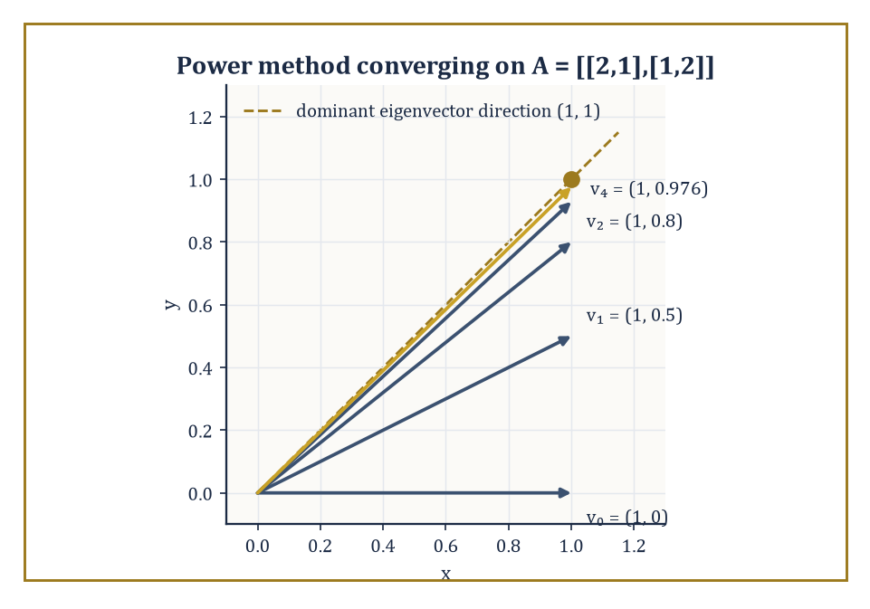
The power method's iterates v₀ through v₄, started at (1,0) and repeatedly multiplied by A = [[2,1],[1,2]], swinging steadily into line with the dominant eigenvector direction (1,1).
PA = LU
This factorization costs O(n³) arithmetic operations for an n×n system. Once you have L and U, solving Ax = b is cheap: forward-substitute to solve Ly = Pb, then back-substitute to solve Ux = y, each an O(n²) operation.
Numeric example — Worked example: LU decomposition and a full solve. Let A = [[2,1,1],[4,3,3],[8,7,9]]. Eliminate column 1:
Row2 − 2·Row1 gives [0,1,1]
Row3 − 4·Row1 gives [0,3,5]
Eliminate column 2:
Row3 − 3·Row2 gives [0,0,2]
So, recording the multipliers used and noting that no row swaps were needed here (since every pivot encountered — 2, then 1, then 2 — was already the largest available, so P = I):
U = [[2,1,1],[0,1,1],[0,0,2]]
L = [[1,0,0],[2,1,0],[4,3,1]]
Check that LU reproduces A — for instance, row 3 of LU:
4·[2,1,1] + 3·[0,1,1] + 1·[0,0,2] = [8,4,4]+[0,3,3]+[0,0,2] = [8,7,9]
This matches A exactly, as do the other two rows. Now solve Ax = b for b = (4, 10, 20). Forward substitution on Ly = b gives:
y₁ = 4
2(4) + y₂ = 10 ⟹ y₂ = 2
4(4) + 3(2) + y₃ = 20 ⟹ 16 + 6 + y₃ = 20 ⟹ y₃ = −2
Back substitution on Ux = y gives:
2x₃ = −2 ⟹ x₃ = −1
x₂ + x₃ = 2 ⟹ x₂ = 3
2x₁ + x₂ + x₃ = 4 ⟹ 2x₁ = 4 − 3 + 1 = 2 ⟹ x₁ = 1
So x = (1, 3, −1). Checking directly against A:
row 1: 2(1)+1(3)+1(−1)=4 ✓
row 2: 4(1)+3(3)+3(−1)=10 ✓
row 3: 8(1)+7(3)+9(−1)=20 ✓
Not every system is so cooperative. The condition number of A measures how much a relative perturbation in the input (A or b) can be amplified into a relative perturbation in the solution x — a well-conditioned matrix (condition number near 1) is forgiving; an ill-conditioned one (condition number in the thousands or millions) can turn a rounding error smaller than you could ever see into a solution that is qualitatively wrong.
Numeric example — Worked example: an ill-conditioned 2×2 system amplifying a tiny perturbation. Let A = [[1,1],[1,1.0001]] and b = (2,2). Solving exactly, from row 1, x₁+x₂=2; subtracting row 1 from row 2 gives:
0.0001x₂ = 0, so x₂ = 0 and x₁ = 2
The solution is (2, 0). Now perturb b by the tiniest amount, to b′ = (2, 2.0001) — a change of just 0.0001 in one entry. Solving again, x₁ + x₂ = 2, and subtracting gives:
0.0001x₂ = 0.0001, so x₂ = 1 and x₁ = 1
The solution is now (1, 1). A change of only 0.0001 in the input produced a change of over 1.4 (in Euclidean norm) in the output — an amplification factor above ten thousand. This is precisely what a large condition number promises: here det(A) = 0.0001 is tiny relative to the entries of A, which is the hallmark of near-singularity, and the ∞-norm condition number works out to roughly 40,000, consistent with the enormous amplification just witnessed by hand.
For systems too large to factor directly — arising, typically, from discretizing a PDE over a fine grid — iterative methods build a sequence of increasingly accurate approximate solutions instead. The simplest, Jacobi iteration, updates every unknown simultaneously using only the previous iterate's other components; Gauss–Seidel uses updated values as soon as they're available within the same sweep and typically converges faster.
The conjugate gradient method (for symmetric positive-definite systems) and GMRES (for general systems) are far more sophisticated, choosing each new approximation to minimise the error, or the residual, over an expanding search space, and are the only realistic option once n reaches the millions.
Numeric example — Worked example: Jacobi iteration converging to a known answer. Solve 5x + y = 11 and x + 5y = 7, whose exact solution is x = 2, y = 1 (check: 5(2)+1=11 ✓, 2+5(1)=7 ✓). Jacobi iteration rearranges each equation to isolate its own variable:
x^(k+1) = (11 − y^(k))/5, y^(k+1) = (7 − x^(k))/5
Starting from (x₀,y₀) = (0,0):
iteration 1: (x₁,y₁) = (2.2, 1.4)
iteration 2: x₂ = (11−1.4)/5 = 1.92, y₂ = (7−2.2)/5 = 0.96
iteration 3: x₃ = (11−0.96)/5 = 2.008, y₃ = (7−1.92)/5 = 1.016
iteration 4: x₄ = (11−1.016)/5 = 1.9968, y₄ = (7−2.008)/5 = 0.9984
The iterates are visibly converging on (2, 1), oscillating in from either side as the diagonal dominance of this system (each row's diagonal entry, 5, exceeds the off-diagonal entry, 1, in magnitude) guarantees they must — no matrix factorisation was needed at any point, only cheap arithmetic repeated a handful of times.
Eigenvalue algorithms round out the toolkit: the power method repeatedly multiplies a vector by A and renormalises, and converges to the eigenvector of the largest-magnitude eigenvalue, since that eigenvalue's contribution dominates every other after enough multiplications.
The QR algorithm, Lanczos, and Arnoldi are more industrial-strength methods for computing the full spectrum, or large chunks of it, of matrices too large to diagonalise directly.
Numeric example — Worked example: the power method finding a dominant eigenvalue. Let A = [[2,1],[1,2]], with eigenvalues found from:
λ² − 4λ + 3 = 0 (trace 4, determinant 3), so λ = 1 or 3
The dominant eigenvalue 3 belongs to the eigenvector direction (1,1). Start the power method at v₀ = (1,0).
v₁ = Av₀ = (2,1); normalise by the largest entry, 2, to get (1, 0.5)
v₂ = A(1,0.5) = (2.5, 2); normalise by 2.5 to get (1, 0.8)
v₃ = A(1,0.8) = (2.8, 2.6); normalise by 2.8 to get (1, 0.928571)
v₄ = A(1,0.928571) = (2.928571, 2.857143); normalise by 2.928571 to get (1, 0.975610)
Two things are converging simultaneously: the direction (1, 0.5), (1, 0.8), (1, 0.928571), (1, 0.975610), … is visibly homing in on (1,1), the dominant eigenvector; and the normalising factors 2, 2.5, 2.8, 2.928571, … are visibly homing in on 3, the dominant eigenvalue — exactly the pair the algebra predicted, extracted using nothing but repeated matrix-vector multiplication.
Underlying all of this is the notion of backward stability: a numerically stable algorithm for solving Ax = b is one whose computed answer x̂ is the exact solution of a slightly perturbed problem
(A + δA)x̂ = b, with δA tiny
This holds even though x̂ itself might be far from the true x, if the problem was ill-conditioned to begin with. LU decomposition with partial pivoting and QR decomposition are both backward stable in this sense. It is a subtle but essential distinction: a stable algorithm cannot manufacture ill-conditioning that wasn't already present in the problem, but it also cannot cure ill-conditioning that was.
Numeric example — Worked example: backward stability rescuing an alarming-looking answer. Return to the ill-conditioned system A = [[1,1],[1,1.0001]], b = (2,2), true solution x = (2,0), condition number ≈40,000. Suppose a rounding-prone solver hands back x̂ = (2.0002, −0.0002) instead — visibly wrong, off by 0.0002 in each coordinate. Is the algorithm to blame? Check the first equation:
x̂₁ + x̂₂ = 2.0002 − 0.0002 = 2.0000
This matches b₁ exactly, so that row of A needs no adjustment at all. Check the second: does x̂ satisfy x₁ + 1.0001x₂ = 2? Plugging in gives:
2.0002 + 1.0001×(−0.0002) = 2.0002 − 0.00020002 = 1.99999998
This is short of 2 by just 0.00000002. So x̂ is not the exact solution of the original system — but nudge the coefficient of x₁ in that row from 1 up to 1.00000001 (a change of one part in 10⁸) and it becomes one:
(1.00000001)(2.0002) + 1.0001×(−0.0002) = 2.00020002 − 0.00020002 = 2.0000
So x̂ is the exact solution of (A + δA)x = b for a δA with a single nonzero entry of size 10⁻⁸ — utterly tiny, and b was never touched. The forward error (0.0002 per coordinate) is roughly 14,000 times the backward error (10⁻⁸) that fully explains it, comfortably inside the bound set by the condition number (≈40,000) computed earlier. The algorithm did nothing wrong; it simply solved, exactly, a problem so close to the one asked that no reasonable person could tell them apart — the ill-conditioning did the rest.

Room 29.6: Numerical Methods for Ordinary Differential Equations
Marching a solution forward one careful step at a time — and knowing when the steps must be very careful indeed
An initial-value problem y′ = f(x,y), y(x₀) = y₀ is advanced through time by one-step methods, which compute yₙ₊₁ purely from yₙ, or multistep methods, which also draw on several previous values. The simplest one-step method, forward Euler, just follows the tangent line.
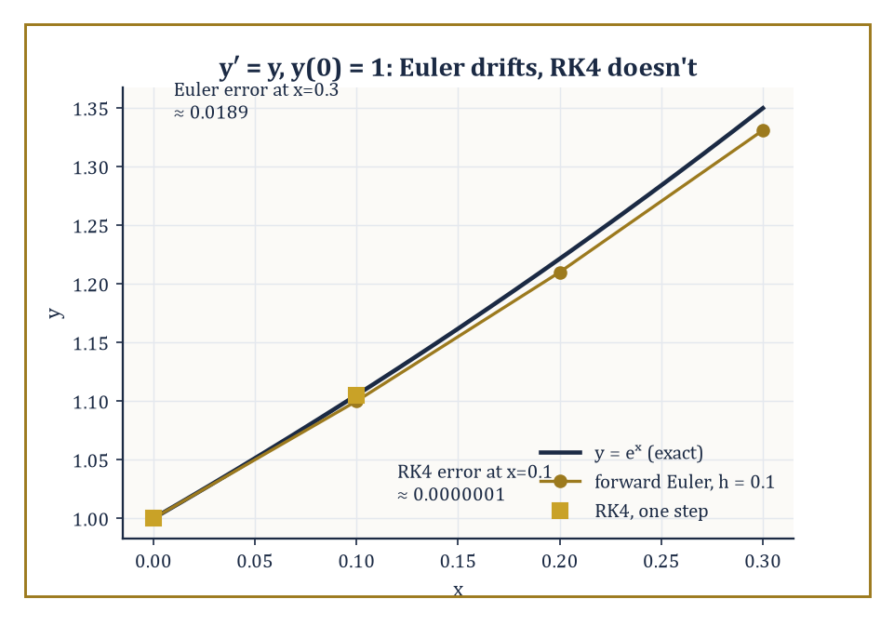
y′ = y, y(0) = 1: forward Euler's step points visibly drift below the true curve eˣ, while a single RK4 step lands on it to six decimal places.
yₙ₊₁ = yₙ + h·f(xₙ,yₙ)
It is first-order accurate — the local error at each step is O(h²), which accumulates to a global error of O(h) — and it is the natural first thing to try, and the natural first thing to be disappointed by.
Numeric example — Worked example: Euler's method drifting away from e^x. Solve y′ = y, y(0) = 1 (exact solution y = eˣ) with step h = 0.1. Since f(x,y) = y, Euler's update is simply yₙ₊₁ = 1.1·yₙ. Three steps produce the following values.
y₁ = 1.1, y₂ = 1.21, y₃ = 1.331
The exact values are e^0.1 = 1.105171, e^0.2 = 1.221403, e^0.3 = 1.349859.
Errors: 0.005171, 0.011403, 0.018859
These errors grow roughly in proportion to the number of steps taken, the signature of a global error that is O(h): a fixed step size buys a fixed, non-shrinking rate of error accumulation per unit of time integrated.
The classical fourth-order Runge–Kutta method (RK4) buys dramatically more accuracy for the same step size, at the cost of four function evaluations per step instead of one: it samples the slope at the start of the interval, twice more at estimated midpoints, and once at an estimated endpoint, then combines all four slope estimates in a weighted average designed so that the resulting step matches the Taylor expansion of the true solution through the fourth-order term.
Numeric example — Worked example: one step of RK4 on the same problem. Same problem, y′ = y, y(0) = 1, h = 0.1. The four slope estimates are computed in turn.
k₁ = f(x₀,y₀) = 1
k₂ = f(x₀+h/2, y₀+ (h/2)k₁) = 1 + 0.05(1) = 1.05
k₃ = f(x₀+h/2, y₀+(h/2)k₂) = 1 + 0.05(1.05) = 1.0525
k₄ = f(x₀+h, y₀+h·k₃) = 1 + 0.1(1.0525) = 1.10525
The RK4 update combines all four.
y₁ = y₀ + (h/6)(k₁ + 2k₂ + 2k₃ + k₄) = 1 + (0.1/6)(1 + 2.1 + 2.105 + 1.10525) = 1 + 0.0166667 × 6.31025 = 1 + 0.1051708 = 1.1051708
The exact value is e^0.1 = 1.1051709 — correct to six decimal places from a single step, where Euler's method at the same step size was wrong in the third decimal place. Four function evaluations bought roughly ten thousand times the accuracy of one.
Some equations resist explicit methods entirely, no matter how small a step you take, if you insist on ordinary efficiency — these are stiff equations, typically ones whose Jacobian has eigenvalues with large negative real parts, meaning some part of the true solution decays extremely fast even while the overall solution you care about is smooth and slow. Explicit methods like Euler and RK4 have a bounded region of stability in the step size, and for a stiff problem that bound can force absurdly tiny steps — not for accuracy's sake, but merely to avoid the numerical solution exploding.
Numeric example — Worked example: an explicit method blowing up on a stiff equation. Solve y′ = −50y, y(0) = 1 (exact solution y = e^(−50x), decaying smoothly to zero) with forward Euler at h = 0.1. The update is yₙ₊₁ = yₙ + 0.1(−50yₙ) = yₙ(1 − 5) = −4yₙ.
y₁ = −4, y₂ = 16, y₃ = −64
The numerical solution oscillates in sign and grows explosively, even though the true solution is monotonically decaying towards zero and is already smaller than 10⁻⁶ by x = 0.3. The culprit is the stability condition for Euler's method applied to y′=λy, which requires |1+hλ| ≤ 1.
λ = −50, h = 0.1 ⟹ |1 − 5| = 4
That value is far outside the stable range. Shrinking to h = 0.01 gives |1 − 0.5| = 0.5, safely stable, and the method then tracks the true exponential decay correctly — but only because the step size was dictated entirely by the fast, uninteresting transient, not by the accuracy you actually wanted.
Numeric example — Worked example: an implicit method handling the same equation gracefully. Apply backward Euler instead: yₙ₊₁ = yₙ + h·f(xₙ₊₁,yₙ₊₁) = yₙ − 50h·yₙ₊₁, which rearranges to yₙ₊₁ = yₙ/(1+50h). With the same h = 0.1, the iterates decay smoothly.
y₁ = 1/6 = 0.166667, y₂ = 0.166667/6 = 0.027778, y₃ = 0.027778/6 = 0.004630
There is no oscillation and no blow-up, despite using the very same 'too-large' step size that destroyed the explicit method. Backward Euler's stability condition, |1/(1+hλ)| ≤ 1, holds for every h > 0 whenever λ has negative real part — it is unconditionally stable (A-stable, in the jargon) for decaying problems, which is exactly why implicit methods, despite requiring a (typically nonlinear, typically Newton-solved) equation at every step rather than a simple formula, are the standard tool for stiff systems.
Practical solvers rarely fix h in advance and then trust to luck; instead they estimate the local error at each step — often by running two methods of different order simultaneously (an embedded pair, sharing most of their function evaluations to keep the extra cost low) and comparing — and shrink or grow the step to keep that estimated error within a user-specified tolerance, a little like a driver constantly adjusting their speed to the bendiness of the road rather than picking one speed for the whole journey.
Boundary-value problems, where conditions are imposed at both ends of the interval rather than all at the start, are handled either by shooting (guess the missing initial condition, integrate forward, and adjust the guess with a root-finder from Room 29.2 until the far-end condition is met — trial, error, and a great deal of politely renamed trial and error) or by discretizing the whole interval at once into a finite-difference or collocation system and solving it as one large algebraic system with the tools of Room 29.5.
Numeric example — Worked example: adaptive step-size control in action. Suppose RK4 (local truncation error scaling as Ch⁵, since it is a fourth-order method) is integrating some initial-value problem with step h = 0.2, and an embedded-pair comparison estimates the local error at that step to be 3.2×10⁻⁵ — but the user asked for a per-step tolerance of 1×10⁻⁶, more than thirty times stricter. Since the error scales as h⁵, halving the step multiplies it by (1/2)⁵ = 1/32.
3.2×10⁻⁵ ÷ 32 = 1.0×10⁻⁶
So a single halving, from h = 0.2 to h = 0.1, lands precisely on the requested tolerance. The standard step-size formula confirms it without any guessing.
h_new = h × (tol/est)^(1/(p+1)) = 0.2 × (10⁻⁶/3.2×10⁻⁵)^(1/5) = 0.2 × (1/32)^(1/5) = 0.2 × (2⁻⁵)^(1/5) = 0.2 × 2⁻¹ = 0.1
This is exactly the arithmetic every adaptive ODE solver performs at every single step, usually with far less obliging numbers and without pausing to admire how neatly they came out.

Room 29.7: Numerical Methods for Partial Differential Equations
Explicit schemes are cheap and skittish; implicit schemes are expensive and imperturbable
Partial differential equations involve derivatives in more than one variable, so discretization now means laying down a grid in space and time (or space and space) and replacing every partial derivative with a difference quotient over that grid.
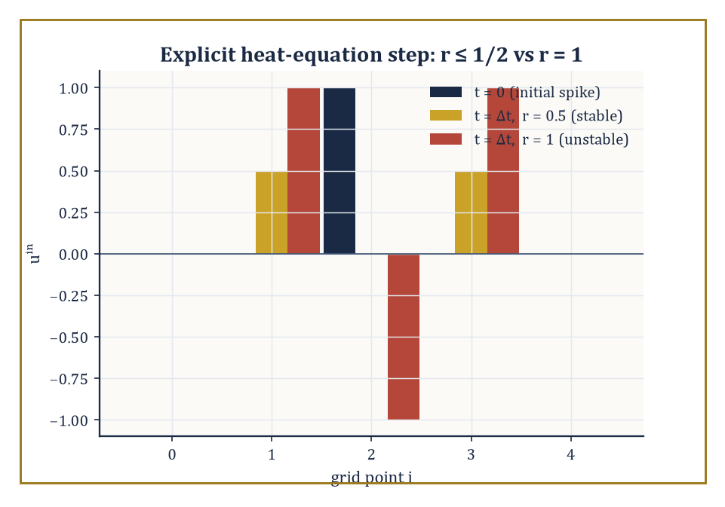
One explicit step on the five-point temperature spike: r = 0.5 diffuses it smoothly and symmetrically, while r = 1 produces a negative temperature — nonsense that only the mesh ratio can be blamed for.
The simplest scheme for the heat equation
uₜ = uₓₓ
is explicit in time, obtained by combining a forward difference in time with a central difference in space:
uᵢⁿ⁺¹ = uᵢⁿ + r(uᵢ₊₁ⁿ − 2uᵢⁿ + uᵢ₋₁ⁿ), where r = Δt/Δx² is the mesh ratio
It is cheap — each new grid value is computed directly from old ones, with no linear system to solve — but it is only stable, in the sense that small errors don't get amplified without bound, when the mesh ratio satisfies
r ≤ 1/2
Numeric example — Worked example: explicit heat equation, stable vs unstable mesh ratio. Take grid values u = [0, 0, 1, 0, 0] at five points with the two ends held fixed at 0 (a temperature spike at the centre).
With r = 0.5 (right at the edge of stability):
u₁ⁿ⁺¹ = 0 + 0.5(1−0+0) = 0.5, u₂ⁿ⁺¹ = 1 + 0.5(0−2+0) = 0, u₃ⁿ⁺¹ = 0 + 0.5(0−0+1) = 0.5
This gives [0, 0.5, 0, 0.5, 0] — the spike has diffused outward smoothly and symmetrically, exactly as heat should behave.
Now try r = 1, twice the stability limit:
u₁ⁿ⁺¹ = 0+1(1−0+0)=1, u₂ⁿ⁺¹=1+1(0−2+0)=−1, u₃ⁿ⁺¹=0+1(0−0+1)=1
This gives [0, 1, −1, 1, 0] — a negative temperature has already appeared, which is nonsense for a diffusion process, and the pattern is alternating in sign, the classic fingerprint of an unstable sawtooth mode.
One more step at r=1 from here gives:
u₁=1+1(−1−2+0)=−2, u₂=−1+1(1+2+1)=3, u₃=1+1(0−2−1)=−2
So [0,−2,3,−2,0] — the magnitude has grown from a peak of 1 to a peak of 3 in two steps and is still climbing. The scheme is diverging in real time, purely because r exceeded 1/2, with nothing else about the problem having changed.
Implicit schemes evaluate the spatial difference at the new time level instead of the old one, which means every unknown at time n+1 is coupled to its neighbours and a linear system (typically tridiagonal, hence cheap to solve despite being implicit) must be solved at every time step.
But in exchange, the scheme becomes unconditionally stable, with no restriction on r whatsoever.
Numeric example — Worked example: the implicit scheme tames the same r = 1. Using the same spike data and the same r = 1, the backward-time scheme gives, for the three interior unknowns u₁, u₂, u₃ (with fixed zero boundaries), the tridiagonal system:
3u₁ − u₂ = 0, −u₁ + 3u₂ − u₃ = 1, −u₂ + 3u₃ = 0
The first and third equations give u₂ = 3u₁ and u₃ = u₁; substituting into the middle equation:
−u₁ + 9u₁ − u₁ = 7u₁ = 1
So u₁ = 1/7 = 0.142857, u₂ = 3/7 = 0.428571, u₃ = 1/7 = 0.142857.
Compare directly with the explicit scheme's catastrophic [0, 1, −1, 1, 0] at the very same r = 1: the implicit result [0, 0.142857, 0.428571, 0.142857, 0] is smooth, symmetric, entirely positive, and behaves exactly the way diffusing heat should — the only thing that changed between the two computations is which time level the spatial difference was evaluated at.
The von Neumann analysis that predicts these thresholds is developed properly in Room 29.8; the underlying restriction, that information cannot be allowed to propagate across the grid faster in the numerical scheme than it does in the true physics, generalises to hyperbolic problems as the Courant–Friedrichs–Lewy (CFL) condition.
Finite-element methods take an entirely different route: rather than discretizing the differential equation pointwise on a grid, they discretize its weak (integrated, or variational) form using functions that are piecewise polynomial on a mesh of elements, which handles irregular geometries far more gracefully than a rectangular grid and produces sparse, symmetric, positive-definite linear systems for the elliptic problems (like steady-state heat flow) where the underlying equation comes from minimising an energy.
Abstract example — Abstract example: a one-element-family finite-element solve. Solve the boundary-value problem
−u″ = 1 on [0,1] with u(0)=u(1)=0
by the weak (Galerkin) formulation, using piecewise-linear 'hat' basis functions on a mesh with a single interior node at x=0.5 (so two elements, each of width h=0.5).
For the interior hat function φ, the stiffness entry is
Kᵢᵢ = ∫φ′² dx = 2/h
(each half of the hat has slope ±1/h over length h, contributing 1/h each), and the load entry is
bᵢ = ∫φ·1 dx = h
(the area of a triangle of base 2h and height 1).
The one-unknown Galerkin system is
(2/h)U₁ = h, so U₁ = h²/2
With h = 0.5, U₁ = 0.125.
The exact solution of the same boundary-value problem is
u(x) = x(1−x)/2 (check: u″ = −1 ✓, u(0)=u(1)=0 ✓)
so u(0.5) = 0.5×0.5/2 = 0.125 — the finite-element solution is exact at the node, not merely close, a pleasant instance of the nodal superconvergence that linear finite elements enjoy for this simple class of problem.
Spectral methods go further still, representing the solution globally by a truncated series in a well-chosen basis (Fourier modes for periodic problems, Chebyshev polynomials otherwise) rather than piecewise polynomials at all.
For a smooth periodic function, the Fourier coefficients decay faster than any power of 1/n — a genuinely infinite-order (spectral) rate of decay — whereas a function with even a single jump discontinuity has coefficients that decay only like O(1/n).
Spectral methods exploit this: on simple domains, for smooth solutions, they can reach machine precision with a handful of basis functions where a finite-difference or finite-element method would need thousands of grid points to match.
The price is a total lack of the geometric flexibility that made finite elements attractive in the first place — you get either simple geometry or dramatic speed, and choosing among finite differences, finite elements, and spectral methods is really a choice about which of geometry, regularity, and conservation properties matters most for the problem in front of you.
Numeric example — Worked example: algebraic decay versus spectral decay, side by side. Take the classic sawtooth
f(x) = x on (−π, π)
extended periodically — a function with a jump discontinuity at the wrap-around point. Its Fourier sine coefficients are
bₙ = 2(−1)ⁿ⁺¹/n
so
|b₁₀| = 2/10 = 0.2 and |b₂₀| = 2/20 = 0.1
doubling n merely halves the coefficient, the textbook signature of O(1/n) decay demanded by the discontinuity.
Now take the Poisson kernel f(θ) with Fourier coefficients
cₙ = rⁿ for some fixed 0 < r < 1
— a perfectly smooth (indeed real-analytic), periodic function with no discontinuity anywhere. With r = 0.5:
c₁₀ = 0.5¹⁰ = 1/1024 ≈ 0.000977, and c₂₀ = 0.5²⁰ = 1/1,048,576 ≈ 0.00000095
Doubling n from 10 to 20 has divided the coefficient not by 2 but by 1024 = 2¹⁰ — geometric decay, annihilating the sawtooth's already-modest rate by three orders of magnitude at n = 20 alone.
This is the whole spectral-methods pitch in two columns of arithmetic: smoothness is not a nicety, it is worth whole powers of ten in every additional basis function you bother to add, which is exactly why a spectral solver can reach machine precision on a smooth problem with a dozen terms, while the sawtooth's cousin PDEs — the ones with shocks, kinks, or other rude discontinuities — are exactly the cases spectral methods handle worst.

Room 29.8: Consistency, Stability, and Convergence
Lax's theorem: be truthful locally, be calm globally, and convergence follows for free
Lax's equivalence theorem is the organising principle behind everything in Rooms 29.6 and 29.7, and it says something almost suspiciously clean: for a consistent finite-difference scheme approximating a well-posed linear problem, stability is necessary and sufficient for convergence. Unpack the three words.
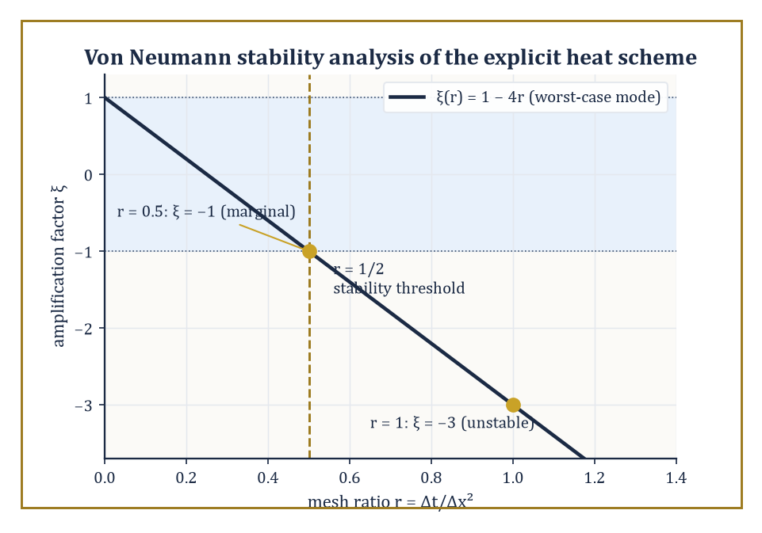
The worst-case amplification factor ξ(r) = 1 − 4r for the explicit heat scheme, crossing out of the stable band |ξ| ≤ 1 exactly at the r = 1/2 threshold used, unproved, back in Room 29.7.
Consistency means the scheme's local truncation error — the residual left over when you substitute the true solution into the discrete formula — tends to zero as the grid is refined; this is checked mechanically by Taylor expansion, exactly as in Room 29.1.
Stability means errors already present (from rounding, or from an earlier approximate step) are not amplified without bound as the computation proceeds.
Convergence, the thing you actually want, means the numerical solution tends to the true solution as the grid is refined. Lax's theorem says you only ever need to check the first two, which are each comparatively easy, to get the third, which on its own would be much harder to verify directly.
Stability itself is most often checked by von Neumann analysis: substitute a single Fourier mode into the difference scheme and solve for the amplification factor ξ as a function of the wavenumber k.
uⱼⁿ = ξⁿe^(ikjΔx)
The scheme is stable exactly when |ξ| ≤ 1 for every k that the grid can represent.
Worked example — Worked example: von Neumann analysis derives the r ≤ 1/2 threshold from Room 29.7. For the explicit heat-equation scheme
uᵢⁿ⁺¹ = uᵢⁿ + r(uᵢ₊₁ⁿ − 2uᵢⁿ + uᵢ₋₁ⁿ)
substituting the Fourier mode gives
ξ = 1 + r(e^(ikΔx) − 2 + e^(−ikΔx)) = 1 − 2r(1 − cos(kΔx)) = 1 − 4r·sin²(kΔx/2)
Stability requires −1 ≤ ξ ≤ 1 for every k; since sin² ranges up to 1, the tightest case is ξ = 1 − 4r, and requiring this to stay ≥ −1 gives
4r ≤ 2, i.e. r ≤ 1/2
exactly the threshold used, without derivation, back in Room 29.7. Plug in the two mesh ratios tested there directly: at r = 0.5, the worst-case mode has
ξ = 1 − 4(0.5)(1) = −1
magnitude exactly 1 — marginal stability, matching the smoothly (if boundary-case) well-behaved numerical result we saw. At r = 1, the worst-case mode has
ξ = 1 − 4(1)(1) = −3
magnitude 3 — meaning that particular Fourier mode, the alternating +1,−1,+1,−1,… sawtooth, triples in amplitude every time step. And that is exactly the mode that appeared in Room 29.7's r=1 example: the sequence [0,1,−1,1,0] then [0,−2,3,−2,0] is precisely a sawtooth pattern growing by very close to a factor of 3 per step, the abstract Fourier prediction and the concrete hand-computed blow-up agreeing to the digit.
For ordinary differential equations, the direct analogue of Lax's theorem (due to Dahlquist) plays out identically: apply a one-step method to the linear test equation y′ = λy, and the method is stable exactly when its amplification factor stays within the unit disk.
Applied to forward Euler, the amplification factor is 1 + hλ, giving the stability condition met already in Room 29.6.
|1 + hλ| ≤ 1
Numeric example — Worked example: Dahlquist's version, tied back to Room 29.6's stiff blow-up. For y′ = −50y with forward Euler at h = 0.1, the amplification factor is
1 + (0.1)(−50) = 1 − 5 = −4
magnitude 4, well outside the stable range |ξ|≤1 — and indeed the computed sequence 1, −4, 16, −64 grows by a factor of exactly 4 in magnitude at every step, matching |ξ|=4 precisely. At h = 0.01, the amplification factor is
1 − 0.5 = 0.5
inside the unit disk, and the sequence 1, 0.5, 0.25, 0.125, … decays geometrically by exactly that factor, tracking the true exponential decay. Consistency was never in question for forward Euler (its local truncation error is O(h²) regardless of λ); it was purely the stability condition, violated at h=0.1 and satisfied at h=0.01, that decided whether the method converged to the truth or diverged from it — Lax's principle, and Dahlquist's, in miniature.
Nonlinear problems refuse to sit still for Fourier analysis, since superposition of modes no longer applies once the equation itself is nonlinear, so convergence proofs there lean on different structural properties instead: monotonicity (the scheme doesn't create new local maxima or minima that weren't in the initial data), the total-variation-diminishing (TVD) property (the total up-and-down wiggle of the solution never increases), and entropy conditions (borrowed conceptually from thermodynamics, they rule out numerical solutions that satisfy the discrete equations but correspond to unphysical shocks the true equation would never produce).
A simple, tangible descendant of the CFL condition mentioned in Room 29.7 governs even the simplest nonlinear-adjacent case, linear advection
uₜ + a·uₓ = 0
with upwind differencing: the scheme is monotone, and hence well-behaved, exactly when the Courant number does not exceed 1.
aΔt/Δx ≤ 1
Numeric example — Worked example: the CFL condition for advection. With wave speed a = 2 and grid spacing Δx = 0.1: choosing Δt = 0.04 gives a Courant number of
2(0.04)/0.1 = 0.8 ≤ 1
safely inside the stable, monotone regime, while choosing Δt = 0.06 gives
2(0.06)/0.1 = 1.2 > 1
which for the upwind scheme produces spurious oscillation and eventual blow-up, for exactly the same structural reason — information trying to move across the grid faster than the numerical stencil can transmit it — that drove the r ≤ 1/2 threshold for diffusion and the |1+hλ|≤1 threshold for stiff ODEs. Three different equations, three different-looking stability conditions, and underneath them all, the same one idea: the numerical domain of dependence must contain the true one.

Room 29.9: Looking Ahead: From Elementary Numerics to High-Performance and Adaptive Methods
The vocabulary is complete; the machine room, mercifully, keeps expanding
We have now acquired the basic vocabulary of numerical methods: root-finding, interpolation and approximation, quadrature, numerical linear algebra, time-stepping for ordinary differential equations, discretization of partial differential equations, and — tying the whole enterprise together — the triad of consistency, stability, and convergence.
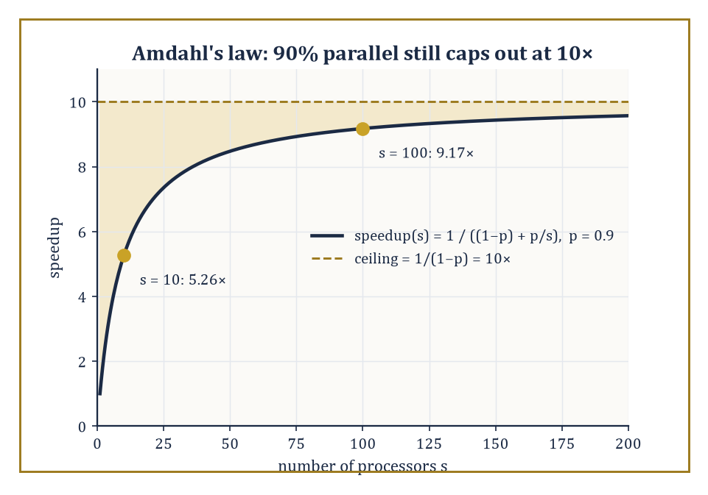
Amdahl's law at p = 0.9: speedup climbs fast at first, then flattens toward a hard ceiling of 10×, no matter how many processors you throw at the stubborn 10% that refuses to parallelize.
Every method we have met has followed the same shape: replace an infinite-dimensional problem with a finite one, bound the truncation error by Taylor expansion or approximation theory, keep the arithmetic stable, and let the two errors — truncation and rounding — settle into a trade-off you understand and can control.
These tools are the foundation of scientific computing, and the frontier from here is mostly about spending the same computational budget more cleverly.
Adaptive mesh refinement concentrates grid points, or elements, precisely where the solution is rough — steep gradients, shocks, singularities — rather than distributing them uniformly across regions where the solution is already smooth and cheap to represent.
Numeric example — Worked example: where adaptivity would have paid off. Recall the explicit heat-equation spike from Room 29.7: a temperature of 1 at the centre grid point, 0 everywhere else.
The solution's curvature — and hence the local truncation error of any fixed-grid scheme — is enormous right at the spike and essentially zero a few points away.
A uniform grid fine enough to resolve the spike accurately wastes nearly all of its resolution on the flat, featureless regions either side.
An adaptively refined grid would place many points near x=2 (the spike) and only a handful near the boundaries, achieving comparable accuracy to the uniform grid's finest resolution using a fraction of the total grid points — the same principle that let Chebyshev nodes in Room 29.3 outperform equally spaced ones, applied dynamically and locally rather than fixed in advance.
Parallel algorithms and high-performance implementations exploit modern many-core and distributed architectures, which changes which algorithms are 'fast' in practice — an algorithm with more total arithmetic but better parallel structure can outrun a leaner sequential one.
But parallelism has its own conservation law, Amdahl's law: if a fraction p of a computation can be parallelised and the rest, fraction (1−p), is stubbornly sequential, then running on s processors gives a speedup of:
Speedup = 1/((1−p) + p/s)
This speedup never exceeds the ceiling
Speedup ≤ 1/(1−p)
no matter how large s grows.
Numeric example — Worked example: Amdahl's law and the ceiling on speedup. Suppose a simulation is 90% parallelisable (p = 0.9, so 1−p = 0.1).
On s = 10 processors, the speedup is:
1/(0.1 + 0.9/10) = 1/(0.1 + 0.09) = 1/0.19 = 5.26×
That's respectable, but nowhere near the naive tenfold hope.
Throw ten times more hardware at it, s = 100: the speedup becomes:
1/(0.1 + 0.009) = 1/0.109 = 9.17×
A tenfold increase in processors bought less than a twofold increase in speedup.
Push s to infinity and the speedup still only approaches:
1/0.1 = 10×
forever capped by that stubborn 10% sequential remainder.
This is why real high-performance numerical codes obsess over minimising the sequential fraction of an algorithm — the communication step, the boundary synchronisation, the single-threaded setup — far more than over adding raw processor count, and it is a sobering, quantitative answer to the naive assumption that more cores simply means proportionally more speed.
Uncertainty quantification propagates uncertainty in a model's inputs through to uncertainty in its outputs, often using Monte Carlo sampling, whose error famously shrinks as O(1/√N) regardless of how many input dimensions the problem has.
That's a blessing for high-dimensional problems where grid-based quadrature is hopeless, and a curse for everyone's patience, since quadrupling the sample size only halves the error, as the next example shows.
Numeric example — Worked example: the diminishing returns of Monte Carlo sampling. If N = 100 samples of some quantity give a standard error of:
σ/√100 = σ/10
Reaching ten times less error, σ/100, requires not ten times but one hundred times as many samples,
N = 10,000
since the error scales with 1/√N.
Going one further order of magnitude down, to σ/1000, requires:
N = 1,000,000
This √N law is exactly why Monte Carlo methods are prized in high dimensions (where the curse of dimensionality makes grid-based quadrature's cost explode exponentially in the number of variables, while Monte Carlo's O(1/√N) rate doesn't care about dimension at all) and exactly why nobody uses Monte Carlo to compute a one-dimensional integral to ten digits — Gaussian quadrature, from Room 29.4, will get there with a handful of points and no randomness required.
Model-order reduction and, increasingly, machine-learning surrogates aim to replace an expensive high-fidelity simulation with a cheap approximate one, trained or constructed once and then queried many times — useful precisely when a numerical model must be evaluated thousands of times inside a larger optimization loop or a real-time control system.
Verification and validation close the loop responsibly: verification asks whether the code correctly solves the equations it claims to solve (a question numerical analysis is well-equipped to answer, with the tools of this storey), while validation asks the separate, harder question of whether those equations actually describe the physical reality you set out to model in the first place — a question no amount of numerical analysis, however rigorous, can answer on its own.
The deeper lesson of this storey, if it has one beyond its formulas, is that computation is not a substitute for analysis but a continuation of it by other means: every reliable numerical result, from a bisected root to a spectrally converged PDE solve, ultimately rests on a theorem about consistency, stability, or approximation, proved with exactly the same rigour as anything else in this Tower.
The machine does the arithmetic; the mathematics is what tells you to trust it.
Numerical methods turn mathematical models into quantitative predictions, and that, when you step back from the individual formulas, is the entire point of the exercise: a differential equation nobody can solve by hand becomes a bridge's stress tolerance, a weather forecast, a dose calculation. We began this storey by admitting that the calculus of variations had left us holding a beautifully characterised equation with no closed-form answer; we end it having built an entire apparatus for extracting trustworthy numbers from exactly that kind of equation anyway, with the error bars to prove it.
If there is a single thread running through every room here, it is that approximation, done honestly, is not a lesser cousin of exact mathematics — it is exact mathematics, applied to a slightly different, and more useful, question. Not 'what is the answer?' but 'how close can I get, how do I know how close I got, and how do I stop the machine's own arithmetic from quietly lying to me along the way?' Every convergence rate, every stability threshold, every condition number in this storey was a theorem before it was a rule of thumb.
One storey up, the Tower turns to optimization in its own right — no longer variational calculus's infinite-dimensional search over curves, but the finite, computational, extremely practical business of finding the best point, subject to constraints, using exactly the kind of iterative machinery root-finding and Newton's method have already previewed here. Bring the condition numbers; you will need them again almost immediately.
We have learned to replace the infinite with the finite and still trust the answer. The Tower continues upward.

Storey 30: Optimization
Algorithms, Duality, and the Art of Finding Better Answers Efficiently
Storey 29 taught us how to compute what cannot be computed exactly — how to bound an error, trust an approximation, and stop pretending that closed-form solutions are the normal case rather than the charming exception. Storey 28, one further down, had already told us what ‘best’ means in the first place: critical points, convexity, the Euler–Lagrange conditions that certify a minimum in principle without troubling themselves over how you might actually locate one. Between them they left a conspicuous gap: knowing what you are looking for, and knowing that a solution exists in principle, is not remotely the same as having a plan of action that will find it, in finite time, without your standing over its shoulder.
This storey fills that gap. It is organized, deliberately, not by application but by structure — because in optimization, structure is destiny. A linear objective over a polyhedron gets the simplex method and a perfect duality theory (Room 30.2). Convexity, wherever it turns up, gets algorithms that need only find a stationary point to have found the global answer (Room 30.5). Smooth unconstrained problems get gradients, Hessians, and the whole spectrum from gradient descent to Newton’s method (Room 30.3); putting the constraints back in gets penalties, barriers, and the Lagrangian (Room 30.4). Discrete variables get branch-and-bound and a hard limit imposed by computational complexity itself (Room 30.7); missing derivatives and enormous datasets get their own dedicated toolkit (Room 30.8). Recognizing which of these worlds a given problem belongs to is, as we shall keep insisting, most of the battle.
A small confession, before we begin: optimization algorithms have an unfortunate tendency to be taught, and used, as black boxes — feed in an objective, receive an answer, ask no further questions. They earn your trust, rather than merely your obedience, only once you understand the geometry they are actually following (descent directions, level sets, the shape of a feasible region) and the certificates they can produce along the way (a duality gap that has shrunk to zero, a KKT residual that has vanished, a proof of infeasibility that cannot be argued with). That understanding, and not merely the ability to call a solver, is this storey’s actual goal.
If the calculus of variations taught us what ‘best’ means, optimization algorithms teach us how to compute it. Let’s solve.

Room 30.1: Modeling and the Landscape of Optimization Problems
In Which We Learn That the Hardest Part Is Admitting What You Actually Want
An optimization problem, stripped to its underwear, consists of three ingredients: a decision vector x — the things you are allowed to choose, living in ℝⁿ for some dimension n; an objective function f(x) — the single number you are trying to make as small (or, by the trivial trick of negating it, as large) as possible; and a feasible set S ⊆ ℝⁿ — the subset of choices you are actually permitted to make, usually carved out by equality constraints gᵢ(x) = 0 and inequality constraints hⱼ(x) ≤ 0.
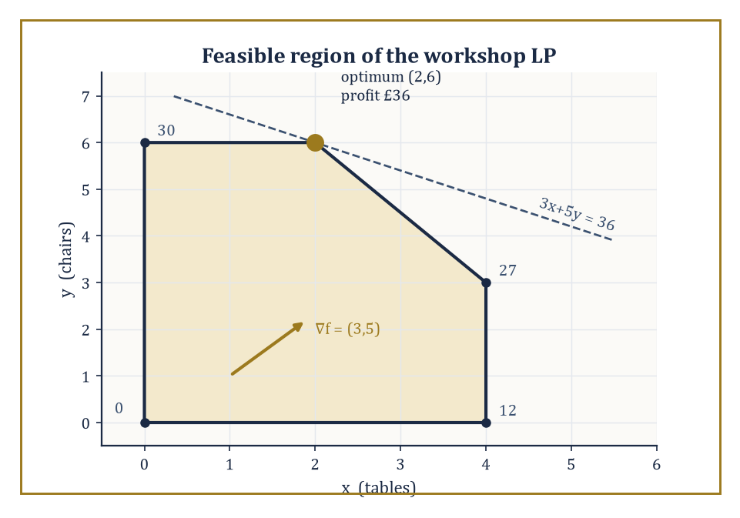
The workshop's feasible pentagon, with the objective's gradient and its level line through the optimum at (2,6) — the vertex the whole storey keeps returning to.
The problem is then simply:
find x* ∈ S minimizing f(x) over all x ∈ S
Everything else in this storey — every algorithm, every convergence proof, every duality certificate — is commentary on how to find, or verify, such an x*. The genuinely difficult part, and the part no textbook can do for you, is choosing f, S, and the meaning of x in the first place.
A model is a translation from ‘what I actually want’ into ‘what an algorithm can chew on’, and translations lose things.
The art of modelling is choosing a translation that loses as little as possible while remaining tractable — a compromise every applied mathematician learns to live with, rather the way one learns to live with a leaking roof in a listed building: not ideal, but the alternative of knocking the whole thing down is worse.
Numeric example — Worked example: setting up and solving a small factory model. A workshop makes tables and chairs. Each table needs 1 hour on the cutting machine (capacity 4 hours/day); each chair needs 2 hours on the finishing machine (capacity 12 hours/day, so at most 6 chairs’ worth); both share a shaping machine, needing 3 hours per table and 2 hours per chair out of 18 hours/day. A table earns £3 profit, a chair £5.
With x = tables and y = chairs, the model is:
maximize 3x + 5y subject to x ≤ 4, 2y ≤ 12, 3x + 2y ≤ 18, x ≥ 0, y ≥ 0
This is a linear objective over a polyhedral feasible set — a linear program. The feasible region is a pentagon with corners (0,0), (4,0), (4,3), (2,6), (0,6).
Check the corner (4,3), which sits exactly on the shaping-machine boundary:
3(4) + 2(3) = 18
Evaluating the objective at each corner — a fact justified properly in Room 30.2, but usable on faith already — gives 0, 12, 27, 36, 30 respectively.
The best corner is (2,6): make 2 tables and 6 chairs, for a daily profit of £36.
The optimum sits at a vertex, not in the interior; this is not a coincidence, and it is the single most important geometric fact about linear programming.
Problems are classified by the shape of f and S, and the classification is not academic pedantry — it is the single most consequential decision you will make, because it determines which algorithms are even available to you.
A linear program (linear f, polyhedral S) can be solved to global optimality in polynomial time for problems with millions of variables.
A convex program (convex f, convex S) still guarantees that any local minimum is global, so the algorithms of Rooms 30.3 and 30.5 apply with confidence.
A smooth nonconvex program offers only local guarantees. A nonsmooth program breaks the derivative-based machinery outright and calls for the subgradient and proximal ideas of Room 30.5.
An integer program restricts some or all of x to the integers, turning a continuous search into a combinatorial one — and, as Room 30.7 will make uncomfortably clear, this single restriction is usually what separates ‘solvable before lunch’ from ‘solvable, in the worst case, some considerable time after the heat death of the universe.’
Recognizing which box a problem falls into, before writing a single line of solver code, is the decisive step; everything downstream is technique.
Numeric example — Worked example: the same workshop, three disguises. Perturb the workshop three ways to see the classification boundaries in action.
(i) If profit is still 3x + 5y, the problem is linear — solvable exactly as above.
(ii) Suppose the shaping machine wears out faster the more it is used, so the effective cost is:
3x + 2y + 0.1(3x+2y)²
This quadratic term keeps the problem convex, since it is a linear function plus a convex quadratic (its Hessian is positive semidefinite), so local methods remain globally trustworthy even though the neat vertex argument of Room 30.2 no longer applies unmodified.
(iii) Suppose chairs must be built as whole objects — obviously true in reality, and blithely ignored in (i) — so y must be a nonnegative integer.
The feasible set is now a finite lattice of points inside the same pentagon rather than the whole pentagon, and although the optimum still happens to be (2,6), since that vertex was already integral, proving no better integer point exists in general requires Room 30.7’s branch-and-bound machinery, not the vertex argument alone.
Before running any algorithm, a modeller should ask two boring but essential questions: does a minimizer actually exist, and if the algorithm reports ‘unbounded’ or ‘infeasible’, what does that mean?
Existence is guaranteed, by the Weierstrass extreme value theorem (met properly in Storey 12, and used constantly ever since), whenever f is continuous and S is nonempty, closed, and bounded — compact, in the jargon.
Drop compactness and existence can fail: the infimum is approached but never attained, rather like a don’s retirement, perpetually one more paper away.
In practice, when a solver reports the problem is unbounded (the objective can be driven to −∞ while staying feasible) or infeasible (S is empty), this is overwhelmingly a modelling error rather than a mathematical curiosity — a missing constraint, a flipped sign, an upper bound the real world imposes but you forgot to write down.
Treat these diagnostics as the solver’s polite way of telling you that you have not yet said what you meant.
Numeric example — Worked example: unbounded and infeasible siblings. Delete both x ≤ 4 and 2y ≤ 12 from the workshop model, keeping only x,y ≥ 0 and 3x+2y ≤ 18.
This alone does not create unboundedness: with x = 0, the shaping constraint still caps y at 9, so the feasible region is merely a larger triangle, and the objective 3x+5y tops out along its edge at:
5(9) = 45
— bounded, just less tightly.
Genuine unboundedness needs the shaping constraint gone too: delete 3x+2y ≤ 18 as well, leaving only x,y ≥ 0.
Now y can grow without limit while x stays at 0, and profit tops out at:
5y → ∞
The solver correctly reports ‘unbounded’ — not a paradox, just a missing capacity constraint, and a reminder that dropping one binding constraint is not always enough to break a model; sometimes you must drop the one actually doing the work.
For infeasibility, restore the original constraints but add a contractual obligation to deliver at least 5 tables per day, x ≥ 5, alongside the original x ≤ 4.
No x can simultaneously satisfy x ≥ 5 and x ≤ 4, so:
S = ∅
and the solver reports ‘infeasible’ — the honest answer to a promise that cannot be kept.

Room 30.2: Linear Programming
Walking the Edges of a Very Well-Behaved Polyhedron
Linear programming — minimize (or maximize) a linear objective cᵀx over a polyhedron — is the best-understood optimization problem in existence, and deservedly so: it is the one case where ‘solve it’ means something completely unambiguous. The polyhedron is defined by:
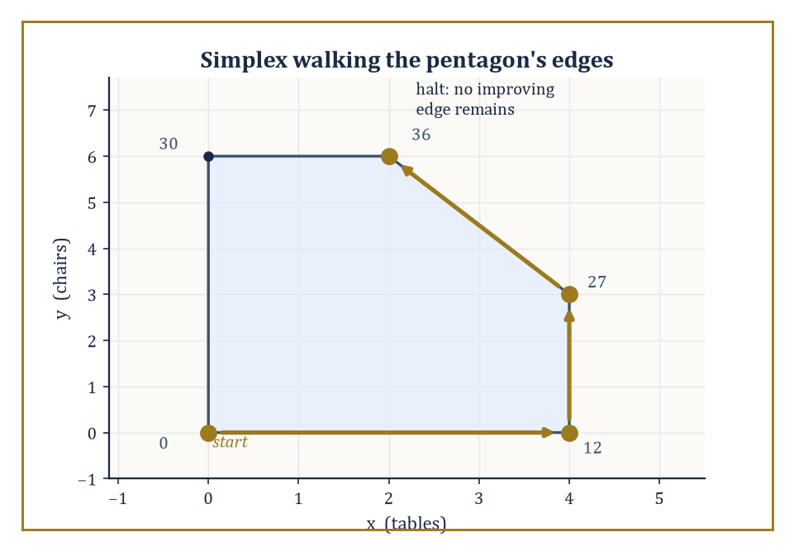
Simplex takes three improving edges — (0,0) to (4,0) to (4,3) to (2,6) — then halts, having visited only four of the pentagon's five vertices.
{x : Ax ≤ b, x ≥ 0}
The simplex method, devised by George Dantzig in 1947 and still, remarkably, competitive today, exploits the fact glimpsed in Room 30.1 that an optimal solution, if one exists, can always be found at a vertex of the polyhedron. It starts at some vertex, looks along each edge leaving that vertex, and if any edge improves the objective, walks along it to the next vertex; when no improving edge remains, it stops, and — this is the theorem that makes the whole enterprise trustworthy — that vertex is guaranteed globally optimal, not merely locally so.
Interior-point methods take the opposite aesthetic: rather than crawling along the boundary, they cut through the interior of the polyhedron along a smooth curve called the central path, parameterized by a barrier weight driven to zero, arriving at the optimal vertex (or face) in the limit.
Simplex tends to win on small-to-medium problems and gives a clean combinatorial picture; interior-point methods tend to win on very large, sparse problems, where their polynomial worst-case complexity is not just a theoretical nicety but a practical guarantee.
Numeric example — Worked example: simplex walking the workshop’s pentagon. Return to the workshop of Room 30.1: maximize 3x+5y over the pentagon with vertices (0,0), (4,0), (4,3), (2,6), (0,6), objective values 0, 12, 27, 36, 30.
A simplex run might start at the origin (0,0), value 0.
The edge toward (4,0) increases the objective (to 12), so simplex takes it.
From (4,0), the edge toward (4,3) increases it further (to 27), so simplex takes that too.
From (4,3), the edge toward (2,6) increases the objective again (to 36) — note x actually decreases along this edge, a reminder that simplex follows edges of the polyhedron, not the steepest local direction in the (x,y) plane.
From (2,6), both remaining edges — toward (4,3) and toward (0,6) — decrease the objective (to 27, or to 30), so simplex halts.
Three pivots, visiting four of the five vertices, and the halting vertex (2,6) is certified optimal purely because no neighbouring edge improves things further — no need to check the fifth vertex (0,0) at all.
Every linear program has a shadow twin, its dual, built from the same data.
If the primal is:
max cᵀx subject to Ax ≤ b, x ≥ 0
the dual is:
min bᵀu subject to Aᵀu ≥ c, u ≥ 0
— the roles of constraints and variables swap, and minimization replaces maximization.
Weak duality is easy: any feasible u gives an upper bound bᵀu on the primal optimum, for any feasible x.
Strong duality is the deeper fact, true for linear programs whenever either side is feasible and bounded: the two optimal values coincide exactly, with no gap.
At a joint optimum, complementary slackness pins down the relationship precisely: for each constraint, either it holds with equality (is ‘tight’ or ‘binding’) or its corresponding dual variable is zero — never both slack at once.
The dual variables have a wonderful economic interpretation as shadow prices: uⱼ* measures how much the optimal objective would improve per unit of extra capacity in constraint j — exactly the sensitivity analysis a manager actually wants, obtained for free once the dual is solved.
Numeric example — Worked example: the workshop’s dual, solved by complementary slackness. The dual of the workshop LP is:
minimize 4u₁ + 12u₂ + 18u₃ subject to u₁ + 3u₃ ≥ 3, 2u₂ + 2u₃ ≥ 5, u₁,u₂,u₃ ≥ 0
(one dual variable per primal constraint: cutting, finishing, shaping). The primal optimum is (x,y) = (2,6). Complementary slackness cuts both ways.
First: since x=2 is strictly less than its bound 4, the cutting constraint is slack, so its dual price is worthless:
u₁ = 0
Second, the other direction of the same principle: since x=2 and y=6 are themselves both strictly positive, their corresponding dual constraints must hold with equality (a primal variable that is actually used forces its dual constraint to bind):
u₁ + 3u₃ = 3, 2u₂ + 2u₃ = 5
(As a consistency check, y=6 and 3x+2y=18 do indeed hit their bounds exactly, so u₂ and u₃ are free to be nonzero — nothing there rules out the values about to be found.) With u₁=0:
3u₃ = 3 ⟹ u₃ = 1
Then:
2u₂ + 2 = 5 ⟹ u₂ = 1.5
Dual objective:
4(0) + 12(1.5) + 18(1) = 0 + 18 + 18 = 36
— exactly the primal optimum of £36, confirming strong duality.
Reading the shadow prices: an extra hour of finishing capacity (u₂=1.5) is worth £1.50/day, an extra hour of shaping capacity (u₃=1) is worth £1/day, and extra cutting capacity (u₁=0) is worth nothing at all, since the workshop was not using all four available hours of it anyway.
Linear programming’s importance far outstrips its apparent simplicity: it is the computational backbone of operations research (scheduling, blending, staffing, logistics), the relaxation at the heart of most integer and mixed-integer solvers (Room 30.7 leans on this relaxation constantly), and a subroutine inside many nonlinear methods (Room 30.4’s SQP solves a sequence of related quadratic — and sometimes linear — programs).
Two structured special cases deserve a mention of their own: network flow problems (route quantity through a graph of nodes and capacitated edges to minimize cost or maximize throughput) and transportation problems (ship goods from several supply points to several demand points at minimum cost) both reduce, on paper, to plain LPs.
But their constraint matrices are so specially structured (‘totally unimodular’, in the jargon) that purpose-built combinatorial algorithms, such as the network simplex method, solve them enormously faster than a general-purpose LP solver would, and, as a pleasant bonus, guarantee integer solutions automatically whenever the supplies and demands are integers, with no need for Room 30.7’s machinery at all.
Numeric example — Worked example: a transportation problem, integral for free. Two warehouses supply two shops. Warehouse 1 holds 5 units, warehouse 2 holds 7 (12 in total); shop A needs 4, shop B needs 8 (12 in total, so the problem balances exactly).
Shipping costs per unit are £2 (warehouse 1 to A), £3 (warehouse 1 to B), £5 (warehouse 2 to A), £1 (warehouse 2 to B). Minimize total cost subject to each warehouse shipping out exactly its supply and each shop receiving exactly its demand — an LP with no integrality constraint imposed anywhere.
Writing x₁₁,x₁₂,x₂₁,x₂₂ for the four shipped quantities, the four equality constraints leave only one free parameter t = x₂₁ (the redundancy is typical of balanced transportation problems):
x₁₁ = 4−t, x₁₂ = 1+t, x₂₂ = 7−t, with t ∈ [0,4]
to keep everything nonnegative. Total cost works out to:
2(4−t) + 3(1+t) + 5t + 1(7−t) = 18 + 5t
minimized by taking t as small as possible, t=0.
That gives x₁₁=4, x₁₂=1, x₂₁=0, x₂₂=7, total cost £18 — and every shipped quantity is already a whole number, with no branch-and-bound in sight, exactly the automatic-integrality bonus the totally-unimodular structure promises whenever supplies and demands are themselves integers.

Room 30.3: Unconstrained Nonlinear Optimization
Downhill, but Cleverly
Once the objective stops being linear, vertices lose their magic and we must search the interior. The oldest idea is gradient descent: from a point xₖ, move a small step in the direction of steepest decrease, −∇f(xₖ), since the gradient always points toward locally increasing f.
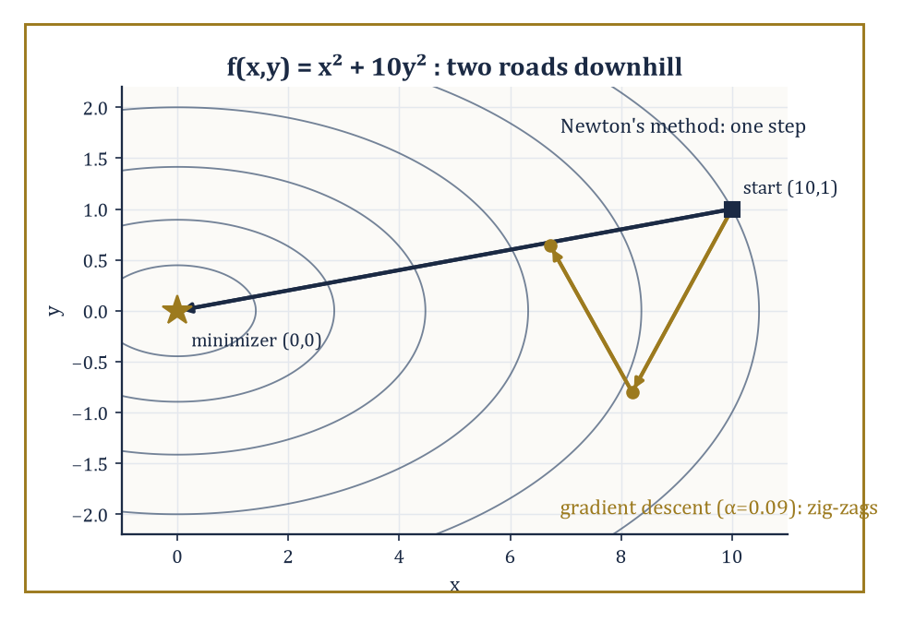
On the elongated bowl x²+10y², gradient descent zig-zags across the narrow valley while Newton's method walks straight to the minimizer in a single step.
xₖ₊₁ = xₖ − α∇f(xₖ)
Iterated, this converges under mild conditions, but can crawl agonizingly slowly along narrow curved valleys — a problem momentum methods address by carrying forward a fraction of the previous step, much as a ball rolling downhill accumulates velocity rather than forgetting it at every instant, and Nesterov's accelerated variant improves further by evaluating the gradient at a look-ahead point rather than the current one, squeezing out a provably faster worst-case rate.
Newton's method takes a fundamentally different view: it builds a local quadratic model of f using the Hessian (the matrix of second derivatives) and jumps straight to that model's minimizer,
xₖ₊₁ = xₖ − H(xₖ)⁻¹∇f(xₖ)
Near a well-behaved minimizer this converges quadratically — the number of correct digits roughly doubles each iteration, a rate gradient descent can only dream of — at the cost of computing and inverting an n×n Hessian, which is where quasi-Newton methods (BFGS, and its memory-frugal cousin L-BFGS) earn their keep, building up an approximation to the Hessian purely from gradients already computed, with no second derivatives required at all.
Trust-region methods hedge against a Newton step that has wandered outside the region where the quadratic model can be trusted, by explicitly bounding the step length and shrinking or growing that bound based on how well the model's prediction matched reality.
Numeric example — Worked example: Newton versus gradient descent on an ill-conditioned bowl. Let f(x,y) = x² + 10y², an elongated quadratic bowl whose Hessian, [[2,0],[0,20]], has eigenvalues 2 and 20 — a condition number of 10, mild by real-world standards but plenty to illustrate the point. Start at (x₀,y₀) = (10,1).
Gradient descent, step size α = 0.09 (close to the largest stable value, 2/20 = 0.1, for the steep y-direction): the gradient at the starting point is
∇f(10,1) = (20,20)
x₁ = (10,1) − 0.09(20,20) = (8.2, −0.8)
Then, at the new point, the gradient is
∇f(8.2,−0.8) = (16.4, −16)
x₂ = (8.2,−0.8) − 0.09(16.4,−16) = (6.724, 0.64)
Notice y flips sign twice in two steps (1 → −0.8 → 0.64) while x creeps down only slowly (10 → 8.2 → 6.724): this zig-zag, forced by one step size having to respect the steep y-direction while the shallow x-direction limps along, is the signature of ill-conditioning, and it worsens as the condition number grows.
Newton's method, by contrast, uses the inverse Hessian H⁻¹ = [[0.5,0],[0,0.05]]; at the same starting gradient ∇f(10,1) = (20,20), the Newton step is
H⁻¹∇f = (0.5·20, 0.05·20) = (10,1)
x₁ = (10,1) − (10,1) = (0,0)
That is the exact minimizer, reached in a single step. This is not a fluke of easy numbers: for any quadratic function, Newton's method reaches the exact minimum in one step, because the local quadratic model it builds is the function.
A method that converges beautifully once it is near a minimizer is of limited use if it diverges before getting there, so both families are wrapped in a globalization strategy.
Line search picks a direction (steepest descent, Newton, quasi-Newton) and then searches along that ray for a step length satisfying sufficient-decrease conditions (the Wolfe or Armijo conditions, in the trade), guaranteeing the objective drops enough to make provable progress. Trust-region methods, as noted above, instead bound the step and adjust the bound adaptively.
Both convert a method with only local convergence guarantees into one with global convergence — meaning convergence to a stationary point from any reasonable starting point, not (confusingly, but this is standard usage) convergence to the global minimum, which nonconvex problems cannot generally promise regardless of the starting point.
The rate near the solution — linear, superlinear, or quadratic, in decreasing order of how painful they are to sit through — and worst-case complexity bounds (how many iterations before the gradient norm is guaranteed below some tolerance ε, in the worst case over a whole class of problems) are the theoretical face of exactly the practical experience above: conditioning, again, decides how many of those iterations you actually need.
Numeric example — Worked example: quasi-Newton curvature from gradient differences alone. Quasi-Newton methods build their Hessian approximation from the secant condition: if you know the gradient at two points, their difference tells you the average curvature between them, with no second derivative required. Take f(x) = x⁴, so f′(x) = 4x³, and, for comparison, the true second derivative f″(x) = 12x².
Evaluate the gradient at x₀=2 and x₁=1.5:
f′(2) = 4(8) = 32
f′(1.5) = 4(3.375) = 13.5
The secant estimate of curvature is
(f′(x₁)−f′(x₀))/(x₁−x₀) = (13.5−32)/(1.5−2) = (−18.5)/(−0.5) = 37
Compare with the true curvature at the midpoint x=1.75:
f″(1.75) = 12(1.75²) = 12(3.0625) = 36.75
The secant estimate (37) is within about 1% of the true value (36.75) — BFGS builds exactly this kind of estimate, in n dimensions, updating it after every step, and it is remarkable how faithfully a method that never touches a second derivative tracks one anyway.
The practical choice among these methods is a triangle of trade-offs: dimension (Newton's O(n³) linear solve per iteration is fine for n=50 and unthinkable for n=10⁸, where L-BFGS's O(n) memory footprint or plain gradient descent is the only option), cost of derivatives (if a gradient is cheap but a Hessian is expensive or simply unavailable analytically, quasi-Newton is the natural compromise), and desired accuracy (a machine-learning training run tolerating a few percent error can happily use noisy first-order methods, while a spacecraft trajectory computation demanding ten correct digits will pay gladly for Newton's quadratic convergence).
There is no universally best method here, only a best method for the problem in front of you — a fact optimization shares with most of applied mathematics, and with restaurant recommendations.

Room 30.4: Constrained Nonlinear Optimization
Downhill, Without Falling Off the Map
Constraints complicate the descent picture: the steepest way downhill may lead straight out of the feasible set.
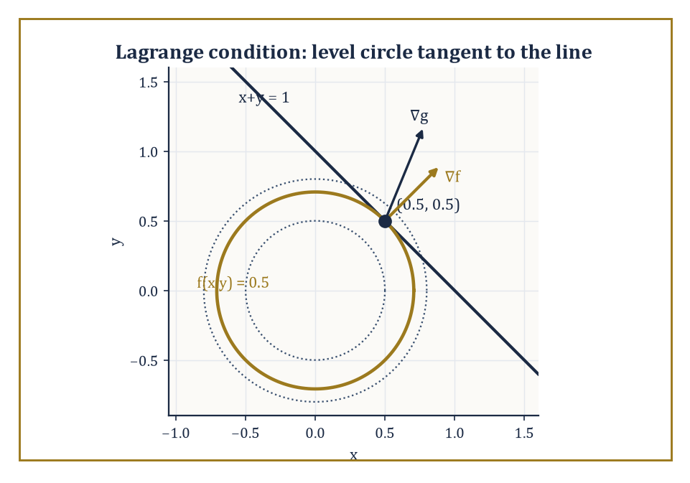
At the constrained minimum (0.5,0.5), the level circle of f just touches the line x+y=1 — tangency is what ∇f = λ∇g looks like.
Penalty methods respond by bribery — replace the constrained problem with an unconstrained one:
minimize f(x) + ρ·(constraint violation)²
Increase the penalty weight ρ until violating the constraint becomes so expensive that the unconstrained minimizer is dragged, in the limit, onto the feasible boundary.
Barrier methods take the opposite tack, adding a term that blows up to +∞ as x approaches the boundary of the feasible region from the inside — enforcing feasibility not by punishment but by making the boundary infinitely unattractive, which is also, not coincidentally, the interior-point idea already met in Room 30.2, generalized from polyhedra to arbitrary convex (and even some nonconvex) constraint sets.
Sequential quadratic programming (SQP) is more surgical still: at each iterate it builds a quadratic model of the Lagrangian and a linear model of the constraints, solves the resulting quadratic program exactly for a step, and repeats — effectively running Newton’s method on the system of optimality conditions (the KKT conditions, met properly below) rather than on the objective alone.
Numeric example — Worked example: penalty and barrier methods homing in from opposite sides. Minimize f(x) = x² subject to x ≥ 1.
The true solution is x* = 1, since x² is increasing for x>0, so the smallest feasible x wins.
f(x*) = 1
Watch the two unconstrained conversions find it.
Penalty: consider the penalized objective, where the constraint is violated (x<1):
φ_ρ(x) = x² + ρ(1−x)²
Setting dφ_ρ/dx = 0:
dφ_ρ/dx = 2x − 2ρ(1−x) = 0
x(2+2ρ) = 2ρ
x_ρ = ρ/(1+ρ)
At ρ=1: x=0.5 (violates by 0.5)
At ρ=9: x=0.9 (violates by 0.1)
At ρ=99: x=0.99 (violates by 0.01)
The penalized minimizer creeps toward 1 as ρ→∞, always staying slightly infeasible.
Barrier: minimize ψ_μ(x) = x − μ ln(x−1) for x>1 (minimizing x itself keeps the arithmetic clean, so the constraint alone prevents the unconstrained-side minimum of −∞):
ψ_μ(x) = x − μ ln(x−1)
Setting dψ_μ/dx = 0:
dψ_μ/dx = 1 − μ/(x−1) = 0
x_μ = 1+μ
At μ=0.1: x=1.1
At μ=0.01: x=1.01
This always stays strictly feasible, approaching 1 from the other side.
Both sequences converge to the true constrained optimum x*=1; they simply approach it from opposite directions, which is exactly the geometric distinction between penalty and barrier methods.
An active-set method takes the view that, at the solution, some inequality constraints will be tight (‘active’, in the jargon) and others irrelevantly slack; if you could only guess correctly which is which, the problem would reduce to an equality-constrained one, solvable directly via the method of Lagrange multipliers.
The Lagrangian turns constrained stationarity into unconstrained stationarity of L over both x and the multipliers λ:
L(x,λ) = f(x) − Σλᵢgᵢ(x)
Stationarity in x, ∇ₓL = 0, recovers the constraint gradients balancing the objective gradient.
Stationarity in the multipliers, ∂L/∂λᵢ = 0, simply recovers the constraint gᵢ(x)=0 itself.
Active-set methods iteratively guess the active set, solve the resulting equality-constrained subproblem, check whether any inactive constraint has been violated or any multiplier has the wrong sign, and update the guess accordingly.
Because progress must be measured on two fronts at once — is the objective decreasing, and is infeasibility shrinking — merit functions combine both into a single scalar to search over (typically f(x) plus a penalty on violation).
Filter methods instead maintain a small Pareto-style list of previously acceptable (objective, violation) pairs and reject any new point dominated by one already on the list, which is rather more forgiving of an occasional uphill objective step made in service of a much-improved feasibility.
Numeric example — Worked example: solving an equality-constrained problem via the Lagrangian. Minimize f(x,y) = x² + y² subject to the equality constraint x + y = 1.
Form the Lagrangian:
L(x,y,λ) = x² + y² − λ(x+y−1)
Stationarity requires:
∂L/∂x = 2x − λ = 0
∂L/∂y = 2y − λ = 0
giving:
x = y = λ/2
i.e. x = y.
Feasibility requires x+y=1, which combined with x=y gives:
x = y = 0.5
λ = 2x = 1
This is exactly the point on the line x+y=1 closest to the origin, as one would hope for minimizing squared distance subject to a linear constraint.
Geometrically, the gradient of f at (0.5,0.5), namely (1,1), is indeed parallel to the constraint’s gradient (1,1), confirming that the circle f=const and the line x+y=1 are tangent at the solution, which is precisely what the Lagrange condition ∇f = λ∇g encodes.
All of this rests on a technical but consequential assumption: that the active constraints’ gradients, at the candidate solution, are linearly independent (or satisfy some weaker but related condition) — a constraint qualification, without which the Lagrange-multiplier machinery can simply fail to certify a genuine minimum, or fail to produce a valid multiplier at all.
Second-order sufficient conditions then distinguish an actual local minimum from a mere stationary saddle: roughly, the Hessian of the Lagrangian must be positive definite on the subspace tangent to the active constraints, ruling out any feasible direction of decrease to second order.
Practical algorithms further need the active set itself to stabilize — to stop flipping constraints in and out — as they converge, since a method that cannot decide which constraints are binding cannot settle into the fast local convergence rate its unconstrained cousin enjoys.
Abstract example — Worked example: a constraint qualification quietly failing. Consider minimizing f(x₁,x₂) = −x₁ subject to x₂ − (1−x₁)³ ≤ 0 and −x₂ ≤ 0 — a standard cautionary tale from the numerical-optimization literature.
The two constraints force:
0 ≤ x₂ ≤ (1−x₁)³
which is only satisfiable when 1−x₁ ≥ 0, i.e. x₁ ≤ 1 — so the feasible region is a cusp-shaped sliver pinched to a single point at (1,0), lying entirely in x₁ ≤ 1.
Minimizing −x₁ means pushing x₁ as large as possible, and x₁ ≤ 1 throughout the sliver, so (1,0) is indeed the solution — the cusp itself, where the constraint reduces to the single point x₁=1, x₂=0.
But look at the active constraint gradients there. The first is:
∇g₁ = (3(1−x₁)², 1)
which, evaluated at x₁=1, gives:
∇g₁ = (0,1)
while the second is:
∇g₂ = (0,−1)
These two vectors are parallel — one is exactly the negative of the other — so they are linearly dependent, and the standard constraint qualification (LICQ) fails at precisely the point where we need it to hold.
Indeed, no valid multipliers exist here at all: stationarity would require:
∇f + λ₁∇g₁ + λ₂∇g₂ = (−1,0) + λ₁(0,1) + λ₂(0,−1) = (0,0)
and since both constraint gradients are purely vertical, no choice of λ₁,λ₂ ≥ 0 can ever cancel that leading −1.
So (1,0) is a genuine, bona fide minimizer for which the Lagrange-multiplier certificate simply fails to exist — exactly the failure a constraint qualification is meant to rule out, and exactly why serious software checks for this kind of degeneracy rather than trusting blindly that a stationary point of the Lagrangian is the same thing as a solution.

Room 30.5: Convex Optimization Algorithms
Where Local Really Does Mean Global
Convexity is optimization’s rare gift: once a problem is convex, any local minimum is automatically global, so an algorithm need only promise convergence to a stationary point to have effectively solved the problem outright.
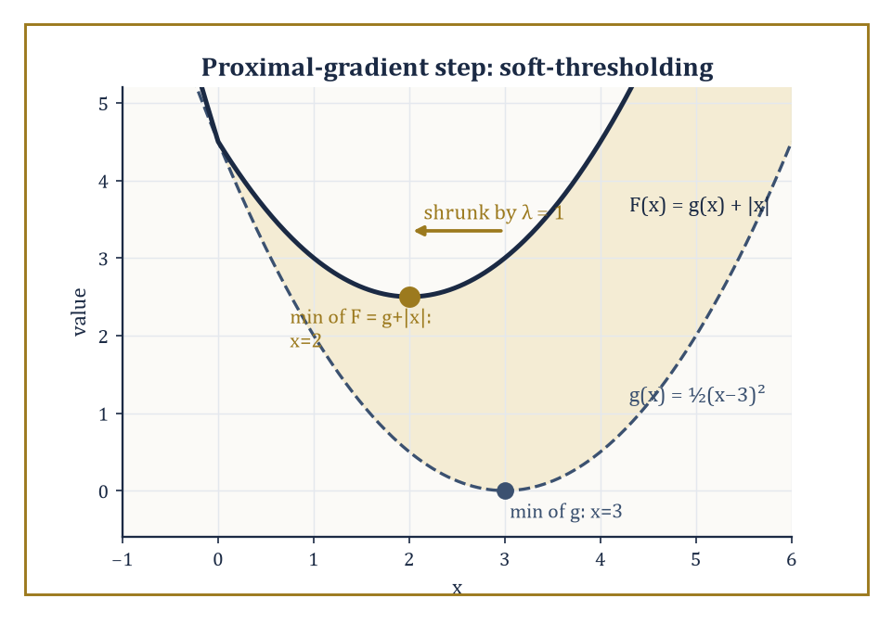
Adding the ℓ₁ penalty |x| to g(x) drags the minimizer from x=3 to x=2 — soft-thresholding made visible.
Projected gradient descent handles simple constraints by alternating an ordinary gradient step with a projection back onto the feasible set (find the nearest feasible point, in Euclidean distance, to the unconstrained step) — cheap whenever that projection is cheap, as it is for a box or a ball, and expensive or worse otherwise.
Proximal gradient generalizes this to composite objectives
f(x) = g(x) + h(x)
where g is smooth and h is convex but possibly nonsmooth (an absolute value, an indicator of a constraint set, a sparsity-inducing norm): take a gradient step on the smooth part g, then apply the proximal operator of h,
prox_h(v) = argmin_z [h(z) + ½‖z−v‖²]
which reduces to plain projection when h is the indicator of a set, and to elegant closed forms, as the next example shows, for many popular choices of h.
Accelerated proximal methods (FISTA and relatives) apply Nesterov’s momentum trick to this composite setting, improving the convergence rate from O(1/k) to O(1/k²) in the number of iterations k — a genuinely free lunch, algorithmically speaking, purchased only by remembering the previous iterate.
Numeric example — Worked example: one proximal-gradient step solves a sparse problem exactly. Minimize F(x) = g(x) + h(x) where g(x) = ½(x−3)², a smooth quadratic, and h(x) = |x|, the nonsmooth ℓ₁ penalty that promotes sparsity — a single variable here for arithmetic’s sake, but the same mechanism scales to LASSO regression in thousands of dimensions.
The proximal operator of λ|·| is soft-thresholding:
prox_{λ|·|}(v) = sign(v)·max(|v|−λ, 0)
Take a proximal-gradient step from x₀=0 with step size t=1: first the gradient step on g alone,
z = x₀ − t∇g(x₀) = 0 − 1·(0−3) = 3
then the proximal step with λ=t=1:
prox(3) = sign(3)·max(3−1,0) = 2
One iteration lands at x₁=2. Because g is quadratic with curvature exactly matching the chosen step size, this single step is in fact exact: checking the subdifferential of F at x=2 directly,
(2−3) + 1·sign(2) = −1+1 = 0 ∈ ∂F(2)
confirming x=2 is the true minimizer — the ℓ₁ penalty has shrunk the unconstrained optimum (x=3) toward zero by exactly λ=1, the ‘soft-thresholding’ behaviour that makes sparse solutions so common in ℓ₁-penalized problems.
For linear, quadratic, and semidefinite programming, interior-point methods (Room 30.2’s central path, generalized) are polynomial-time in the worst case and, for problems up to a few thousand variables, blisteringly efficient in practice, typically converging in a number of iterations that barely depends on problem size at all — a handful of dozens, whether n is 50 or 5,000.
Their Achilles’ heel is the linear system solved at each iteration, which costs roughly O(n³) and eventually becomes the bottleneck; first-order methods (gradient, proximal, accelerated variants) trade this cubic per-iteration cost for a much cheaper O(n) or O(n log n) iteration, at the price of needing many more iterations to reach the same accuracy — the right trade when n is enormous and a few correct digits will do, which describes most of modern machine learning.
Numeric example — Worked example: how the iteration budgets actually compare. A typical interior-point solver needs roughly O(√n · log(1/ε)) iterations to reach accuracy ε; a typical first-order method needs roughly O(1/ε) (or O(1/√ε) with acceleration) iterations, with no explicit dependence on n at all. Suppose n=10,000 and ε=10⁻⁶.
Interior-point:
√10,000 · log₁₀(10⁶) ≈ 100 · 6 = 600 iterations
each costing O(n³) ≈ 10¹² operations for the linear solve — expensive per step.
Accelerated first-order: 1/√ε = 1,000 iterations, each costing only O(n) ≈ 10⁴ operations.
Interior-point needs far fewer iterations but each is vastly more expensive; first-order needs more iterations but each is nearly free. Totting up:
first-order costs roughly 10⁴ × 10³ = 10⁷ operations against interior-point’s roughly 10¹² × 600 ≈ 6×10¹⁴
which is exactly why first-order methods dominate large-scale machine learning while interior-point solvers still rule moderate-sized, high-accuracy engineering problems.
Beyond raw dimension, convex problems often carry exploitable structure: separability (the objective splits into a sum of pieces each touching only a few variables), sparsity or group sparsity (most of the optimal x, or blocks of it, are expected to be exactly zero), or low rank (the optimal matrix variable is expected to have far fewer independent directions than its size suggests).
Splitting methods, of which the alternating direction method of multipliers (ADMM) is the most celebrated, are built precisely to exploit this: they solve a problem of the form
minimize f(x)+g(z) subject to a linear coupling constraint Ax+Bz=c
by alternately minimizing over x (with z fixed), minimizing over z (with x fixed), and updating a multiplier that enforces the coupling — turning one hard joint problem into a sequence of easy separate ones, each often solvable in closed form.
Abstract example — Worked example: one ADMM cycle splitting a joint problem in two. Minimize x² + z² subject to the coupling constraint x + z = 4 — trivial to solve directly (by symmetry and Lagrange multipliers, x=z=2), but instructive to watch ADMM find its way there by alternating.
The augmented Lagrangian (penalty weight ρ=1) is
L(x,z,y) = x² + z² + y(x+z−4) + ½(x+z−4)²
Start at z₀=0, y₀=0. x-update: minimize x² + ½(x+0−4)² over x; setting 2x + (x−4) = 0 gives
3x=4, x₁=4/3
z-update: minimize z² + ½(4/3+z−4)² = z² + ½(z−8/3)² over z; setting 2z + (z−8/3) = 0 gives
3z=8/3, z₁=8/9
Multiplier update:
y₁ = y₀ + ρ(x₁+z₁−4) = 4/3+8/9−4 = 12/9+8/9−36/9 = −16/9
After a single cycle, x₁≈1.33 and z₁≈0.89 have both moved substantially off their starting value of 0, toward the true answer of 2 each; the residual −16/9 measures the remaining coupling violation, and further cycles shrink it toward zero, each cycle costing nothing more than two independent one-variable minimizations plus a trivial update — the entire point of splitting being that neither subproblem ever has to look at the other’s variable directly, only at its current value.

Room 30.6: Duality in Practice
How to Prove You’ve Won Without Playing Every Move
The Lagrangian, met in Room 30.4 as a device for locating stationary points, has a second life as a certificate-generating machine. Define the dual function as follows (inequality constraints gᵢ(x)≤0, multipliers λᵢ≥0, for concreteness):
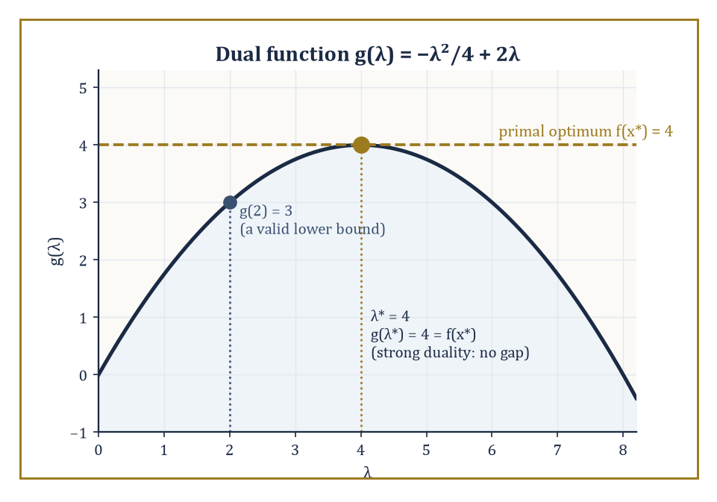
The dual function g(λ) is always concave; here its peak at λ*=4 exactly meets the primal optimum, closing the duality gap to zero.
g(λ) = min_x L(x,λ) = min_x [f(x) − Σλᵢgᵢ(x)]
Weak duality is almost embarrassingly easy to prove and holds always, convex or not: for any feasible x and any λ≥0,
g(λ) ≤ f(x)
because at a feasible x the subtracted terms −λᵢgᵢ(x) are all ≥0. So g(λ) is a lower bound on the true minimum for every choice of λ≥0 — and maximizing g over λ (the dual problem) hunts for the best such bound.
Strong duality — the dual's best bound exactly equals the primal's true minimum, with zero gap — holds for convex problems under a mild regularity condition (Slater's condition: some point strictly satisfies all inequality constraints).
When it holds, solving the dual is exactly as good as solving the primal, and often computationally cheaper or more naturally decomposable; and when a candidate (x,λ) satisfies stationarity and complementary slackness, that pair is a certificate of optimality checkable in a fraction of the time it took to find it.
It is worth dwelling on why this works at all: g(λ) is a minimum of a family of functions of x, and a pointwise minimum of a family of (affine-in-λ) functions is always concave in λ, whatever the convexity or otherwise of the original f — so the dual problem, maximize g(λ) over λ≥0, is always a concave maximization, hence itself a convex-flavoured (and typically easier) problem, even when the primal is not convex at all.
Duality, in other words, is not merely a bookkeeping trick; it manufactures a well-behaved problem out of a possibly ill-behaved one, at the cost of only ever giving you a bound rather than an answer, unless strong duality happens to close the gap.
Numeric example — Worked example: weak and strong duality for a one-variable convex program. Minimize f(x) = x² subject to x ≥ 2 (rewritten as 2−x ≤ 0). The Lagrangian is as follows.
L(x,λ) = x² − λ(x−2) = x² − λx + 2λ
The dual function is g(λ) = min_x [x² − λx + 2λ]; setting the x-derivative to zero, 2x−λ=0, gives x=λ/2, and substituting back:
g(λ) = (λ/2)² − λ(λ/2) + 2λ = λ²/4 − λ²/2 + 2λ = −λ²/4 + 2λ
Check weak duality first at an arbitrary λ=2:
g(2) = −4/4+4 = 3
Indeed 3 is a valid lower bound: the true minimum, at x*=2, is f(2)=4, and 3 ≤ 4 as weak duality promises.
Now maximize g over λ≥0: dg/dλ = −λ/2+2=0 gives λ*=4, and
g(4) = −16/4+8 = 4
— exactly matching the primal optimum. Strong duality holds (the problem is convex, and x=3 strictly satisfies x>2, so Slater's condition is met), and λ*=4 together with x*=2 is a complete, checkable certificate: no cleverer feasible x could possibly beat f=4, because the dual has just proved a matching lower bound.
In linear and conic programming the dual is, happily, an explicit optimization problem in the same class as the primal (a linear program's dual is another linear program, as Room 30.2 showed; a semidefinite program's dual is another semidefinite program), so 'solve the dual' is a genuine, practical alternative rather than an abstract existence statement.
In combinatorial optimization, where integrality typically destroys strong duality (a gap persists between the best achievable bound and the true integer optimum — the integrality gap), weak duality survives regardless and becomes the engine of every branch-and-bound method: solve a relaxation (drop the integrality requirement, or drop some hard constraints) to get a bound, and use that bound to prove — without ever examining most of the exponentially many candidate solutions — that huge swathes of the search space cannot possibly contain anything better than the best integer solution found so far.
Numeric example — Worked example: an LP-relaxation bound for a small knapsack problem. A thief has a sack of capacity 50 and three items: A (value 60, weight 10), B (value 100, weight 20), C (value 120, weight 30) — each either taken whole or left behind (a 0/1 knapsack). Relax the 0/1 requirement to 0≤(fraction taken)≤1 — a linear program, dropping the combinatorial structure entirely.
The greedy LP-optimal fills by value-per-weight ratio: A (6/unit), then B (5/unit), then C (4/unit). Take A fully (weight 10, value 60, 40 remaining); take B fully (weight 20, value 100, 20 remaining); take 20/30 of C, computed as follows:
120×2/3 = 80
LP-relaxation value:
60+100+80 = 240
— an upper bound on any 0/1 solution, since the 0/1 feasible set sits inside the fractional one. Compare against the true integer optimum: checking combinations under weight 50, B+C (weight 50, value 220) beats A+B (weight 30, value 160) and A+C (weight 40, value 180); A+B+C exceeds capacity. True optimum: 220.
The LP bound (240) does not equal the true optimum (220) — an integrality gap of 20 — but it proves, instantly and without checking a single explicit combination, that nothing scores above 240, exactly the kind of certificate branch-and-bound uses to prune a search tree, as Room 30.7 now demonstrates on this very example.
This is the real payoff of duality, and it is worth stating plainly: an algorithm that merely returns 'here is my best answer' asks you to trust it; an algorithm that returns a primal solution together with a matching, or provably close, dual bound asks for no trust at all, because the gap between the two is itself a certificate you can check by hand, in time far shorter than it took to solve the problem.
This is what separates optimization as engineering from optimization as an act of faith — and it is why a well-written solver reports not just 'optimal value: 36' but also the dual variables that prove it, the way a well-written proof does not merely assert a theorem but exhibits the construction that makes it undeniable.

Room 30.7: Integer and Combinatorial Optimization
Where the Continuous World’s Tricks Mostly Stop Working
Integer linear programs (ILPs) require some or all decision variables to be integers — a single word, ‘integer’, that converts a problem solvable in polynomial time into one that is, in the worst case, NP-hard, meaning informally (a proper technical treatment awaits many storeys hence) that no algorithm known to humanity solves every instance in time bounded by a polynomial in the input size, and most complexity theorists suspect none exists.
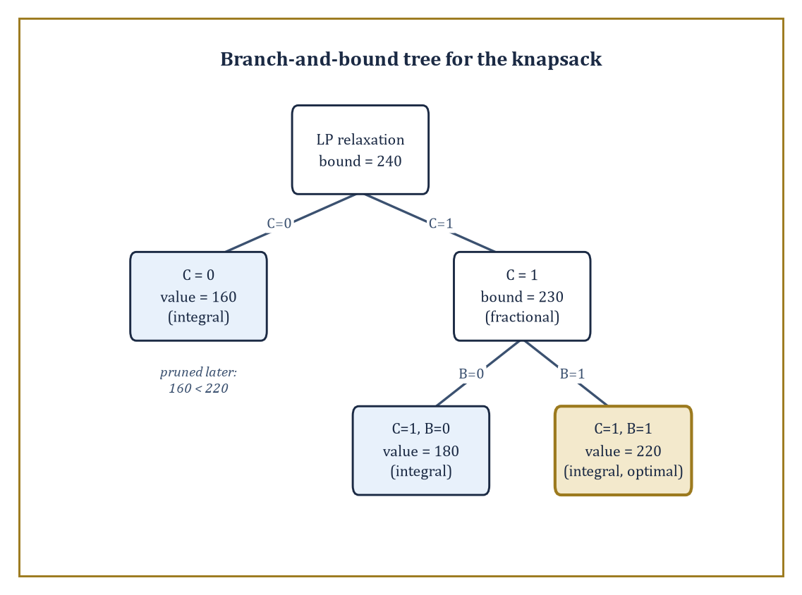
Four subproblems, not eight combinations: the knapsack's branch-and-bound tree, each bound doing the pruning the exhaustive search never needed.
Branch-and-bound is the standard weapon: solve the LP relaxation (Room 30.6’s trick — drop integrality, solve the continuous problem); if the relaxed solution happens to be integral already, you are done. If not, pick a variable with a fractional value, say xⱼ=2.4, and branch into two subproblems:
xⱼ ≤ 2
xⱼ ≥ 3
Each of the two subproblems is then solved recursively in the same way.
Bound each subproblem by its own LP relaxation value, and prune — discard without further branching — any subproblem whose bound is no better than the best integer solution found so far; the entire efficiency of the method rests on how quickly bounds allow whole branches to be pruned unexamined.
Branch-and-cut supplements this with cutting planes: additional valid inequalities, satisfied by every integer point but violated by the current fractional relaxed solution, added on the fly to tighten the relaxation and shrink the gap before branching at all.
The strength of the relaxation matters enormously in practice: a badly chosen formulation of the same underlying problem can leave the LP relaxation bound miles from the true integer optimum (a large integrality gap, forcing branch-and-bound to explore a vast tree before it can prune anything), while a cleverer formulation — often found by adding valid inequalities that are individually obvious but collectively tightening — can shrink that gap dramatically, sometimes closing it entirely, before a single branch is taken.
Good heuristics that find strong feasible incumbents early play a complementary role, since a good incumbent value is precisely what allows the bounding step to prune aggressively.
Numeric example — Worked example: branch-and-bound solving the Room 30.6 knapsack. Recall the knapsack — A(60,10), B(100,20), C(120,30), capacity 50 — with LP-relaxation bound 240 (fractional at C=2/3). Branch on the fractional item C.
Branch C=0: remaining items A,B fit entirely (weight 30 ≤ 50) — already integral.
value = 60 + 100 = 160
This is a feasible incumbent.
Branch C=1 (weight 30, value 120, capacity remaining 20): relax A,B by ratio — A fully (weight 10, value 60, 10 remaining), then B at 10/20=0.5 (value 50).
bound = 120 + 60 + 50 = 230
Since 230 > 160, this branch is not yet pruned, and since it is still fractional, it must be branched again.
Sub-branch C=1,B=0: capacity 20 available, take A fully — integral.
value = 120 + 60 = 180
This is a new incumbent (it beats 160).
Sub-branch C=1,B=1: capacity is exhausted, so A is excluded — integral.
weight = 30 + 20 = 50
value = 120 + 100 = 220
This is a new incumbent (it beats 180).
All branches are now integral and exhausted, so the search tree is complete and the certified optimum is 220 — matching the exhaustive answer of Room 30.6, but reached here by examining only four subproblems rather than every one of the 2³=8 possible 0/1 combinations.
Each pruning decision was backed by an LP bound proving the discarded branch could not possibly contain anything better.
Some combinatorial problems, despite looking superficially like generic integer programs, possess enough hidden structure to admit fast, purpose-built polynomial-time algorithms that never touch branch-and-bound at all: shortest path (Dijkstra’s algorithm, and its relatives for negative weights), maximum matching in a graph, and network flow (Room 30.2’s special case, solvable by augmenting-path or push-relabel methods) are the classical success stories, each exploiting a specific combinatorial property — no negative cycles; bipartite or general graph structure; the max-flow-min-cut duality — that a generic ILP solver would never discover on its own.
Other problems — the travelling salesman problem (TSP), set cover, and most of their relatives — are provably NP-hard, with no such shortcut known, and for these, approximation algorithms trade exactness for a provable performance guarantee: an algorithm that runs in polynomial time and is guaranteed to return a solution within some fixed factor (a constant multiple, or 1+ε for any desired ε) of the true optimum, without ever needing to find that optimum exactly.
Numeric example — Worked example: how fast the exact TSP search space explodes. The travelling salesman problem on n cities has the following number of distinct tours (fixing a starting city removes redundant rotations, and dividing by 2 removes each tour’s mirror image):
number of tours = (n−1)!/2
For n=10, this works out to a number checkable by a patient computer in well under a second:
9!/2 = 362,880/2 = 181,440
For n=20, however, the number explodes:
19!/2 = 121,645,100,408,832,000/2 = 60,822,550,204,416,000 ≈ 6.08×10¹⁶
At a billion tours checked per second, that works out to roughly 6.08×10⁷ seconds, the better part of two years, spent on nothing but a single ten-city upgrade.
Adding a mere ten cities has not made the problem ten times harder, or even a hundred times harder, but roughly 335 billion times harder — the practical face of NP-hardness, and exactly the kind of growth that separates ‘solve it exactly and go home’ from ‘settle for an approximation algorithm, and be grateful one exists.’
The boundary between what is polynomially solvable (shortest path, matching, flow, linear programming itself) and what is NP-hard (TSP, general integer programming, set cover) is not a minor technical footnote — it is arguably the central organizing question of theoretical computer science, formalized as the P versus NP problem, one of the seven Clay Millennium Prize problems and, at time of writing, entirely unresolved despite the collective effort of several generations of extremely clever, occasionally sleep-deprived people.
For the working optimizer, the practical lesson is more modest but no less important: recognizing which side of this boundary your problem sits on tells you, before you write a line of code, whether to reach for an exact polynomial algorithm, brace for exponential worst-case behaviour tamed only by good bounds and heuristics, or settle deliberately for a provably near-optimal approximation.
It also explains why so much of algorithm design, in practice, is not about inventing cleverer search strategies but about finding the right relaxation or the right structural reformulation that moves a problem, or at least a useful approximation of it, from the hard side of the boundary to the tractable one.

Room 30.8: Derivative-Free, Stochastic, and Large-Scale Methods
When You Can’t (Or Shouldn’t) Compute the Gradient
Every method met so far has assumed access to a gradient, computed cheaply and exactly.
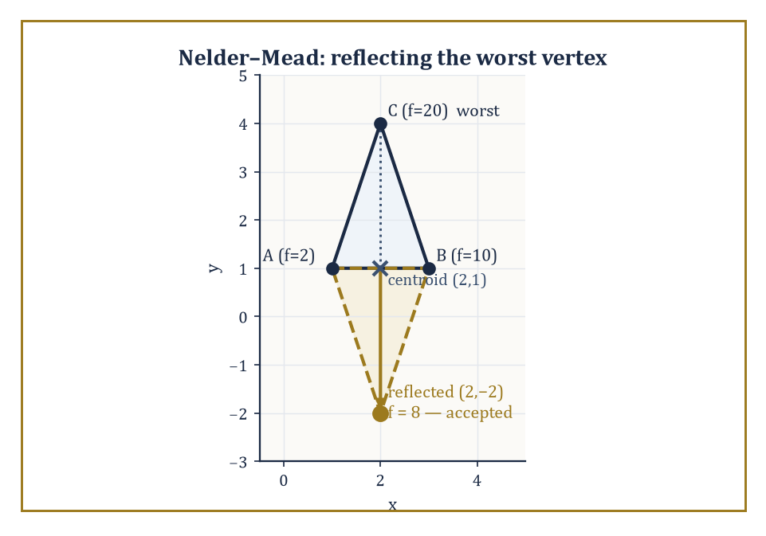
Nelder–Mead reflects the worst vertex C through the centroid of A and B, landing at f=8 and replacing C outright — no derivative in sight.
That assumption fails constantly in practice: the objective might come from a black-box simulation, a physical experiment, or someone else’s undocumented legacy code, with no derivative in sight. Derivative-free methods manage with function values alone.
The Nelder–Mead simplex method maintains n+1 points forming a simplex (a triangle in 2D, a tetrahedron in 3D) and, at each step, reflects the worst point through the centroid of the remaining points, accepting the reflection if it improves things and falling back to more conservative moves (contraction, shrinkage) if it does not — a purely geometric, gradient-free hill-descending dance.
Pattern search methods poll a fixed set of directions around the current point and move to the first (or best) improving one found. Model-based trust-region methods build a local quadratic (or simpler) surrogate from a modest number of function evaluations and minimize that surrogate instead, refitting as they go.
Bayesian optimization goes further, building a full probabilistic surrogate (typically a Gaussian process) that models both a best guess and an uncertainty estimate at every unvisited point, then chooses the next expensive evaluation to balance exploiting the current best region against exploring where uncertainty is high — the method of choice for genuinely expensive black-box evaluations (a physical experiment costing a day per run, a hyperparameter search costing a GPU-week per run) in low dimension, where a Gaussian process remains tractable.
Numeric example — Worked example: one Nelder–Mead reflection step. Minimize f(x,y) = x²+y² using a Nelder–Mead simplex with current vertices A=(1,1) [f=2], B=(3,1) [f=10], C=(2,4) [f=20]. C is worst.
Compute the centroid of the remaining two vertices:
centroid = ((1+3)/2, (1+1)/2) = (2,1)
Reflect C through the centroid with the standard coefficient 1:
x_reflect = centroid + (centroid − C) = (2,1) + ((2,1)−(2,4)) = (2,1) + (0,−3) = (2,−2)
Evaluate:
f(2,−2) = 4+4 = 8
Since 8 beats the worst vertex it replaces (20) — indeed beats the second-worst, B, at 10 as well — the reflection is accepted outright (a plain ‘reflection’ move, as opposed to the more aggressive ‘expansion’ that would be tried next had 8 also beaten the best vertex A’s 2). The new simplex is A=(1,1)[2], B=(3,1)[10], and the reflected point (2,−2)[8], and the whole process repeats — no derivative was consulted at any point, only three function evaluations.
At the opposite extreme from expensive black boxes sit problems with cheap but astronomically numerous gradient contributions — the defining situation of machine learning, where the objective is a sum (or average) over millions of training examples, and computing the exact gradient means touching every single one.
Stochastic gradient descent (SGD) sidesteps this by estimating the gradient from a single randomly chosen example (or a small mini-batch) at each step: cheap, noisy, and — remarkably — still guaranteed to converge, not because any individual step is trustworthy, but because the noise averages out over many steps, giving convergence in expectation (the expected distance to the optimum shrinks) or with high probability, rather than the deterministic, monotonic decrease of full-batch gradient descent.
Variance-reduction techniques (SVRG, SAGA, and relatives) periodically anchor the noisy estimate to a full-gradient computation to cut the variance without paying the full cost every step; adaptive step-size methods (AdaGrad, Adam, and their descendants) rescale each coordinate’s step by its own historical gradient magnitude, which helps enormously when different parameters naturally want very different step sizes; mini-batching trades off the cheapness of single-example noise against the smoother estimates of larger batches, and is essentially always used in practice as the compromise.
Numeric example — Worked example: one full-batch step versus two stochastic steps. Minimize f(w) = (1/2n)Σᵢ(w−aᵢ)² over the three data points a = {1,3,5}, n=3.
This is minimized at the sample mean:
w* = (1+3+5)/3 = 3
Full-batch gradient at w₀=0:
∇f(0) = (1/3)[(0−1)+(0−3)+(0−5)] = (1/3)(−9) = −3
A full-batch step with learning rate 1:
w₁ = 0 − 1·(−3) = 3
— the exact minimizer, in one step (an artifact of f being a simple quadratic average, as in Room 30.3’s Newton example). Now the stochastic version, using one randomly drawn sample per step: suppose the first draw is a=1:
stochastic gradient estimate = (w₀−1) = −1
(only this one term, not the average). Step:
w₁ = 0−1·(−1) = 1
— an under-shoot, because sample 1 alone pulls toward 1, not the true mean 3. Suppose the second draw is a=5:
stochastic gradient = (w₁−5) = (1−5) = −4
Step:
w₂ = 1 − 1·(−4) = 5
— an over-shoot past the true mean. The path 0→1→5 bounces noisily around the true optimum 3 rather than marching straight to it, yet its expected behaviour over many more such random draws does converge on 3 — precisely ‘convergence in expectation’.
When a problem’s data or variables genuinely do not fit on one machine, or when updating all variables simultaneously is wasteful, further tricks apply.
Coordinate descent updates one variable (or one block of variables) at a time, holding all others fixed, cycling through the coordinates repeatedly — trivially parallelizable across variables when they interact weakly, and often exact after a single pass when the problem happens to be separable.
Distributed and parallel algorithms (of which the ADMM of Room 30.5 is a natural fit, since its subproblems already decouple) spread both data and computation across many machines, communicating only the small quantities (gradients, dual variables) needed to keep everyone synchronized rather than the raw data itself.
Sketching techniques compress a large problem (a huge matrix, an enormous dataset) into a much smaller random projection that provably preserves the quantities the optimization actually needs, trading a controlled, quantifiable amount of accuracy for a dramatic reduction in the size of the problem actually solved — skimming a very long document on the strength of a mathematical guarantee that the gist survives, rather than on faith alone.
Numeric example — Worked example: coordinate descent solving a separable problem in one cycle. Minimize f(x,y) = (x−1)² + (y−2)², starting from (0,0) — deliberately separable, to see coordinate descent’s best-case behaviour.
Step 1: fix y=0, minimize over x alone:
d/dx (x−1)² = 2(x−1) = 0 ⟹ x=1
New point: (1,0).
Step 2: fix x=1, minimize over y alone:
d/dy (y−2)² = 2(y−2) = 0 ⟹ y=2
New point: (1,2) — the exact global minimum, reached after a single full cycle through the two coordinates. This is the best case, guaranteed whenever the objective is separable (no cross-terms coupling x and y); a non-separable objective, such as (x−1)² + (y−2)² + xy, would instead need many cycles, each nudging both coordinates a little closer, since fixing one variable now genuinely changes the optimal value of the other.

Room 30.9: Looking Ahead: From Algorithms to Advanced Optimization and Applications
We Have Learned to Compute the Best
We have now acquired the algorithmic core of optimization: linear programming and its duality (Room 30.2), unconstrained smooth methods from gradient descent to Newton (Room 30.3), constrained methods built on penalties, barriers, and the Lagrangian (Room 30.4), the specialized machinery convexity unlocks (Room 30.5), duality as a certificate-producing habit of mind rather than a mere theoretical nicety (Room 30.6), the combinatorial world of integer programming and its complexity boundary (Room 30.7), and the derivative-free and stochastic methods that scale to expensive or enormous problems (Room 30.8).

An equal blend of two uncorrelated assets carries less risk than either asset alone — diversification, computed rather than merely asserted.
Between them, these cover the overwhelming majority of optimization problems anyone actually solves for a living. Notice, in retrospect, how much of the storey has been one idea wearing different hats: exploit whatever structure the problem hands you — linearity, convexity, separability, sparsity, cheap-but-noisy gradients — and let that structure choose the algorithm, rather than reaching by habit for the one method you happen to know best.
A hammer is a fine tool, but a linear program is not a nail, and neither, for that matter, is a semidefinite one.
These tools support applications across the whole of science and engineering, and it is worth naming a few explicitly, if only to watch the same handful of algorithmic ideas recur under different costumes.
Portfolio optimization (choose asset weights to balance expected return against risk) is a quadratic program, solved by the interior-point or first-order methods of Room 30.5.
Structural design (choose a beam’s cross-section, or a truss’s topology, to minimize weight subject to stress and deflection limits) is a constrained nonlinear program, often nonconvex, leaning on Room 30.4’s SQP or interior-point machinery.
Machine learning training is large-scale, usually nonconvex, unconstrained (or lightly constrained) optimization, overwhelmingly solved by the stochastic gradient methods of Room 30.8.
Control (choose a sequence of actions to steer a system toward a target while respecting physical limits) frequently reduces to solving a fresh, small quadratic program at every time step — model predictive control is, quite literally, Rooms 30.2 and 30.5’s machinery run in a tight loop, thousands of times a second, on hardware small enough to sit inside a car.
Logistics (route vehicles, schedule staff, plan supply chains) is typically integer or mixed-integer programming, Room 30.7’s domain, at industrial scale.
And statistics — maximum likelihood estimation, regularized regression, the LASSO of Room 30.5’s proximal-gradient example — is optimization wearing yet another hat.
A later storey, Storey 48, picks up the advanced and unfinished business this one has had to leave aside: nonconvex landscape analysis (why, empirically, large neural networks train at all, despite Room 30.3’s guarantees covering only local behaviour), stochastic programming (optimizing under genuine uncertainty about future data, not just noisy gradients), robust optimization (guarding against the worst case within an uncertainty set rather than merely the expected case), multi-objective optimization (there is no single ‘best’ when two goals genuinely conflict, only a frontier of trade-offs), and the still-developing interface between optimization theory and the empirical successes of machine learning.
In practice almost none of this is coded up from scratch: modelling languages and solvers (CVX, JuMP, Gurobi, IPOPT, and their many relatives) turn the algorithms of this storey into everyday working tools, letting a user write down a model in something close to mathematical notation and leave the choice of algorithm to decades of accumulated engineering.
Numeric example — Worked example: a two-asset portfolio, minimizing risk for a target return. Two assets: expected returns 8% and 12%, standard deviations 20% and 30% (variances 0.04 and 0.09), assumed uncorrelated for simplicity (covariance 0). Choose weights w₁ and w₂, constrained to sum to one, to achieve a target expected return of 10% at minimum variance:
w₁+w₂=1
The return constraint sets the weighted average return to the 10% target:
8w₁+12w₂=10
Substituting w₁=1−w₂ and solving:
8(1−w₂)+12w₂=10 ⟹ 8+4w₂=10 ⟹ w₂=0.5
So w₁=0.5 too — an equal split.
Portfolio variance, with no covariance term since correlation is zero, works out to:
w₁²(0.04)+w₂²(0.09) = 0.25(0.04)+0.25(0.09) = 0.01+0.0225 = 0.0325
This gives a portfolio standard deviation of √0.0325 ≈ 18.03% — notably less than either asset’s own standard deviation (20% and 30%), the entire point of diversification made numerically explicit: combining two imperfectly related risks can reduce total risk below what either asset offers alone, and finding exactly how much to combine is, mechanically, nothing more than the quadratic programming of Room 30.5.
The deeper lesson, if this storey has one, is that a well-modelled optimization problem, paired with an algorithm that exploits its structure, converts a design or decision question — what should I build, buy, route, or believe — into a computation whose result can actually be trusted, checked, and in the best cases certified beyond reasonable doubt.
That is no small thing to have built, and it is worth remembering how recent most of it is: the simplex method is younger than the transistor, interior-point methods for linear programming are younger than the personal computer, and stochastic gradient descent — a technique now training models with hundreds of billions of parameters — was, for most of its history, a mathematical curiosity used to fit rather modest statistical models.
An entire computational discipline, still visibly under construction.
Optimization is the computational engine of decision-making under constraints — which, on reflection, describes rather a lot of what a life consists of.
So ends our tour of finding the best answer efficiently — vertex by vertex, gradient step by gradient step, branch by pruned branch, always accompanied, where we could manage it, by a certificate proving we were right rather than merely lucky.
Storey 31 climbs into differential geometry, and the change of scenery is more relevant to everything we have just done than it might first appear. Every gradient we followed this storey lived quietly in flat Euclidean space, where ‘downhill’ needs no further justification. On a curved manifold, that convenience evaporates: ‘downhill’ first needs a metric before it means anything at all, and the natural generalization of gradient descent — as any student of modern statistics or robotics eventually discovers, usually the hard way — has to account for a curvature the naive Euclidean version was blithely ignoring all along. The tower continues upward, and the ground, it turns out, was never quite as flat as we assumed.

Storey 31: Differential Geometry
Curves, Surfaces, Curvature, and the Art of Geometry by Calculus
Storey Thirty comes down, at last, to a single ruthless instruction: find the bottom. Convex functions, Lagrange multipliers, gradient descent trudging downhill like a man late for a meeting he doesn't want to attend — all of it in service of one question, where is the minimum? It is a fine question, and we answered it with some rigour. But notice what it never asked. It never asked what shape the hill was. It assumed the landscape and hunted for its lowest point; it did not once ask whether the landscape itself was curved, and if so, by how much, and whether a beetle living on it could work that out without ever being allowed to climb out and look.
That is the question this storey exists to answer. Differential geometry takes the calculus we have spent thirty storeys building — derivatives, integrals, vectors, the whole apparatus — and points it not at functions of a real variable but at curves and surfaces themselves, treating shape as something you can differentiate. Euclidean geometry, two millennia ago, studied rigid figures with a ruler and a compass, the sort of thing you could draw and then simply admire. Analytic geometry, several storeys back in this Tower's foundations, described the same figures with coordinates and equations, so that a circle became x² + y² = r² and a parabola became something you could plug numbers into. Differential geometry does something rather more ambitious: it asks how curves and surfaces bend, and it insists on measuring that bending with the exact same machinery — tangent vectors, derivatives, integrals — that has carried us this far up the Tower.
The single most startling discovery in the whole subject, and the one this storey is quietly organised around, is that a great deal of geometry is intrinsic — measurable from inside, without ever needing to know how, or whether, the surface sits inside some larger space. A sufficiently clever and sufficiently patient insect, confined forever to the surface of a sphere, can determine that it is not living on a flat plane purely by taking measurements along the surface itself, never once being permitted to fly up and look down from outside. That fact is not a curiosity. It is the seed from which Riemannian geometry, and eventually Einstein's picture of gravity as curved spacetime, will grow. We will spend this storey building the classical machinery — curves, the Frenet–Serret frame, the first and second fundamental forms, geodesics, and the extraordinary Gauss–Bonnet theorem — that makes that insect's discovery precise.
A small professional confession before we start: differential geometry is the subject in which computation and insight are most uncomfortably intertwined. The formulas look baroque on first encounter — a jungle of E's, F's, G's and Christoffel symbols with more indices than a bureaucrat's filing system — until the moment you see what they are actually measuring, at which point they become, all at once, obvious. We will try to reach that moment as often as possible, and to show our working every single time we get there. The next storey up concerns Topology, which will ask what survives when you throw all these lovingly computed curvatures away and keep only the shape's coarsest, most stubborn features; today we are still interested in the fine print. Let's compute some curvature.

Room 31.1: What Differential Geometry Actually Is
In which we discover that geometry can be done without ever standing outside it
Differential geometry, stated plainly, is the study of geometric objects using the tools of differential and integral calculus. In its classical guise — the one this storey mostly inhabits — the geometric objects are curves and surfaces sitting inside ordinary three-dimensional Euclidean space ℝ³, the space you and your coffee mug occupy.
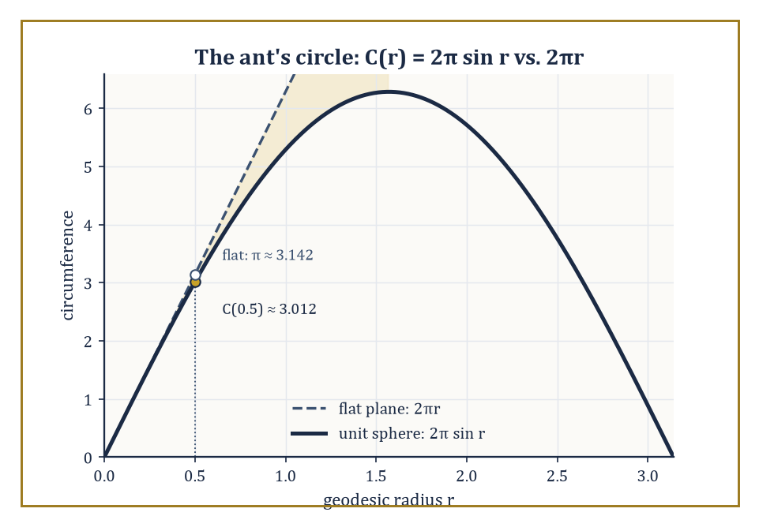
The ant's rope traces C(r) = 2π sin r on the sphere, falling short of the flat-plane prediction 2πr — a shortfall measured entirely from within.
In its modern guise, which later storeys will unveil, the objects are manifolds: spaces that locally resemble ℝⁿ but need not sit inside any larger space at all, equipped with extra structure such as a Riemannian metric, a connection, or a symplectic form.
Do not worry yet about what those words mean; this storey builds the classical case so thoroughly that the modern generalisation, when it arrives, will feel less like a leap and more like a shrug.
The subject is organised around one relentless question, asked in several disguises throughout the storey: which properties of a curved shape can be detected by measurement alone, and which require you to step outside and look?
A property is called intrinsic if an inhabitant confined to the surface — measuring distances, angles, and areas using only paths that stay on the surface — can determine it. A property is extrinsic if it depends on how the surface happens to be sitting inside the ambient space.
The central and rather startling discovery of this storey, due mostly to Gauss, is that curvature — the very thing you would swear requires standing outside a shape to see it bend — is, properly defined, intrinsic. We will prove this precisely in Room 31.8, under the magnificent name Gauss gave his own theorem: Theorema Egregium, Latin for 'remarkable theorem', which is either admirable restraint or immodesty so complete it wraps around into humility; historians disagree.
Here is the flagship illustration, in numbers, before we have defined a single piece of formal machinery. Imagine an ant standing on the surface of a sphere of radius 1 (any convenient unit — call it a very large beach ball).
The ant walks outward along the surface, in every direction simultaneously, to a fixed geodesic distance r from its starting point — think of it as tracing out a circle by walking a rope of length r taut along the surface and pivoting. On a flat plane, that procedure produces a circle of circumference exactly 2πr, as everyone learns in school. On the sphere it does not, and the size of the shortfall is a direct, measurable signature of curvature.
Numeric example — The ant's shortfall. Take r = 0.5 (half the sphere's radius) on the unit sphere. The circumference actually traced out by the ant's rope is given by the following formula, which we will derive properly once the first fundamental form is in hand (Room 31.4) — for now simply evaluate it.
C(r) = 2π sin(r)
Since sin(0.5 radians) ≈ 0.47943, we get:
C(0.5) = 2π × 0.47943 ≈ 3.0123
Compare this to the flat-plane prediction:
2π × 0.5 = π ≈ 3.1416
The ant's measured circumference falls short by about 0.129 — roughly four per cent — and that shortfall is entirely computable from measurements the ant made without ever leaving the surface. No flight required, no view from outside, just a very patient ant with a rope and a talent for arithmetic. That the shortfall is a reliable, repeatable, computable quantity — and that it grows as the sphere gets more tightly curved — is the entire content of Gaussian curvature stated informally, and unpacking it properly is most of what this storey does.
Not every curvature-flavoured quantity is intrinsic, and telling the two kinds apart early will save considerable confusion later. Consider the equator of that same unit sphere, traced as a curve in three-dimensional space.
As a space curve it bends rather sharply — its curvature, in the sense Room 31.3 will define precisely, is 1, the tightest a curve of that particular radius can manage. But as a curve confined to the surface of the sphere, the equator is perfectly straight in the only sense available to an inhabitant: it is a geodesic, and its geodesic curvature — the part of its bending that the surface itself can detect — is exactly 0.
The difference between these two numbers is the entire distinction between extrinsic bending (how the curve looks from outside, embedded in space) and intrinsic bending (how much the curve deviates from straightness according to measurements taken along the surface). We will make both notions rigorous in Rooms 31.3 and 31.6; for now, file away the fact that a curve can be dramatically curved in space while being perfectly straight according to anyone actually standing on it.
Abstract example — The flight to Vancouver. A commercial airliner flying from London to Vancouver along the shortest available route does not fly in a straight line on the map — it curves alarmingly northward, arcing up over Greenland, which looks to a passenger glancing at the in-flight map like a wild detour.
To the pilot's instruments, however, the aircraft is flying as straight as physically possible: it is following a geodesic of the Earth's surface, a great-circle route, exactly analogous to the equator above. The 'curve' visible on a flat map is an artefact of extrinsic curvature — the sphere's shape as seen from outside, distorted further by the map projection — while the geodesic curvature actually experienced by the flight is zero throughout.
This is not a metaphor; it is the literal reason transatlantic and transpacific flight paths look bent on a Mercator projection while being, in the geometry that actually matters to the aircraft, dead straight.
Differential geometry is therefore best understood as a direct continuation of the multivariable calculus developed many storeys ago, redirected at geometric objects rather than at scalar-valued functions, and it is simultaneously the foundation on which modern geometry, geometric analysis, and — several storeys hence — general relativity are built. Everything from here on is an attempt to make the ant's discovery, and the pilot's straight-but-curved flight path, completely precise.

Room 31.2: Curves in the Plane and in Space
Where speed becomes irrelevant and shape becomes everything
Everything in this storey begins with the humble parametric curve: a smooth map r(t) from an interval of real numbers into the plane ℝ² or into space ℝ³, thought of as tracing out a path as the parameter t increases, the way a satellite's position traces a path as time passes.
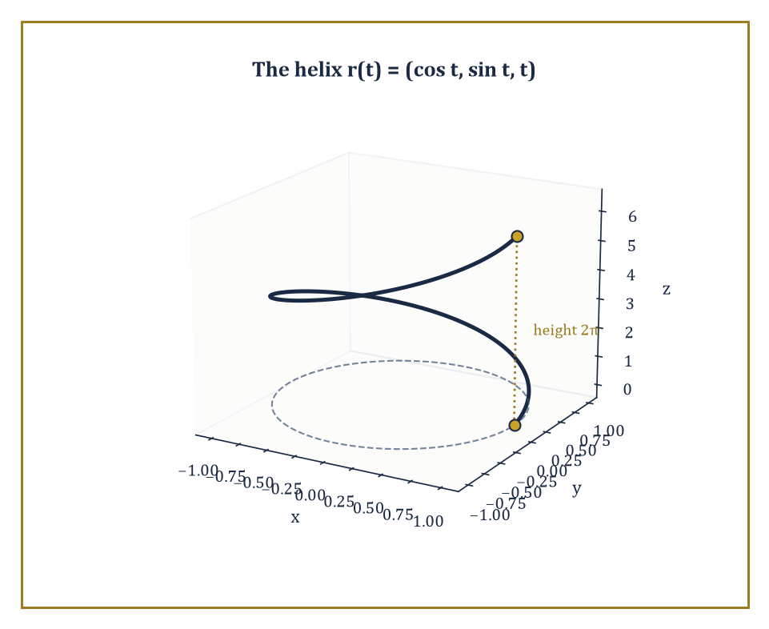
One full turn of the helix r(t) = (cos t, sin t, t), climbing a height of 2π while circling the unit circle below.
We insist the curve be regular, meaning its velocity r′(t) never vanishes — the tracing object never simply stops dead. This is not pedantry: a curve with a vanishing derivative can develop a sharp corner or a cusp at that instant (think of the path traced by a point on the rim of a rolling wheel, which momentarily stops and reverses at the point of contact with the ground), and the smooth theory of curvature we are about to build requires there to be no such stopping points.
The parameter t itself, however, is largely bookkeeping — an artefact of how you happened to describe the curve, not a property of the curve's shape. Two different people could trace an identical circle at wildly different speeds, one crawling and one sprinting, and produce the same geometric object.
To strip away this arbitrary choice, we reparametrize by arc length: we replace t by the distance s already travelled along the curve, defined by
s(t) = ∫[t₀, t] |r′(u)| du
and rewrite the curve as a function of s instead. The payoff is that the reparametrized curve automatically has unit speed,
|dr/ds| = 1
everywhere — because by construction you have travelled exactly one unit of curve-distance for every unit increase in s.
This unit-speed form is the standard costume the curve wears for the rest of the theory: once a curve is parametrized by arc length, its unit tangent vector T = dr/ds is genuinely a unit vector, and its rate of change dT/ds measures curvature directly, with no leftover speed factors cluttering the formula.
Numeric example — Arc length of a helix. Consider the circular helix
r(t) = (cos t, sin t, t), t ∈ [0, 2π]
a point spiralling once around the unit circle while climbing steadily upward, tracing out one full turn of a spring. Its velocity is
r′(t) = (−sin t, cos t, 1)
and its speed is
|r′(t)| = √(sin²t + cos²t + 1) = √(1 + 1) = √2
a constant — this particular helix happens to move at the same speed throughout, which is convenient but not typical. The arc length of one full turn is therefore
s = ∫₀^{2π} √2 dt = 2π√2 ≈ 8.886
Note that this is longer than the 2π ≈ 6.283 you would get from just going around the underlying unit circle in the plane — entirely sensible, since the helix has to climb a height of 2π on top of going around, and √2 > 1 is exactly the factor by which the climbing lengthens the path. To reparametrize by arc length we would write
s = t√2, i.e. t = s/√2
and substitute; we shall spare the reader the resulting expression and simply note that it exists and behaves exactly as promised.
Once a plane curve is unit-speed, its curvature is defined as the signed rate at which its unit tangent vector turns:
κ(s) = dφ/ds
where φ is the angle the tangent makes with a fixed direction, or equivalently the scalar κ such that
dT/ds = κN
for the unit normal N obtained by rotating T through a right angle.
For a curve given in an arbitrary, not necessarily unit-speed, parametrization (x(t), y(t)), the same quantity is computed by the formula
κ = (x′y″ − y′x″) / (x′² + y′²)^{3/2}
which looks less inevitable than it is: it is simply the arc-length formula run through the chain rule to strip out the speed dependence, so that curvature — a genuinely geometric quantity — comes out the same regardless of how fast you happened to be tracing the curve.
Numeric example — Circle and parabola. For a circle of radius R traced as
r(t) = (R cos t, R sin t)
we have
x′ = −R sin t, y′ = R cos t, x″ = −R cos t, y″ = −R sin t
Then:
x′y″ − y′x″ = (−R sin t)(−R sin t) − (R cos t)(−R cos t) = R²sin²t + R²cos²t = R²
(x′² + y′²)^{3/2} = (R²)^{3/2} = R³
So:
κ = R²/R³ = 1/R
exactly — a tight little circle of radius 1 has curvature 1, while a lazy circle of radius 100 has curvature 0.01, confirming the intuitive fact that curvature is the reciprocal of the radius of the best-fitting circle, and that gentler bends have smaller curvature.
As a second data point, the parabola y = x² at the origin, written as (t, t²), has
x′ = 1, y′ = 2t, x″ = 0, y″ = 2
at t = 0 this gives
κ = (1·2 − 0·0)/(1 + 0)^{3/2} = 2
The parabola at its vertex bends exactly as sharply as a circle of radius 1/2 — which is, incidentally, exactly the osculating circle that best fits y = x² at the origin, a fact you are welcome to verify by drawing it.
For plane curves, curvature alone determines the shape completely: the fundamental theorem of plane curves states that a prescribed continuous curvature function κ(s) determines the curve uniquely up to a rigid motion of the plane — there is, up to sliding and turning the picture, exactly one curve with that curvature history.
Closed plane curves carry a further intrinsic accountant, the rotation index — the total number of full turns the tangent vector makes as you traverse the curve once.
Two classical results bound how curvature can behave: Fenchel's theorem says the total absolute curvature of any closed space curve is at least 2π (you cannot close a loop without turning through at least one full revolution somewhere), and the four-vertex theorem guarantees that any simple closed plane curve has at least four points where curvature is locally extreme (an ellipse, for instance, has exactly four such vertices, at the ends of its two axes).
Abstract example — Two circles, one shape. Take two circles of radius 3, one centred at the origin and traced starting at (3,0) going counterclockwise, the other centred at (7,7) and traced starting at (7,10) going counterclockwise. These look like different curves — different starting points, different locations in the plane — but both have the exact same constant curvature function:
κ(s) = 1/3 for all s
The fundamental theorem of plane curves guarantees, correctly, that they are the same curve up to rigid motion: slide the second circle's centre to the origin and it lands exactly on the first, with matching starting point after an appropriate rotation of the parametrization.
This is the theorem's entire content in miniature — curvature is shape, stripped of position and orientation — and it is why no amount of relabelling coordinates can turn a circle into an ellipse: their curvature functions, constant versus periodically varying, are genuinely different.
Space curves have one more trick available to them that plane curves do not: they can leave the plane. A plane curve's shape is captured entirely by κ(s), but a curve wandering through three dimensions can twist out of any given plane, and curvature alone cannot detect this — a helix and a circle can have related curvature behaviour while looking nothing alike, precisely because the helix is climbing out of the plane the circle stays confined to.
Capturing that extra freedom requires a second scalar invariant, torsion, which measures the rate at which the curve departs from planarity. Torsion, together with curvature, will turn out to determine a space curve completely, in exact analogy with the plane case — but building torsion properly requires the full apparatus of the next room, the Frenet–Serret frame, so we leave it dangling here deliberately, as a promissory note.

Room 31.3: The Frenet–Serret Apparatus
Three mutually perpendicular vectors, doing all the work
At every point of a regular space curve with nonvanishing curvature, we can erect a moving orthonormal frame — three mutually perpendicular unit vectors, rigidly attached to the curve, that travel along with it like a tiny cockpit bolted to the curve's leading edge.
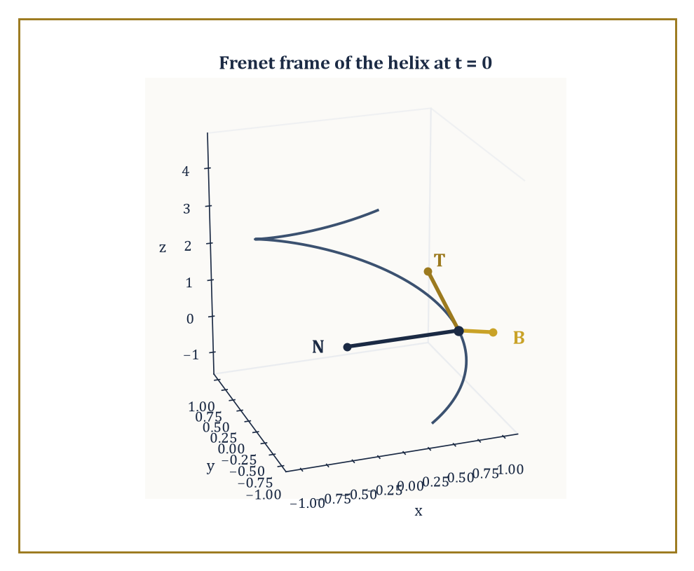
The Frenet frame {T, N, B} of the helix at t = 0, computed exactly in the worked example alongside it.
The first is the unit tangent, already familiar from the previous room, pointing in the direction of travel:
T = dr/ds
The second is the principal normal, pointing in the direction the tangent is turning — the direction, informally, that centripetal acceleration would point if you were riding the curve like a vehicle:
N = (dT/ds)/|dT/ds|
The third is the binormal, perpendicular to both, completing a right-handed frame the way the x, y, and z axes complete each other:
B = T × N
This trio {T, N, B} is called the Frenet frame, and it is the prototype for one of the most powerful ideas in the whole subject: attach a frame to a geometric object and track how the frame itself rotates as you move.
The rate at which this frame rotates is captured by two scalars, curvature κ and torsion τ, through the Frenet–Serret equations:
dT/ds = κN
dN/ds = −κT + τB
dB/ds = −τN
Read them as a statement about spin: the tangent tips toward the normal at rate κ (that is just the definition of curvature restated); the normal tips back toward −T at the same rate κ, but also tips toward the binormal at rate τ; and the binormal tips toward −N at rate τ.
Torsion, precisely, is the rate at which the osculating plane — the plane momentarily containing T and N, the plane the curve is instantaneously flattest against — twists about the tangent direction. A curve confined permanently to a single plane never twists that osculating plane at all, so a plane curve has torsion identically zero — torsion is, quite literally, the measurement of how much a space curve refuses to lie flat.
Numeric example — The Frenet frame of a helix. Return to the helix r(t) = (cos t, sin t, t) from Room 31.2. Since it is not parametrized by arc length, we use the general formulas:
κ = |r′ × r″| / |r′|³
τ = ((r′ × r″) · r‴) / |r′ × r″|²
Compute the derivatives:
r′ = (−sin t, cos t, 1), r″ = (−cos t, −sin t, 0), r‴ = (sin t, −cos t, 0)
The cross product r′ × r″ works out to (sin t, −cos t, 1) — check the k-component alone as a sanity test:
(−sin t)(−sin t) − (cos t)(−cos t) = sin²t + cos²t = 1
which matches. Its magnitude is:
|r′ × r″| = √(sin²t + cos²t + 1) = √2
and we already know |r′| = √2, so |r′|³ = 2√2. That gives:
κ = √2 / (2√2) = 1/2
a constant — this helix bends exactly as sharply everywhere along its length, a pleasant symmetry consequence of the parametrization's own regularity.
For torsion:
(r′ × r″) · r‴ = (sin t, −cos t, 1) · (sin t, −cos t, 0) = sin²t + cos²t + 0 = 1
and |r′ × r″|² = 2, giving:
τ = 1/2
This particular helix, remarkably, has curvature and torsion equal — it bends and twists at exactly matched rates, everywhere, forever.
At t = 0 we can assemble the actual frame. The point is r(0) = (1, 0, 0). The unit tangent is:
T = r′(0)/|r′(0)| = (0, 1, 1)/√2
The binormal is B = (r′ × r″)/|r′ × r″| evaluated at t = 0, which is:
B = (0, −1, 1)/√2
The principal normal follows from N = B × T (to keep the frame right-handed): computing the cross product of (0,−1,1) and (0,1,1) gives (−1−1, 0−0, 0+0) = (−2, 0, 0), and dividing out the two leftover factors of √2 (which multiply to 2) gives:
N = (−1, 0, 0)
exactly — a clean unit vector pointing straight from the point (1,0,0) toward the z-axis, exactly the direction you would expect the curve to be curving toward, since the helix is wrapping around that axis.
As a check, T × N should reproduce B:
(0,1,1)/√2 × (−1,0,0) = (0,−1,1)/√2
which is indeed B. The bookkeeping closes perfectly, which is always a relief in a subject with this many indices.
These two scalar functions turn out to be the entire story: the fundamental theorem of space curves states that any two continuous functions κ(s) > 0 and τ(s), prescribed in advance, determine a space curve uniquely up to a rigid motion of ℝ³. This is the three-dimensional upgrade of the fundamental theorem of plane curves from the previous room, and it says something rather remarkable — that all the infinite variety of possible space curves is secretly indexed by nothing more than two functions of a single real variable.
Existence and uniqueness both follow from standard theorems about ordinary differential equations, applied to the Frenet–Serret system itself: given κ and τ as data, the Frenet equations become a linear system of ODEs for T, N, B, which has a unique solution once initial values are fixed, and integrating T then recovers the curve r(s) itself.
Abstract example — The general helix. Consider the general circular helix
r(t) = (a cos t, a sin t, bt), a > 0
of which our worked example above was the special case a = b = 1. A short computation, entirely parallel to the one above, gives constant curvature and torsion:
κ = a/(a² + b²), τ = b/(a² + b²)
Plugging in a = b = 1 recovers κ = τ = 1/2 exactly as computed. Because these are constant, the fundamental theorem tells us something strong: any space curve whatsoever with constant positive curvature and constant torsion must be a circular helix of this form (or, in the degenerate case τ = 0, simply a circle) — there is no other shape available to it.
This is the payoff of the fundamental theorem in practice: two numbers, held constant, pin down the geometry completely, without needing to solve a single differential equation by hand.
The Frenet frame is the first instance, but by no means the last, of a moving frame — an orthonormal basis attached to a geometric object and differentiated to reveal its bending. The same idea, generalized, reappears attached to surfaces (the Darboux frame, quietly at work in Room 31.6) and to submanifolds of every dimension in later, more abstract storeys.
Once you have seen curvature packaged as 'the rotation rate of an attached frame', the generalization to higher-dimensional curved objects becomes a matter of bookkeeping rather than a conceptual leap — which is, not coincidentally, exactly the sales pitch differential geometry has been making since Frenet and Serret worked this out for curves in the 1850s.

Room 31.4: Surfaces and the First Fundamental Form
Measuring a surface without ever admitting it lives in space
A regular surface is the two-dimensional generalization of a regular curve: a smooth map r(u, v) from a region of the (u, v)-plane into ℝ³, whose two partial derivatives r_u and r_v are linearly independent at every point — that is, they span an honest two-dimensional plane rather than collapsing onto a line.
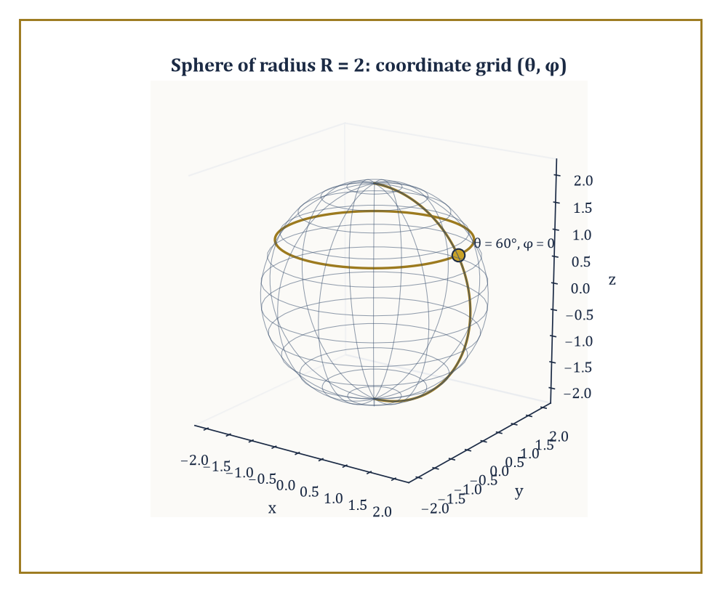
The (θ, φ) coordinate grid on a sphere of radius 2, with the meridian and latitude circle through the worked point θ = 60°, φ = 0.
That spanned plane, translated to sit at the point r(u,v) itself, is the tangent plane at that point: the best flat approximation to the surface there, exactly as a tangent line is the best flat approximation to a curve. Think of a sheet of paper laid flat against a globe at a single point of contact — the paper models the tangent plane, and it touches the sphere at exactly one point while approximating its curving surface arbitrarily well in the immediate vicinity of that contact.
The first fundamental form is the tool that lets us measure lengths, angles, and areas on the surface using only the parameters (u, v), without ever referring back to the ambient space ℝ³ the surface happens to sit inside. It is simply the ordinary Euclidean dot product, restricted to vectors lying in the tangent plane, and expressed in coordinates by three functions:
E = r_u · r_u, F = r_u · r_v, G = r_v · r_v
Given these, the length-squared of an infinitesimal displacement (du, dv) on the surface is:
ds² = E du² + 2F du dv + G dv²
a direct two-dimensional analogue of Pythagoras, complicated only by the fact that the (u, v) grid need not be a nice rectangular grid of unit squares once it is bent onto the curved surface.
Numeric example — The first fundamental form of a sphere. Parametrize a sphere of radius R by
r(θ, φ) = (R sinθ cosφ, R sinθ sinφ, R cosθ)
the usual spherical coordinates with θ the angle down from the north pole and φ the angle around the equator. Differentiating:
r_θ = (R cosθ cosφ, R cosθ sinφ, −R sinθ), r_φ = (−R sinθ sinφ, R sinθ cosφ, 0)
A short computation, expanding each dot product and using sin² + cos² = 1 twice, gives:
E = r_θ·r_θ = R², F = r_θ·r_φ = 0, G = r_φ·r_φ = R² sin²θ
Take a concrete case: R = 2 and θ = 60° = π/3, so sinθ = √3/2 and sin²θ = 3/4. Then:
E = 4, F = 0, G = 4 × 3/4 = 3
The first fundamental form at that point is therefore:
ds² = 4 dθ² + 3 dφ²
A small step of dθ = 0.1 and dφ = 0.1 (in radians) has length:
ds = √(4 × 0.01 + 3 × 0.01) = √0.07 ≈ 0.2646
computed entirely from E and G, with no need ever to plug the displacement back into the three-dimensional formula for r. Notice also that G shrinks as θ approaches 0 or π, the poles, which is the first fundamental form correctly reporting that circles of latitude shrink to points at the poles — a fact that resurfaces, with consequences, the moment we integrate area below.
Because arc length, area, and angle are all built from the dot product and hence entirely computable from E, F, G alone, any quantity expressible purely in terms of the first fundamental form is intrinsic in the precise sense of Room 31.1 — it can be measured by an inhabitant of the surface who has access only to the (u,v) coordinates and the functions E, F, G, never to the ambient embedding r itself.
The area of a region is one such quantity: the area element is
dA = √(EG − F²) du dv
and integrating it over a parameter region gives the total surface area.
Numeric example — The area of a sphere, derived intrinsically. Continuing with the sphere of radius R, the area element is:
dA = √(R² · R²sin²θ − 0) dθ dφ = R² sinθ dθ dφ
Integrating over the whole sphere, θ from 0 to π and φ from 0 to 2π, gives:
Area = ∫₀^{2π} ∫₀^{π} R² sinθ dθ dφ = R² × 2π × [−cosθ]₀^π = R² × 2π × 2 = 4πR²
the familiar schoolroom formula for the surface area of a sphere, now derived entirely from an intrinsic recipe rather than remembered from a textbook. For our R = 2 example, this gives:
4π(4) = 16π ≈ 50.27
square units — you may check this against any reference for the surface area of a sphere of radius 2 and find perfect agreement.
Two surfaces, or two regions of surface, are called isometric if there is a correspondence between their points that preserves the first fundamental form — equivalently, that preserves all lengths of curves drawn on the surfaces.
This is a strictly weaker condition than being congruent by a rigid motion of the ambient space: a surface can be bent, without stretching or tearing, into a wildly different-looking shape in ℝ³ while remaining isometric to its original self throughout the bending, precisely because bending without stretching does not change any of E, F, or G. This distinction — intrinsic sameness without extrinsic sameness — is the doorway into everything the rest of this storey does with curvature.
Abstract example — Rolling paper into a cylinder. Take a flat rectangular sheet of paper and roll it into a cylinder without stretching or creasing it. Parametrize the resulting cylinder as
r(u, v) = (cos u, sin u, v)
Then r_u = (−sin u, cos u, 0) and r_v = (0, 0, 1), giving:
E = r_u·r_u = sin²u + cos²u = 1, F = r_u·r_v = 0, G = r_v·r_v = 1
So the first fundamental form of the cylinder is:
ds² = du² + dv²
exactly the flat, ordinary Pythagorean metric of the original flat sheet of paper, coordinate for coordinate.
The cylinder, despite being visibly and undeniably curved when viewed from outside in ℝ³, is intrinsically indistinguishable from a flat plane: any measurement an inhabitant could make of distances and angles on the cylinder comes out identical to what it would have been on the original unrolled sheet.
This is not a trick of choosing convenient coordinates — it is the precise, provable statement that rolling paper into a tube is an isometry, and it is the reason a flat sheet of paper can be rolled into a cylinder without ever tearing, while a flat sheet cannot be wrapped around a sphere without wrinkling or cutting somewhere, a fact every mapmaker and every giftwrapper has discovered the hard way, and which Room 31.8 will explain completely.

Room 31.5: The Second Fundamental Form and Curvature
Where the surface finally admits it isn't flat
The first fundamental form measures distances and angles within the tangent plane, but it says nothing about how the surface curves away from that tangent plane as you move off the point of tangency — and it cannot say anything about that, because a flat sheet of paper and a sphere can share identical first fundamental forms locally, as the previous room's cylinder example showed, while looking utterly different in space.
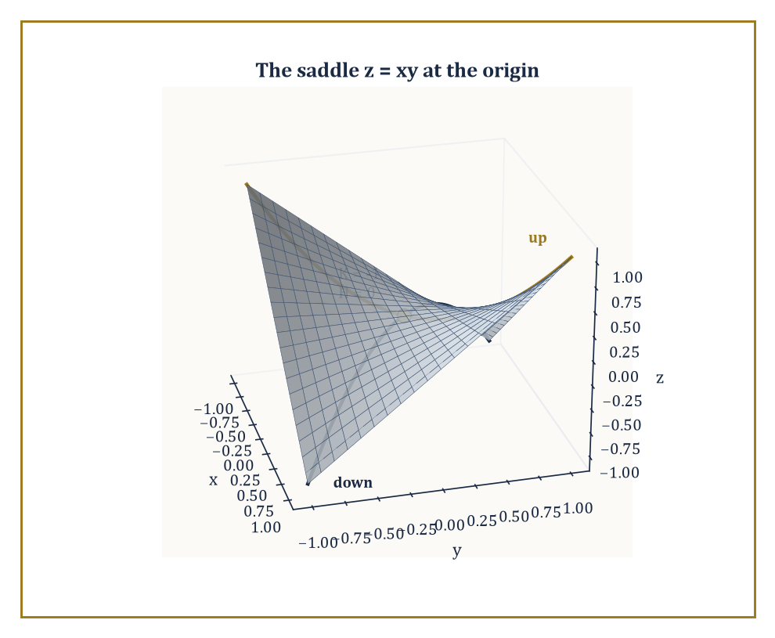
The saddle z = xy at the origin: K = −1, H = 0 — curving upward along one principal direction and downward along the other.
To capture the surface's actual bending, we need a second object entirely: the second fundamental form, which measures the rate at which the surface pulls away from its own tangent plane. It is built from the unit normal vector:
n = (r_u × r_v)/|r_u × r_v|
the vector sticking straight out of the surface at each point — via the coefficients:
e = r_uu · n, f = r_uv · n, g = r_vv · n
the normal components of the surface's second derivatives, exactly the part of the surface's acceleration that the tangent plane cannot see.
From e, f, g together with E, F, G, two numbers of central importance are extracted. The principal curvatures κ₁ and κ₂ are the eigenvalues of the shape operator, the linear map on the tangent plane built by combining the two fundamental forms, and they measure the maximum and minimum rates of bending of the surface at that point, taken over all possible directions.
Their product is the Gaussian curvature, computable directly by the formula:
K = κ₁κ₂ = (eg − f²)/(EG − F²)
their average is the mean curvature:
H = (κ₁+κ₂)/2 = (eG − 2fF + gE)/(2(EG − F²))
Points where κ₁ = κ₂, the surface bending equally in every direction like a sphere, are called umbilic points; the classification of a point as elliptic (K > 0, bowl-shaped, bending the same way in all directions), hyperbolic (K < 0, saddle-shaped, bending opposite ways in different directions), or parabolic (K = 0, flat in at least one direction) is read off directly from the sign of K.
Numeric example — Curvature of a sphere. Return to the sphere of radius R from Room 31.4, at θ = π/3, R = 2 (giving E = 4, F = 0, G = 3). Differentiating the normal appropriately (a computation we spare in full but whose outcome is standard) gives, using the outward normal convention:
e = −R, f = 0, g = −R sin²θ
so with R = 2 and sin²θ = 3/4:
e = −2, f = 0, g = −2 × 3/4 = −1.5
Then Gaussian curvature:
K = (eg − f²)/(EG − F²) = ((−2)(−1.5) − 0)/((4)(3) − 0) = 3/12 = 0.25
matching, reassuringly, the general formula K = 1/R² = 1/4 for a sphere of radius 2, independent of which point θ, φ you evaluate it at, exactly as intrinsic curvature should be. Mean curvature works out to:
H = (eG − 2fF + gE)/(2(EG−F²)) = ((−2)(3) − 0 + (−1.5)(4))/(2 × 12) = (−6 − 6)/24 = −0.5
matching the general formula H = −1/R. Because K and H agree with the general sphere formulas at this arbitrarily chosen point, and because the sphere formulas themselves do not depend on θ or φ at all, every point of a sphere is umbilic — it bends identically in every direction, which is, after all, more or less the definition of a sphere.
Numeric example — Curvature of a saddle. Now the opposite case. Consider the saddle surface z = xy, parametrized as
r(x, y) = (x, y, xy)
at the origin. Here r_x = (1, 0, y) and r_y = (0, 1, x), which at the origin give r_x = (1,0,0) and r_y = (0,1,0), so:
E = 1, F = 0, G = 1
the tangent plane at the origin is just the flat xy-plane, unsurprisingly. The unit normal at the origin, from r_x × r_y = (0,0,1) there, is n = (0,0,1). The second derivatives are r_xx = (0,0,0), r_yy = (0,0,0), and r_xy = (0,0,1) (differentiate r_x = (1,0,y) with respect to y). So:
e = r_xx·n = 0, g = r_yy·n = 0, f = r_xy·n = (0,0,1)·(0,0,1) = 1
Then:
K = (eg − f²)/(EG − F²) = (0 − 1)/(1 − 0) = −1
a clean, negative Gaussian curvature, confirming that the origin of z = xy is a genuine saddle point, curving upward in one direction and downward in the perpendicular direction, exactly as the surface's picture suggests. Mean curvature here is:
H = (eG − 2fF + gE)/(2(EG−F²)) = (0 − 0 + 0)/2 = 0
the two principal curvatures at this point are equal and opposite, so their average vanishes even though neither is individually zero, precisely the local signature of a minimal surface point.
Surfaces with H = 0 everywhere, not just at one point, are called minimal surfaces — the mathematical formalization of a soap film stretched across a wire loop, which physically minimizes surface area subject to its boundary, and which mean curvature zero characterizes exactly (a fact whose proof belongs to the calculus of variations rather than this storey, but which explains the name).
Surfaces of constant mean curvature more generally include spheres, where H is the nonzero constant −1/R computed above, and cylinders, and arise physically as the shapes of soap bubbles and fluid interfaces under uniform pressure.
Of the two curvatures, Gaussian curvature K is by a wide margin the more important for the rest of this storey: it is the one that turns out, per the Theorema Egregium of Room 31.8, to be intrinsic, while mean curvature H genuinely depends on how the surface is embedded and can be changed by bending alone — flattening a cylinder partway, for instance, changes H without changing K, since the cylinder stays isometric to the flat plane throughout.

Room 31.6: Geodesics
As straight as the surface will allow
A geodesic is a surface's best available substitute for a straight line — the straightest possible curve the surface permits, given that the surface itself may not allow anything genuinely straight to exist on it at all.
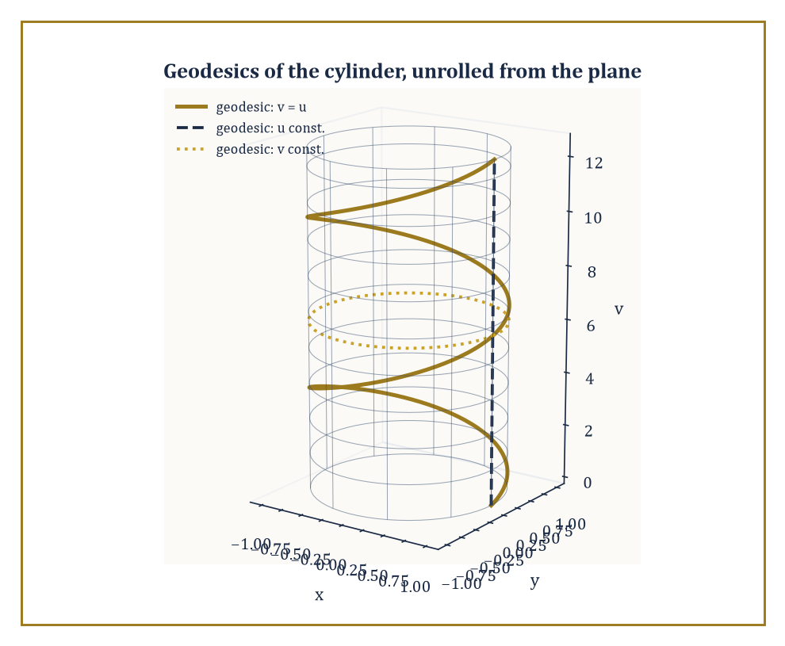
The geodesics of a cylinder are exactly the images of straight lines under unrolling: helices, vertical lines, and circles.
Precisely: a curve on a surface is a geodesic if its acceleration, as a curve in the ambient space ℝ³, has no component tangent to the surface at all — every bit of its bending is forced on it by the surface curving away beneath it, and none of it is the curve choosing, of its own accord, to turn left or right within the surface.
Equivalently, its geodesic curvature κ_g — the tangential part of its curvature, the part an inhabitant of the surface could actually feel as sideways turning — vanishes identically. A straight line drawn on a flat plane is trivially a geodesic, its acceleration being zero altogether; the interest begins once the surface itself is curved.
Geodesics have a variational characterization that justifies calling them 'straightest': among all curves connecting two nearby points on the surface, the geodesic is a critical point of the arc-length functional — locally, it is the shortest path between the points, or at least a locally shortest one; globally, other geodesics may beat it, as we shall see.
Written out in the surface's own coordinates, a curve (u(t), v(t)) is a geodesic exactly when it satisfies a pair of second-order ordinary differential equations involving the Christoffel symbols — correction terms, built entirely from E, F, G and their derivatives, that account for how the coordinate grid itself twists as you move across the surface. Because these are ordinary differential equations of the standard existence-and-uniqueness type, prescribing a starting point and a starting direction determines a unique geodesic, exactly as prescribing a position and velocity determines a unique straight-line trajectory in flat space.
Numeric example — The equator is a geodesic. On the unit sphere, take the equator
r(t) = (cos t, sin t, 0)
Its velocity is r′(t) = (−sin t, cos t, 0) and its acceleration is:
r″(t) = (−cos t, −sin t, 0) = −r(t)
Since the sphere is centred at the origin, the outward unit normal at the point r(t) is simply n(t) = r(t) itself, as it already has length 1. So the acceleration:
r″(t) = −r(t) = −n(t)
points directly along the normal direction, with no tangential component whatsoever. By the definition above, this means geodesic curvature κ_g = 0 along the entire equator: it is a geodesic.
The same argument, run with any great circle in place of the equator (any circle on the sphere whose centre coincides with the sphere's centre), gives the same conclusion — great circles are exactly the geodesics of the sphere, which is why international flight routes hug great circles rather than lines of constant latitude, except, notably, the equator itself, which is both.
On a complete surface — one where geodesics can be extended indefinitely without running off an edge — any two sufficiently close points are joined by a geodesic that is actually the shortest path between them, not merely a critical point of length. This local minimizing property can fail globally: travel far enough along a geodesic and you may pass a conjugate point, beyond which the geodesic, while still a geodesic, is no longer the shortest route to nearby points on it.
The sphere gives the cleanest possible illustration: every geodesic leaving the north pole, regardless of initial direction, reconverges exactly at the south pole — the north and south poles are conjugate points of each other along any of the meridian geodesics connecting them, and any geodesic extended even slightly past the south pole is demonstrably no longer minimizing, since you could instead go the short way round.
Geodesics interact beautifully with the isometries of Room 31.4, because the geodesic equations depend only on the Christoffel symbols, which depend only on E, F, G — purely intrinsic data. An isometry, by definition, preserves E, F, G exactly, and therefore must carry geodesics to geodesics.
This gives a shortcut for finding geodesics on the cylinder without solving any differential equation at all: since the cylinder is isometric to the flat plane (Room 31.4), and straight lines are trivially the geodesics of the flat plane, the images of straight lines under the unrolling map must be the geodesics of the cylinder.
Abstract example — Unrolling the cylinder's geodesics. Unroll the flat (u, v)-plane onto the cylinder
r(u, v) = (cos u, sin u, v)
the inverse of the rolling-up operation from Room 31.4's isometry example. A straight line in the plane at 45° to the v-axis, say v = u, becomes, under this map, the curve:
(cos u, sin u, u)
which is precisely the unit circular helix analyzed at length in Room 31.3, where we computed its constant curvature κ = 1/2 and constant torsion τ = 1/2 as a curve in space. Because straight lines are geodesics of the flat plane, and the unrolling map is an isometry, this helix must be a geodesic of the cylinder — a fact that would be considerably more tedious to verify directly from the geodesic differential equations.
Steeper or shallower lines in the (u,v)-plane produce more tightly or loosely wound helices; a vertical line (u constant) produces a straight vertical line on the cylinder, and a horizontal line (v constant) produces a circle round the cylinder — all geodesics, all inherited for free from the trivial geodesics of the plane they were unrolled from.
Geodesics are, in the end, the intrinsic replacement for straight lines promised at the start of this room, and they are the natural carriers of a surface's intrinsic geometry: the lengths of geodesic triangles, the angles at which geodesics cross, and the way nearby geodesics converge or diverge all encode the surface's curvature without any reference to the ambient embedding. That encoding is made completely explicit in the next room, by the single most quotable theorem in the whole of classical differential geometry.

Room 31.7: The Gauss–Bonnet Theorem
Where local bending finally has to answer to global shape
Every theorem so far has been resolutely local: curvature at a point, geodesics through a point, fundamental forms defined pointwise. The Gauss–Bonnet theorem is the first genuinely global statement in this storey, and it is one of the most quietly astonishing results in all of mathematics: it asserts that the total amount of curvature spread across an entire closed surface is not free to be anything at all — it is locked, rigidly, to the surface's topology.
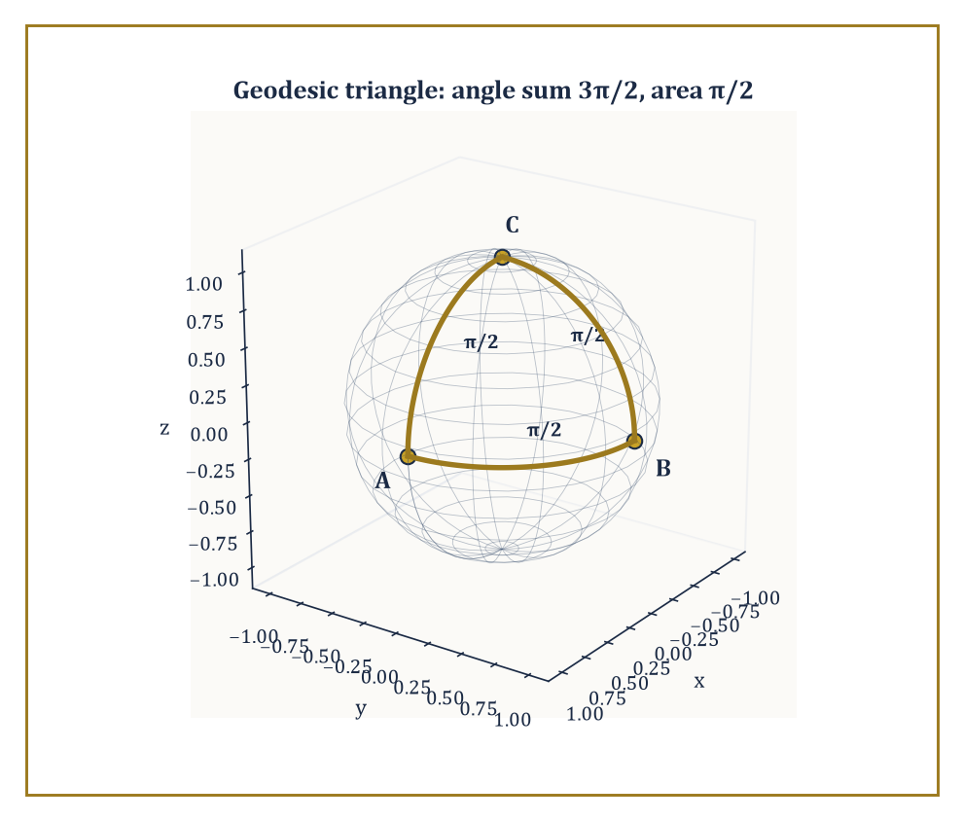
A right-angled octant triangle on the unit sphere: three π/2 angles summing to 3π/2, exceeding π by exactly the enclosed area.
Precisely, for a closed orientable surface:
∫∫ K dA = 2π χ
where χ is the Euler characteristic, a purely topological integer (2 for a sphere, 0 for a torus, and so on down through the more elaborately handled surfaces that Storey 32 will formalize properly).
More generally, for a region R on a surface with boundary, the local form reads:
∫∫_R K dA + ∮_{∂R} κ_g ds = 2π χ(R)
balancing the curvature trapped inside the region against the geodesic curvature of its boundary and the region's topology.
Numeric example — Total curvature of a sphere, any size. Take a sphere of radius R, with constant Gaussian curvature K = 1/R² (Room 31.5) and total surface area 4πR² (Room 31.4). The total curvature is:
∫∫ K dA = (1/R²)(4πR²) = 4π
for every value of R whatsoever — a large sphere has proportionally less curvature per unit area but proportionally more area, and the two effects cancel exactly.
Since a sphere has Euler characteristic χ = 2, a fact Storey 32 will justify properly but which you may already recall from Euler's formula for polyhedra, Gauss–Bonnet predicts:
2πχ = 2π(2) = 4π
an exact match, and one that holds regardless of the sphere's radius, which is the whole point: the theorem relates a topological invariant, which cannot change under bending or scaling, to a curvature integral that individually can change enormously (a beach ball and a marble have very different K) but whose total, integrated, cannot.
Applied to a single geodesic triangle — a triangle whose three sides are geodesics — the local Gauss–Bonnet formula collapses into a beautifully quotable statement about angles: if the triangle's interior angles are α, β, γ, then:
(α + β + γ) − π = ∫∫ K dA
over the triangle's interior, the boundary term vanishing because geodesics have κ_g = 0 by definition. On a flat surface this recovers the schoolroom fact that a triangle's angles sum to exactly π; on a positively curved surface the angles sum to more than π, and on a negatively curved surface, less.
Numeric example — A right-angled octant triangle. On the unit sphere (R = 1, K ≡ 1), take the geodesic triangle with vertices at (1,0,0), (0,1,0), and (0,0,1) — one on the equator at longitude 0, one on the equator at longitude 90°, and one at the north pole. Each side is a quarter of a great circle, and each of the three interior angles, where the sides meet, is exactly π/2, a right angle — you can see this directly, since the two equatorial sides meet the meridian sides at right angles by symmetry. The angle sum is therefore:
3 × π/2 = 3π/2
exceeding π by exactly π/2. Independently, this triangle is exactly one octant of the sphere, so its area is one-eighth of the total area:
4π(1)² = 4π, area = π/2
Since K = 1 on the unit sphere, ∫∫ K dA over the triangle equals its area, π/2, matching the angle excess exactly, as Gauss–Bonnet demands. The sphere's positive curvature has visibly fattened the triangle's angles beyond the flat total of π, and the theorem tells you by exactly how much: the enclosed curvature, no more, no less.
The theorem's consequences reach well beyond pleasant angle-counting. Because ∫∫ K dA = 2πχ and χ(sphere) = 2 ≠ 0, Gaussian curvature cannot be identically zero anywhere on a sphere-topology surface — there must be points of strictly positive curvature somewhere, which in particular proves that no flat (K ≡ 0) metric can ever be put on a sphere, however cleverly you try to bend or deform it; the theorem forbids it outright, by a topological argument that requires no calculation of any specific metric.
This single fact is the rigorous version of every mapmaker's ancient complaint: you cannot flatten the Earth's surface onto a sheet of paper without distortion, because a genuinely undistorted, isometric, hence curvature-preserving flattening would require the Earth to be intrinsically flat, and Gauss–Bonnet forbids that categorically.
Abstract example — The torus's curvature budget. Now consider a torus (a doughnut surface), which has Euler characteristic χ = 0, so Gauss–Bonnet demands:
∫∫ K dA = 0
exactly. Unlike the sphere, the torus's curvature is not constant: parametrizing the tube by an angle θ around its circular cross-section, the standard torus of tube radius r and central radius R₀ has Gaussian curvature:
K = cosθ / (r(R₀ + r cosθ))
which is positive on the outer part of the tube, θ near 0, the part bulging away from the central hole, shaped locally like a sphere, and negative on the inner part, θ near π, the part curving in toward the hole, shaped locally like a saddle, passing through zero exactly at the very top and bottom of the tube (θ = ±π/2), where the surface is momentarily flat in one direction.
The positive contribution from the outer region and the negative contribution from the inner region cancel in the integral exactly, forced to do so by Gauss–Bonnet, however the torus's specific proportions, the ratio of r to R₀, are chosen. No mere geometric coincidence: it is topology, in the shape of χ = 0, insisting on the outcome before a single integral is computed.
Gauss–Bonnet is the prototype for an entire genre of theorem that recurs throughout the upper storeys of this Tower: a local, differential, calculus-flavoured quantity, curvature, is shown to integrate to a global, discrete, algebraic quantity, the Euler characteristic, that depends only on the coarse topological type of the space, utterly indifferent to how that space happens to be curved or embedded. It is, in a very real sense, this storey's handshake with the next one.

Room 31.8: Intrinsic Geometry and the Theorema Egregium
Gauss's remarkable theorem, and why he had every right to name it that
We have been promising, since Room 31.1, a precise version of the claim that Gaussian curvature is intrinsic — measurable from within the surface, unaffected by how the surface happens to sit in space. Gauss's Theorema Egregium delivers exactly that: it proves that K, defined in Room 31.5 as (eg − f²)/(EG − F²) using the extrinsic second fundamental form, can in fact be rewritten entirely in terms of E, F, G and their derivatives alone, with no reference to e, f, or g whatsoever.
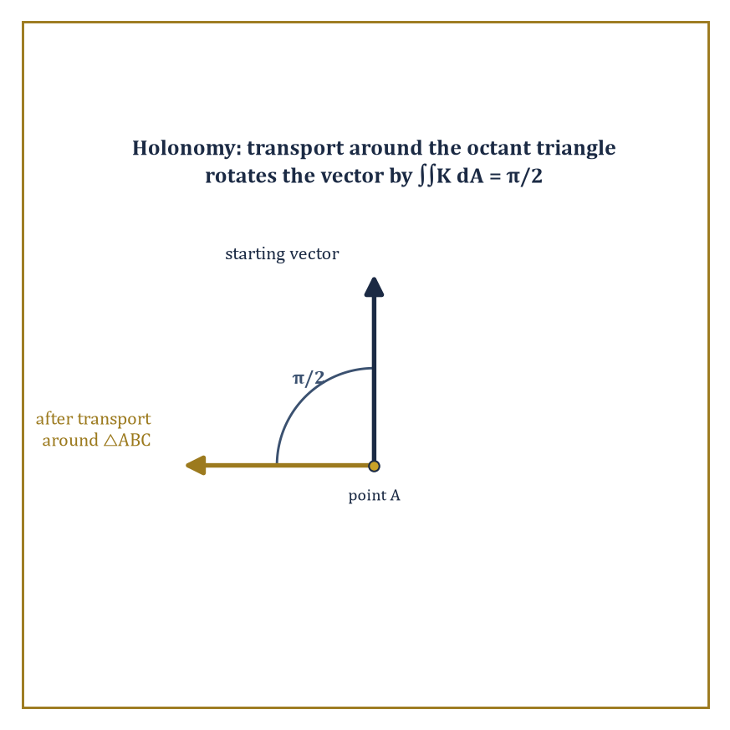
Carried around the octant triangle of Room 31.7, a vector returns rotated by π/2 — holonomy made visible, and equal to the enclosed curvature.
The proof is a genuinely nontrivial computation — a compatibility condition, called the Gauss equation, relating the two fundamental forms, from which the e, f, g dependence can be algebraically eliminated — but the conclusion is what matters here: bend a surface without stretching or tearing it, an operation that by definition preserves E, F, G exactly, and its Gaussian curvature at every point is unchanged, even though the surface may look, from outside, dramatically different.
This resolves, with total rigour, the paradox lurking in the cylinder example of Room 31.4. The cylinder is visibly curved when viewed sitting in ℝ³ — you can clearly see it bending away from any tangent plane — and indeed its second fundamental form is not zero.
Numeric example — The cylinder's honest confession. For the cylinder r(u,v) = (cos u, sin u, v), we found E = 1, F = 0, G = 1 in Room 31.4. Continuing the computation: the unit normal is n = (cos u, sin u, 0), pointing straight outward from the cylinder's axis, and r_uu = (−cos u, −sin u, 0), giving:
e = r_uu · n = −cos²u − sin²u = −1
decidedly nonzero, confirming that the cylinder really is extrinsically curved, bending away from its tangent plane at a definite, measurable rate. Meanwhile r_vv = (0,0,0) gives g = 0, and r_uv = (0,0,0) gives f = 0. Plugging into the Gaussian curvature formula:
K = (eg − f²)/(EG − F²) = ((−1)(0) − 0)/((1)(1) − 0) = 0
Despite e = −1 being emphatically nonzero — the cylinder is genuinely bending in space — the Gaussian curvature comes out exactly zero, matching the flat plane it is isometric to.
This is the Theorema Egregium made completely concrete: extrinsic bending (e ≠ 0) and intrinsic curvature (K) are simply different quantities, and a surface can have plenty of the first while having none of the second.
The machinery that makes this rewriting possible — expressing K purely from E, F, G — runs through the Christoffel symbols mentioned already in Room 31.6, which are themselves built entirely from E, F, G and their partial derivatives by an explicit, if visually intimidating, formula, and through the Riemann curvature tensor, the higher-dimensional generalization of curvature that later, more abstract storeys will need in full force but which, for a two-dimensional surface, collapses down to essentially nothing more than the single number K.
This collapse is a special gift of dimension two: in three or more dimensions the Riemann tensor carries vastly more independent information than a single scalar, which is precisely why general relativity, a four-dimensional theory, needs a tensor with twenty independent components rather than one lonely number, but that reckoning belongs to a much later storey.
Perhaps the most physically vivid manifestation of intrinsic curvature is parallel transport: carrying a vector along a curve on the surface while keeping it, at every instant, as 'unchanging' as the surface will permit — no tangential turning is applied to it beyond what following the curve itself requires.
Carry a vector all the way around a closed loop back to its starting point, and in flat space it returns exactly as it left. On a curved surface it generally does not: it returns rotated, by an angle called the holonomy of the loop, and that rotation angle is exactly the total Gaussian curvature enclosed by the loop — precisely the ∫∫ K dA that Gauss–Bonnet already taught us to compute.
Abstract example — Parallel transport around the octant triangle. Take the same geodesic triangle from Room 31.7 — vertices at (1,0,0), (0,1,0), (0,0,1) on the unit sphere, enclosing a total curvature of π/2. Stand at (1,0,0) holding an arrow tangent to the sphere, pointing, say, due north along the meridian toward (0,0,1).
Parallel-transport that arrow along the first geodesic side to (0,0,1), then along the second side to (0,1,0), then along the third side back to (1,0,0), at every stage keeping the arrow as unrotated relative to the direction of travel as the surface allows. When the arrow returns to its starting point, it has been rotated by exactly π/2 — a quarter turn — relative to its original direction, precisely matching the enclosed curvature computed in Room 31.7.
This is not a coincidence dressed up as a theorem; it is the same theorem, viewed through a different, more tactile lens: Gauss–Bonnet's curvature integral and the holonomy of parallel transport are two descriptions of the identical underlying fact about how the surface bends.
The intrinsic/extrinsic distinction, sharpened here into the Theorema Egregium, is the conceptual centre of gravity of the entire subject, and the reason abstract Riemannian manifolds — spaces with a notion of distance and curvature but no ambient embedding to fall back on at all — are even possible to define.
If curvature genuinely required an outside view to make sense, an un-embedded abstract space could never be said to be curved; because it does not, curvature becomes a self-contained property a space can simply have, embedding or no embedding, which is exactly the freedom the rest of this Tower's geometric storeys will spend so lavishly.

Room 31.9: Looking Ahead: From Surfaces to Manifolds, Riemannian Geometry, and Relativity
The view from the top of the classical theory
We have, over eight rooms, assembled the complete classical theory of curves and surfaces sitting inside three-dimensional Euclidean space: arc length and the Frenet–Serret frame for curves; the first fundamental form for measuring within a surface; the second fundamental form and its curvatures for measuring how the surface bends; geodesics as the intrinsic replacement for straight lines; the Gauss–Bonnet theorem tying local curvature to global topology; and the Theorema Egregium establishing, with full rigour, that Gaussian curvature is intrinsic all along.
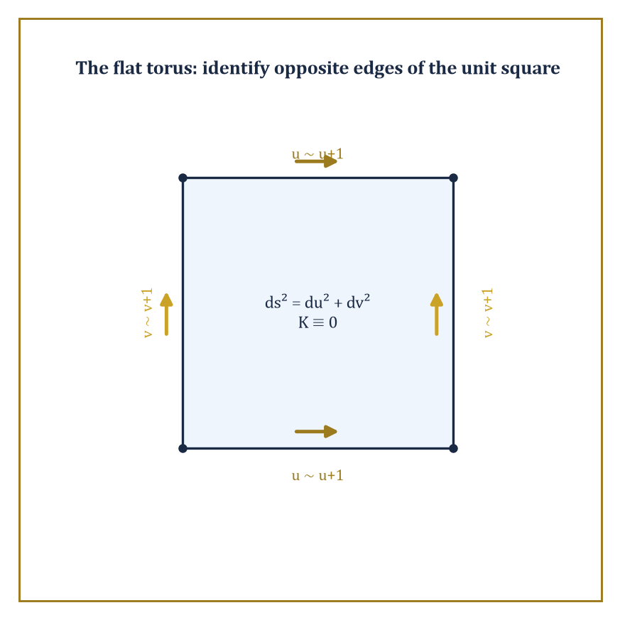
The flat torus: glue opposite edges of a unit square and the flat metric ds² = du² + dv² survives intact, with K ≡ 0 everywhere.
That is a formidable amount of machinery, and it was all built using nothing more exotic than the vector calculus and linear algebra earlier storeys already supplied.
The modern theory generalizes every piece of it, and the generalization is best understood as simply removing the crutch of the ambient space. A manifold abstracts the local structure of a surface — something that looks like ordinary flat space up close, in small enough patches — to any number of dimensions, and crucially without requiring that manifold to sit inside some larger Euclidean space at all; it can simply exist, defined by how its local patches are glued together.
A Riemannian metric generalizes the first fundamental form, supplying a notion of length and angle at every point of such a manifold, purely intrinsically. The Levi-Civita connection generalizes the Christoffel symbols, telling you how to parallel-transport vectors and hence what 'straight', or geodesic, means, again with no outside space to lean on. Sectional curvature generalizes Gaussian curvature, measuring how two-dimensional slices through the manifold bend.
Abstract example — Two toruses, one topology. Compare two versions of the torus. The embedded doughnut of Room 31.7, sitting in ℝ³, has Gaussian curvature that varies continuously from positive on the outer rim to negative on the inner rim, yet integrates to zero exactly as Gauss–Bonnet demands, since χ = 0.
Now consider the flat torus, defined abstractly with no embedding at all: take the flat (u,v)-plane with the ordinary metric
ds² = du² + dv²
and identify u with u+1 and v with v+1 — glue the left edge of a unit square to the right edge, and the top to the bottom, exactly as classic video games wrap the screen. This is a perfectly legitimate manifold, carrying a perfectly legitimate Riemannian metric,
E = G = 1, F = 0
everywhere, by construction, with Gaussian curvature K ≡ 0 identically, since it is locally indistinguishable from the flat plane at every point. Gauss–Bonnet still applies, and still gives the correct answer:
∫∫ K dA = 0 = 2π(0) = 2πχ
trivially satisfied because every term is already zero.
The doughnut and the flat torus share the exact same topology, χ = 0, and hence the exact same total curvature, 0, but wildly different local geometry — one bulges and pinches through positive and negative curvature, the other is perfectly flat everywhere. Topology, it turns out, constrains the total; it has almost nothing to say about the local details, precisely the gap the next storey is built to explore properly, and precisely the freedom this storey's local machinery was built to exploit.
The single most consequential application of all this machinery lies several storeys further up the Tower, in general relativity, which identifies physical spacetime itself with a four-dimensional Lorentzian manifold — a close cousin of a Riemannian manifold, differing only in a sign convention that keeps time from behaving exactly like space — whose curvature is determined, via Einstein's field equations, by the distribution of matter and energy within it.
Gravity, in that picture, stops being a force reaching out across space and becomes instead a direct consequence of spacetime's intrinsic curvature — massive objects do not pull on each other so much as they bend the geometry that everything else must then travel as straight as possible, that is, as a geodesic, through. It is, in the most literal sense available, the ant on the sphere from Room 31.1, promoted to four dimensions and handed the entire universe to measure.
The deeper lesson of this storey, stated once more before we leave it, is that geometry can be done entirely from within — by measurements available to a patient, sufficiently clever inhabitant who never gets to step outside and look — and that the resulting intrinsic geometry is rich enough to describe both the classical curved surfaces of the nineteenth century and the curved spacetime of the twentieth.
Differential geometry is, in the end, the mathematics of curved space, done honestly, from the inside. The next storey turns away from measuring exactly how curved a space is and asks the coarser, stranger question of what survives when curvature itself is thrown away entirely — when a coffee mug and a doughnut become, for every purpose that matters, the same object. We have learned, here, to measure bending with derivatives; up in Topology, we learn what is true regardless of any bending at all.
And so this storey closes exactly where the last theorem of Room 31.8 pointed: at the boundary between geometry, which measures precisely how much a space bends, and topology, which cares only about the shape's most stubborn, unshakeable features. The Gauss–Bonnet theorem was the whole storey's quiet thesis smuggled into a single equation — ∫∫ K dA = 2πχ — a local, calculus-flavoured, entirely bendable quantity on the left, and a rigid, discrete, unbendable integer on the right, held together by nothing more than a proof.
Storey 32 picks up that integer and runs with it. Topology will cheerfully throw away every curvature we have spent nine rooms so carefully computing — a sphere squashed into a cube, a mug reshaped into a doughnut, all quantities of interest here rendered meaningless there — and ask instead what remains constant through any amount of stretching, squashing, and bending short of tearing. It is, in a sense, the discipline that begins exactly where our patience for measuring precise numbers runs out, and asks the coarser but in some ways harder question of shape stripped down to its bones.
A closing word of reassurance for the climb ahead, since differential geometry has a reputation, not entirely undeserved, for burying good ideas under bad notation: every formula in this storey — the Frenet–Serret equations, the two fundamental forms, Gauss–Bonnet itself — turned out, without exception, to be a precise restatement of something you could picture. That habit does not stop here. It has simply been, for one storey, dressed up in Christoffel symbols and asked to compute exactly.
The Tower continues upward. We have learned to measure the bending of space with derivatives; next, we learn what survives when we stop measuring it altogether.

Storey 32: Topology
Continuity, Connectedness, and the Art of Geometry Without Distance
The previous storey spent its many rooms teaching us to measure a bent sheet with real precision — Gaussian curvature computed to the decimal place, geodesics tracked as if we owned a very small and very diligent surveyor, the Theorema Egregium proving that some of what we measured was secretly independent of how we bent the sheet in the first place. Now we do something that will feel, for the first few rooms at least, faintly indecent: we put the ruler down. Not lose it, in the manner of most rulers in most houses — put it down on purpose, to see what is left standing once the ability to measure length or angle is taken away entirely.
What is left, it turns out, is a great deal. Nearness survives, in a suitably laundered form. Continuity survives. So does the qualitative fact that a coffee cup and a doughnut are, deep down, the same shape, however differently they behave at breakfast, and the equally qualitative fact that neither of them is a sphere. Topology is the discipline built entirely out of what remains after distance has been confiscated, and the standing joke about the field — that its definitions look almost empty and its theorems turn out to be surprisingly strong — is not really a joke at all. The emptiness is the whole method: throw away everything except the purely qualitative skeleton of a space, and what is left over is precisely what a continuous deformation cannot destroy.
This storey climbs from the comfortable ground of metric spaces, where continuity still has an ε and a δ to hide behind, up through the more austere world of general topological spaces defined by open sets alone, through the two great structural properties — connectedness and compactness — and the separation axioms that keep a space civilised, and finally into algebraic topology proper: homotopy, the fundamental group, covering spaces, and the complete classification of closed surfaces, one of the few genuinely finished answers topology has ever produced to the question of what shapes there are.
Let's forget distances.

Room 32.1: What Topology Actually Is
In Which We Confiscate the Ruler
Topology is the study of those properties of a space that survive continuous deformation — stretching, bending, squashing, twisting — but never tearing and never gluing. It is sometimes called rubber-sheet geometry, a name that undersells it slightly, since rubber sheets are things you can actually buy, and topology has no interest in what a space is made of, only in how its points hang together.
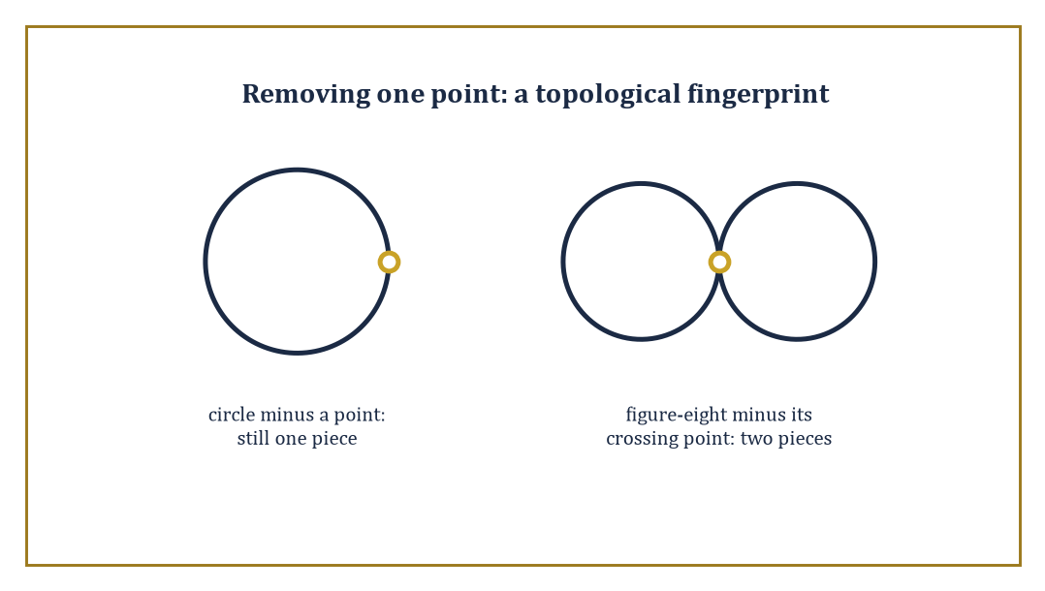
Delete one point from a circle and it stays whole; delete the crossing point from a figure-eight and it falls into two pieces — a topologist's fingerprint, no ruler required.
Two spaces count as the same — technically, homeomorphic — if one can be continuously deformed into the other, with a continuous deformation running in reverse to undo it. Distance is not invited to this discussion. Neither is angle.
What survives is something thinner and, as it turns out, considerably more robust: the pattern of which points are near which other points.
Abstract example — Worked example: the mug and the doughnut. The standard illustration, repeated in every topology course since roughly the dawn of time, is the coffee mug and the doughnut (properly, the torus). Both objects have exactly one hole clean through them — the doughnut's is obvious, the mug's is the handle.
Watch a deformation: soften the mug like warm wax; let the bowl of the mug sag and flatten into a thick disc while the handle stays put; keep flattening until the disc becomes a fat ring with a hole exactly where the handle already met it. What remains, up to some cosmetic squashing, is a torus.
At no stage did we tear the wax or press two previously separate points together — we only bent and squashed, and squashing is free in topology.
A solid ball, by contrast, has no hole to preserve; no amount of squashing turns a doughnut into a ball without either tearing the ring open or gluing its ends into a single point, both forbidden moves.
Hence the old joke that a topologist cannot tell her coffee cup from her doughnut — though she can, immediately, tell either one from the ball-shaped paperweight on her desk, which is precisely why the discipline is not, despite appearances, a complete abdication of rigour.
The subject splits, historically and pedagogically, into two branches this storey will visit in turn. Point-set topology (also called general topology) builds the basic vocabulary: open sets, continuity, connectedness, compactness — the grammar in which every later sentence of the subject will be written.
Algebraic topology takes the braver step of attaching algebraic objects — groups, rings, vector spaces — to a space, in such a way that continuous maps between spaces become algebraic homomorphisms between their invariants.
The point of this seemingly baroque manoeuvre is entirely practical: algebra is far easier to compute with than raw point-set data, and two spaces with non-isomorphic invariants cannot possibly be homeomorphic, however hard they might be to tell apart by eye.
Abstract example — Worked example: telling a circle from a disc. Consider the circle S¹ and the closed disc D² (the circle together with everything it encloses). Staring at them, one might wonder whether some devious continuous bending could turn one into the other — both are bounded, both are connected, both look round.
Algebraic topology settles the question outright. The disc is contractible: it can be continuously shrunk to its centre point, so its fundamental group (built properly in Room 32.7) is trivial, containing only the identity element.
The circle is not contractible — a loop winding once around the hole in the middle cannot be shrunk to a point without leaving the circle — and its fundamental group turns out to be the infinite cyclic group ℤ, one copy of the integers for each possible winding number.
Trivial group versus infinite group: the two cannot be isomorphic, so S¹ and D² cannot be homeomorphic.
Notice what happened — a question about bending and stretching was answered using nothing but group theory. That transfer of labour, geometry's hard questions handed over to algebra's comparatively tractable ones, is the entire strategic point of algebraic topology, and we shall lean on it for the rest of the storey.
Abstract example — Worked example: a point-set argument, no algebra required. Not every distinction needs algebra. Consider the circle S¹ and the figure-eight (two circles joined at a single crossing point).
Remove the crossing point from the figure-eight: what remains is two disjoint open arcs, a disconnected space — removing one point split it in two.
Now remove any point from the circle instead: what remains is a single connected arc, however oddly bent, since a circle with one point deleted is still all one piece.
A homeomorphism must send a point whose removal disconnects the space to a point whose removal disconnects the space, since counting how many pieces are left behind after deleting a point is itself a topological invariant, no algebra needed.
The figure-eight has such a point and the circle does not, so the two spaces cannot be homeomorphic — connectedness alone, patiently applied, already settles a question one might instinctively have reached for the fundamental group to answer, and Room 32.4 will make this trick precise.
Topology, then, supplies the load-bearing vocabulary underneath most of modern geometry, analysis, and dynamical systems — whenever someone asks whether two structures are essentially the same shape, or whether a space has a hole, or whether a system's trajectories can be continuously deformed into one another, they are asking a topological question, whether or not they use the word.
We will spend the rest of this storey building that vocabulary from the ground up: first through the familiar comfort of metric spaces, then through the more austere abstraction of general topological spaces, and finally into the algebraic machinery that lets us count holes for a living.

Room 32.2: Metric Spaces and Continuity
Where Distance Still Behaves Itself, For Now
A metric space is a set X equipped with a distance function d: X × X → ℝ satisfying three axioms: positivity, symmetry, and the triangle inequality.
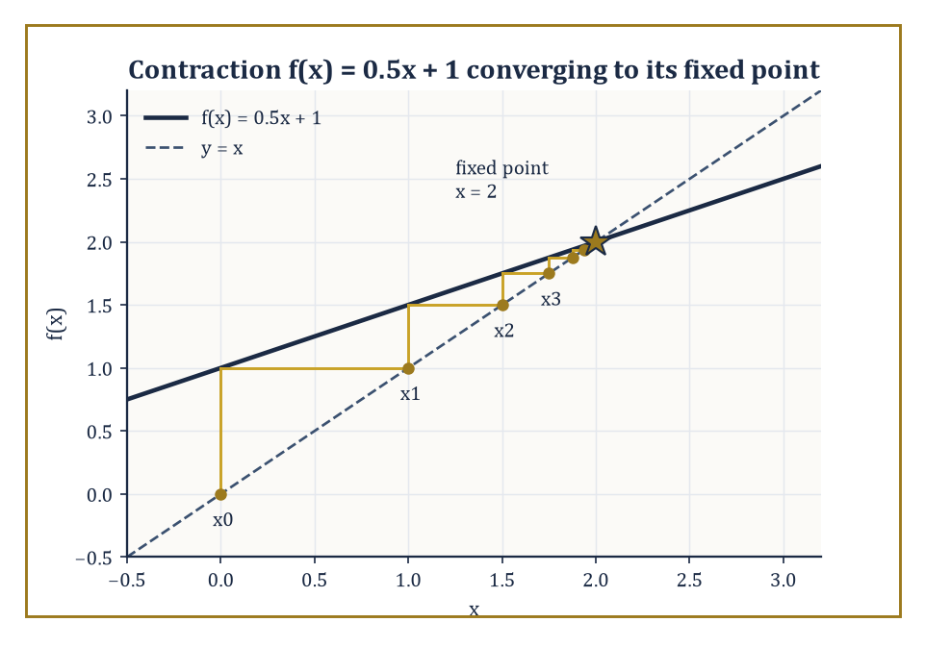
The contraction f(x) = 0.5x + 1, iterated from x0 = 0, staircases its way straight into the fixed point x = 2 — exactly as promised by a constant L = 0.5 comfortably under 1.
d(x,y) ≥ 0, with equality precisely when x = y
d(x,y) = d(y,x)
d(x,z) ≤ d(x,y) + d(y,z)
The triangle inequality is the formal statement that a detour is never shorter than the direct route. From d alone we build open balls, and declare a set U open if every point of U sits inside some open ball entirely contained in U.
B(x,r) = {y ∈ X : d(x,y) < r}
This collection of open sets is the topology generated by the metric — the first, and friendliest, example of the more general structure met properly in Room 32.3.
Numeric example — Worked example: checking the axioms. Take the Euclidean plane ℝ² with distance
d(p,q) = √((p₁−q₁)² + (p₂−q₂)²)
and three points p = (0,0), r = (3,0), q = (3,4). Then:
d(p,r) = √(3²+0²) = 3
d(r,q) = √(0²+4²) = 4
d(p,q) = √(3²+4²) = √25 = 5
A 3-4-5 right triangle, chosen to keep the square roots honest. Symmetry is immediate: swapping the arguments swaps nothing in the formula. Positivity holds since all three points are distinct, giving strictly positive distances.
And the triangle inequality reads:
5 ≤ 3 + 4 = 7
Comfortably true, with equality reserved for the degenerate case where the middle point lies exactly on the straight segment, which r here does not.
A function f: X → Y between metric spaces is continuous at a point x if points near x are sent to points near f(x): for every ε > 0 there exists δ > 0 such that
d(x,x′) < δ implies d(f(x),f(x′)) < ε
This is the familiar ε–δ definition from analysis, and it turns out to be exactly equivalent to the topological statement that the pre-image of every open set is open — continuity, reframed, is simply the demand that closeness pull back correctly through f. The equivalence is worth sitting with: analysis phrases continuity in terms of numbers getting small; topology phrases the same fact in terms of open sets pulling back, with no numbers in sight. Discarding the numbers is exactly what will let the idea extend to spaces where no distance function exists at all.
Numeric example — Worked example: an ε–δ check. Let f(x) = x² on ℝ, and check continuity at x₀ = 2 with tolerance ε = 0.1. We need |x − 2| < δ to force |x² − 4| < 0.1. Factor:
|x² − 4| = |x − 2|·|x + 2|
Restrict to δ ≤ 1, so x lies in (1,3) and |x+2| < 5. Choosing:
δ = min(1, 0.1/5) = 0.02
then gives, whenever |x − 2| < 0.02:
|x² − 4| = |x−2|·|x+2| < 0.02 × 5 = 0.1
Exactly the bound required. So δ = 0.02 works for ε = 0.1 at x₀ = 2 — a small, honest computation standing in for the general fact that every polynomial is continuous everywhere.
The concept covers far more than Euclidean space. Function spaces carry metrics too: the uniform metric measures the worst-case vertical gap between two functions,
d(f,g) = sup_x |f(x) − g(x)|
while the integral metric measures the total area between their graphs,
d(f,g) = ∫|f(x) − g(x)| dx
two genuinely different notions of nearby function, generating two genuinely different topologies on the same set of functions. At the other extreme sits the discrete metric, which declares every point isolated from every other.
d(x,y) = 0 if x = y and 1 otherwise
Numeric example — Worked example: the discrete metric. On X = {a, b, c} with the discrete metric, the open ball
B(a, 0.5) = {y ∈ X : d(a,y) < 0.5}
contains only a itself, since
d(a,b) = d(a,c) = 1 ≥ 0.5
The same holds for every point, so every singleton {a}, {b}, {c} is open, and since arbitrary unions of open sets are open, every subset of X is open. The discrete metric therefore generates the discrete topology, in which nothing is ever close to anything else except itself — a useful, if slightly antisocial, toy example to keep in reserve whenever a general claim about topological spaces needs testing against an extreme case.
A metric space is complete if every Cauchy sequence (one whose terms eventually cluster arbitrarily close together) actually converges to a point of the space. ℝ is complete; ℚ is not, since a sequence of rationals can Cauchy-converge toward √2 without ever reaching a rational limit. Every incomplete metric space can be completed by formally adjoining the missing limit points — this is exactly how ℝ is built from ℚ in the first place.
Completeness matters because it powers the contraction mapping theorem (the Banach fixed-point theorem): if f: X → X on a complete metric space satisfies
d(f(x),f(y)) ≤ L·d(x,y) for some fixed L < 1
then f has exactly one fixed point, and iterating f from any starting point converges to it. This single theorem underwrites the existence and uniqueness theory for ordinary differential equations and generates the self-similar fractals met several storeys ago — a piece of pure metric-space topology quietly doing heavy lifting elsewhere in the Tower.
Numeric example — Worked example: a contraction in action. Let f(x) = 0.5x + 1 on ℝ (complete, certainly). For any x, y:
|f(x) − f(y)| = |0.5x − 0.5y| = 0.5|x − y|
so f is a contraction with L = 0.5 < 1. Its fixed point solves:
x = 0.5x + 1, so 0.5x = 1, so x = 2
Iterate from x₀ = 0:
x₁ = f(0) = 1
x₂ = f(1) = 1.5
x₃ = f(1.5) = 1.75
x₄ = f(1.75) = 1.875
x₅ = f(1.875) = 1.9375
The errors 2 − xₙ run 2, 1, 0.5, 0.25, 0.125, 0.0625 — exactly halving at each step, precisely as the contraction constant L = 0.5 predicts, converging inexorably to the true fixed point x = 2 regardless of where the iteration started.

Room 32.3: Topological Spaces and Continuous Maps
Open Sets, All the Way Down
A topological space is a set X together with a distinguished collection τ of subsets, called open sets, satisfying three axioms: ∅ and X are both open; arbitrary unions of open sets are open; and finite intersections of open sets are open. Notice what has been discarded — there is no distance function anywhere in this definition, only a bookkeeping rule for which subsets count as open.
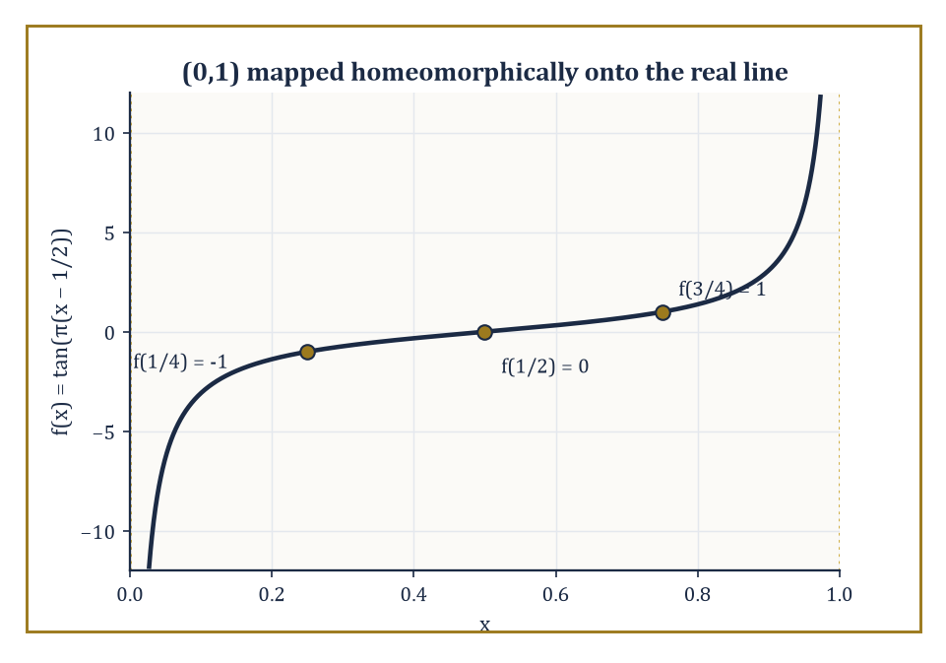
f(x) = tan(π(x − 1/2)) bends the bounded interval (0,1) into the whole real line — proof that boundedness was only ever a fact about the ruler, not about the space.
A closed set is the complement of an open set. The interior of a set A is the largest open set contained in A; its closure is the smallest closed set containing A; and its boundary is the closure minus the interior — the skin of A, belonging to neither its open interior nor its open exterior.
Abstract example — Worked example: a topology on three points. Let X = {a, b, c} and declare
τ = { ∅, {a}, {a,b}, X }
Check the axioms directly: ∅ and X are present, as required. Unions:
{a} ∪ {a,b} = {a,b} ∈ τ
{a} ∪ X = X ∈ τ
every union formable from the listed sets is already on the list. Intersections:
{a} ∩ {a,b} = {a} ∈ τ
{a,b} ∩ X = {a,b} ∈ τ
All three axioms hold, so τ is a genuine topology on X — despite no distance function ever being mentioned, and despite this particular topology being deliberately lopsided (notice {c} is not open, nor is {b} on its own). The closed sets are the complements of the open ones: the complement of ∅ is X, the complement of {a} is {b,c}, the complement of {a,b} is {c}, and the complement of X is ∅. So {c} is closed but not open, {b,c} is closed but not open, and X and ∅ are, as always, both open and closed simultaneously.
Numeric example — Worked example: interior, closure, boundary. Consider A = [0,1) inside ℝ with its standard topology. The interior of A is the largest open set contained in A: every point of (0,1) has a small open interval around it that stays entirely inside A, but 0 does not — any open interval around 0, however small, pokes out into the negative numbers, so 0 fails to be an interior point. Hence
interior(A) = (0,1)
The closure of A is the smallest closed set containing A. A itself is not closed: its complement is (−∞,0) ∪ [1,∞), and this complement is not open, since 1 has no open interval around it that avoids A entirely (any such interval dips back below 1, into A). The smallest closed set containing A must therefore also contain the limit point 1, giving
closure(A) = [0,1]
The boundary is closure minus interior:
[0,1] minus (0,1) = {0,1}
the two edge points of the half-open interval, one of which (0) happens to belong to A and one of which (1) does not, a useful reminder that boundary points need not belong to the set whose boundary they form.
A function f: X → Y between topological spaces is continuous if the pre-image f⁻¹(V) of every open set V ⊆ Y is open in X — no numbers, no ε, no δ, just open sets pulling back to open sets.
A homeomorphism is a continuous bijection whose inverse is also continuous; homeomorphic spaces are, topologically, indistinguishable, and homeomorphisms play exactly the role isomorphisms play elsewhere in mathematics. A topological invariant is any property preserved by homeomorphisms — connectedness, compactness, and the fundamental group, still to come, are the working invariants of this storey, and proving two spaces are not homeomorphic is almost always done by finding an invariant on which they disagree.
Abstract example — Worked example: continuity between finite spaces. Equip Y = {1, 2} with the Sierpiński topology
σ = { ∅, {1}, Y }
the smallest topology on two points that is not discrete. Take X = {a,b,c} with the topology τ from the earlier example, and define f: X → Y by f(a) = 1, f(b) = 1, f(c) = 2. To check continuity, test every open set of Y:
f⁻¹(∅) = ∅ (open in X)
f⁻¹({1}) = {a,b} (open in X, since {a,b} ∈ τ)
f⁻¹(Y) = X (open in X)
All three pre-images are open, so f is continuous — verified entirely by set membership, without a single distance computed, exactly the promise of the topological definition.
Worked example — Worked example: a bounded interval is homeomorphic to the whole line. Consider the open interval (0,1) and the whole real line ℝ, which look different in size — one is bounded, the other is not — yet are homeomorphic. The map
f(x) = tan(π(x − 1/2))
sends (0,1) bijectively onto ℝ, is continuous throughout the open interval (tangent only misbehaves at odd multiples of π/2, never reached on this domain), and has a continuous inverse. Check three values:
f(1/2) = tan(0) = 0
f(3/4) = tan(π/4) = 1
f(1/4) = tan(−π/4) = −1
As x sweeps from just above 0 to just below 1, f(x) sweeps out the entire real line — boundedness, in other words, is not a topological invariant in its own right, only a property of a particular metric someone happened to put on the space.
Three standard constructions build new topological spaces from old ones. The subspace topology on A ⊆ X takes as open sets all intersections of A with open sets of X. The product topology on X × Y takes as a basis all products U × V of open sets from each factor. The quotient topology, given an equivalence relation ~ on X, declares a subset of X/~ open exactly when its pre-image under the quotient map is open in X — the topology that makes gluing points together a continuous operation, at the cost of being the trickiest of the three to picture.
Worked example — Worked example: building a circle by gluing an interval's ends. Take X = [0,1] and glue the two endpoints together, declaring 0 ~ 1. The quotient map q: [0,1] → [0,1]/~ can be pictured concretely as
q(t) = (cos 2πt, sin 2πt) ∈ ℝ²
landing on the unit circle S¹. Check values:
q(0) = (1,0)
q(1) = (cos 2π, sin 2π) = (1,0)
the two endpoints, as promised, land on the same point. Meanwhile
q(1/4) = (cos(π/2), sin(π/2)) = (0,1)
q(1/2) = (cos π, sin π) = (−1,0)
q(3/4) = (0,−1)
four evenly spaced points going once around. The quotient topology confirms what the picture already suggests: [0,1]/(0~1) is homeomorphic to the circle S¹, and this take-an-interval-and-glue-the-ends construction is the standard way to build a circle out of a straight piece of string, topologically speaking.
The range of topologies in active use is wide. Euclidean space carries its familiar metric topology; a discrete space declares every subset open; the Zariski topology of algebraic geometry declares a set closed exactly when it is the zero set of some collection of polynomials (on the real line, this reduces to the cofinite topology, whose open sets are complements of finite sets); and the weak topologies of functional analysis are built to be just barely fine enough to make a chosen family of functions continuous, no finer.
Numeric example — Worked example: axioms in the cofinite topology. On ℝ with the cofinite topology, declare a set open exactly when its complement is finite (plus the empty set). Take two open sets U = ℝ minus {1,2} and V = ℝ minus {3,4,5}. Their intersection U ∩ V is ℝ minus {1,2,3,4,5} — complement of size 5, still finite, so U ∩ V is open, confirming the finite-intersection axiom on this concrete pair.
For unions: an arbitrary union of cofinite open sets has a complement equal to the intersection of the corresponding finite complements, which is contained in any single one of them and hence finite — so the union is again open, and the arbitrary-union axiom survives contact with an infinite family, not just the pair tested by hand.

Room 32.4: Connectedness and Path-Connectedness
On Being in One Piece
A topological space X is connected if it cannot be written as the union of two disjoint, nonempty open sets. Equivalently — and this phrasing matches intuition best — X is connected if it is genuinely in one piece, with no way to split it into two open chunks sharing no points and together using up all of X.
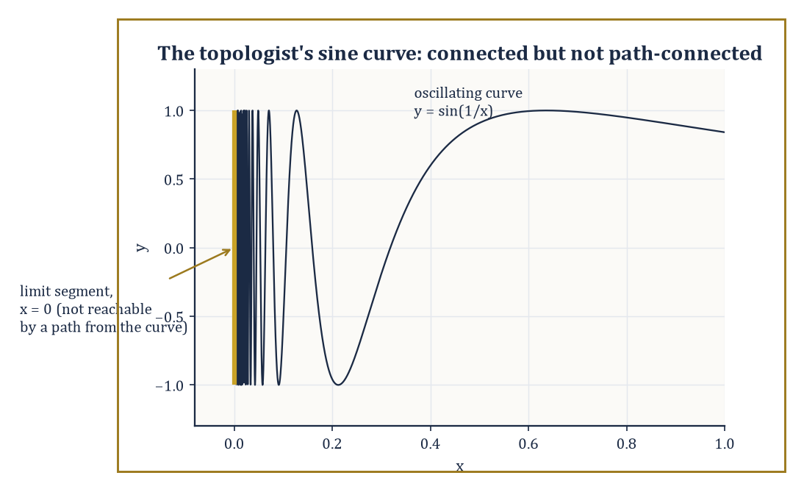
The topologist's sine curve: the oscillating graph and the vertical segment it accumulates onto form one connected set that no path can actually cross.
Continuous images of connected spaces are connected: if f: X → Y is continuous and X is connected, then f(X) cannot be disconnected either, since a splitting of f(X) into two disjoint nonempty open pieces would pull back to a splitting of X.
The classical intermediate value theorem is exactly the special case where X is a closed interval [a,b] (connected, since intervals in ℝ are precisely the connected subsets) and f is continuous and real-valued: the image f([a,b]) is connected, hence an interval, hence contains every value between f(a) and f(b).
Numeric example — Worked example: a disconnection and an intermediate value. First, a disconnection: ℝ minus {0} splits as the union of two disjoint nonempty open sets whose union is the whole punctured line.
ℝ \ {0} = (−∞,0) ∪ (0,∞)
So ℝ minus {0} is disconnected, matching the picture of two separate half-lines with a gap punched in the middle. Now the intermediate value theorem itself: let f(x) = x² − 2 on the connected interval [1,2].
f(1) = 1 − 2 = −1
f(2) = 4 − 2 = 2
Since f is continuous and [1,2] is connected, f([1,2]) is an interval containing both −1 and 2, hence containing 0 — so somewhere in (1,2) there is a root of x² − 2 = 0, namely
x = √2 ≈ 1.41421
Connectedness of the interval is doing all the real work here; the familiar fact that a continuous function cannot skip a value is nothing but the connectedness of [1,2] transported through f.
The connected components of a space are its maximal connected subsets — every point lies in exactly one component, components are always closed, and the space is connected precisely when it has a single component.
Numeric example — Worked example: counting the pieces. Let
X = [0,1] ∪ [2,3] ⊂ ℝ
with the subspace topology. Each of [0,1] and [2,3] is connected (both are intervals), and they cannot be joined into a larger connected subset of X, since any subset straddling both would itself split along the gap between 1 and 2 — for instance
U = X ∩ (−1, 1.5) = [0,1]
V = X ∩ (1.5, 4) = [2,3]
are disjoint, nonempty, and open in X, with union all of X. So X has exactly two connected components, [0,1] and [2,3], matching the picture of two separate solid bars with a visible gap between them.
Path-connectedness demands more: X is path-connected if any two points x, y ∈ X can be joined by a continuous path γ: [0,1] → X with γ(0) = x and γ(1) = y.
Every path-connected space is connected (the image of the connected interval [0,1] under a continuous map is connected, and it links x to y), but the converse can fail.
In Euclidean space specifically, open connected sets are always path-connected — one can always thread a polygonal path between any two points of an open connected region — so the two notions coincide for the friendly open regions differential geometry has been living in for the last several storeys. The divergence shows up only once the space is allowed to be less well-behaved, and local connectedness (every point has arbitrarily small connected neighbourhoods) and local path-connectedness are the technical conditions that keep the two notions tied together.
Numeric example — Worked example: a straight-line path. To connect two points of ℝ² explicitly, take x = (0,0) and y = (3,4).
γ(t) = (1−t)x + t·y = (3t, 4t), t ∈ [0,1]
This is a continuous path with γ(0) = (0,0) and γ(1) = (3,4), threading through every point in between:
γ(0.5) = (1.5, 2)
the midpoint of the segment. Since ℝ² is open, connected, and convex, this straight-line trick works for any pair of points at all, confirming directly that ℝ² is path-connected — and hence, since path-connected always implies connected, also confirming that ℝ² is connected, without needing to hunt for a hypothetical disconnection and rule it out by hand.
Abstract example — Worked example: the topologist's sine curve. The standard example of connected-but-not-path-connected is the topologist's sine curve: let S be the graph
{(x, sin(1/x)) : 0 < x ≤ 1}
together with the extra segment
{(0,y) : −1 ≤ y ≤ 1}
on the vertical axis. As x approaches 0 from the right, 1/x blows up and sin(1/x) oscillates through every value in [−1,1] infinitely often, so the curve's closure necessarily includes the whole vertical segment — which is exactly why S is connected: it cannot be split into two disjoint open pieces, since every neighbourhood of a point on the vertical segment meets the oscillating curve.
But S is not path-connected: no continuous path can start on the vertical segment and reach the oscillating part, because any such path would need infinitely many oscillations in a finite time interval near x = 0, which continuity forbids. It is the standard cautionary tale told to anyone tempted to assume connected automatically means path-connected, and it earns its keep in every topology course for exactly that reason.

Room 32.5: Compactness
A Kind of Finiteness, Politely Disguised
A space X is compact if every open cover of X — every collection of open sets whose union is all of X — admits a finite subcover, a finite sub-collection that still covers all of X.
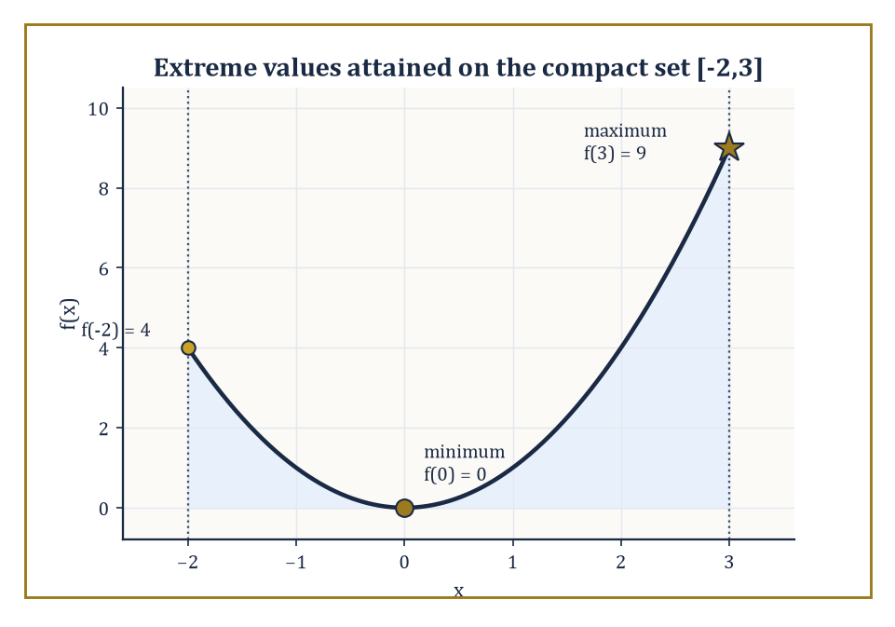
f(x) = x^2 on the compact interval [-2,3]: the extreme value theorem's minimum and maximum are not just approached but actually attained, at x = 0 and x = 3.
The definition looks almost too weak to be useful the first time one meets it, since it says nothing about size or boundedness directly; its power only becomes visible once one starts using it.
The intuition worth holding onto is that compactness is the topological stand-in for finiteness: many arguments that work effortlessly on a finite set (a finite set of numbers always has a largest element; a function on a finite set is automatically bounded) turn out, almost unchanged, to work on any compact set as well, however infinite it may be as a set of points. The finite-subcover clause is precisely the mechanism that smuggles a finite argument into an infinite setting, which is why compactness hypotheses show up so relentlessly throughout analysis.
Numeric example — Worked example: two spaces that fail to be compact, and why. Cover the open interval (0,1) by the sets Uₙ = (1/n, 1) for n = 2, 3, 4, … . Every point of (0,1) lies in some Uₙ (a point x has 1/n < x once n exceeds 1/x), so this is a genuine open cover.
But no finite sub-collection Uₙ₁, …, Uₙₖ covers (0,1): taking N as the largest index among the finitely many chosen, the union of the chosen sets is still just (1/N, 1), which misses every point in (0, 1/N] — for instance the point 1/(2N) is left uncovered.
Since any proposed finite subcover always leaves a point out, no finite subcover exists, and (0,1) is not compact; the failure traces to (0,1) not being closed (it is missing its boundary point 0).
A second, complementary failure: cover the whole line ℝ by Vₙ = (−n, n) for n = 1, 2, 3, …, a genuine open cover since every real number lies in some Vₙ.
Any finite sub-collection has a largest index N, and its union is just (−N, N), which misses N + 1 and every point beyond it — so ℝ is not compact either, this time because it is unbounded rather than because it is missing a boundary point.
Heine–Borel needs both closed and bounded, and these two examples show neither condition alone is enough to spare.
In Euclidean space, the Heine–Borel theorem gives a complete and computable answer: a subset of ℝⁿ is compact exactly when it is both closed and bounded.
Continuous images of compact spaces are compact, and a continuous real-valued function on a compact space is automatically bounded and attains both a maximum and a minimum — the extreme value theorem, another classical result from single-variable calculus revealed as a special case of a purely topological fact.
Numeric example — Worked example: extreme values on a compact set. Let f(x) = x² on the compact set [−2,3] (closed and bounded, hence compact by Heine–Borel).
The minimum occurs at x = 0, since x² ≥ 0 everywhere with equality only at the origin, which lies in the domain.
f(0) = 0
The maximum occurs at whichever endpoint is farther from 0.
f(−2) = 4
f(3) = 9
So the maximum is 9, attained at x = 3. Both extrema are actually attained, as compactness guarantees — contrast this with f(x) = x² on the non-compact open interval (−2,3), where the supremum is still 9 but is never reached, since x = 3 is excluded from the domain.
Sequential compactness — every sequence has a convergent subsequence — coincides with compactness for metric spaces (this equivalence is the content of the Bolzano–Weierstrass theorem in its topological dress), though the two notions can diverge in more exotic, non-metrizable topological spaces.
Tychonoff's theorem states that an arbitrary product of compact spaces, even an infinite product, is again compact; the proof requires the axiom of choice, and the result is one of the hardest-working single theorems in analysis and logic, quietly underwriting compactness arguments in infinite-dimensional settings where Heine–Borel gives no direct help.
Numeric example — Worked example: a subsequence that behaves. On the compact interval [−1,1], take the sequence xₙ = (−1)ⁿ, i.e. −1, 1, −1, 1, … . The full sequence does not converge (it oscillates forever), but it has convergent subsequences.
The even-indexed terms x₂, x₄, x₆, … are all 1, converging trivially to 1, and the odd-indexed terms are all −1, converging to −1.
Sequential compactness of [−1,1] only promises some convergent subsequence exists, not that the whole sequence converges — and indeed here there are two, landing on the two different limit points 1 and −1, both comfortably inside the compact set.
Abstract example — Worked example: an infinite product that stays compact. For a genuinely infinite-dimensional instance, consider the countably infinite product {0,1} × {0,1} × {0,1} × ⋯, each factor the two-point discrete space (certainly compact, being finite).
A point of this product is an infinite sequence of coin-flips, (b₁,b₂,b₃,…) with each bᵢ ∈ {0,1}.
Tychonoff's theorem guarantees this infinite product is compact in the product topology — by no means obvious from staring at it, since the space has uncountably many points and no finite subcover is remotely visible by inspection.
This particular compact space, incidentally, is homeomorphic to the Cantor set, connecting an abstract existence theorem back to one of the strangest concrete objects in all of analysis.

Room 32.6: Separation Axioms and Countability
How Civilised Is Your Space?
Separation axioms measure how generously a topology allows points and closed sets to be pried apart using open sets.
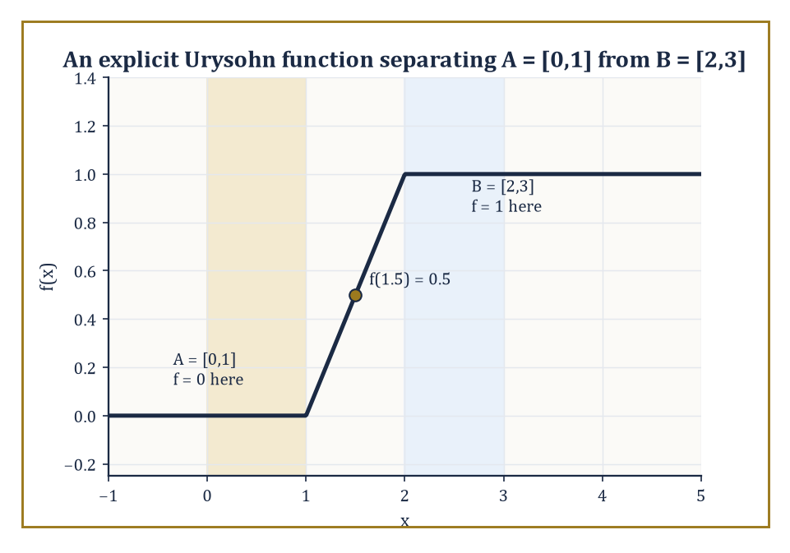
An explicit Urysohn function ramping linearly from 0 on A = [0,1] to 1 on B = [2,3] — the closed sets kept apart, the numbers kept honest.
The hierarchy runs, roughly, T₀ (distinct points have at least one open set containing one but not the other), T₁ (each single point is a closed set), T₂ or Hausdorff (any two distinct points have disjoint open neighbourhoods), regular and T₃ (a point and a closed set not containing it can be separated by disjoint open sets), and normal and T₄ (any two disjoint closed sets can be separated by disjoint open sets).
Hausdorff is the working assumption of almost all of analysis: in a Hausdorff space, compact subsets are automatically closed, and limits of sequences, when they exist, are unique — without the Hausdorff property, a sequence can legitimately converge to two different points at once, exactly the kind of pathology one wants to rule out before doing calculus.
Abstract example — Worked example: T₀ without T₁. Recall the Sierpiński space Y = {1,2} with topology { ∅, {1}, Y }.
It is T₀: the open set {1} contains 1 but not 2, enough to distinguish them.
But it fails T₁: T₁ requires every singleton to be closed, and {1} is closed only if its complement {2} is open — but {2} is not among the three sets in the topology, so {1} is not closed, and Y fails T₁.
It therefore also fails Hausdorff, since Hausdorff would require disjoint open neighbourhoods separating 1 from 2, and the only open set containing 2 at all is Y itself, which also contains 1.
Abstract example — Worked example: T₁ without Hausdorff. For a subtler example, return to the cofinite topology on an infinite set, say ℝ (open sets: complements of finite sets, plus ∅).
This space is T₁: every singleton {x} is closed, since its complement is ℝ minus {x}, cofinite and hence open.
But it is not Hausdorff: take any two distinct points x ≠ y and any open sets U ∋ x, V ∋ y.
Each has finite complement, so U ∩ V has complement equal to the union of two finite sets — still finite — meaning U ∩ V is cofinite, and in particular nonempty (an infinite set minus a finite set is never empty).
So U and V can never be made disjoint, however cleverly chosen, and the cofinite topology on an infinite set satisfies T₁ without satisfying Hausdorff — the standard example showing the separation hierarchy really does have distinct rungs.
Countability axioms measure the size of the topology's bookkeeping rather than its separating power.
A space is first-countable if every point has a countable neighbourhood basis; second-countable if the whole topology has a countable basis; and separable if it contains a countable dense subset.
Second-countable spaces are automatically separable and Lindelöf (every open cover has a countable subcover), and manifolds are conventionally required to be second-countable precisely so that they admit countable atlases and partitions of unity — the technical infrastructure differential geometry, in the previous storey, quietly relied on throughout.
Numeric example — Worked example: ℝ is second-countable and separable. ℝ with its usual topology is second-countable: the collection of open intervals (p,q) with p, q rational forms a countable basis, since there are only countably many pairs of rationals, and every open subset of ℝ is a union of such intervals.
ℝ is also separable, witnessed directly by ℚ itself: every real number is a limit of rationals — for instance:
1.4, 1.41, 1.414, 1.4142, … converges to √2
— so ℚ, a countable set, is dense in ℝ.
These are the same underlying fact wearing two different hats — a countable basis of intervals and a countable dense set of points — and the equivalence between them is exactly what second-countability buys you.
Urysohn's lemma is the payoff for working in a normal space: given two disjoint closed sets A and B, there exists a continuous function
f: X → [0,1], with f ≡ 0 on A and f ≡ 1 on B
The Tietze extension theorem strengthens this further, allowing any continuous real-valued function defined on a closed subset to be extended continuously to the whole space.
Together they are the bridge from the purely qualitative world of open and closed sets back into the world of honest, computable, real-valued functions — the world analysis actually wants to work in.
Numeric example — Worked example: an explicit Urysohn function. On ℝ (normal, being metric), take the disjoint closed sets:
A = [0,1], B = [2,3]
An explicit Urysohn function is given piecewise, ramping linearly from 0 to 1 across the gap between the two closed sets:
f(x) = 0 for x ≤ 1
f(x) = x − 1 for 1 ≤ x ≤ 2
f(x) = 1 for x ≥ 2
Check continuity at the joins. At x = 1, the left piece gives f(1) = 0 and the middle piece gives:
f(1) = 1 − 1 = 0
matching. At x = 2, the middle piece gives:
f(2) = 2 − 1 = 1
and the right piece gives f(2) = 1, matching again. And at the midpoint of the gap:
f(1.5) = 1.5 − 1 = 0.5
exactly halfway between the two target values, as the linear ramp promises.
This one function, built by hand in thirty seconds, is already an instance of Urysohn's lemma in action — the general theorem simply guarantees such a function exists even when the two closed sets are too gnarled to write a formula down by inspection.

Room 32.7: Homotopy and the Fundamental Group
Counting Holes for a Living
Two continuous maps f, g: X → Y are homotopic if there is a continuous family of maps H: X × [0,1] → Y, a homotopy, interpolating between them, so that at the endpoints of the time parameter it agrees with f and g:
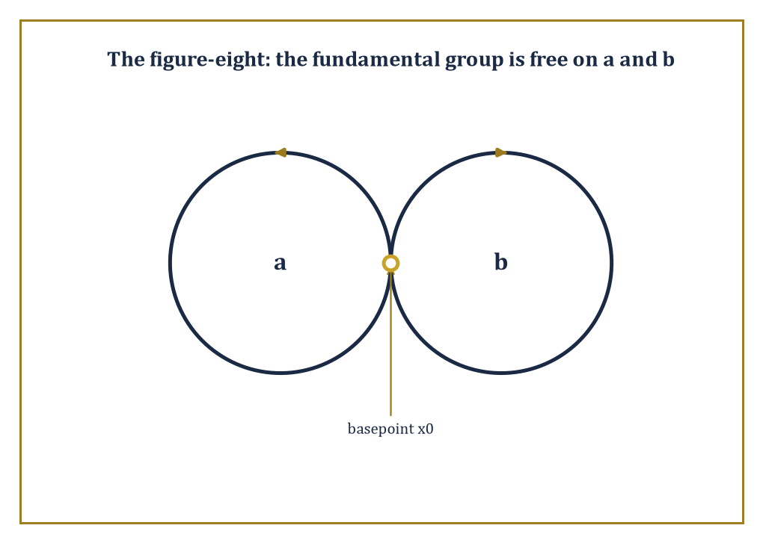
The figure-eight's two lobes, a and b, generate its fundamental group freely — with no filled-in square behind them to let one loop slide past the other and force them to commute.
H(x,0) = f(x), H(x,1) = g(x) for every x
Think of the parameter t ∈ [0,1] as time, and H(·,t) as a film showing f smoothly morphing into g.
Homotopy is an equivalence relation and is compatible with composition, so it descends to a sensible notion of sameness up to continuous deformation for maps, not just for spaces.
A space X is contractible if the identity map on X is homotopic to a constant map — informally, if X can be continuously shrunk down to a single point without leaving X.
Numeric example — Worked example: sliding one point to another, and shrinking a plane. In ℝ² (or any convex subset of it), any two continuous maps f, g: X → ℝ² are homotopic via the straight-line homotopy, sliding each image point along the segment from f(x) to g(x):
H(x,t) = (1−t)f(x) + t·g(x)
Take X a single point, f the constant map to (2,3), and g the constant map to (0,0). Then:
H(t) = (1−t)(2,3) + t(0,0) = (2(1−t), 3(1−t))
At t = 0, H = (2,3); at t = 0.5, H = (1, 1.5); at t = 1, H = (0,0)
That is a straight, continuous slide from one point to the other.
The same recipe applied to the identity map on all of ℝ², homotoped to the constant map at the origin, shows ℝ² itself is contractible:
H(x,t) = (1−t)x
Every point slides straight in to the origin as t runs from 0 to 1, and at t = 1 the whole plane has collapsed onto a single point.
Fix a basepoint x₀ ∈ X. The fundamental group π₁(X,x₀) is the set of homotopy classes of loops based at x₀ — continuous maps γ: [0,1] → X satisfying:
γ(0) = γ(1) = x₀
Two loops count as homotopic if one can be continuously deformed into the other while keeping the basepoint fixed throughout.
The group operation is concatenation — run one loop, then the other, at double speed to fit into the same time interval — and this genuinely satisfies the group axioms up to homotopy, with the constant loop at x₀ as identity and a loop run backwards as its inverse.
π₁ is a topological invariant: homeomorphic spaces have isomorphic fundamental groups, based at corresponding points, for path-connected spaces where the basepoint choice does not matter.
Numeric example — Worked example: concatenating two loops. Concatenation is defined piecewise: for loops γ, δ based at x₀,
(γ ∗ δ)(t) = γ(2t) for t ∈ [0, 1/2], and δ(2t − 1) for t ∈ [1/2, 1]
That is, run γ in the first half of the time available, δ in the second half, each compressed to fit. Now concatenate the winding-number-1 loop
γ₁(t) = (cos 2πt, sin 2πt)
with itself, and check continuity at the join, t = 1/2:
γ₁(2t) at t = 1/2 gives γ₁(1) = (1,0), matching γ₁(0) = (1,0)
So the join is continuous. Over the first half the loop winds around once; over the second half it winds around once more; the concatenation has total winding number
1 + 1 = 2
matching γ₂ from the example below and confirming that the group operation on π₁(S¹) really does correspond to addition of integers under the winding-number isomorphism.
Numeric example — Worked example: winding number two on the circle. For the circle S¹, the fundamental group π₁(S¹) is the infinite cyclic group ℤ, and the isomorphism has a concrete description: it sends a loop to its winding number, the signed number of times the loop travels around the circle. Take the loop
γₙ(t) = (cos 2πnt, sin 2πnt), for an integer n
This loop starts and ends at (1,0) and winds around exactly n times. For n = 2, trace it step by step:
t = 0: γ₂(0) = (1,0)
t = 1/4: 2π·2·(1/4) = π, cos π = −1, sin π = 0, so γ₂(1/4) = (−1,0)
t = 1/2: 2π·2·(1/2) = 2π, so γ₂(1/2) = (1,0)
t = 3/4: 2π·2·(3/4) = 3π, so γ₂(3/4) = (−1,0)
t = 1: 2π·2·1 = 4π, so γ₂(1) = (1,0)
That's two full laps — winding number 2, corresponding to the element 2 ∈ ℤ. No two loops with different winding numbers are homotopic, since a loop cannot be unwound without cutting it as it crosses the hole — which is why π₁(S¹) is genuinely infinite rather than trivial or finite.
The torus has fundamental group ℤ × ℤ, generated by two independent loops — one going around the long way through the hole, one going the short way around the tube — that commute with each other, since the two loops can slide past one another on the surface.
The figure-eight, two circles joined at a single point, has fundamental group free on two generators, one loop per lobe, and crucially these do not commute: going around the left lobe then the right is not homotopic to right-then-left, since there is no room on a figure-eight for one loop to slide past the other the way there was on the torus.
Abstract example — Worked example: why the torus's two loops commute. Picture the torus as a square with opposite sides identified: the bottom edge glued to the top edge produces the loop b (the long way through the hole), the left edge glued to the right edge produces the loop a (the short way around the tube).
Tracing a then b runs along the bottom edge and then up the right edge of the square; tracing b then a runs up the left edge and then along the top edge.
Because the whole square is filled in — it is a solid 2-cell, not just its boundary — one path can be slid continuously across that filled interior onto the other, so the loop a, then b, then a backwards, then b backwards, is homotopic to the constant loop at the corner:
aba⁻¹b⁻¹ ≃ constant loop at the corner
and a and b commute exactly as ℤ × ℤ requires. The figure-eight has no such filled square lurking behind its two loops, which is precisely why its two generators are free to disagree about order rather than being forced to agree.
The Seifert–van Kampen theorem lets one compute the fundamental group of a space built by gluing two open pieces U, V together along a path-connected overlap, in terms of π₁(U), π₁(V), and π₁(U ∩ V):
π₁(U ∪ V) ≈ π₁(U) ∗ π₁(V), with relations imposed by however loops in the overlap map into each piece
Abstract example — Worked example: van Kampen on the figure-eight. Apply the theorem directly to the figure-eight: let U be a small neighbourhood of the left circle, deformation-retracting onto it, and V a small neighbourhood of the right circle, likewise deformation-retracting, so that:
π₁(U) ≅ ℤ, π₁(V) ≅ ℤ
The two neighbourhoods overlap only in a small contractible patch around the shared basepoint, where π₁(U ∩ V) is trivial. With no relations imposed by the trivial overlap group, Seifert–van Kampen gives:
π₁(figure-eight) = ℤ ∗ ℤ
exactly the free group on two generators asserted above — the general gluing theorem reproducing, from a formula, the answer stated by direct inspection two paragraphs earlier, which is reassuring in the way two independent routes to the same destination always are.

Room 32.8: Covering Spaces and Classification of Surfaces
The Complete List, No Exceptions
A covering space of a base space X is a space X̃ together with a map p: X̃ → X that is a local homeomorphism with discrete fibers.
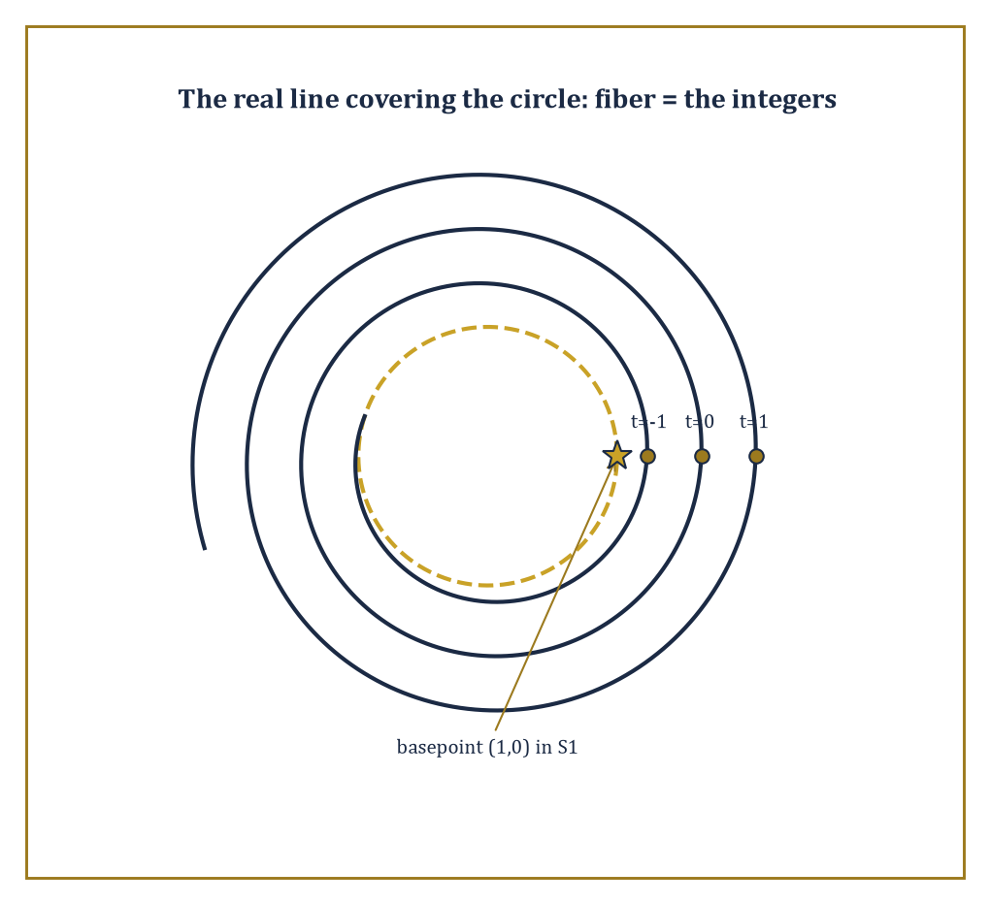
The real line spirals endlessly above the circle's basepoint (1,0); each integer t marks one more sheet of the cover, and the whole tower unwinds the one loop the circle cannot shrink away.
Concretely, every point of X has an open neighbourhood U such that p⁻¹(U) splits into disjoint open copies of U, each mapped homeomorphically onto U by p — the classic image is a spiral staircase or parking-garage ramp lying above a circle on the ground, wrapping around it repeatedly.
The word local is doing serious work in that definition: p need not be a homeomorphism globally — indeed the whole point of the construction is usually that it is not, since it is precisely the many-to-one wrapping that lets a simply connected space like the staircase sit above a space with a genuine hole, like the circle at its base.
Numeric example — Worked example: the line covering the circle. The standard example is p: ℝ → S¹, wrapping the real line around the circle infinitely many times, given by the map below.
p(t) = (cos 2πt, sin 2πt)
Take the base point (1,0) ∈ S¹; its fiber, p⁻¹((1,0)), is the set of all t satisfying the two conditions below.
cos 2πt = 1 and sin 2πt = 0
These conditions hold exactly when t is an integer, so the fiber is a discrete copy of the integers sitting inside ℝ:
p⁻¹((1,0)) = {…,−2,−1,0,1,2,…} = ℤ
Near (1,0), a small arc of the circle lifts to infinitely many disjoint small intervals on ℝ, one around each integer, and p restricted to any one of them is a homeomorphism onto the arc — exactly the local-homeomorphism-with-discrete-fibers picture the definition demands.
The fundamental group of the base acts on the fiber above the basepoint, and this action turns out to encode the entire classification: covering spaces of X (with X reasonably well-behaved) correspond exactly to subgroups of π₁(X), up to a natural notion of equivalence.
The trivial subgroup corresponds to the universal cover — the most unwound covering space, itself simply connected, from which every other covering space can be built as a further quotient.
Abstract example — Worked example: the double cover of the circle. For S¹, the subgroup 2ℤ ⊂ ℤ = π₁(S¹) — the even integers, index 2 in the full group — corresponds to the double cover q: S¹ → S¹, given below.
q(z) = z², or equivalently q(θ) = 2θ on angles
A loop winding once around the base circle (winding number 1) does not lift to a closed loop at all: it lifts to an open path that travels only halfway around the covering circle, ending at the point diametrically opposite where it started.
Only loops whose winding number is a multiple of 2 lift to genuinely closed loops upstairs, exactly matching the subgroup 2ℤ.
The universal cover of S¹, corresponding to the trivial subgroup {0} ⊂ ℤ, is precisely the ℝ → S¹ covering from the previous example. ℝ is simply connected, so there is nowhere further to unwind, and every other cover of the circle sits between ℝ and S¹ in this hierarchy of subgroups.
Closed surfaces — compact, connected, boundaryless two-dimensional manifolds — are completely classified up to homeomorphism by two pieces of data: orientability, and genus, the number of handles.
The orientable ones form the sequence: the sphere (genus 0, no handles), the torus (genus 1, one handle), the double torus (genus 2, two handles glued in a connected sum), and so on.
The non-orientable ones are built from connected sums of projective planes: the projective plane itself, the Klein bottle (the connected sum of two projective planes), and further sums beyond that.
Every closed surface, however wildly it is presented, is homeomorphic to exactly one entry on this list — one of the genuinely complete classification theorems in all of topology, and the historical template every later, harder classification problem in topology has tried, usually without success, to imitate.
Numeric example — Worked example: reading off genus from the Euler characteristic. The Euler characteristic — vertices minus edges plus faces, for any polyhedral decomposition of the surface — is a complete invariant distinguishing genus, given by the formula below.
χ = V − E + F
For an orientable surface of genus g, it relates to the genus by the formula below.
χ = 2 − 2g
Take a cube: it has 8 vertices, 12 edges, and 6 faces, giving the Euler characteristic below.
χ = 8 − 12 + 6 = 2
Solving for the genus gives the result below, correctly identifying the cube's surface as topologically a sphere — which indeed it is, since rounding off the corners deforms it straight into one.
2 = 2 − 2g, so g = 0
For the double torus, genus g = 2 by construction, so the Euler characteristic works out as shown below.
χ = 2 − 2(2) = 2 − 4 = −2
This negative Euler characteristic reflects that each additional handle punches the count down by 2, offering a clean numeric fingerprint for a shape that would otherwise take some effort to describe in words.
This same Euler characteristic reappears, unexpectedly from the topological side, as the topological half of the Gauss–Bonnet theorem from the previous storey: the integral of Gaussian curvature K over the surface equals 2πχ.
The left-hand side is a purely geometric, distance-dependent quantity; the right-hand side is a purely topological invariant that does not care how the surface is bent or measured, only how many handles it has.
That a curvature integral, which visibly depends on the metric, always collapses to a multiple of a topological invariant that does not depend on the metric at all, is as good a one-line summary as any of why geometry and topology insist on talking to each other.
It also settles, in one stroke, a question that might otherwise seem to require checking every possible metric one at a time: no matter how a torus is bent, stretched, or dented, the total curvature spread across it always integrates to exactly the value below (since χ(torus) = 0).
2π·0 = 0
This is because bending the surface can move curvature around from one region to another but can never change the topological total it is required to sum to.

Room 32.9: Looking Ahead: From Basic Topology to Algebraic Topology and Manifolds
Onward, Upward, Still No Ruler
We have, in the space of eight rooms, built the working core of point-set topology and taken the first real steps into algebraic topology: topological spaces and continuous maps, connectedness and compactness as the two basic global invariants, the separation and countability axioms that keep spaces well-behaved enough for analysis, homotopy and the fundamental group as our first genuinely algebraic invariant, and covering spaces and the classification of closed surfaces as the reward for all the machinery — a complete, checkable answer to the question of what shapes a closed surface can actually be.
It is worth pausing on how much of that list needed no numbers at all. Connectedness, compactness, and the fundamental group were each defined without ever writing down a distance, and yet each one was strong enough to prove genuine, sharp, previously-unobvious facts — that a circle is not a disc, that a bounded interval is secretly the same shape as the whole real line, that a doughnut and a two-holed pretzel are different no matter how one is squashed toward the other.
The emptiness promised on this storey's opening page turned out, true to form, to be exactly the source of the strength.
These tools open directly onto the rest of the subject. Higher homotopy groups πₙ(X) for n ≥ 2 generalise the fundamental group to loops of higher dimension (a map from the n-sphere rather than the circle); homology and cohomology theories offer computationally friendlier invariants that, unlike the higher homotopy groups, are almost always tractable to actually calculate, at some cost in discriminating power.
Manifold topology narrows attention to spaces that look locally like Euclidean space, and becomes the shared setting of differential topology and geometric topology, where the classification triumph of Room 32.8 is attempted, with much greater difficulty and several dimensions higher, for 3-manifolds and 4-manifolds — a project that consumed a fair fraction of twentieth-century mathematics and is nowhere near as finished as the surface case might lead one to hope.
Abstract example — Worked example: a fundamental group that misses something. Consider S², the ordinary sphere. Its fundamental group π₁(S²) is trivial — any loop on a sphere can be slid off to one side and shrunk to a point, since the sphere has no hole for a loop to catch on.
But its second homotopy group π₂(S²) is ℤ, detected by the identity map from S² to itself, which cannot be continuously deformed to a constant map (a fact provable rigorously via degree theory).
More strikingly still, π₃(S²) is also infinite cyclic — the celebrated Hopf fibration, an honestly surprising fact that no amount of staring at loops alone could have revealed.
The fundamental group, powerful as it is, is blind to structure that only shows up one or two dimensions higher, which is exactly the gap the higher homotopy groups and homology theories exist to close.
Abstract example — Worked example: what homology forgets, on purpose. Homology's tractability comes largely from a theorem of Hurewicz relating it back to the fundamental group: for a path-connected space, the first homology group H₁(X) is the abelianisation of π₁(X) — the same group with a new relation forced on it, that every pair of elements commutes.
Recall from earlier in this room that π₁(figure-eight) is the free group on two generators a and b, where a and b do not commute: the element aba⁻¹b⁻¹ (go around the left lobe, then the right, then backward around the left, then backward around the right) is not the identity in the free group, since nothing forces the loops to slide past each other.
Pass to the abelianisation, however, and aba⁻¹b⁻¹ becomes, once commuting is allowed to reorder the letters:
ab a⁻¹ b⁻¹ = (aa⁻¹)(bb⁻¹) = e
So:
H₁(figure-eight) = ℤ × ℤ
That is strictly smaller information than π₁(figure-eight) itself. Homology, in other words, is the fundamental group with all the non-commuting detail sanded off: easier to compute, because there is provably less of it to compute.
Further out still, characteristic classes and cobordism theory extract algebraic invariants from manifolds equipped with extra structure — a vector bundle, an orientation — and these feed directly into index theorems, results equating an analytic quantity (counting solutions to a differential equation) with a topological one (an integral of characteristic classes), and into the gauge theory used in mathematical physics, where the topology of a space of fields constrains the physics living on it.
The flagship result of manifold topology in dimension three is the Poincaré conjecture: every simply connected closed 3-manifold is homeomorphic to the 3-sphere S³, a claim that sounds like nothing more than a three-dimensional cousin of the surface classification in Room 32.8, and which resisted proof for very nearly a century until Grigori Perelman settled it in 2003 — fittingly enough, using Ricci flow, a tool borrowed from the previous storey's subject rather than from topology's own toolkit.
Its four-dimensional analogue remains open to this day, a reminder that the tidy, finished classification of surfaces was a nineteenth-century gift that later dimensions have been under no obligation to repeat.
The throughline connecting all of it back to this storey's opening page is simple to state and endlessly productive in practice: continuity alone, with no distance in sight, is already a powerful organising principle, and the qualitative shape of a space can be captured by algebraic invariants that are both genuinely computable and genuinely discriminating.
We arrived at the top of this storey having built, from nothing but open sets and continuity, a working vocabulary for shape itself: connectedness for being in one piece, compactness for a kind of topological finiteness, separation axioms for civility, and a fundamental group sharp enough to prove, by pure algebra, that a circle is not a disc and a sphere is not a torus. Along the way we recovered the classification of closed surfaces — genus and orientability, the complete list, no exceptions — one of the great satisfying finished theorems of the subject, in a field not otherwise overflowing with finished theorems.
The next storey puts a surprising amount of the ruler back. Integral geometry asks what happens when one integrates, not over a space of points, but over a space of lines, planes, or other geometric objects sweeping through it — Crofton's formula, the kinematic measure, and their descendants recover geometric quantities like length and area by averaging over how often a random line happens to cross a curve. It is, in a sense, geometry and topology meeting each other halfway: the measuring apparatus returns, but organised by exactly the kind of global, qualitative thinking this storey has spent its length cultivating.
We have learned, at any rate, to recognise shape without measuring distance. Not a bad trick for a subject whose opening definitions look, on first meeting, almost too thin to hold any weight at all. The Tower continues upward.

Storey 33: Integral Geometry (Advanced)
Valuations, Kinematic Formulas, and the Art of Measuring Geometry with Groups
You have just spent an entire storey being assured that shape, in the end, does not matter. A teacup and a doughnut are, to a topologist squinting through sufficiently smudged spectacles, the same object, and questions like 'how long is it' or 'how much does it hold' were treated as vulgar distractions from the real business of counting holes. It was liberating, in the way that being told your possessions don't matter is liberating right up until the bailiffs arrive with a tape measure. Up here on the thirty-third storey we reverse the polarity entirely. Shape matters again. Size matters again, and rather badly. We are going to spend a great deal of effort insisting that certain numbers attached to a solid lump of space — its volume, its surface area, something engagingly called its 'mean width', and one stubborn old acquaintance, the Euler characteristic, last seen counting holes upstairs — are not merely well defined, but are, in a precise sense that this storey exists to make precise, the only numbers of their kind that could possibly exist.
Long ago, back on Storey 19, we built the classical apparatus of integral geometry: invariant measures on the space of lines and planes, the Cauchy–Crofton theorem relating the length of a curve to how often random lines cross it, and the first, elementary kinematic formulas — averages, taken as one convex body is jiggled and rotated past another, that come out to tidy closed forms. That storey's tools were concrete: pick a line at random, count intersections, integrate. This storey's tools are the same tools with the safety catches removed. Instead of asking 'what happens when I average over lines', we ask 'what is the complete space of quantities that COULD be averaged, and what algebraic structure does it carry'. The answer turns out to be startlingly small and startlingly rigid, and once you know it, every kinematic formula you will ever need writes itself.
The central actors are continuous valuations on convex bodies — functionals that behave like area or volume in the one respect that matters (they add up correctly when you glue pieces together) without necessarily being area or volume. Hadwiger's characterization theorem will tell us, astonishingly, that there are only finitely many independent invariant valuations in each dimension: the intrinsic volumes, full stop, nothing else need apply. Chern's principal kinematic formula will tell us how these interact when one body is swept past another by the full group of rigid motions. And curvature measures will localize all of this, spreading the intrinsic volumes out over the boundary of a body the way a smeared-out density spreads mass over a solid. The whole enterprise leans on the classical material of Storey 19 and on the language of convex geometry and differential forms, so if either has gone a little soft in the memory, a glance backward will not go amiss. Nothing here requires more than that.
A small confession, before we start climbing: advanced integral geometry has a well-earned reputation for being a very long list of very structured formulas, the kind of subject that looks, from the outside, like a phone directory with theorems in it. It stops looking that way the moment you notice that every entry in the list is a consequence of one principle — the uniqueness of invariant valuations, married to the algebraic structure of the kinematic product — so that the geometry is, quite literally, encoded in the representation theory of the motion group. Classical integral geometry taught us to average geometric quantities over lines and planes. The modern theory teaches us to let the entire group of rigid motions act, all at once, and to read the geometry off as an algebraic identity. Let's let the group measure.

Room 33.1: From Classical Formulas to Modern Valuations
In which we stop computing averages and start classifying them
The classical Crofton and kinematic formulas of Storey 19 all share a family resemblance: on the left-hand side sits some geometric quantity of an intersection — a length, an area, a count — and on the right sits an integral over a group of motions. Modern integral geometry performs a small act of intellectual jujitsu: instead of treating each left-hand side as a bespoke computation, it asks what kind of object a 'geometric quantity of a convex body' could be in general, gives that object a name — a valuation — and then classifies all of them at once.
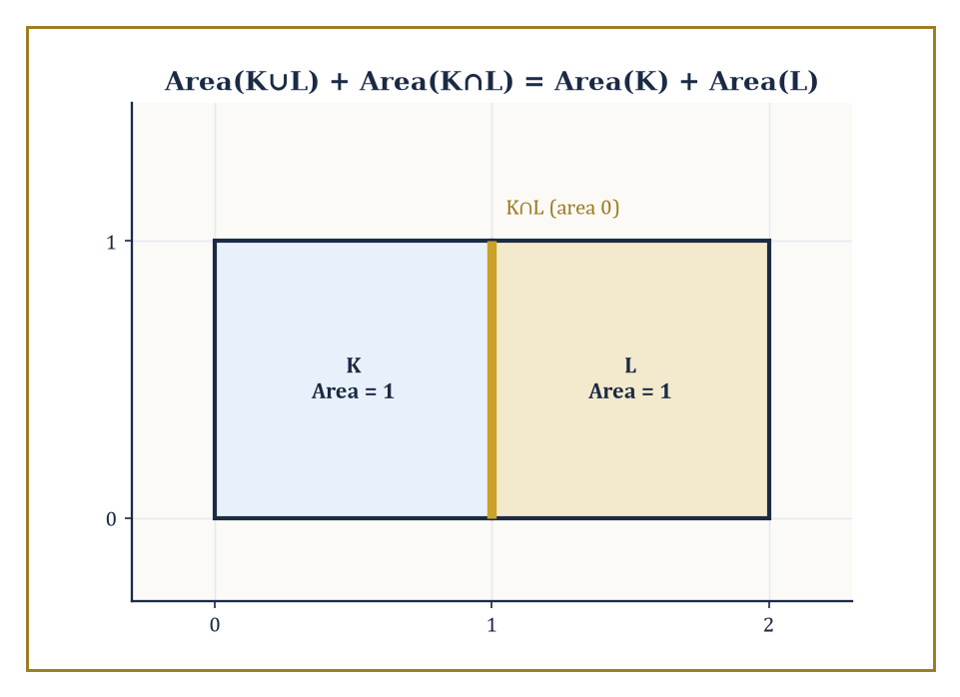
Two unit squares sharing an edge: the union and intersection contribute 2 and 0 respectively, so both sides of the valuation law come to 2.
A valuation is a function μ assigned to convex bodies (or, more generously, to polyhedra, or to the still larger class of sets of positive reach that we will meet in Room 33.4) satisfying one structural law: whenever K and L are convex bodies whose union K∪L also happens to be convex, the following holds.
μ(K∪L) + μ(K∩L) = μ(K) + μ(L)
This is exactly the inclusion–exclusion law that area and volume already obey; a valuation is simply anything that obeys it, whether or not it started life as a measure. Unlike an honest measure, a valuation is not required to be non-negative — the Euler characteristic itself is a valuation that returns 1 for a point and, on more elaborate constructible sets, can happily return negative values — nor is it required to satisfy the stronger countable-additivity axiom that measure theory insists on. What it must do is behave correctly under exactly the one operation convex geometry actually performs on convex sets: gluing two of them together along a shared convex boundary.
Numeric example — Worked example: checking the valuation law on two rectangles. Let K = [0,1]×[0,1] and L = [1,2]×[0,1], two unit squares sharing the edge x = 1. Their union K∪L = [0,2]×[0,1] is itself a rectangle, hence convex, so the valuation law applies directly.
The areas of K and L are:
Area(K) = 1, Area(L) = 1
The intersection K∩L is the segment {1}×[0,1] — a line, with two-dimensional area 0, while the union has area:
Area(K∩L) = 0, Area(K∪L) = 2×1 = 2
Check the law:
Area(K∪L) + Area(K∩L) = 2 + 0 = 2
Area(K) + Area(L) = 1 + 1 = 2
They agree. Note what the example is quietly demonstrating: a valuation need not distinguish a fat two-dimensional overlap from a knife-edge one-dimensional overlap — both simply contribute whatever their own area happens to be, here zero. That is the whole content of the axiom, and it is exactly strong enough to force everything that follows.
The two-body law is not restricted to pairs — applied repeatedly, it extends to any finite union of convex sets, at the cost of a longer inclusion–exclusion sum, exactly as ordinary measure theory would lead one to expect.
This is precisely the mechanism by which a valuation, originally defined only on single convex bodies, extends to the whole ring of polyconvex sets (finite unions of convex bodies): an n-fold union is decomposed by inclusion–exclusion into intersections of subsets, each individually convex or empty, and the valuation's value on the union is assembled from its values on all of them, with alternating signs, the way a careful accountant avoids double-counting overlapping claims.
Numeric example — Worked example: inclusion–exclusion for three overlapping intervals. Let A = [0,4], B = [2,6], C = [4,8] on the real line, all of length 4. The three-set inclusion–exclusion law states:
|A∪B∪C| = |A|+|B|+|C| − |A∩B| − |A∩C| − |B∩C| + |A∩B∩C|
Compute each piece:
A∩B = [2,4], length 2
B∩C = [4,6], length 2
A∩C = [4,4] = {4}, a single point, length 0
A∩B∩C = {4} also, length 0
The right-hand side is therefore:
4+4+4 − 2−0−2 + 0 = 12 − 4 = 8
Directly:
A∪B∪C = [0,8], of length 8
matching exactly. The two-body valuation axiom, applied twice in succession (first to A and B, then to that union and C), reproduces this three-body formula automatically — nobody needed to invent a separate axiom for three sets, or for three hundred.
This is the natural continuation of a research programme going back to Blaschke and Santaló, and completed in the convex setting across the twentieth century by Hadwiger, then Federer, then — bringing genuinely new algebraic structure — Alesker.
Blaschke and Santaló supplied the classical integral formulas of Storey 19; Hadwiger supplied the classification theorem explaining why those particular formulas, and no others, were ever going to arise; Federer supplied the geometric-measure-theoretic machinery (curvature measures, sets of positive reach) needed to push the theory past smooth convex bodies and into genuinely singular ones; and Alesker, working within living memory, supplied the algebra — the discovery that the space of valuations is not merely a list but a ring, with its own multiplication, which Room 33.6 will meet in full.
The intrinsic volumes will turn out to be the complete answer to 'what are the invariant valuations', and the kinematic product will turn out to be the complete answer to 'how do they combine'. Everything else in this storey is detail, admittedly rather a lot of very beautiful detail.
Abstract example — Abstract example: why 'union must be convex' is the whole ballgame. Consider two disjoint unit disks K and L, sitting far apart in the plane. Their union is emphatically not convex — a straight line drawn between a point of K and a point of L leaves the union entirely, passing through the empty space in between. The valuation axiom, as stated, simply does not apply to this pair; it is silent.
And yet ordinary area obeys additivity for disjoint sets regardless, because the intersection is empty:
Area(K∪L) = Area(K) + Area(L), since Area(K∩L) = Area(∅) = 0
The moral is that the valuation axiom is deliberately weaker than full measure-theoretic additivity — it only ever commits itself when the union stays inside the convex world.
This is precisely what makes the theory tractable: to extend a valuation from convex bodies to arbitrary finite unions of convex bodies (the polyconvex sets of the previous paragraph), one must actually prove an extension theorem, rather than getting it for free. That extension theorem exists, and it is the quiet workhorse behind every 'Euler characteristic of a union of convex pieces' computation in the rest of this storey.

Room 33.2: Convex Bodies and Intrinsic Volumes
Steiner's formula, or: what happens when you inflate a shape with a hosepipe
Take a convex body K in ℝⁿ and fatten it: form the parallel body K + εB, the set of all points within distance ε of K, where B is the unit ball and ε > 0. (In ℝ², think of pushing a disc of radius ε out along the whole boundary at once — the corners round off, the edges push out in parallel strips.) The volume of this fattened body turns out to be a polynomial in ε, the Steiner formula.
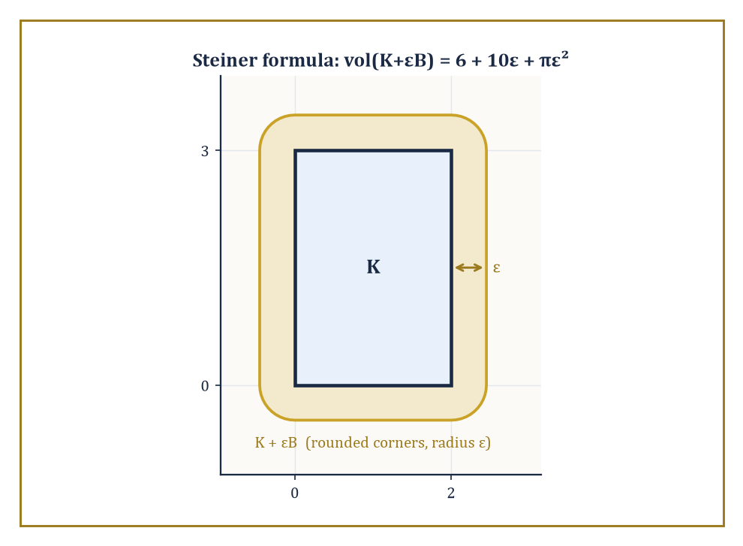
The 2×3 rectangle fattened by ε: its rounded parallel body's area, 6 + 10ε + πε², reads off the three intrinsic volumes at a glance.
vol(K + εB) = Σᵢ ε^(n−i) κ_(n−i) Vᵢ(K)
Here κⱼ denotes the volume of the unit ball in ℝʲ (so κ₀ = 1, κ₁ = 2, κ₂ = π, κ₃ = 4π/3, and so on), and the coefficients V₀(K), …, Vₙ(K) are precisely the intrinsic volumes. They are called 'intrinsic' because, unlike the surface area or the volume of the fattened body, they depend only on K itself, not on the ambient dimension n it happens to be sitting inside — a square is a square whether you view it inside the plane or inside a thousand-dimensional space with 998 spare dimensions doing nothing in particular. Vₙ(K) is ordinary volume, Vₙ₋₁(K) is (half) the surface area, and V₀(K) is the Euler characteristic — which for any convex body, however oddly shaped, is simply 1.
Numeric example — Worked example: Steiner's formula for a 2×3 rectangle. Let K be the rectangle [0,2]×[0,3] in ℝ², so n = 2. Fattening K by ε means keeping the original 2×3 rectangle, adding four border strips (two of size 2×ε along the short sides, two of size 3×ε along the long sides) and rounding the four corners into quarter-circles of radius ε, which together assemble into one full circle of area πε². So directly:
vol(K+εB) = 6 + 2(2ε) + 2(3ε) + πε² = 6 + 10ε + πε²
Now match this against the Steiner formula in ℝ²:
vol(K+εB) = ε²κ₂V₀(K) + εκ₁V₁(K) + κ₀V₂(K) = πε²V₀(K) + 2εV₁(K) + V₂(K)
Comparing coefficients term by term:
V₀(K) = 1
matching the πε² term exactly — and indeed a rectangle, being convex, has Euler characteristic 1.
2V₁(K) = 10, so V₁(K) = 5
exactly half the perimeter, which is 2(2+3) = 10, as it should be.
V₂(K) = 6
the area. Three coefficients, extracted from one polynomial, and every one of them is an old friend wearing a new uniform.
Exactly the same technique works one dimension up, and the reader with a healthy suspicion of things that 'obviously generalize' is encouraged to check it rather than take it on faith — which is exactly what the next example does. In ℝ³ the relevant unit-ball volumes are κ₀ = 1, κ₁ = 2, κ₂ = π, κ₃ = 4π/3, and the Steiner formula now produces four intrinsic volumes, V₀ through V₃, rather than three.
Numeric example — Worked example: Steiner's formula for a ball in ℝ³. Let K be a ball of radius r in ℝ³. Its parallel body K + εB is simply a larger ball of radius r + ε, with volume (4/3)π(r+ε)³. Expand the cube:
(r+ε)³ = r³ + 3r²ε + 3rε² + ε³
so
vol(K+εB) = (4/3)πr³ + 4πr²ε + 4πrε² + (4/3)πε³
Now match against the general ℝ³ Steiner formula:
vol(K+εB) = ε³κ₃V₀ + ε²κ₂V₁ + εκ₁V₂ + κ₀V₃ = (4π/3)ε³V₀ + πε²V₁ + 2εV₂ + V₃
Comparing the constant (ε⁰) terms:
V₃ = (4/3)πr³
the volume, exactly as expected. Comparing the ε¹ terms:
2V₂ = 4πr², so V₂ = 2πr²
half the surface area 4πr², matching the general rule that Vₙ₋₁ is half the surface area. Comparing the ε² terms:
πV₁ = 4πr, so V₁ = 4r
Comparing the ε³ terms:
(4π/3)V₀ = 4π/3, so V₀ = 1
the Euler characteristic of a ball, as it must be.
V₀=1, V₁=4, V₂=2π≈6.283, V₃=4π/3≈4.189
At r = 1, this reads as four numbers, all pulled out of one cubic polynomial, generalizing the 2×3 rectangle example above by exactly one dimension and one extra term, with not a single new idea required.
The intrinsic volumes do not merely sit still waiting to be read off a Steiner expansion; they also satisfy their own integral-geometric identities, generalizing the Crofton and Cauchy formulas of Storey 19. The cleanest of these is the Cauchy projection formula: the perimeter (twice V₁) of a planar convex body equals the integral, over all directions θ from 0 to π, of the width of the body's shadow in that direction. Intuitively, if you shine a very thin beam of light through K from every angle and add up the width of every shadow it casts, you recover exactly the perimeter — a fact that feels almost too generous to be true, and yet is.
Numeric example — Worked example: Cauchy's formula on a unit square. Let K be the unit square with vertices (0,0), (1,0), (0,1), (1,1). Its width function — the length of its shadow when light shines from angle θ — is
w(θ) = |cos θ| + |sin θ|
Cauchy's formula claims
perimeter(K) = ∫₀^π w(θ) dθ
Split the integral. Since sin θ ≥ 0 throughout [0,π]:
∫₀^π |sin θ| dθ = ∫₀^π sin θ dθ = [−cos θ]₀^π = (−(−1)) − (−1) = 2
For cos θ, it is non-negative on [0, π/2] and non-positive on [π/2, π], so:
∫₀^π |cos θ| dθ = ∫₀^(π/2) cos θ dθ + ∫_(π/2)^π (−cos θ) dθ = [sin θ]₀^(π/2) + [−sin θ]_(π/2)^π = 1 + 1 = 2
Adding the two pieces:
∫₀^π w(θ) dθ = 2 + 2 = 4
which is exactly the perimeter of the unit square. As a second check, for a disc of radius r the width is constant, w(θ) = 2r, and
∫₀^π 2r dθ = 2πr
the familiar circumference. Two very different shapes, one formula, no exceptions.

Room 33.3: Continuous Valuations and Hadwiger's Theorem
The theorem that puts the whole subject out of a job, in the best possible way
Fix the valuation law from Room 33.1, add two further demands — invariance under rigid motions (rotate or translate K, and μ(K) does not change) and continuity with respect to the Hausdorff metric (wiggle K a little, and μ(K) wiggles only a little in response, ruling out valuations that jump discontinuously as a body deforms) — and Hadwiger's characterization theorem delivers a result of almost suspicious tidiness: every such μ is a linear combination of the intrinsic volumes V₀, …, Vₙ, and nothing else.
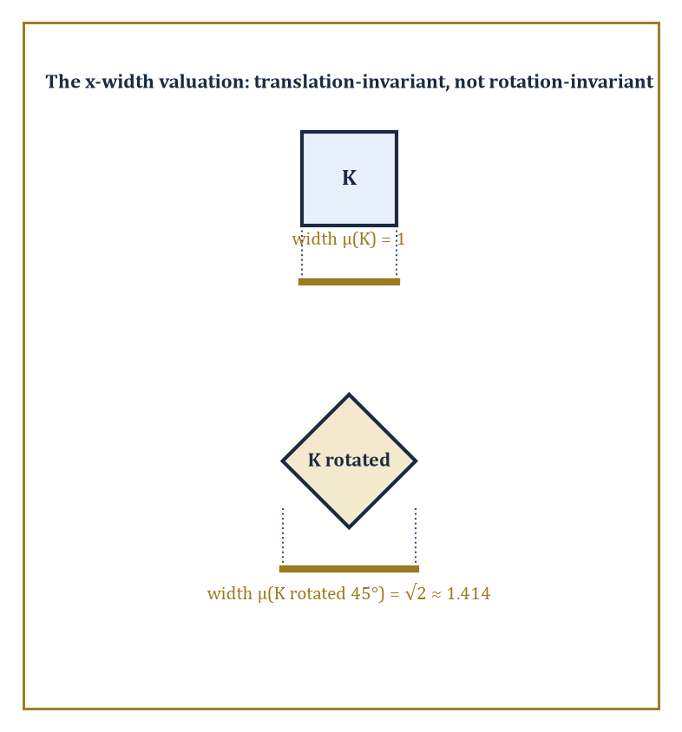
A square's x-shadow has width 1, but rotate it 45° and the shadow widens to √2 — exactly the anisotropy Hadwiger's theorem forbids once rotation-invariance is required.
There is no secret extra invariant valuation lurking undiscovered in some corner of convex geometry; the intrinsic volumes are the entire cast list.
The proof proceeds by induction on dimension, first showing that a valuation vanishing on every lower-dimensional convex body must be a multiple of ordinary volume, and then building the full classification storey by storey (an image this Tower cannot resist).
One practical consequence dominates everything that follows: to identify a mystery invariant valuation, you no longer need to understand it in general — you only need to evaluate it on balls, or any other single convenient family of test bodies, and Hadwiger's theorem guarantees the coefficients you find there are the whole truth about it everywhere else.
Numeric example — Worked example: pinning down a valuation from its values on discs. Suppose μ is known, by whatever means, to be a continuous rigid-motion-invariant valuation in the plane of the form
μ = 2V₀ + 3V₁ + V₂
— perhaps this combination fell out of some computation and we merely want its value on a specific body. Hadwiger's theorem guarantees this is a legitimate and complete description; there is nothing further to check. Evaluate μ on a disc K of radius r = 3. Recall from Room 33.2 that for a disc of radius r,
V₀ = 1, V₁ = πr, V₂ = πr²
where V₁ is half the circumference 2πr and V₂ is the area. At r = 3, these become:
V₀ = 1, V₁ = 3π, V₂ = 9π
μ(K) = 2(1) + 3(3π) + 1(9π) = 2 + 9π + 9π = 2 + 18π
That number, 2 + 18π ≈ 58.55, is now known with total confidence to be the value of μ on every disc of radius 3, on every rotated or translated copy of one, and — via the same linear formula with the intrinsic volumes of whatever body you like — on every convex body in the plane at all.
It is worth pausing to see an example of a perfectly plausible-looking functional that fails to be a valuation at all, if only to appreciate how little slack the definition actually leaves. Consider the functional
μ(K) = 1 if the origin lies in the interior of K, and μ(K) = 0 otherwise
— a natural enough thing to want to measure, and certainly rigid-motion invariant is not what is being claimed here (it flatly is not, since it privileges the origin), but let us test only the additivity law, holding the origin fixed as a landmark, to see whether it even survives that much scrutiny.
Abstract example — Abstract example: a functional that looks geometric but is not a valuation. Let K = [0,2]×[−1,1] and L = [−2,0]×[−1,1], two rectangles meeting along the segment {0}×[−1,1]. Their union K∪L = [−2,2]×[−1,1] is convex, so the valuation law is entitled to be tested.
The origin lies on the boundary of K (on its left edge, x=0), not in its interior, so μ(K) = 0; by the mirror-image argument, μ(L) = 0 as well. The intersection K∩L is the segment {0}×[−1,1], a set with empty interior in the plane, so it cannot contain the origin as an interior point either: μ(K∩L) = 0. But the union K∪L = [−2,2]×[−1,1] does contain the origin in its interior, so μ(K∪L) = 1.
Check the valuation law:
μ(K∪L) + μ(K∩L) = 1 + 0 = 1, while μ(K) + μ(L) = 0 + 0 = 0
These disagree — 1 ≠ 0 — so this 'origin-detector' fails the valuation axiom outright, on a perfectly ordinary pair of convex rectangles, well before invariance or continuity ever enter the discussion. Hadwiger's theorem is not merely ruling out exotic pathologies; the definition of a valuation itself is already strict enough to exclude functionals that look, at a glance, entirely reasonable.
Hadwiger's theorem was proved for scalar-valued valuations on convex bodies in Euclidean space, but the same rigidity persists as the hypotheses are relaxed one at a time.
Drop rotation-invariance and keep only translation-invariance, and the classification enlarges but stays governed by representation theory of the orthogonal group (this is the doorway through which Room 33.6's algebra enters).
Allow the valuation to take values in tensors rather than in scalars, and one obtains the Lipschitz–Killing tensor valuations, central to modern shape statistics. Weaken continuity to a coarser topology, and yet another controlled enlargement results.
In every variant, the moral survives unscathed: an apparently vast space of 'reasonable' geometric functionals collapses, under invariance and continuity, to something finite-dimensional and completely listable.
Numeric example — Worked example: a valuation that survives translation but not rotation. To see the classification genuinely widen once rotation-invariance is dropped, consider the width of K in a fixed direction, say the x-direction — the length of K's shadow when projected onto the x-axis:
μ(K) = max{x : (x,y)∈K} − min{x : (x,y)∈K}
Check the valuation law on the two unit squares from Room 33.1's very first example: K=[0,1]×[0,1] and L=[1,2]×[0,1], with union K∪L=[0,2]×[0,1] convex. Here μ(K)=1, μ(L)=1, μ(K∩L)=μ({1}×[0,1])=0 (a vertical segment has zero x-extent), and μ(K∪L)=2. Check:
μ(K∪L)+μ(K∩L)=2+0=2, and μ(K)+μ(L)=1+1=2
the law holds, so μ is a genuine valuation, and it is translation-invariant, since sliding K along either axis never changes the spread of its x-coordinates.
But μ is emphatically not rotation-invariant: rotate the unit square by 45° about its centre, and its x-shadow becomes the square's diagonal, of length √2 ≈ 1.414, not 1. Nor can μ be written as a combination of V₀, V₁, V₂ alone, since none of those three changes under rotation while μ visibly does.
This is exactly the kind of extra functional that becomes available the moment rotation-invariance is struck from the list of hypotheses, precisely as the preceding paragraph promised, and precisely why the translation-only classification needs more than three numbers to describe it.

Room 33.4: Curvature Measures and the Normal Cycle
Smearing the intrinsic volumes across the boundary, one corner at a time
The intrinsic volumes Vᵢ(K) are global numbers — one figure summarizing the whole body. Curvature measures ask a sharper, more local question: how much of Vᵢ(K) is 'located' near any given patch of the boundary of K? Formally, the i-th curvature measure Cᵢ(K, ·) is a measure supported on (or associated with) the boundary of K, whose total mass over the whole boundary recovers the intrinsic volume:
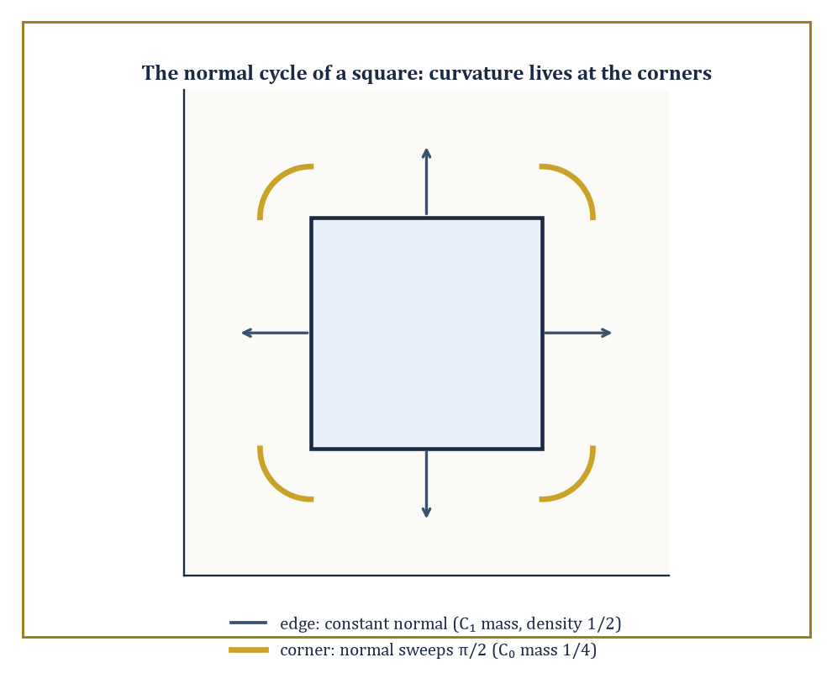
The normal cycle of a square: C₁ spreads evenly along the flat edges while C₀ concentrates entirely in the four π/2 turns at the corners.
Cᵢ(K, ∂K) = Vᵢ(K)
For a smooth convex body this localization is entirely painless — curvature measures are literally built from the classical curvatures of the boundary, integrated against appropriate combinatorial weights. For a body with corners and edges, like a cube or a square, the curvature concentrates in unexpected places: flat faces contribute nothing to the lower curvature measures, while it is the corners and edges that carry all the interesting information, a fact with no classical-calculus analogue since ordinary curvature is not even defined at a corner.
Federer's extension of the theory to sets of positive reach — sets that are locally well-approximated by their tangent planes, a strictly larger class than convex bodies — is what allows curvature measures to survive contact with genuinely non-convex geometry.
Numeric example — Worked example: the Euler curvature measure of a square, concentrated at its corners. Let K be a square, and consider its zeroth curvature measure C₀ — the localization of V₀, the Euler characteristic. For a convex polygon, C₀ places all of its mass at the vertices, and the mass at a vertex equals (exterior angle at that vertex) / 2π, where the exterior angle is the amount the boundary direction turns as it passes through the corner.
A square has interior angles of π/2 at each of its four corners, so the exterior (turning) angle at each corner is:
π − π/2 = π/2
The mass placed at each corner is therefore:
(π/2)/(2π) = 1/4
Summing over all four corners:
4 × 1/4 = 1
This equals V₀(square) = 1, exactly as the localization property demands — the Euler characteristic of a square, normally an abstract fact about connectedness, has just been shown to live entirely in its four right-angle corners, a quarter-unit apiece, with the flat edges contributing precisely nothing.
The complementary curvature measure, C₁, tells the opposite story: rather than concentrating at isolated corners, it spreads itself uniformly along the edges, leaving the corners entirely untouched. For a convex polygon, C₁ has linear density exactly 1/2 with respect to arc length along each edge — half a unit of C₁-mass for every unit of edge length — and no atomic mass at the vertices at all.
This is a genuinely different distribution from C₀'s, even though both are localizations of intrinsic volumes belonging to the very same body, and the contrast is the whole point: different intrinsic volumes are 'stored' in geometrically different parts of the boundary, corners for V₀, edges for V₁ (and, in three dimensions, whole faces for V₂), a fact with no counterpart at all for a global number like the Euler characteristic on its own.
Numeric example — Worked example: the C₁ curvature measure of a 2×3 rectangle. Return to the 2×3 rectangle K of Room 33.2, with V₁(K) = 5 and total perimeter (edge length) 10. Since C₁ has density exactly 1/2 per unit of edge length, its total mass is:
(1/2) × 10 = 5
matching V₁(K) = 5 exactly, as the localization property Cᵢ(K,∂K) = Vᵢ(K) requires. Concretely, each of the two length-2 edges carries C₁-mass:
(1/2)(2) = 1
and each of the two length-3 edges carries C₁-mass:
(1/2)(3) = 1.5
Summing all four:
1 + 1 + 1.5 + 1.5 = 5
exactly V₁(K). Compare this with C₀ on the same rectangle: all of its mass, again totalling 1 (since V₀ = 1 for any convex body), sits at the four corners, a quarter-unit each, by the identical corner computation used for the square above (a rectangle's interior angles are all π/2 too). The same shape, the same boundary, but two entirely different residential patterns for its curvature — one concentrated in four points, the other spread continuously along four edges.
The mechanism behind this concentration is the normal cycle: instead of working with K directly, one works with the set of pairs (boundary point, outward unit normal at that point), living in the sphere bundle over ℝⁿ.
Along a flat edge of a polygon, the outward normal is constant, so the normal cycle traces a single flat segment there. At a corner, the normal direction has nowhere unique to point, and instead sweeps continuously through every direction between the two adjacent edges' normals — the normal cycle develops a little arc exactly there.
Integrating suitable differential forms over this combined object (flat segments plus corner arcs) reconstructs every curvature measure at once, and is the genuine bridge between the combinatorial convex geometry of this storey and the differential-geometric machinery of currents and geometric measure theory.
Abstract example — Abstract example: the normal cycle of a square, arc by arc. Return to the square, and track its normal cycle directly. Over each of the four edges, the outward normal is a single fixed direction (pointing right, up, left, or down in turn), so the normal cycle contributes four flat segments, one per edge, carrying no curvature at all — consistent with C₀ placing zero mass on the interiors of edges.
At each corner, the normal direction must rotate from one edge's normal to the next; since the interior angle is π/2, the normal direction sweeps through an arc of exactly π/2 as well (the normal turns by the same amount the boundary turns). Four corners, each contributing a swept arc of π/2, gives a total swept angle of:
4 × π/2 = 2π
exactly one full turn, matching the general fact that the total turning of the boundary of any convex body in the plane is 2π. Dividing that total turning by 2π, as the definition of C₀ demands, returns 1, reproducing V₀(square) = 1 by an entirely different, and entirely differential-geometric, route than the direct corner count above.
This is precisely the computational engine — kinematic formulas applied to curvature measures rather than to the global intrinsic volumes — that modern stereology runs on, and that Room 33.8 will put to practical use.

Room 33.5: The Principal Kinematic Formula and Its Relatives
Two shapes, one enormous group, and a very tidy answer
Here is the question the whole storey has been building toward: take two convex bodies K and L, and let one of them, say gL, wander over every possible position and orientation as g ranges over the group of rigid motions. As g varies, K ∩ gL winds up empty most of the time (once gL has wandered far enough away) and some convex shape the rest of the time. What is the total 'amount' of overlap, averaged with the natural invariant measure on the motion group?
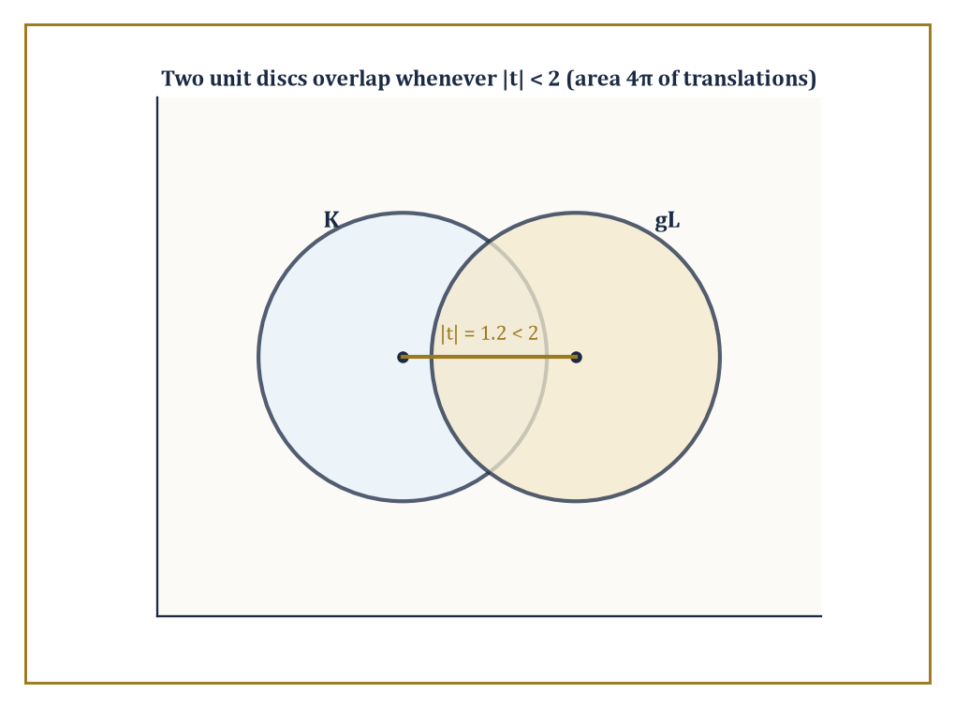
Two unit discs centred a distance |t| = 1.2 apart: they overlap for every |t| < 2, the disc of translations whose area 4π drives Santaló's formula.
The principal kinematic formula answers this for the crudest possible measure of overlap, the Euler characteristic (which is 1 whenever the two bodies meet, 0 whenever they do not, since an intersection of convex sets is itself convex or empty): the integral of χ(K ∩ gL) over the whole motion group comes out as an explicit, finite sum of products of intrinsic volumes of K and of L separately.
The formula is finite — despite the motion group itself being non-compact and infinite in extent — precisely because χ(K∩gL) vanishes for all sufficiently distant or extreme placements of g, so the integrand has compact support even though the domain of integration does not.
Numeric example — Worked example: the simplest possible case, two intervals on a line. Before tackling the plane, it pays to see the pattern in its barest form, one dimension down. Let K = [0,3] and L = [0,5] on the real line, where the 'motion group' is simply translation (there is no rotation to speak of in one dimension). Translate L by x to get L+x = [x, x+5]. The two intervals overlap exactly when x + 5 > 0 and x < 3, that is, for x ∈ (−5, 3), an interval of length 3 − (−5) = 8. So directly:
∫_ℝ χ(K ∩ (L+x)) dx = 8
Now compare this to the general pattern the kinematic formula predicts: in dimension n = 1, the intrinsic volumes are V₀ (Euler characteristic, equal to 1 for any nonempty compact interval) and V₁ (length), and the one-dimensional kinematic formula reads:
∫ χ(K∩(L+x)) dx = V₀(K)V₁(L) + V₁(K)V₀(L)
Plugging in: V₀(K)=1, V₁(K)=3, V₀(L)=1, V₁(L)=5, giving
1×5 + 3×1 = 8
The direct geometric computation and the abstract formula agree exactly, which is reassuring, since the whole of the rest of this room is this same idea with a rotation thrown in.
In the plane, the classical form of the principal kinematic formula (due, in this generality, to Santaló) is:
∫ χ(K ∩ gL) dg = 2π(Area(K) + Area(L)) + Perimeter(K)·Perimeter(L)
where dg = dθ dx dy is the natural kinematic density (θ the rotation angle, (x,y) the translation), integrated over the full rigid-motion group of the plane. Notice the shape of the right-hand side: it is a sum of products of intrinsic volumes of K with intrinsic volumes of L, with the degrees always adding up to n = 2 (an area, degree 2, paired with V₀, degree 0; and V₁, degree 1, paired with V₁, degree 1). This 'degrees add to n' pattern is not a coincidence — it is a shadow of a genuine algebraic structure that Room 33.6 will name properly.
Numeric example — Worked example: two unit discs in the plane. Let K and L both be discs of radius 1. Then Area(K) = Area(L) = π and Perimeter(K) = Perimeter(L) = 2π. Santaló's formula gives:
∫ χ(K∩gL) dg = 2π(π + π) + (2π)(2π) = 2π·2π + 4π² = 4π² + 4π² = 8π²
As a check, integrate out the rotation first: since discs look the same from every angle, χ(K∩gL) does not depend on θ at all, so integrating over θ ∈ [0,2π) simply multiplies by 2π, leaving:
2π · ∫_(ℝ²) χ(K∩(L+t)) dt = 8π², i.e. ∫χ(K∩(L+t)) dt = 4π
But that remaining integral is just the area of the set of translation vectors t for which two unit discs with centres a distance |t| apart overlap — which happens exactly when |t| < 2, a disc of radius 2, of area π·2² = 4π. The two computations, one via the abstract formula and one via elementary plane geometry, agree on the nose.
Higher kinematic formulas repeat the trick for the other intrinsic volumes and for curvature measures instead of χ, each time producing a sum of products with degrees adding to n, and each time with explicit combinatorial coefficients. This is more than a curiosity: the classical Crofton formula of Storey 19 (relating the perimeter of a body to how often random lines cross it) can itself be recovered as a limiting or degenerate case of the kinematic formula — take L to be a very thin sliver, or more precisely let one of the bodies degenerate towards a line, and the principal kinematic formula collapses down into the Crofton formula, which was there all along, sitting inside the general theory as a special case rather than a separate result. Transfer principles and template methods exploit this systematically, letting one reduce an unfamiliar-looking integral-geometric computation to reading off a handful of already-tabulated coefficients.
Abstract example — Abstract example: Crofton's formula as a shrunk-down kinematic formula. Take the plane formula
∫χ(K∩gL)dg = 2π(Area(K)+Area(L)) + Perimeter(K)Perimeter(L)
and let L shrink to a thin rectangle of width δ and some fixed length ℓ, aligned so it behaves, in the limit δ → 0, like a line segment sweeping across the plane. As δ → 0, Area(L) → 0 (a rectangle of vanishing width has vanishing area), so the 2π(Area(K)+Area(L)) term degenerates to 2π·Area(K) alone — a bounded quantity that measures how often a full line, rather than a segment, passes through K at all, which is not quite what Crofton's formula is about.
The perimeter term, meanwhile, survives: Perimeter(L) stays bounded near 2ℓ even as δ → 0 (a thin rectangle still has two long sides of length ℓ each, contributing 2ℓ to the perimeter regardless of how thin it gets). It is precisely this surviving Perimeter(K)·Perimeter(L) term, isolated in the thin-body limit, that becomes (up to the standard normalizing constant) the Cauchy–Crofton relation between the perimeter of K and the measure of lines crossing it — the general kinematic formula for two fat bodies contains the classical formula for a body and a line as a genuine special case, obtained exactly this way.

Room 33.6: The Algebra of Valuations
In which the kinematic formula turns out to be a multiplication table
Every kinematic formula so far has had the same silhouette: integrate over the motion group, get out a sum of products of intrinsic volumes with degrees adding to n.
Alesker's great structural discovery was that this silhouette is not decorative — the space of continuous translation-invariant valuations genuinely carries a commutative, associative product (now called the Alesker product), and the kinematic formula for two valuations μ and ν is precisely the statement that averaging μ(K)ν(gL) over the motion group computes the coefficient of the product μ ⋆ ν, expanded in the basis of intrinsic volumes.
The whole zoo of kinematic formulas — principal, higher-order, for curvature measures — collapses into a single multiplication table for a single finite-dimensional graded algebra.
The grading is by degree: Vᵢ has degree i, and the algebra is filtered so that products respect degree in exactly the additive way every example so far has hinted at.
Numeric example — Worked example: reading structure constants off Santaló's formula. Rewrite the plane kinematic formula from Room 33.5 entirely in terms of intrinsic volumes, using the substitutions
Area = V₂, Perimeter = 2V₁
so that
Perimeter(K)Perimeter(L) = 4V₁(K)V₁(L)
and the kinematic formula reads:
∫χ(K∩gL)dg = 2π·V₀(K)V₂(L) + 2π·V₂(K)V₀(L) + 4·V₁(K)V₁(L)
This is nothing but the multiplication table of the algebra, laid bare: the pair (V₀,V₂) contributes with structure constant 2π, the pair (V₂,V₀) also with 2π (the product is commutative, as it must be), and the pair (V₁,V₁) contributes with structure constant 4.
No other pairing of intrinsic-volume degrees appears — there is no V₀·V₀ term, no V₀·V₁ term — because those pairs of degrees do not add up to n = 2:
0 + 0 = 0, 0 + 1 = 1
and the algebra's grading forbids them from contributing to a degree-2 output.
Three numbers, 2π, 4, and 2π, are the entire multiplication table of the plane's algebra of valuations in top degree, and every kinematic formula for convex bodies in the plane is secretly built from just these three constants.
Before Hadwiger's theorem is invoked at all, the space of every conceivable continuous rigid-motion-invariant valuation on convex bodies in ℝⁿ might reasonably be feared to be infinite-dimensional — after all, 'continuous functional on the space of convex bodies' is, a priori, an enormous space to search.
Hadwiger's theorem is exactly the statement that this fear is unfounded, and the algebra of valuations records the resulting finite-dimensionality as its most basic feature: a basis for the rigid-motion-invariant valuations is simply V₀, V₁, …, Vₙ, and nothing more, so the whole algebra in this most invariant sense has dimension exactly n+1.
Abstract example — Abstract example: how small the algebra really is. In the plane (n=2), the space of continuous rigid-motion-invariant valuations has dimension exactly 3, spanned by V₀, V₁, V₂ — three numbers describe every such functional, completely, on every convex body in ℝ².
In space (n=3), the dimension grows to exactly 4, spanned by V₀, V₁, V₂, V₃, as the worked ball computation in Room 33.2 already exhibited in miniature: four coefficients, no more, extracted from a single Steiner polynomial.
Contrast this with the vastly larger space one might naively have expected: an arbitrary continuous functional on the (infinite-dimensional) space of convex bodies has no reason at all to be finite-dimensional in this sense, and indeed is not, once either the invariance or the additivity hypothesis is dropped.
It is the conjunction of finite additivity, rigid-motion invariance, and continuity — three hypotheses, none dispensable, as Room 33.3's failed 'origin-detector' example demonstrated for additivity alone — that squeezes an a priori unruly space down to something you could, if pressed, list on an index card.
This graded algebra is not an arbitrary bookkeeping device; its graded pieces are literally the irreducible representations of the orthogonal group O(n) acting on valuations of each degree, so the algebra of valuations is, quite precisely, a piece of representation theory wearing a geometric disguise.
Two further theorems cement the resemblance to intersection theory and complex algebraic geometry: a hard Lefschetz theorem for the algebra of valuations (multiplication by a fixed 'ample' class, essentially the volume valuation, behaves exactly as Lefschetz's theorem predicts on the cohomology of a projective variety), and a Poincaré duality, pairing degree-i valuations with degree-(n−i) valuations in a way that is non-degenerate exactly on complementary degrees — precisely the pattern already visible in the multiplication table above, where only pairs of degrees summing to n = 2 produced anything nonzero.
Abstract example — Abstract example: Poincaré duality, read off the same table. The Poincaré duality property claims that the pairing between degree-i and degree-j valuations is non-degenerate precisely when
i + j = n
and zero otherwise.
Test this against the plane's multiplication table found above, where n = 2: the pairing of V₀ (degree 0) with V₂ (degree 2) is nonzero, with structure constant 2π — and indeed
0 + 2 = 2 = n
The pairing of V₁ with itself (degree 1 with degree 1) is nonzero, constant 4 — and
1 + 1 = 2 = n
again on the nose.
Meanwhile the pairing of V₀ with V₀ (degrees 0 and 0, summing to 0 ≠ 2) simply never appears in the formula at all, nor does V₀ with V₁ (degrees summing to 1 ≠ 2), nor V₁ with V₂ (summing to 3 ≠ 2).
Every 'off-diagonal' pairing that duality predicts should vanish, vanishes; every 'on-diagonal' pairing that duality predicts should survive, survives, with an explicit nonzero constant attached.
The abstract representation-theoretic statement and the concrete two-line kinematic formula for two convex bodies in the plane are, when you look closely enough, saying exactly the same thing.

Room 33.7: Integral Geometry on Spaces of Higher Rank
Lines were only ever the beginning
Everything so far has used the group of rigid motions of ℝⁿ acting on convex bodies, but the same programme — find the invariant measure, prove a Crofton-type formula, prove a kinematic formula — makes sense wherever a group acts nicely on a homogeneous space of geometric objects.
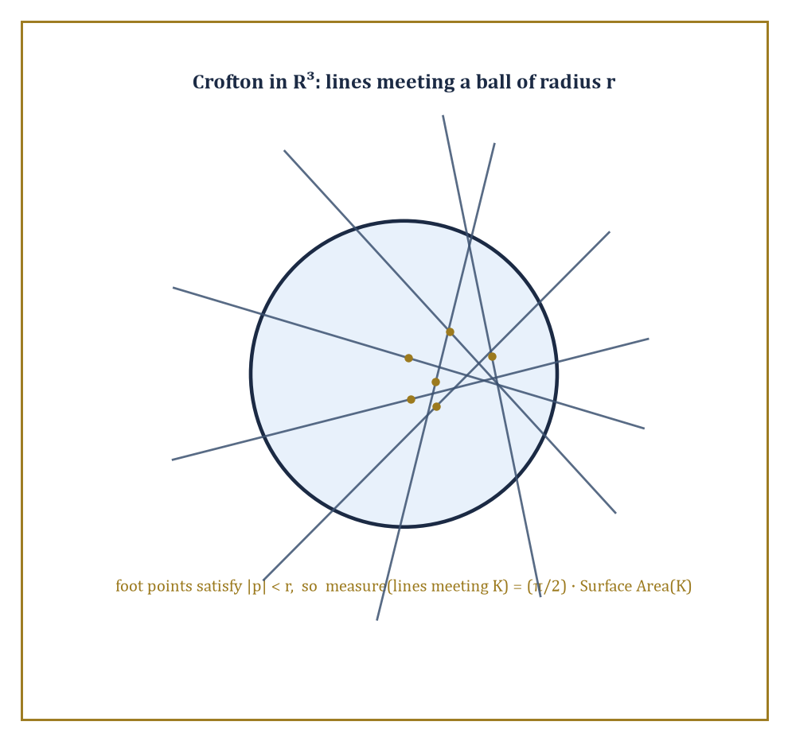
A ball in R³ with several random lines crossing it, foot point marked on each: only lines whose foot lies within radius r contribute, giving measure (π/2)·Surface Area(K).
The affine Grassmannian of k-dimensional planes in ℝⁿ (lines when k=1, hyperplanes when k=n−1, and everything in between) carries its own invariant measure and its own Crofton formula, relating the measure of k-planes meeting a convex body to that body's intrinsic volumes.
The case k=1 (lines) and k=n−1 (hyperplanes) are, technically, 'rank-one' cases — the corresponding Grassmannian of linear subspaces is, in a precise sense from Lie theory, as simple as such a space can be.
Genuinely higher-rank behaviour, with several independent invariants rather than one, appears only once 1 < k < n−1, for instance 2-planes inside ℝ⁴ — which is where the phrase 'higher rank' in this room's title starts to earn its keep.
Numeric example — Worked example: lines meeting a ball in ℝ³. Even the rank-one case in three dimensions is worth doing carefully, since it is the direct three-dimensional generalization of Storey 19's Crofton formula and the launching point for everything higher-rank.
Parametrize a line in ℝ³ by a direction ω on the unit sphere S² and a foot point p — the point on the line closest to the origin — lying in the two-dimensional plane through the origin perpendicular to ω. The natural invariant measure is:
dμ = dp dω
Fix a ball of radius r centred at the origin. A line in direction ω meets the ball exactly when its foot point satisfies:
|p| ≤ r
This is a disc of area πr² in the perpendicular plane. Integrating over all ω ∈ S² (total surface area 4π):
∫_(S²) πr² dω = 4π · πr² = 4π²r²
Since each physical line has been counted twice this way (direction ω and direction −ω describe the same line), halve the result: the measure of lines meeting the ball is
2π²r²
For r = 1 this is simply
2π²
Compare this to the ball's surface area, 4πr²: the ratio is
(2π²r²)/(4πr²) = π/2
This is independent of r, so the formula reads, in general:
μ(lines meeting K) = (π/2)·Surface Area(K)
for any convex body K in ℝ³ — a genuine three-dimensional Crofton formula, with an explicit and dimensionally correct constant, derived here from nothing but a direct integration over the sphere.
The complementary rank-one case — hyperplanes rather than lines, k=n−1 rather than k=1 — is worth doing too, precisely because it uses a different intrinsic volume, and the contrast between the two is the cleanest possible illustration of why intermediate ranks need more than one number at all.
Numeric example — Worked example: planes meeting a ball in ℝ³. Parametrize a plane (hyperplane) in ℝ³ by its unit normal u ∈ S² and its signed distance t ∈ ℝ from the origin, so the plane is given by:
{x : x·u = t}
The natural invariant measure is:
dμ = dt du
A ball of radius r centred at the origin meets this plane exactly when
|t| ≤ r
an interval of length 2r for each fixed u. Integrating over u ∈ S² (area 4π):
∫_(S²) 2r du = 2r · 4π = 8πr
Here too each plane has been counted twice — normal u at distance t and normal −u at distance −t describe the same plane {x : x·u = t} — so halve the result: the measure of planes meeting the ball is
4πr
The mean width of a ball of radius r is the constant 2r (its shadow has the same width, 2r, from every direction), so the ratio is:
(4πr)/(2r) = 2π
This is again independent of r, so in general:
μ(hyperplanes meeting K) = 2π·(mean width of K)
Lines are governed by surface area with constant π/2; hyperplanes are governed by mean width with constant 2π — two different intrinsic volumes for the two extreme ranks, which is exactly the seed of the higher-rank story: an intermediate k, neither 1 nor n−1, cannot simply pick one intrinsic volume to be governed by, and needs a genuinely richer invariant instead.
Complex integral geometry replaces the orthogonal group by the unitary group, acting on complex projective space or on Grassmannians of complex subspaces, and produces its own intrinsic volumes and its own kinematic formulas — structurally identical in spirit to the real case, but with the combinatorics governed by the representation theory of U(n) rather than O(n).
Quaternionic analogues, with the symplectic group in place of the unitary group, complete the classical trio.
What unifies all three is not a shared formula but a shared method: identify the relevant compact group, find its invariant measure, and let representation theory hand you the kinematic formula's structure constants — the same method, verbatim, that produced Room 33.6's multiplication table.
Abstract example — Abstract example: two 2-planes in ℝ⁴, a genuinely higher-rank instance. Take two 2-dimensional linear subspaces of ℝ⁴ in general position. Since the dimensions add up exactly:
2 + 2 = 4 = dim ℝ⁴
generically the two planes meet only at the origin, so naïvely one might expect their relative position to be described by a single number, as it would be for two lines in the plane (where the only invariant is the angle between them). It is not.
The correct classical description, via principal angles, requires two numbers θ₁ and θ₂, measuring how the two planes twist against each other along two independent directions simultaneously — one plane cannot, in general, be rotated onto the other using a single angle of rotation, the way two lines through the origin always can be. These angles satisfy:
0 ≤ θ₁ ≤ θ₂ ≤ π/2
This is the concrete manifestation of 'rank two': the homogeneous space of pairs of 2-planes in ℝ⁴ genuinely needs two coordinates to describe its geometry, not one, and any Crofton-type or kinematic formula built on this Grassmannian must be a function of both θ₁ and θ₂ together, rather than of a single Crofton-style angle as in the rank-one theories above.
The representation theory controlling the coefficients of such a formula is correspondingly richer — governed by the full rank-two structure of O(4) rather than by a single binomial coefficient — which is exactly why this room stops short of writing the formula out in full and instead points, with a straight face, at the literature.

Room 33.8: Applications: Stereology, Tomography, and Geometric Probability
Where all this machinery finally earns its keep
Stereology is the practical discipline of estimating the three-dimensional shape of an object — a biological tissue sample, a mineral deposit, a porous material — from lower-dimensional data: planar sections, or even just a scattering of points and lines.
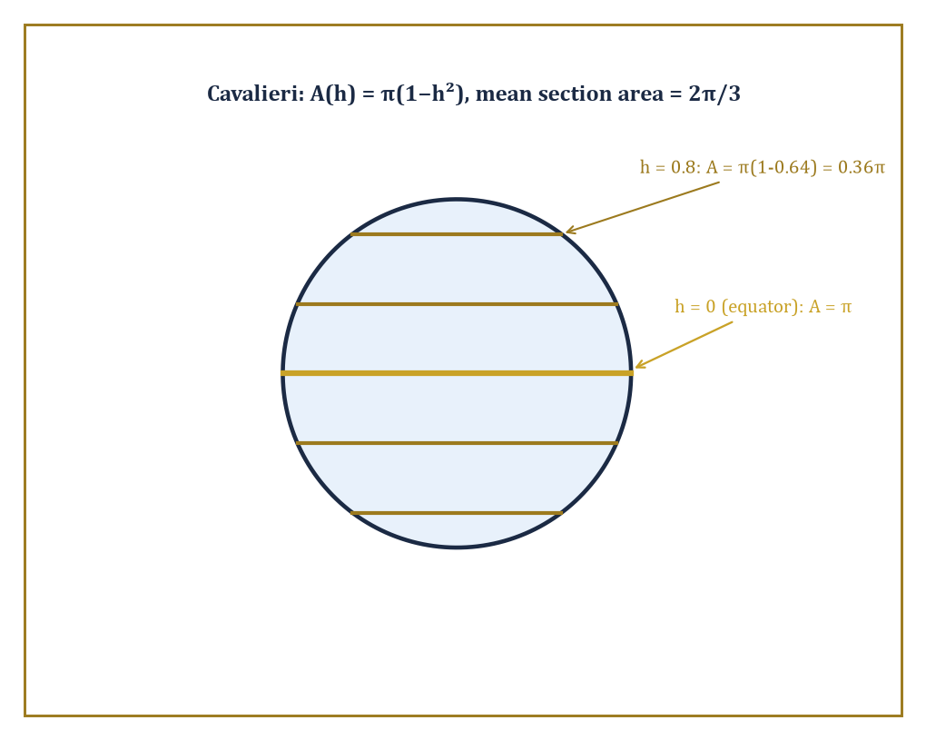
Slicing the unit ball at several heights h: the cross-sectional area π(1−h²) shrinks away from the equator, and its average over all h recovers the volume by Cavalieri's principle.
The kinematic formulas of this storey are precisely what make such estimation unbiased rather than merely hopeful: if you know exactly how a section's area behaves on average as the sectioning plane varies over all positions (with the correct invariant measure), you can invert that average to recover the volume of the original solid, without ever having to reconstruct its full three-dimensional shape.
This is Cavalieri's principle, now recognisable as the simplest possible curvature-measure kinematic formula: the volume of a solid equals the integral, over parallel slicing planes, of the cross-sectional area.
Numeric example — Worked example: mean section area of a ball, and Cavalieri's check. Let K be a ball of radius r = 1, and slice it with a plane at signed height h ∈ [−1, 1] from the centre.
The cross-section at height h is a disc of radius √(1−h²), with area:
A(h) = π(1−h²)
First, Cavalieri's principle directly: integrating A(h) over the full range of heights should recover the volume of the ball.
∫_(−1)^1 π(1−h²) dh = π[h − h³/3]_(−1)^1 = π[(1 − 1/3) − (−1 + 1/3)] = π[(2/3) − (−2/3)] = π(4/3) = 4π/3
That is exactly the volume of the unit ball, as it must be. Now compute the mean section area, averaging A(h) uniformly over h ∈ [−1,1]:
mean = (1/2)∫_(−1)^1 π(1−h²) dh = (1/2)(4π/3) = 2π/3 ≈ 2.094
Compare this to the area of the equatorial great circle, π ≈ 3.1416: the mean section is noticeably smaller than the biggest possible slice, precisely because most randomly chosen heights land well away from the equator, on shrinking discs near the poles.
A stereologist averaging many random section areas from an unknown ball-shaped sample would, on this evidence, expect to see roughly 2π/3 times the squared radius as their average reading — and could recover the volume from that average by simply multiplying by the total height range, exactly as Cavalieri's principle prescribes.
Tomographic reconstruction pushes the same idea further: recover an entire function (a density, an image) from its integrals — its Radon transform — over lines or planes, rather than recovering a single number like volume.
The invertibility of the Radon transform, together with stability estimates controlling how noise in the measured projections propagates into errors in the reconstructed image, is itself a room's worth of integral geometry on its own, and the medical CT scanner sitting in any large hospital is, underneath its casing, a machine for inverting a Radon transform in real time.
A toy, purely discrete version of the same idea — recovering an unknown grid of numbers from a handful of its row, column, and diagonal sums — captures the logical shape of the problem without any of the analytic machinery.
Numeric example — Worked example: reconstructing a 2×2 grid from its projections. Suppose an unknown 2×2 grid of numbers, [[a,b],[c,d]], is probed only through its 'projections': the row sums, the column sums, and the sum along the main diagonal. Measurement reveals:
a+b = 5, c+d = 3
a+c = 4, b+d = 4
a+d = 3
From the sum a+b=5, solve for b:
b = 5−a
From the sum a+c=4, solve for c:
c = 4−a
Substitute into c+d=3 to solve for d:
d = 3−c = 3−(4−a) = a−1
Check consistency against the fourth measurement, b+d=4:
(5−a)+(a−1) = 4
This holds for every a — so the row and column sums alone leave one degree of freedom undetermined, exactly as four equations with only three independent constraints must. This is where the diagonal projection earns its place: substitute d = a−1 into a+d=3.
a + (a−1) = 3, so 2a = 4 and a = 2
Then compute the remaining unknowns:
b = 5−2 = 3, c = 4−2 = 2, d = 2−1 = 1
The reconstructed grid is [[2,3],[2,1]] — and indeed it checks out against every original measurement:
2+3=5, 2+1=3, 2+2=4, 3+1=4, 2+1=3
all consistent. Three families of projections (rows, columns, one diagonal) sufficed to pin down all four unknowns uniquely; a real Radon transform performs the same feat, continuously, with a whole circle's worth of projection angles instead of three, and the same question — how many projections, from which angles, are enough to reconstruct the object without ambiguity — is exactly the subject of tomographic sampling theory.
Geometric probability closes the loop by turning kinematic formulas directly into probabilities: if a body is dropped uniformly at random within some large region, the kinematic formula's overlap measure, divided by the size of that region, is precisely the probability of a collision, intersection, or containment event.
This is Buffon's needle all grown up, with lines replaced by arbitrary convex shapes and a single trigonometric integral replaced by the full apparatus of Rooms 33.5 and 33.6.
Numeric example — Worked example: the probability two unit discs overlap. From the worked example in Room 33.5, two unit discs overlap exactly when their centres lie within distance 2 of each other, and the set of such relative positions is a disc of radius 2, with area:
π·2² = 4π
Suppose one disc's centre is fixed, and the second disc's centre is dropped uniformly at random somewhere inside a large 10×10 square window, of area A = 100 (with the fixed disc's centre comfortably away from the window's edge, so boundary effects can be ignored).
The probability of the two discs overlapping is then approximately (favourable area)/(window area):
4π/100 ≈ 12.566/100 ≈ 0.1257
That is a little over 12.5 per cent. Halve the window's side length to 5×5 (area 25) and the same favourable region of area 4π now occupies a much larger fraction:
4π/25 ≈ 50.3 per cent
This is a stark illustration of how geometric probability depends on nothing but the ratio of two areas, one of them a kinematic-formula overlap measure and the other simply the size of the sample space, with no calculus required once the kinematic formula itself has done the hard work.

Room 33.9: Looking Ahead: Valuations on Manifolds and Algebraic Integral Geometry
The view from the thirty-third floor, before the lift doors close
We have now acquired the modern core of integral geometry: continuous valuations and their classification by Hadwiger's theorem, curvature measures and the normal cycle that produces them, the principal kinematic formula and its relatives, the algebra that organizes them all, and a first glimpse of what happens once the acting group grows richer than rigid motions of flat space.
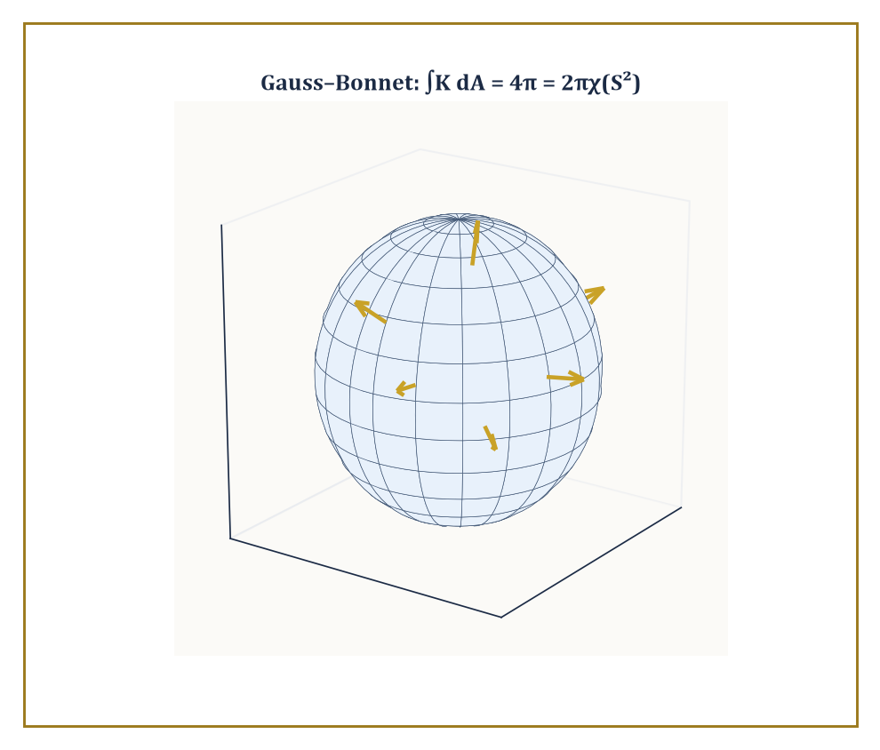
The unit sphere, curving by exactly K = 1 at every point: integrate that curvature over the whole surface and Gauss–Bonnet hands back 4π = 2πχ(S²).
Every one of these pieces was built on convex bodies sitting inside a flat Euclidean space ℝⁿ — a setting chosen for its tractability, not because the ideas secretly require flatness.
The frontier of the subject asks the obvious next question: what happens to all of this once the ambient space is curved?
The answer, largely due to Alesker, is reassuring rather than catastrophic: smooth valuations make sense on arbitrary smooth manifolds, not merely on ℝⁿ, with a suitably generalized notion of curvature measure built from the manifold's own Riemannian structure rather than borrowed — as every curvature measure in this storey has so far quietly been — from an ambient Euclidean embedding it never actually asked for.
This is precisely where Storey 34's subject, tensors and manifolds, stops being a neighbouring topic and starts being a prerequisite: to even state what a curvature measure means on a curved space, one first needs the tensorial language for curvature that Storey 34 will build from scratch.
Numeric example — Worked example: Gauss–Bonnet on the sphere, a first curved-space valuation. The cleanest possible preview of valuations on a curved manifold is a formula you may already know without having filed it under this name: the Gauss–Bonnet theorem.
On the unit sphere S² (radius 1), the Gaussian curvature K is constant and equal to 1 everywhere — a sphere of radius 1 curves 'by exactly 1' at every point, by definition of Gaussian curvature for a sphere of radius r being 1/r².
The total surface area of the unit sphere is 4π. So the integral of curvature over the whole surface is:
∫_(S²) K dA = 1 × 4π = 4π
The Gauss–Bonnet theorem states this integral must equal 2π times the Euler characteristic of the surface:
∫_(S²) K dA = 2πχ(S²)
The Euler characteristic of a sphere is the famous χ(S²) = 2 — check it on any convex polyhedron with the topology of a sphere, such as a tetrahedron:
4 vertices − 6 edges + 4 faces = 2
Then:
2πχ(S²) = 2π × 2 = 4π
This matches the direct curvature integral exactly.
This is a curvature measure — literally, Gaussian curvature integrated against area — recovering an intrinsic-volume-like topological invariant on a genuinely curved space, with no flat ambient ℝⁿ or Steiner formula in sight.
It is the natural manifold-level descendant of every corner-counting computation this storey has performed on flat convex bodies, and it is exactly the sort of identity Storey 34 will generalize far beyond spheres.
A parallel algebraic strand runs through the study of constructible functions and characteristic cycles, where the Euler characteristic itself is treated as a kind of measure to be integrated against — 'Euler integration' — reproducing, in an algebraic-geometric register, exactly the additivity law that opened this whole storey in Room 33.1.
A constructible function is simply a finite linear combination of indicator functions of convex (or more generally definable) pieces, and its Euler integral is computed by the obvious rule: weight each piece's Euler characteristic by its coefficient, and add.
Numeric example — Worked example: an Euler integral of a simple constructible function. Let f be a function on the real line taking the value 2 on the closed interval [0,1], the value 3 on the closed interval [2,3], and 0 everywhere else, defined by:
f = 2·1_([0,1]) + 3·1_([2,3])
These are two disjoint compact pieces, chosen disjoint precisely to sidestep any subtlety about how open and closed pieces interact at shared boundary points.
Since both [0,1] and [2,3] are compact and contractible, each has Euler characteristic 1 in every sense of the term worth worrying about here.
The Euler integral is then simply:
∫f dχ = 2·χ([0,1]) + 3·χ([2,3]) = 2(1) + 3(1) = 5
This is exactly the same bookkeeping as Room 33.1's very first inclusion–exclusion example, now dressed in the language of characteristic cycles: a valuation-weighted sum over disjoint convex pieces.
This is the entire content of 'Euler integration' at the level this storey can responsibly present it, and precisely the operation that the deeper algebraic theory extends to vastly more elaborate constructible functions than this one.
The same circle of ideas resurfaces, disguised, in convex optimization (support functions and mixed volumes are simply intrinsic volumes and their polarizations wearing a different hat) and in the statistical study of random geometric structures, where kinematic formulas compute exact expectations that would otherwise require simulation.
The deeper lesson of the whole storey is worth stating plainly: the group of rigid motions, acting on the space of geometric objects, produces a finite-dimensional algebra of invariants whose multiplication table is the kinematic formula.
Geometry is thereby reduced, in a precise and rather startling sense, to representation theory and measure theory.
Advanced integral geometry is the systematic exploitation of that reduction — and, one suspects, will remain a going concern for exactly as long as there are groups willing to act and geometers willing to let them.
So that is the deal advanced integral geometry offers: hand over your intuition that 'measuring a shape' means picking one number — a length, an area, a volume — and depend on circumstance, and receive in exchange a complete, finite, classified list of every invariant measurement there could ever be, together with an exact multiplication table telling you how they interact under the one operation, the kinematic formula, that the whole subject cares about. Hadwiger's theorem did the classifying. The principal kinematic formula and the algebra of valuations did the multiplying. Curvature measures did the localizing, spreading global numbers back out over boundaries, corners, and normal directions so that stereologists, tomographers, and the occasional geometric probabilist could put the whole apparatus to work on real, physical, section-by-section data.
It is worth pausing, on the landing here at the top of Storey 33, to notice what has quietly happened to the word 'measure' across this Tower. Down on Storey 19 it meant a way of assigning length to lines and area to sets of lines — modest, concrete, countable on the fingers. Up here it means an entire algebra, governed by representation theory, in which every classical formula you might once have memorized turns out to be one entry in a multiplication table. That is not a change of subject; it is the same idea, allowed to grow up.
Ahead lies Storey 34, on tensors and manifolds, where the flat Euclidean stage this storey insisted on will finally be struck for good, and curvature — which has made only cameo appearances here, at a square's corners and on a sphere's surface — becomes the main character in its own right, on spaces with no ambient ℝⁿ to fall back on at all. Bring the intrinsic volumes; they will need tensorial company from here on. The Tower continues upward. We have learned to let groups measure geometry.

Storey 34: Tensors & Manifolds
Multilinear Algebra, Smooth Spaces, and the Art of Coordinate-Free Geometry
After an entire storey spent reconstructing objects from their integrals — recovering a function from its shadows, a convex body from the widths it casts in every direction, a density from the X-rays a hospital takes of you before it will admit you have a broken rib — you might reasonably expect the Tower to reward you with something equally photogenic. Instead we are handing you a crate of index-laden machinery and asking you to help us build, from first principles, the very stage on which all that integral geometry was secretly being performed the whole time. It turns out you cannot measure a width or a shadow without first choosing a notion of length, angle, and orientation at every point of the space you are measuring in, and nobody on the last storey thought to tell you where those notions came from. We are going to tell you now, and it will take rather longer than a chalk-dust hand-wave, because the honest answer involves rebuilding linear algebra to cope with more than one vector at a time and then rebuilding space itself to cope with the fact that it might not be flat.
Linear algebra, several storeys below, taught you vectors and the linear maps between them. Multilinear algebra is what you get when you stop being satisfied with one vector at a time and start asking what a machine that eats several vectors — or several vectors and several covectors — and spits out a number, linearly in each slot, might look like. Such a machine is called a tensor, and you have met tensors before without the introduction being made formally: a bilinear form is a tensor, a linear map is a tensor in disguise, and the first and second fundamental forms that measured the curving of a surface back in Storey 31 were tensors all along, quietly doing geometry while nobody used the word.
The second half of this storey asks a more ambitious question: what if the space you are doing geometry on does not live inside a Euclidean space at all, or lives there so awkwardly — a sphere, a torus, the set of all possible configurations of a robot arm — that insisting on a single global coordinate system does it violence? The answer is the smooth manifold: a space that looks like ordinary Euclidean space if you get close enough and squint, stitched together from many such local views by transition maps that are themselves smooth. Once you have manifolds, you can put tensors on them point by point, and the resulting tensor fields — vector fields, differential forms, metrics, curvature — are the grammar in which modern geometry, and modern physics, is written.
A small confession before we start, the kind this Tower is fond of: tensors are traditionally introduced to undergraduates by their transformation laws under a change of coordinates, a presentation that produces a great deal of anxiety and very little understanding, and turns the subject into what one of our authors' more embittered colleagues used to call an orgy of index gymnastics. We will not do that to you. A tensor is, first and intrinsically, a multilinear object that does not care what basis you use; the transformation law is merely what happens to its components as a consequence of your choosing one basis rather than another, and it is a symptom, not a diagnosis. Keep the intrinsic picture primary, and the indices become bookkeeping rather than mysticism. Let us go coordinate-free — and then, once we understand why we're allowed to, choose coordinates wisely and without guilt.

Room 34.1: Multilinear Algebra and Tensors
In which one vector at a time turns out to have been the beginner slope
A tensor on a vector space V is a multilinear map: it eats some number of copies of V and some number of copies of the dual space V* (the space of linear functionals on V, i.e. covectors) and produces a scalar, linearly in every single slot separately.
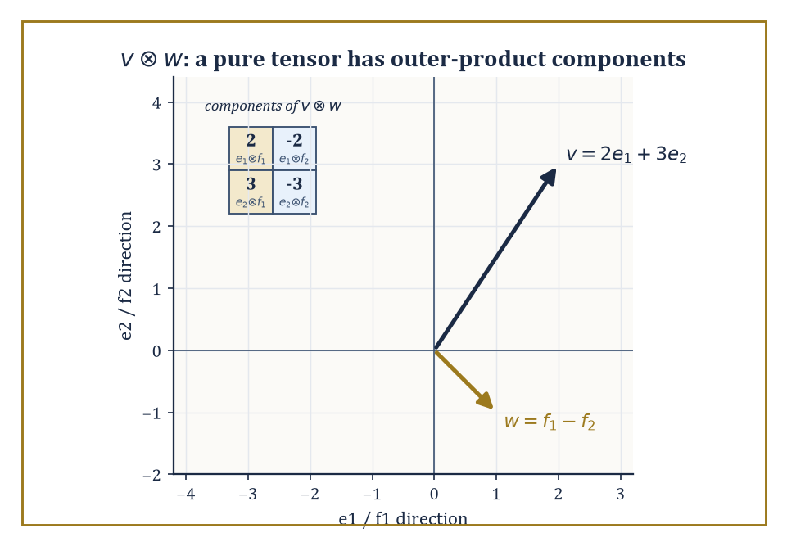
The worked example v⊗w = 2e1⊗f1 − 2e1⊗f2 + 3e2⊗f1 − 3e2⊗f2, with its components laid out as the outer product they are.
A tensor that eats k copies of V* and l copies of V is called a (k,l)-tensor, or a tensor of type (k,l); k is the number of contravariant slots and l the number of covariant slots, terminology inherited from how the components behave under a change of basis, which we will get to honestly rather than by decree.
Vectors themselves are (1,0)-tensors in this scheme — a vector v defines a linear functional on V* by evaluation:
v(φ) = φ(v)
and covectors are (0,1)-tensors. A bilinear form is a (0,2)-tensor. A linear map V → V, via the pairing (φ,v) ↦ φ(Tv), is a (1,1)-tensor. Everything you did in linear algebra was secretly low-rank tensor theory.
Numeric example — Worked example: a linear map as a (1,1)-tensor. Let V = ℝ² with standard basis e1, e2, and let T: V → V be the linear map with matrix A, so that T(e1) = 2e1 and T(e2) = e1 + 3e2:
A = [[2, 1], [0, 3]]
As a (1,1)-tensor, T is the map that eats a covector φ and a vector v and returns φ(Tv). Take φ = e¹ (the first coordinate functional, with e¹(e1) = 1 and e¹(e2) = 0) and v = e2.
Tv = T(e2) = e1 + 3e2
φ(Tv) = e¹(e1 + 3e2) = 1
In matrix language this is exactly reading off the (1,2) entry of A, which is 1 — the (1,1)-tensor's 'components' T^i_j are just the matrix entries A_ij, and evaluating the tensor on a basis covector and a basis vector is exactly how you read a matrix entry off a matrix. Nothing new has happened; we have merely learned to see an old friend (the matrix) as an instance of a new and more general species (the tensor).
The tensor product V ⊗ W of two vector spaces is built to be the universal recipient of bilinear maps out of V × W: there is a bilinear map ⊗: V × W → V ⊗ W, and every bilinear map β: V × W → U factors uniquely as a linear map ℓ: V ⊗ W → U composed with ⊗:
β = ℓ ∘ ⊗
In plainer terms, V ⊗ W is the space where 'v tensor w' lives as a genuinely new, formal object, and it is exactly big enough to encode every possible bilinear behaviour of v and w without throwing any information away or keeping any redundant information around.
If dim V = m and dim W = n, then:
dim(V ⊗ W) = mn
with basis e_i ⊗ f_j for basis vectors e_i of V and f_j of W. Higher tensor products, and the space of (k,l)-tensors on V, are built the same way by iterating: (k,l)-tensors on V are exactly
V ⊗ ⋯ ⊗ V ⊗ V* ⊗ ⋯ ⊗ V* (k copies of V, l copies of V*)
Numeric example — Worked example: an explicit tensor product. Let V = W = ℝ² with bases e1, e2 and f1, f2. Take v = 2e1 + 3e2 and w = f1 − f2. Expand v ⊗ w by bilinearity:
v ⊗ w = 2e1⊗f1 − 2e1⊗f2 + 3e2⊗f1 − 3e2⊗f2
Writing the coefficients of e_i⊗f_j as a 2×2 array (row i, column j) gives:
[[2, −2], [3, −3]]
which is precisely the outer product of the column vectors (2,3) and (1,−1): entry (i,j) is (component i of v)×(component j of w). This is the general fact in miniature — a 'pure' tensor v ⊗ w always has components that are the outer product of the components of v and w — and it is also a warning: most tensors in V ⊗ W are sums of several such outer products and cannot be written as a single v ⊗ w.
(Try to write [[1,0],[0,1]] as a single outer product and you will spend an unpleasant afternoon discovering you can't; its rank as a matrix is 2, not 1.)
From tensors of a given type you can manufacture new ones. Contraction pairs off one contravariant slot with one covariant slot and sums, generalising the trace of a matrix (which is exactly the contraction of a (1,1)-tensor with itself).
Symmetrization averages a tensor over all permutations of a chosen set of slots, producing something unchanged by swapping those slots; alternation averages with alternating signs, producing something that flips sign under a swap and vanishes whenever two of the swapped arguments coincide.
Applying alternation to all l covariant slots of a totally covariant tensor and keeping only the totally antisymmetric survivors builds the exterior algebra Λ•V*, whose degree-k piece Λ^k V* is the home of the differential k-forms we will meet properly in Room 34.5; applying symmetrization instead builds the symmetric algebra, home to quadratic forms, metrics, and polynomials in disguise.
Numeric example — Worked example: symmetrizing and alternating a bilinear form. Take the (0,2)-tensor B with matrix [[2, 1], [0, 3]] from before, now read as a bilinear form B(u,v) rather than a linear map. Its symmetric part is:
Sym(B) = (B + Bᵀ)/2 = ([[2,1],[0,3]] + [[2,0],[1,3]])/2 = [[4,1],[1,6]]/2 = [[2, 0.5], [0.5, 3]]
This is symmetric, as promised, since swapping the two entries off the diagonal leaves it unchanged. Its antisymmetric part is:
Alt(B) = (B − Bᵀ)/2 = [[0,1],[−1,0]]/2 = [[0, 0.5], [−0.5, 0]]
Check the books balance:
Sym(B) + Alt(B) = [[2, 0.5+0.5], [0.5−0.5, 3]] = [[2,1],[0,3]] = B
This holds exactly as it must, since every bilinear form is the sum of its symmetric and antisymmetric parts and nothing has been lost or invented in the split.
Choose a basis of V, and every abstract tensor acquires components: a (k,l)-tensor becomes an array of numbers with k upper indices and l lower indices.
Choose a different basis, related to the first by a change-of-basis matrix P, and the components transform: each upper index gets multiplied by P⁻¹ (because vectors themselves, expanded in a new basis, pick up P⁻¹), and each lower index gets multiplied by P (because covectors, being linear functionals, transform the opposite way to keep the pairing between vectors and covectors basis-independent).
This is the celebrated transformation law, and the crucial thing to notice — the whole point of this room — is that it is derived, not postulated. A collection of numbers that happens to obey the right transformation law is a tensor's components; a collection that does not is just numbers with delusions of grandeur.
Numeric example — Worked example: two transformation laws from one array of numbers. Let A = [[2,1],[0,3]] represent a (1,1)-tensor (a linear map) and, separately, let the same array of numbers B = [[2,1],[0,3]] represent a (0,2)-tensor (a bilinear form) — same numbers, different species. Change basis via P = [[1,1],[1,-1]] (so the new basis vectors are e1+e2 and e1−e2); one computes P⁻¹ = [[0.5, 0.5],[0.5, −0.5]].
The (1,1)-tensor transforms by similarity, A′ = P⁻¹AP: first AP, then P⁻¹ times that.
AP = [[3,1],[3,−3]]
A′ = P⁻¹(AP) = [[3,−1],[0,2]]
Note that the trace is preserved:
trace(A′) = 3+2 = 5 = trace(A) = 2+3
the trace, being a contraction, is basis-independent, exactly as the theory promises. The (0,2)-tensor transforms by congruence instead, B′ = PᵀBP (here Pᵀ = P, since our P happens to be symmetric): BP is the same intermediate product as before, then P times that.
BP = [[3,1],[3,−3]]
B′ = P(BP) = [[6,−2],[0,4]]
So A′ = [[3,−1],[0,2]] but B′ = [[6,−2],[0,4]] — the identical array of numbers transforms into two genuinely different arrays, because 'transforms like a tensor' is meaningless until you say which kind of tensor you mean. This is precisely why the sentence 'is this a tensor?' is only ever answerable once you have specified its type.
Abstract example — Abstract example: the exterior square of ℝ³. Let V = ℝ³ with basis e1, e2, e3. The space Λ²V, built by alternating (2,0)-tensors, has basis e1∧e2, e1∧e3, e2∧e3 — dimension C(3,2) = 3, matching the general formula dim Λ^k V = C(n,k) for V of dimension n. Take u = (1,2,0) and v = (0,1,3), i.e. u = e1+2e2 and v = e2+3e3.
Expanding u∧v by bilinearity and using e_i∧e_i = 0 and e_i∧e_j = −e_j∧e_i, the coefficients work out as follows: of e1∧e2 is (1)(1)−(2)(0) = 1, of e1∧e3 is (1)(3)−(0)(0) = 3, and of e2∧e3 is (2)(3)−(0)(1) = 6.
u∧v = e1∧e2 + 3(e1∧e3) + 6(e2∧e3)
Swap the order — compute v∧u — and every coefficient flips sign, since wedging is antisymmetric; this is the alternation from two paragraphs ago, made concrete rather than merely asserted.

Room 34.2: Tensor Fields and Transformation Laws
Or: how to tell a real tensor from an impostor with delusions
Everything in the previous room happened at a single point, with a single fixed vector space V. Geometry, being greedy, wants a tensor at every point of a region — a tensor field.
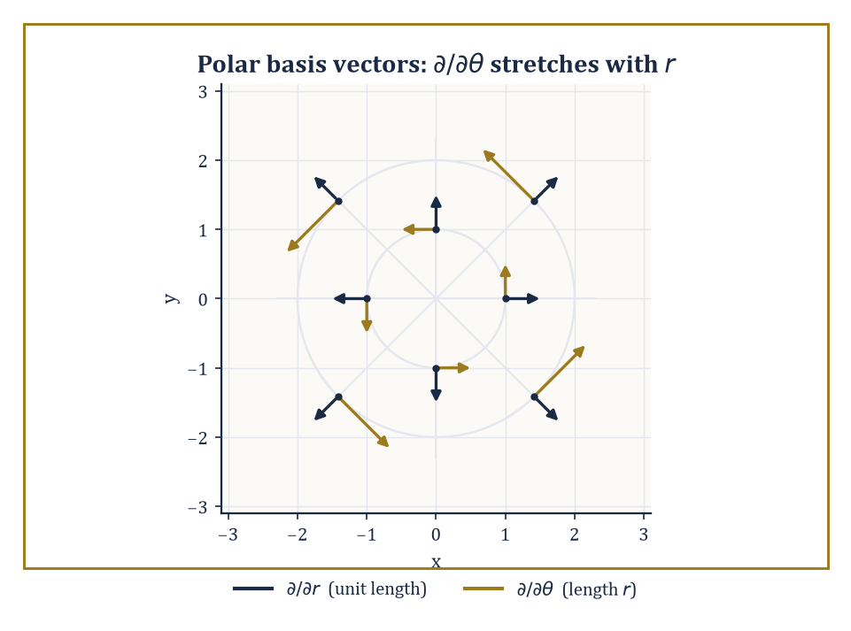
Why the Christoffel symbols are not tensor components: the polar basis vectors themselves rotate and stretch from point to point, even though the underlying plane is flat.
On an open subset of ℝⁿ, a tensor field of type (k,l) assigns to each point p a (k,l)-tensor on the tangent space at p (which, on flat Euclidean space, is just another copy of ℝⁿ), and does so smoothly: the components, relative to the standard basis at each point, are smooth functions of position.
Under a change of coordinates — not just a change of basis at one point, but a genuinely different coordinate system covering the region — the components transform by the Jacobian matrix of the coordinate change and its inverse, index by index, exactly as in Room 34.1, except that the 'change-of-basis matrix' P is now itself a function of position, since the tangent directions of the new coordinates rotate and stretch as you move.
This transformation law is not merely decorative; it is the practical test of tensorial legitimacy. If you hand a working mathematician a list of component functions in one coordinate system and ask whether they define a genuine tensor field, the honest test is to change coordinates and check whether the components transform the way the theory demands.
Fail the test, and what you have is a collection of numbers that happened to look tensor-like in one particular coordinate system by coincidence — flattering in Cartesian coordinates, treacherous everywhere else.
Numeric example — Worked example: a covector field in polar coordinates. On ℝ², consider the 1-form (covector field) ω = x dy − y dx, i.e. with Cartesian components ω_x = −y, ω_y = x. Convert to polar coordinates x = r cosθ, y = r sinθ, using dx = cosθ dr − r sinθ dθ and dy = sinθ dr + r cosθ dθ.
Substituting:
x dy = r cosθ sinθ dr + r²cos²θ dθ
y dx = r sinθ cosθ dr − r²sin²θ dθ
Subtracting, the dr terms cancel exactly (r cosθ sinθ − r sinθ cosθ = 0) and the dθ terms add:
ω = r²(cos²θ+sin²θ) dθ = r² dθ
So in polar coordinates ω has components (ω_r, ω_θ) = (0, r²). Check this really is the transformation law and not a fluke: at the point (x,y) = (3,4), r = 5 and cosθ = 3/5, sinθ = 4/5, so the Jacobian entries are ∂x/∂r = 0.6, ∂x/∂θ = −4, ∂y/∂r = 0.8, ∂y/∂θ = 3.
The transformation law for a covector is ω′_μ = ω_x(∂x/∂x′^μ) + ω_y(∂y/∂x′^μ); with (ω_x,ω_y) = (−4,3):
ω′_r = (−4)(0.6) + (3)(0.8) = −2.4+2.4 = 0
ω′_θ = (−4)(−4) + (3)(3) = 16+9 = 25 = r² (since r=5)
Both routes — substituting the coordinate change directly into the form, and applying the abstract transformation law to the components — agree, which is exactly what 'being a genuine tensor field' means in practice.
Now for the cautionary tale the room is really building towards. Christoffel symbols — you will meet them properly in Rooms 34.7 and 34.8, but they are the coefficients that tell you how basis vectors twist as you move through curved or merely curvilinear coordinates — look, superficially, exactly like the components of a (1,2)-tensor: three indices, transformation-law shaped equations in every textbook.
They are not a tensor. The proof is almost insultingly short.
Abstract example — Abstract example: why Christoffel symbols fail the test. In Cartesian coordinates on flat ℝ², the basis vectors ∂/∂x and ∂/∂y do not change direction or length as you move, so every Christoffel symbol vanishes identically:
Γ = 0 everywhere (Cartesian coordinates)
In polar coordinates on the very same flat plane, the basis vectors ∂/∂r and ∂/∂θ do rotate and rescale as you move (∂/∂θ gets longer the further out you go, and both directions rotate as θ increases), and one finds nonzero values such as:
Γ^r_θθ = −r (computed properly in Room 34.7)
Now suppose, for contradiction, that the Christoffel symbols were the components of a genuine tensor. A basic fact about tensors, immediate from the transformation law, is that a tensor which is identically zero in one coordinate system is identically zero in every coordinate system — the transformation law multiplies zero by Jacobian factors and gets zero back, no matter how contorted the change of coordinates.
But the Christoffel symbols are zero in Cartesian coordinates and nonzero in polar coordinates, on the same underlying flat plane. That is a direct contradiction, so the Christoffel symbols cannot be tensor components.
What they actually are — the data of a connection, not a tensor — is the subject of Room 34.8, and this small failure is the first hint, planted early precisely so it can pay off later, that 'connection' and 'tensor' are different kinds of animal even though both come dressed in indices.
Tensor fields, understood this way, are the raw material of continuum mechanics (the stress tensor, the strain tensor), of electromagnetism (the field-strength tensor, which we will meet again in Room 34.9 wearing the more fashionable name F = dA), and of general relativity (the metric tensor, the stress-energy tensor, the Riemann curvature tensor).
All of that machinery is presently confined to open subsets of Euclidean space, transforming under changes of coordinates that are still, ultimately, changes of coordinates on ℝⁿ. The next room removes that crutch entirely and lets the underlying space itself be curved, so that 'a change of coordinates' becomes 'gluing one local view of the world to another,' which is a considerably more honest description of what a map of the Earth is actually doing.

Room 34.3: Smooth Manifolds
A space that is locally boring and globally anything but
A smooth manifold of dimension n is a topological space that, near every point, looks like an open subset of ℝⁿ — 'looks like' meaning there is a homeomorphism (a continuous bijection with continuous inverse) from a neighbourhood of the point onto an open subset of ℝⁿ, called a chart.
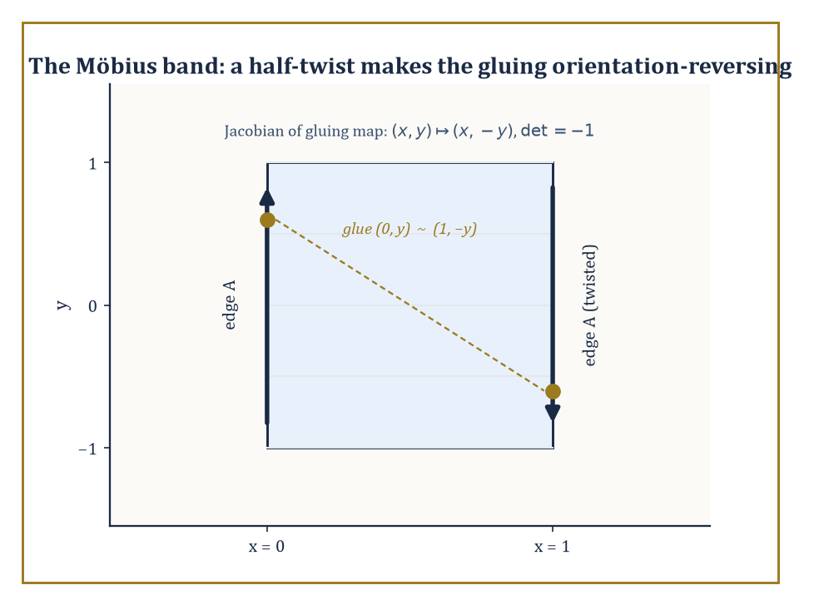
The half-twisted gluing (0,y) ~ (1,−y) that makes the Möbius band the Tower's smallest counterexample to orientability.
A collection of charts covering the whole space is an atlas, in shameless and deliberate analogy with a real atlas of the Earth: no single flat page can honestly represent the whole globe, but a book of overlapping local pages can, provided the pages agree with each other where they overlap.
That agreement condition is the heart of the definition: wherever two charts overlap, the transition map — go into the overlap via one chart's coordinates, come back out via the other's — must be a smooth (infinitely differentiable) map between open subsets of ℝⁿ.
This is what makes calculus possible on the manifold: you do calculus inside a chart, where you already know how, and the smooth transition maps guarantee that the answer does not depend on which chart you happened to pick.
Numeric example — Worked example: the sphere via stereographic charts. Let S² = {(x,y,z) ∈ ℝ³ : x²+y²+z² = 1}. Stereographic projection from the north pole N = (0,0,1) sends any other point of the sphere to where the line through N and that point crosses the plane z=0, giving a chart φ_N : S²∖{N} → ℝ². Projection from the south pole S=(0,0,−1) gives a second chart φ_S : S²∖{S} → ℝ². Together they cover the whole sphere, since no point is omitted by both.
On the overlap (everything except the two poles), the transition map works out to an inversion in the unit circle:
φ_S∘φ_N⁻¹(u,v) = (u,v)/(u²+v²)
Check smoothness at a sample point:
at (u,v)=(1,0): (1,0)/1 = (1,0)
at (u,v)=(2,0): (2,0)/4 = (0.5,0)
The formula (u,v)/(u²+v²) is a ratio of smooth functions whose denominator u²+v² vanishes only at the origin — which corresponds to the point N, correctly excluded from this chart's domain — so the transition map is smooth everywhere it is defined. Two charts, one honest overlap condition checked directly by formula: that is the entire content of 'the sphere is a smooth 2-manifold,' with no appeal to its being embedded in ℝ³ required at all.
The zoo of examples is large and mostly familiar in disguise. Open subsets of ℝⁿ are manifolds trivially, with the identity map as their only chart. Spheres, tori, and real or complex projective spaces are manifolds by constructions much like the stereographic one above.
The general linear group GL(n,ℝ), the set of invertible n×n matrices, is a manifold because it is an open subset of the n²-dimensional space of all matrices — invertibility means nonzero determinant, and the determinant is a continuous (indeed polynomial) function, so its complement is a closed set and GL(n,ℝ) itself, being the complement of that closed set, is open.
Configuration spaces of mechanical systems — the space of all possible positions of a robot arm with several joints, say — are manifolds too, glued from the ranges of the joint angles.
Abstract example — Abstract example: GL(2,ℝ) as an open manifold. Identify the space of 2×2 real matrices with ℝ⁴ via [[a,b],[c,d]] ↔ (a,b,c,d). The determinant map is continuous (it is a polynomial):
det(a,b,c,d) = ad − bc
So GL(2,ℝ) = det⁻¹(ℝ∖{0}) is open in ℝ⁴, hence a 4-dimensional manifold with the identity as a single global chart.
Concretely, the matrix [[1,2],[3,4]] has determinant:
(1)(4) − (2)(3) = 4 − 6 = −2 ≠ 0
so it lies in GL(2,ℝ); since det is continuous, every matrix close enough to it — say [[1.01, 2], [3, 3.99]] — is also in GL(2,ℝ), with determinant:
(1.01)(3.99) − (2)(3) = 4.0299 − 6 = −1.9701
still nonzero. That is openness made tangible: invertibility is a robust property, stable under small perturbation, which is exactly what 'GL(n,ℝ) is open' is asserting.
A map between manifolds is smooth if it looks smooth when read through charts on both ends — pull back the target chart, push forward the source chart, and check smoothness of the resulting map between open subsets of Euclidean space, where the word already has a meaning.
A diffeomorphism is a smooth map with a smooth inverse; diffeomorphisms are the isomorphisms of the category of manifolds, the maps that identify two manifolds as 'the same' for every purpose differential geometry cares about, even if they look utterly different as subsets of some ambient space.
A further piece of machinery, the partition of unity — a collection of smooth bump functions, each supported near one chart, summing to 1 everywhere — lets you take constructions that only make sense locally (inside one chart) and glue them into a single globally-defined object, provided the manifold is paracompact, a mild point-set condition satisfied by essentially every manifold you will meet in this Tower.
Numeric example — Worked example: a diffeomorphism from an interval to the whole line. Define f: (−1,1) → ℝ by:
f(x) = x/(1−x²)
This is smooth on (−1,1) (the denominator never vanishes there), and one checks f′(x) = (1+x²)/(1−x²)² > 0 always, so f is strictly increasing, hence injective; as x → ±1, f(x) → ±∞, so f is also surjective onto ℝ, hence a bijection with a smooth inverse (by the inverse function theorem, since f′ never vanishes).
f(0.5) = 0.5/(1−0.25) = 0.5/0.75 = 2/3
f(−0.8) = −0.8/(1−0.64) = −0.8/0.36 ≈ −2.222
So the bounded open interval (−1,1) and the entire real line ℝ are diffeomorphic — as manifolds they are indistinguishable, even though one is a bounded set and the other is not, because 'bounded' is a metric notion and diffeomorphism only cares about the smooth structure, not the ruler you happened to measure it with.
Manifolds come with further attributes, each of which quietly decides which theorems apply. A manifold is orientable if it admits an atlas in which every transition map has positive Jacobian determinant — informally, if 'clockwise' and 'anticlockwise' (or their higher-dimensional analogues) can be defined consistently across the whole space.
Compactness is the familiar topological notion, and boundary — present in a manifold-with-boundary, like a closed disc — introduces an edge where the local model is a half-space rather than the whole of ℝⁿ.
Abstract example — Abstract example: the Möbius band fails to be orientable. Build a band by gluing the two vertical edges of the strip [0,1] × (−1,1) via the identification (0,y) ~ (1,−y) — a half-twist before gluing. Near the seam, the transition map from one side's local coordinates (x,y) to the other's is:
(x,y) ↦ (x, −y), Jacobian matrix [[1,0],[0,−1]], determinant −1
Contrast with the cylinder, built the ordinary way by gluing (0,y) ~ (1,y) with no twist:
(x,y) ↦ (x,y), Jacobian the identity matrix, determinant +1
A negative-determinant transition is precisely the algebraic signature of an orientation-reversing gluing, and no amount of re-choosing charts on the Möbius band can fix every transition map to have positive determinant simultaneously — that impossibility is what 'non-orientable' means.
Walk a small clockwise loop around the band once, and it comes back anticlockwise; the ant on the Möbius band, as generations of illustrators have gleefully pointed out, ends up on 'the other side' without ever crossing an edge, because there was only ever one side to begin with.

Room 34.4: Tangent Vectors, Vector Fields, and Flows
Three definitions of 'direction' that turn out to be secretly the same one
On a manifold that need not sit inside any ℝᴺ, 'a vector at a point' cannot simply mean 'an arrow', because there may be no surrounding space for the arrow to poke into. Three definitions of the tangent space at a point p rescue the notion, and — reassuringly, since a subject that offered three incompatible definitions of its central object would not deserve your tuition fees — all three turn out to be equivalent.
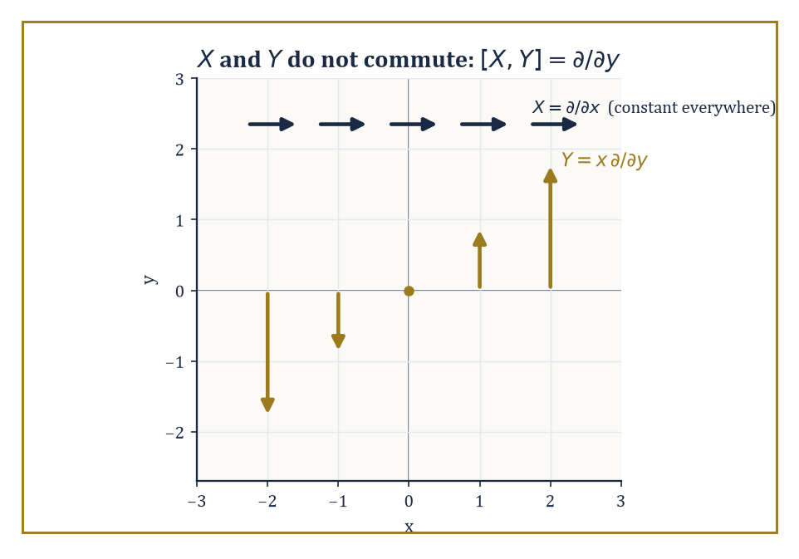
X = ∂/∂x is the same everywhere, but Y = x ∂/∂y grows and flips sign with x — which is exactly why flowing along one and then the other is not the same as doing it in the opposite order.
The first: a tangent vector is a derivation of the algebra of germs of smooth functions at p, meaning a linear map D from (germs of) smooth functions to ℝ satisfying the Leibniz rule:
D(fg) = f(p)D(g) + g(p)D(f)
This is the directional-derivative operator in disguise.
The second: a tangent vector is an equivalence class of smooth curves through p, two curves being equivalent if they have the same velocity at p, as detected by their effect on functions.
The third, more constructive: build the tangent bundle directly from charts, gluing copies of ℝⁿ (one per chart, with tangent vectors given in chart coordinates) via the derivative of each transition map, and the tangent space at p is the fibre of this bundle over p. A vector field is then a smooth choice of one tangent vector at every point — a smooth section of the tangent bundle.
Numeric example — Worked example: two definitions of tangent vector agree. Work in ℝ² at the point p = (1,1), with the curve γ(t) = (1+2t, 1−t), so γ(0) = p and γ′(0) = (2,−1) =: v. Take the test function f(x,y) = x²+y².
Definition 2 (curves) computes:
d/dt|_{t=0} f(γ(t)) = d/dt|_{t=0}[(1+2t)² + (1−t)²] = [2(1+2t)(2) + 2(1−t)(−1)]|_{t=0} = 2(1)(2) + 2(1)(−1) = 4 − 2 = 2
Definition 1 (derivation / directional derivative) computes the directional derivative of f at p in direction v = (2,−1):
v·∇f(p) = (2,−1)·(2x,2y)|_{(1,1)} = (2,−1)·(2,2) = 4 − 2 = 2
Both definitions hand back the number 2. This is not a coincidence for this one function; it holds for every smooth f, which is exactly the content of the theorem that 'equivalence class of curves' and 'derivation' define the same tangent space, merely described from two different angles.
Two vector fields do not, in general, commute: flow along X for a moment, then along Y, and you land somewhere different from flowing along Y first and then X. The Lie bracket [X,Y] measures exactly this failure to commute, to leading order, and is defined by:
[X,Y]f = X(Yf) − Y(Xf)
One must check this is again a derivation, i.e. again a vector field — a small miracle of cancellation.
The flow of a vector field X is the family of maps φ_t obtained by solving the ordinary differential equation dp/dt = X(p) with initial condition p(0) = the starting point; local existence and uniqueness hold on manifolds by exactly the same theorem (Picard–Lindelöf) that guarantees them in ℝⁿ, since the equation is read inside a chart.
Numeric example — Worked example: computing a Lie bracket. On ℝ², let X = ∂/∂x and Y = x ∂/∂y. Test both sides of [X,Y]f = X(Yf) − Y(Xf) on f(x,y) = x²y.
First:
Xf = ∂f/∂x = 2xy, so Y(Xf) = x·∂(2xy)/∂y = x·(2x) = 2x²
Second:
Yf = x·∂f/∂y = x·x² = x³, so X(Yf) = ∂(x³)/∂x = 3x²
So:
[X,Y]f = X(Yf) − Y(Xf) = 3x² − 2x² = x²
Now compare with the claimed bracket [X,Y] = ∂/∂y, obtained symbolically: X(Yf) = ∂/∂x(x·∂f/∂y) = ∂f/∂y + x∂²f/∂x∂y, while Y(Xf) = x·∂²f/∂y∂x, and the mixed partials cancel, leaving exactly ∂f/∂y. Applied to our f, ∂f/∂y = x², which matches the direct computation exactly.
So [∂/∂x, x∂/∂y] = ∂/∂y — the flows of 'slide right' and 'slide up at a rate proportional to how far right you are' genuinely fail to commute, and the bracket has correctly quantified the failure.
Numeric example — Worked example: a flow by direct solution. Let V = x ∂/∂x on ℝ (or on the x-axis of ℝ², ignoring y). The flow solves dx/dt = x, x(0) = x₀, giving x(t) = x₀e^t by separation of variables.
Starting at x₀ = 2 and flowing for time t = ln 3:
x(ln 3) = 2·e^{ln 3} = 2·3 = 6
Flowing for a further time t = ln 2 from there lands at:
6·e^{ln 2} = 6·2 = 12
which agrees with flowing from the start for total time ln 3 + ln 2 = ln 6:
x(ln 6) = 2·e^{ln 6} = 2·6 = 12
The flow composes correctly, φ_s∘φ_t = φ_{s+t}, exactly as the defining differential equation guarantees — flows form a one-parameter group, the continuous-time analogue of the additive group of real numbers, quietly present every time you solve dx/dt = x.
The tangent bundle TM (all tangent vectors at all points, glued together) and the cotangent bundle T*M (all covectors at all points) are themselves manifolds — of dimension 2n if M has dimension n, since you need n coordinates to say where you are and another n to say which tangent direction you mean.
Once you have a vector bundle like TM, the tensor-algebra machinery of Room 34.1 can be repeated fibre by fibre, at every point simultaneously, producing tensor bundles: bundles whose fibre over p is the space of (k,l)-tensors on T_pM.
A tensor field, properly defined at last, is a smooth section of the appropriate tensor bundle — the definition Room 34.2 was implicitly using all along, now given a home that does not secretly require the manifold to sit inside a Euclidean space.
Numeric example — Worked example: dimension count for a tensor bundle. Take M = ℝ³, so n = 3. The tangent bundle TM has dimension:
2n = 6
three coordinates to specify the base point, three more to specify the tangent vector sitting there. Now consider the bundle of (1,1)-tensors over M — the fibre over each point p is the space of (1,1)-tensors on T_pM, which (Room 34.1) has dimension:
n² = 9
one number for each entry of a 3×3 matrix. The total space of this tensor bundle is therefore itself a manifold of dimension:
n + n² = 3 + 9 = 12
three coordinates for the base point, nine more for the components of the tensor living above it. Repeat the count for the bundle of (0,2)-tensors, where the metric of Room 34.7 will shortly come to live, and you get exactly the same fibre dimension, n² = 9 — because a (k,l)-tensor space always has dimension n^{k+l} regardless of how k and l are split between upper and lower indices, and only the transformation law, never the dimension, cares which is which.

Room 34.5: Differential Forms and Exterior Calculus
The totally antisymmetric tensors get their own weather system
A differential k-form is a smooth field of totally antisymmetric (0,k)-tensors — a smooth section of the bundle Λ^k T*M built by the exterior-algebra construction of Room 34.1, applied fibrewise.
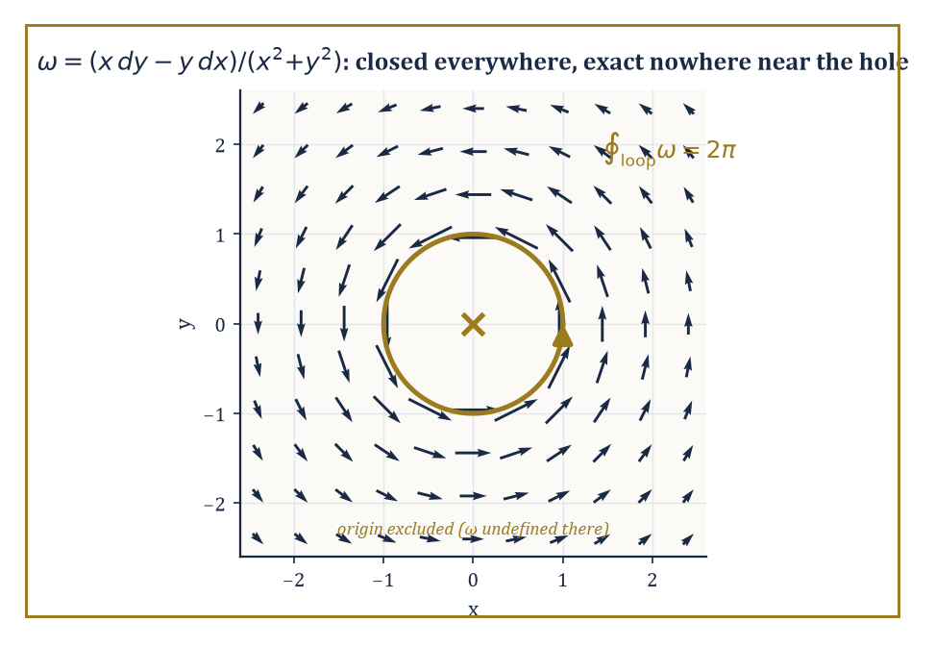
The angle form ω, closed everywhere it is defined, circulating endlessly around the one point where it isn't — the puncture is the entire reason it fails to be exact.
The exterior derivative d takes a k-form to a (k+1)-form and satisfies the fundamental identity:
d² = 0
Differentiate twice and you always get zero — a fact that looks like an algebraic curiosity until de Rham cohomology, two rooms from now, turns it into a topological measuring instrument.
Two further operations act on forms: the interior product i_X (also written ι_X), which plugs a vector field X into the first slot of a form and lowers the degree by one, and the Lie derivative L_X, which differentiates a form along the flow of X.
Cartan's magic formula ties the three operations together:
L_X = d∘i_X + i_X∘d
This is an identity that looks unmotivated until you have used it to shortcut a calculation you would otherwise have had to grind out by brute force, at which point it becomes, suddenly, the best formula you own.
Numeric example — Worked example: computing an exterior derivative. On ℝ², take the 1-form ω = x²y dx + xy² dy, i.e. P = x²y, Q = xy². The general formula for a 1-form is:
dω = (∂Q/∂x − ∂P/∂y) dx∧dy
Here ∂Q/∂x = y² and ∂P/∂y = x², so:
dω = (y² − x²) dx∧dy
Check ω is not closed in general: dω = 0 only where y² = x², i.e. along the two lines y = ±x, not everywhere — so this particular ω is an example of a form that is neither closed nor exact almost everywhere, which is the generic (uninteresting) case; the interesting cases, coming next, are the exceptions.
Abstract example — Abstract example: closed but not exact — the angle form. On ℝ²∖{0}, define:
ω = (x dy − y dx)/(x²+y²)
Room 34.2 already computed x dy − y dx = r² dθ in polar coordinates, so:
ω = r² dθ / r² = dθ
As dθ is (locally) the derivative of the coordinate function θ, one might reflexively call ω 'exact', and it is exact on any region where θ can be defined as a single continuous function — say, the plane with the positive x-axis removed.
But θ itself is not a well-defined smooth function on all of ℝ²∖{0}: walk once anticlockwise around the origin and θ increases by 2π rather than returning to its starting value, so there is no single global function α with dα = ω on the punctured plane.
Yet dω = 0 everywhere ω is defined (a direct computation, or simply: d(dθ) = 0 by the identity d² = 0, applied on any patch where θ is single-valued, and the resulting 2-form is globally consistent even though θ itself is not).
So ω is closed everywhere but not globally exact — the first, and archetypal, example of a closed form that fails to be exact, and the failure is caused entirely by the hole at the origin. This single example is the seed from which the entire subject of de Rham cohomology (Room 34.6) grows.
The Poincaré lemma is the local converse: on a contractible region (one that can be continuously shrunk to a point without leaving the region, such as a ball, or indeed any open subset of ℝⁿ that is star-shaped about a point), every closed form is exact.
The angle-form example shows this is a genuinely local statement — it holds on any small disc not containing the origin, and fails on the whole punctured plane precisely because the punctured plane is not contractible (you cannot shrink a loop around the hole to a point without crossing the hole).
Pull-back by a smooth map f: N → M sends forms on M back to forms on N and commutes with d, meaning:
f*(dω) = d(f*ω)
This always holds — exterior calculus is natural, it does not care which manifold you are currently standing on, and this naturality is what lets Stokes' theorem, in the next room, be stated once and mean the same thing on every manifold simultaneously.
Numeric example — Worked example: pulling a form back along a circle. Let f: ℝ → ℝ² be f(t) = (cos t, sin t), the standard parametrisation of the unit circle, and pull back ω = x dy − y dx from Room 34.2 along f. Compute dx = −sin t dt and dy = cos t dt from the parametrisation, and substitute x = cos t, y = sin t:
f*ω = (cos t)(cos t dt) − (sin t)(−sin t dt) = cos²t dt + sin²t dt = (cos²t + sin²t) dt = dt
using the Pythagorean identity. So the pullback of ω along the unit circle is simply dt — a strikingly clean answer for a form that looked considerably less clean in Cartesian coordinates.
Integrating this pulled-back form from t = 0 to t = 2π gives:
∫₀^{2π} dt = 2π
exactly the value ∫_{unit circle} ω = 2π computed by other means in Room 34.6 — naturality of the pullback under d, applied here in its integrated form, is precisely what guarantees these two routes to the same number could never have disagreed.
Numeric example — Worked example: checking Cartan's magic formula. Let X = ∂/∂x on ℝ² and ω = y dx. Compute both sides of L_Xω = d(i_Xω) + i_X(dω) independently.
Right-hand side, first term:
i_Xω = i_X(y dx) = y·(i_X dx) = y·1 = y
(a function, since contracting a 1-form with a vector field lowers degree to 0), so d(i_Xω) = dy.
Right-hand side, second term:
dω = d(y dx) = dy∧dx = −dx∧dy
i_X(dx∧dy) = (i_Xdx)dy − dx(i_Xdy) = (1)dy − dx(0) = dy
so i_X(dω) = i_X(−dx∧dy) = −dy. Adding the two right-hand terms:
dy + (−dy) = 0
Left-hand side, computed directly: since X = ∂/∂x is a coordinate vector field:
L_X(y dx) = (Xy) dx + y·L_X(dx) = (∂y/∂x) dx + y·d(i_X dx) = 0·dx + y·d(1) = 0 + 0 = 0
Both sides equal 0. The identity holds in this case, as it must in every case — but seeing it hold, term by term, on a two-line example is worth more than watching the general proof scroll past.

Room 34.6: Integration on Manifolds and Stokes' Theorem
Green, Gauss, and Stokes turn out to have been the same theorem all along
An n-form on an oriented n-manifold can be integrated: cover the manifold by oriented charts, pull the form back into each chart (where it becomes an ordinary density that ordinary Riemann or Lebesgue integration already knows how to handle), multiply by a partition of unity to avoid double-counting the overlaps, and sum.
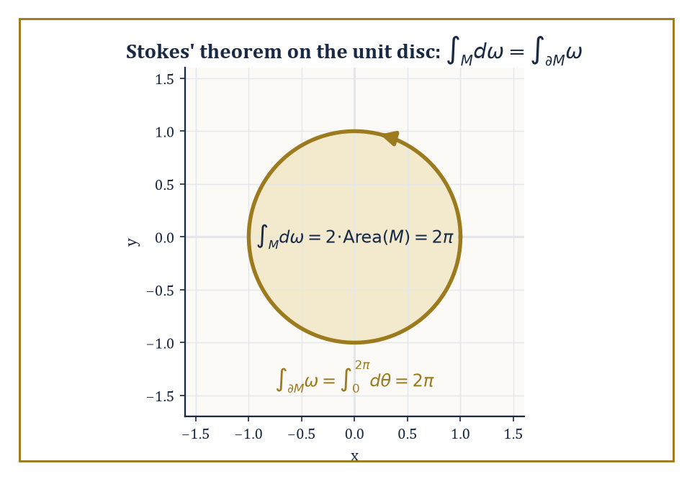
Two routes to 2π on the unit disc — integrate dω over the interior, or ω over the boundary — arriving, as Stokes insists they must, at exactly the same number.
The result does not depend on which atlas or which partition of unity you chose — a fact that requires the change-of-variables formula for multiple integrals, which is exactly the statement that the Jacobian determinant is the correct correction factor, i.e. exactly the transformation law of Room 34.1 applied to a top-degree form.
A manifold-with-boundary inherits an induced orientation on its boundary (the 'outward normal first' convention, made precise) from the orientation of the manifold itself.
Stokes' theorem is the single sentence that makes all of this worth building, for any (n−1)-form ω on an oriented n-manifold-with-boundary M:
∫_M dω = ∫_{∂M} ω
In words: the integral of the derivative over the whole space equals the integral of the original form over just the boundary.
Every 'fundamental theorem' you have met in this Tower is this one theorem wearing a costume: the fundamental theorem of calculus itself (M an interval, ∂M its two endpoints with signs), Green's theorem in the plane, Gauss's divergence theorem in space, and the classical Stokes' theorem for surfaces bounded by curves are all the single identity ∫_M dω = ∫_{∂M} ω, specialised to different dimensions and different degrees of form.
Numeric example — Worked example: Stokes' theorem on the unit disc. Let M be the closed unit disc {x²+y² ≤ 1} in ℝ², oriented the standard way, with boundary the unit circle traversed anticlockwise. Take ω = x dy − y dx, the same 1-form from Room 34.2, where we already found ω = r²dθ in polar coordinates.
Right-hand side of Stokes: on the unit circle r = 1, so ω restricts to dθ, and:
∫_{∂M} ω = ∫₀^{2π} 1² dθ = 2π
Left-hand side:
dω = d(x dy) − d(y dx) = (dx∧dy) − (dy∧dx) = dx∧dy − (−dx∧dy) = 2 dx∧dy
Integrating:
∫_M dω = ∫_M 2 dx∧dy = 2·Area(M) = 2·π(1)² = 2π
Both sides equal 2π. Stokes' theorem holds here not as an act of faith but as two independent computations landing on the same number, which is, after all, the only kind of confirmation mathematics ever really offers.
The classical vector-calculus theorems drop out as corollaries once the dictionary between vector fields and forms (via the metric — the same dictionary Room 34.7 will build properly) is in place: Green's theorem is the n=2 case just verified above, Gauss's divergence theorem is the n=3 case with a 2-form playing the role of flux, and the classical Kelvin–Stokes theorem relating a surface integral of curl to a line integral around its boundary is the n=2-inside-3 case.
What used to be three separate theorems, each proved by its own ad hoc argument and memorised separately by generations of engineering students, is revealed as one theorem, proved once, about the interaction of d and ∂.
Numeric example — Worked example: integrating over a boundaryless manifold. The unit sphere S² has no boundary at all, so Stokes' theorem forces, for any 2-form ω that happens to be exact:
∫_{S²} dω = ∫_{∂S²} ω = ∫_∅ ω = 0
A closed manifold kills every exact top-degree form's integral automatically.
Yet the sphere's own area form σ is manifestly not exact, since its integral is nonzero (computed directly, in spherical coordinates σ = sinφ dφ∧dθ):
∫_{S²} σ = ∫₀^π∫₀^{2π} sinφ dθdφ = 2π·[−cosφ]₀^π = 2π·(1−(−1)) = 2π·2 = 4π
and exactness would force it to vanish by the argument just given. This one nonzero number, 4π, is (up to normalisation) exactly what de Rham cohomology records as the generator of H²(S²) ≅ ℝ — the statement, extracted purely by integrating a 2-form, that the sphere is not simply a boundary of something, which is really just a fancy way of saying the sphere encloses a genuine hole in the middle, the same phenomenon Room 34.5's punctured-plane example caught one dimension down.
Abstract example — Abstract example: what the hole obstructs. Recall from Room 34.5 that ω = (x dy − y dx)/(x²+y²) is closed but not exact on ℝ²∖{0}. Suppose, for contradiction, someone claims ω = dα for some smooth function α defined on the whole punctured plane.
Apply Stokes to the unit circle (the boundary of the unit disc) — but the unit disc itself contains the origin, where ω is not defined, so the disc is not a legitimate domain for this ω, and Stokes cannot be applied over the full disc. That failure is not a technicality to be waved away; it is the entire content of the phenomenon.
If instead we integrate honestly over the annulus 0.5 ≤ r ≤ 1 (which does avoid the origin and does have M itself as a legitimate domain, with ∂M consisting of two circles, the outer one anticlockwise and the inner one clockwise by the induced-orientation convention), Stokes gives:
∫_M dω = 0 (since dω = 0 on the whole annulus)
which correctly forces the two boundary integrals to cancel:
∫_{outer} ω = 2π and ∫_{inner} ω = 2π
(both traversed anticlockwise as circles, but the inner one contributes with a minus sign as part of ∂M), so 2π − 2π = 0, consistent.
The nonzero value 2π attached to any single loop around the origin is exactly what de Rham cohomology packages up as the statement H¹(ℝ²∖{0}) ≅ ℝ: a topological fact about the puncture, extracted entirely by differential calculus, with no topology textbook required.

Room 34.7: Riemannian Metrics
Where the manifold finally learns to measure itself
Everything so far — charts, tangent vectors, forms, integration — works on a manifold with no notion of length or angle at all; you can integrate top-degree forms, but you cannot yet ask how long a curve is or whether two tangent vectors are perpendicular.
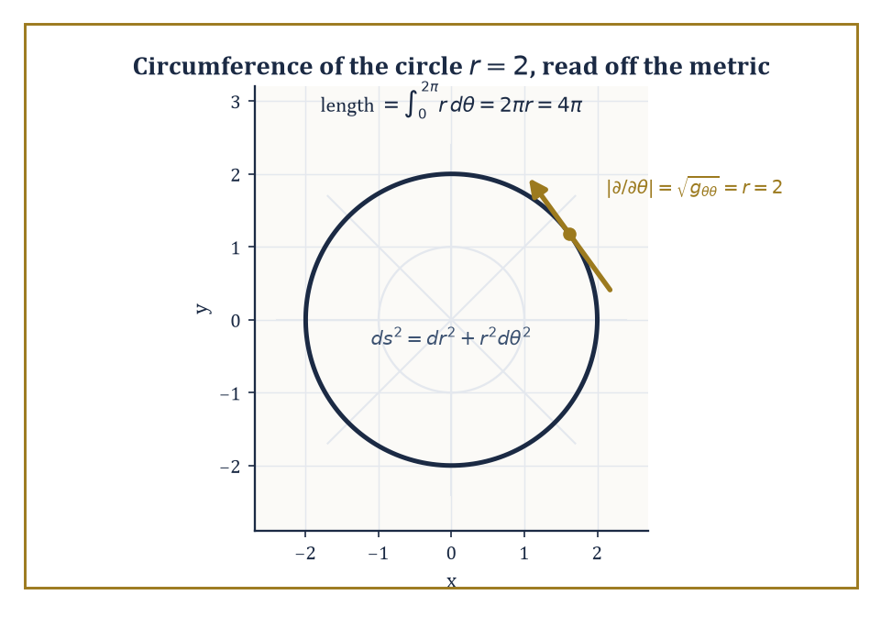
The circle r=2, its tangent direction ∂/∂θ stretched to length r by the metric g = diag(1, r²), integrating out to the circumference 4π you already trusted.
A Riemannian metric supplies exactly that: a smoothly varying inner product g on each tangent space, i.e. a (0,2)-tensor field that is symmetric and positive-definite at every point. In coordinates, g is represented by a symmetric positive-definite matrix of smooth functions g_ij(x).
The metric lets you compute the length of a tangent vector:
|v| = √(g(v,v))
the length of a curve, by integrating the speed √(g(γ′,γ′)) along it; angles between vectors; and volumes, via √(det g), the correction factor that makes the integration of Room 34.6 metric-aware.
It also supplies the musical isomorphisms — the metric-induced dictionary that lowers a vector's index to produce a covector (v ↦ g(v,·), traditionally written v♭, 'v flat') and raises a covector's index back (traditionally ω♯, 'omega sharp'), the very dictionary Room 34.6 promised and postponed.
Numeric example — Worked example: circumference from the metric. The flat plane in polar coordinates carries the metric:
ds² = dr² + r²dθ², i.e. g = diag(1, r²): g_rr = 1, g_θθ = r², g_rθ = 0
The circle of radius r = 2 is parametrised by θ ↦ (2, θ), θ ∈ [0,2π), with velocity dr/dθ = 0, dθ/dθ = 1, so its speed at every point is:
√(g_θθ·1²) = √(r²) = r = 2
Its length is:
∫₀^{2π} 2 dθ = 4π
This is the familiar circumference formula 2πr with r = 2, recovered from the metric tensor rather than assumed, which is exactly the point: the metric is the object from which every geometric quantity you already trust is derived, and checking it reproduces a formula you already knew is how you convince yourself the machine is correctly built before trusting it on a question you don't already know the answer to.
Numeric example — Worked example: lowering an index with the musical isomorphism. Still with g = diag(1, r²) on the punctured plane in polar coordinates, take the vector v = ∂/∂θ at the point r = 2 (components v^r = 0, v^θ = 1). Its flat, v♭ = g(v, ·), has components (v♭)_i = g_ij v^j:
(v♭)_r = g_rr v^r + g_rθ v^θ = (1)(0) + (0)(1) = 0
(v♭)_θ = g_θr v^r + g_θθ v^θ = (0)(0) + (r²)(1) = r² = 4 at r = 2
So v♭ = 4 dθ at that point — the covector 'dual' to the coordinate vector ∂/∂θ is not simply dθ, as it would naively be in a flat orthonormal frame, but r² dθ, because the metric itself is doing work: ∂/∂θ is a long vector far from the origin (its own length is √(g_θθ) = r = 2 here), and the musical isomorphism duly stretches its dual covector to match.
Raising the index again correctly undoes the stretch:
(dθ)♯ = g^{θθ} ∂/∂θ = (1/r²)∂/∂θ
since g^{θθ} = 1/g_θθ for a diagonal metric — the two musical isomorphisms are genuine inverses of one another, as any self-respecting isomorphism ought to be.
A Riemannian metric determines a unique connection compatible with it: the Levi-Civita connection, characterised by two conditions — it is torsion-free (symmetric in a sense the next room makes precise) and metric-compatible (parallel transport, defined in Room 34.8, preserves lengths and angles measured by g).
Its Christoffel symbols are given by the Koszul formula, which, worked out in coordinates, expresses Γ^k_ij entirely in terms of first derivatives of the components g_ij — the metric alone determines the connection, with no further geometric input required, a fact that is genuinely remarkable and not merely notational bookkeeping.
Geodesics are the curves that are 'as straight as the metric allows': autoparallel with respect to the Levi-Civita connection, and equivalently the critical curves of the energy functional ∫ g(γ′,γ′) dt among curves with fixed endpoints. The Euler–Lagrange equations of that variational problem are precisely the geodesic equation:
d²x^k/dt² + Γ^k_ij (dx^i/dt)(dx^j/dt) = 0
Numeric example — Worked example: Christoffel symbols of the flat plane in polar coordinates. For g = diag(1, r²), the Koszul formula reduces to Γ^k_ij = ½ g^{kl}(∂_i g_jl + ∂_j g_il − ∂_l g_ij) with g^{rr} = 1, g^{θθ} = 1/r² (the inverse metric, since g is diagonal).
Γ^r_θθ = ½ g^{rr}(∂_θ g_θr + ∂_θ g_θr − ∂_r g_θθ) = ½(1)(0 + 0 − ∂_r(r²)) = ½(−2r) = −r
Γ^θ_rθ = ½ g^{θθ}(∂_r g_θθ + ∂_θ g_θr − ∂_θ g_rθ) = ½(1/r²)(∂_r(r²) + 0 − 0) = ½(1/r²)(2r) = 1/r
By the symmetry Γ^θ_θr = Γ^θ_rθ = 1/r as well. All other Christoffel symbols (Γ^r_rr, Γ^r_rθ, Γ^θ_rr, Γ^θ_θθ) vanish, since the corresponding derivatives of g are all zero. At r = 5, concretely, Γ^r_θθ = −5 and Γ^θ_rθ = 0.2.
Plug into the geodesic equation for a radial line θ = const (so dθ/dt = 0 throughout): the equation reduces to:
d²r/dt² + Γ^r_θθ(dθ/dt)² = d²r/dt² + (−r)(0)² = d²r/dt² = 0
i.e. r moves at constant speed along a straight radial line — exactly matching the elementary fact that straight lines through the origin are geodesics of the flat plane, now derived from the connection machinery rather than assumed from a picture.
This intrinsic approach to length, angle, and geodesics generalises directly the intrinsic geometry of surfaces developed with such labour back in Storey 31 — the first and second fundamental forms of that storey are, respectively, exactly the induced Riemannian metric and (roughly) the shape operator that measures how the surface's own metric fails to be flat.
Riemannian geometry is what you get when you stop assuming the surface sits inside ℝ³ and instead take the metric g as the entire starting datum, deriving everything else — lengths, geodesics, and, in the next room, curvature — from it alone. The surface no longer needs an ambient space to be curved in; it can simply be curved, on its own terms.

Room 34.8: Connections, Covariant Derivatives, and Curvature
The room in which flatness finally gets a precise definition, and the sphere fails it magnificently
A connection on the tangent bundle (or, more generally, on any vector bundle) is the extra piece of structure that lets you differentiate a vector field Y in the direction of another vector field X, producing the covariant derivative ∇_XY.
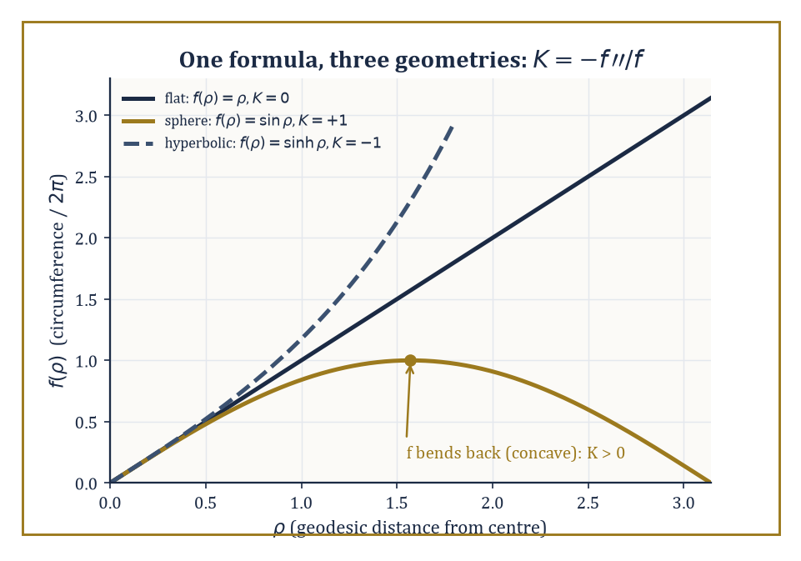
K = −f″/f, plotted for the same f(ρ) in all three geometries at once: a straight line stays straight, a sine bends back on itself, a sinh runs away — zero, positive, and negative curvature, read directly off the shape of one function.
It must be tensorial in X (its value at a point depends only on the value of X at that point, not on how X behaves nearby — consistent with X being 'a direction', a purely local piece of data) and a derivation in Y (satisfying a Leibniz rule, since Y is being differentiated, not merely evaluated).
This is precisely the gap Room 34.2 left open: ordinary partial differentiation of vector-field components is not well-defined on a general manifold (the components live in different tangent spaces at different points, which cannot be compared without extra structure), and a connection is exactly the extra structure that makes comparison — and hence differentiation — meaningful.
Torsion measures the failure of the connection to be 'symmetric' in the sense that matters:
T(X,Y) = ∇_XY − ∇_YX − [X,Y]
Curvature measures the failure of covariant differentiation in two different directions to commute the way ordinary partial derivatives on flat space always do:
R(X,Y)Z = ∇_X∇_YZ − ∇_Y∇_XZ − ∇_{[X,Y]}Z
The Riemann curvature tensor, obtained from R(X,Y)Z above by feeding in basis vector fields and reading off components R^l_ijk, is the fundamental local invariant of a connection.
It obeys a battery of symmetries (antisymmetry in its first pair of indices, antisymmetry in its second pair once fully lowered, and a symmetry under swapping the two pairs) and the Bianchi identities, which together cut the number of independent components down drastically from the naive n⁴.
Two useful contractions survive with clear geometric meaning: the Ricci curvature (contract one index of Riemann against another, producing a symmetric (0,2)-tensor) and the scalar curvature (contract once more, using the metric, producing a single function).
Sectional curvature packages the Riemann tensor's information plane by plane — one real number for each 2-dimensional subspace of the tangent space — and reduces, in two dimensions, to the ordinary Gaussian curvature already met in Storey 31.
Numeric example — Worked example: the flat plane really is flat, Christoffel symbols notwithstanding. Room 34.7 found nonzero Christoffel symbols Γ^r_θθ = −r and Γ^θ_rθ = Γ^θ_θr = 1/r for the flat plane in polar coordinates — a fair worry, since nonzero connection coefficients might suggest nonzero curvature. Check directly, using the formula:
R^ρ_σμν = ∂_μΓ^ρ_νσ − ∂_νΓ^ρ_μσ + Γ^ρ_μλΓ^λ_νσ − Γ^ρ_νλΓ^λ_μσ
computing R^θ_rrθ (ρ=θ, σ=r, μ=r, ν=θ) term by term:
term 1: ∂_rΓ^θ_θr = ∂_r(1/r) = −1/r²
term 2: ∂_θΓ^θ_rr = ∂_θ(0) = 0
term 3: Γ^θ_rλΓ^λ_θr = Γ^θ_rr·Γ^r_θr + Γ^θ_rθ·Γ^θ_θr = (0)(0) + (1/r)(1/r) = 1/r²
term 4: Γ^θ_θλΓ^λ_rr = Γ^θ_θr·Γ^r_rr + Γ^θ_θθ·Γ^θ_rr = (1/r)(0) + (0)(0) = 0
Assembling:
R^θ_rrθ = −1/r² − 0 + 1/r² − 0 = 0, for every value of r (check at r = 3 if you like: −1/9 − 0 + 1/9 − 0 = 0)
Curvature vanishes identically despite the connection coefficients not vanishing — exactly the resolution the room promised: nonzero Christoffel symbols reflect nothing more than an inconvenient choice of coordinates on a space that remains, underneath the inconvenience, perfectly flat.
Numeric example — Worked example: the plane, the sphere, and the saddle, unified by one formula. For any metric of the form ds² = dρ² + f(ρ)²dφ² (geodesic polar coordinates, with ρ measuring distance from a chosen point), the Gaussian curvature is given by the standard formula:
K(ρ) = −f″(ρ)/f(ρ)
Apply it three times. Flat plane: f(r) = r, so f″ = 0, giving:
K = −0/r = 0
matching the direct Riemann-tensor computation just above. Unit sphere, using geodesic polar coordinates from the north pole: f(ρ) = sin ρ, so f″(ρ) = −sin ρ, giving:
K = −(−sinρ)/sinρ = 1
matching the classical fact that the unit sphere has constant Gaussian curvature +1. Hyperbolic plane: f(ρ) = sinh ρ, so f″(ρ) = sinh ρ, giving:
K = −sinhρ/sinhρ = −1
matching the classical fact that the hyperbolic plane has constant curvature −1. Three metrics, one formula, three signs: zero, positive, negative — the entire trichotomy of two-dimensional geometry (Euclidean, spherical, hyperbolic) sitting inside a single ratio of a function to its own second derivative.
Curvature is not merely a number attached to a metric; it is operationally what parallel transport around a closed loop actually feels. Transport a tangent vector around a small loop, always keeping it 'as parallel as the connection allows' (∇ of the vector along the loop's velocity is zero throughout), and it returns rotated — the holonomy of the loop — by an amount governed, to leading order, by the curvature enclosed.
Vanishing curvature is exactly equivalent to local flatness: zero curvature everywhere is precisely the condition under which parallel transport around every sufficiently small loop returns the vector unrotated, which is why the flat-plane computation above, despite its nonzero Christoffel symbols, is entitled to call itself flat without embarrassment.
Numeric example — Worked example: holonomy on the unit sphere, via Gauss–Bonnet. Take the spherical triangle cut out by an octant of the unit sphere — one point on the equator, walk a quarter of the equator to a second point, then up a meridian to the north pole, then back down a second meridian to the start. Each of its three corners is a right angle (π/2), so its angle sum is 3π/2, exceeding the Euclidean value of π by an excess of π/2.
Its area is exactly one-eighth of the sphere's total area:
(4π)/8 = π/2
The Gauss–Bonnet relation for a geodesic triangle states that the angle excess equals ∫∫ K dA over the enclosed region; here K = 1 (constant, from the previous example), so:
∫∫K dA = 1·(π/2) = π/2
matching the angle excess exactly. Consequently, a tangent vector parallel-transported once around this triangle returns rotated by π/2 (a right angle) relative to where it started, purely as a consequence of the curvature enclosed: hard evidence, arithmetic rather than hand-waving, that curvature is not an abstraction invented to torment students but the literal amount by which the sphere refuses to let a vector come home unrotated.

Room 34.9: Looking Ahead: From Manifolds to Riemannian Geometry, Gauge Theory, and Relativity
The grammar is finished; the essays are due next
Take stock of the toolkit assembled across this storey: multilinear algebra and tensors (Room 34.1), the transformation laws that test whether a collection of numbers deserves the name (34.2), smooth manifolds as the spaces where all of this can happen without a Euclidean ambient space to lean on (34.3), tangent vectors, vector fields, and flows (34.4), differential forms and the exterior calculus that makes d² = 0 into a working tool rather than a curiosity (34.5), integration and Stokes' theorem unifying a century of vector-calculus folklore into one identity (34.6), Riemannian metrics that let a manifold measure itself (34.7), and connections and curvature that let it know, intrinsically, whether it is bent (34.8).
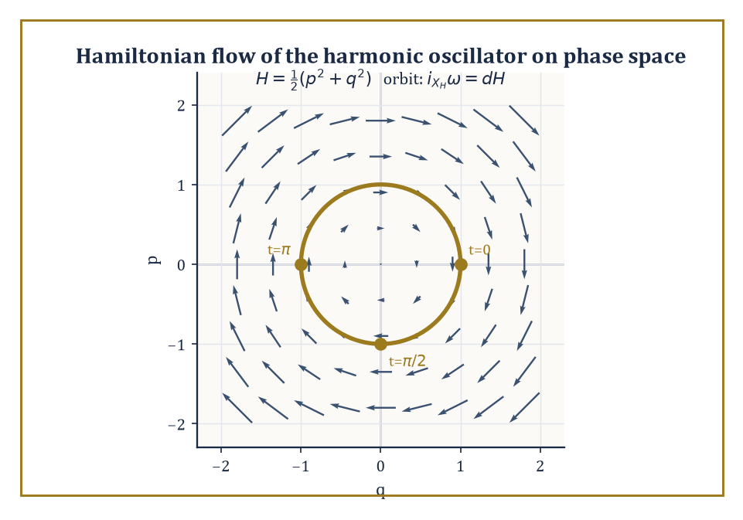
The harmonic oscillator's orbit in phase space, riding the Hamiltonian vector field defined by i_{X_H}ω = dH — classical mechanics, revealed as one closed curve inside a symplectic swirl.
This is not a miscellany; it is a single grammar, built in the order it had to be built, each room a prerequisite for the next.
Riemannian geometry proper takes the local curvature of Room 34.8 and asks what it forces globally: comparison theorems (a space that is 'at least as curved as' a sphere behaves, in aggregate, somewhat like a sphere), sphere theorems (enough curvature and not too much diameter forces you to actually be a sphere, topologically), and Ricci flow, the technique — heat-equation-flavoured, evolving a metric in the direction that smooths out its own curvature — that Grigori Perelman used to settle the Poincaré conjecture and decline the million dollars that came with it, on the perfectly defensible grounds that a mathematician ought to be paid in theorems.
Gauge theory generalises the connections of Room 34.8 from the tangent bundle to more general vector (or principal) bundles, and in doing so recovers electromagnetism and the strong and weak nuclear interactions as the geometry of connections on such bundles — a physicist's field is, from this vantage, simply a curvature.
Numeric example — Worked example: a round sphere under Ricci flow. A round sphere of radius r carries constant Gaussian curvature K = 1/r² (Room 34.8's formula K = −f″/f with f(ρ) = r sin(ρ/r), suitably rescaled) and hence Ricci tensor Ric = K·g.
Under the Ricci flow equation:
∂g/∂t = −2 Ric
a round sphere stays round — the flow simply shrinks its radius — and substituting g = r(t)²·(unit-sphere metric) into the flow equation and matching coefficients gives:
d(r²)/dt = −2, so r(t)² = r₀² − 2t
Starting from the unit sphere, r₀ = 1, the radius shrinks to zero — the sphere flows into a point — at time t = 1/2, since 1 − 2(1/2) = 0.
This finite-time vanishing is exactly the phenomenon Perelman had to control with great technical delicacy for far more complicated 3-manifolds, where the flow can develop 'neckpinches' rather than shrinking uniformly to a single point; the round-sphere case above is the one instance simple enough to solve by hand in three lines, and it is worth doing so once, precisely so that the word 'singularity' in the Ricci-flow literature stops sounding like magic and starts sounding like the entirely explicit r₀²−2t running out of room.
Abstract example — Abstract example: electromagnetism as curvature. On ℝ⁴ (or a patch of it), let A be a 1-form — the electromagnetic vector potential — and set F = dA, a 2-form: the electromagnetic field-strength tensor, playing exactly the role of a curvature 2-form for a connection on a U(1) (circle-group) bundle.
Take the toy example A = x dy on ℝ² (a 'connection' with only two of the four spacetime directions active, to keep the arithmetic honest and short):
F = dA = d(x)∧dy = dx∧dy
a constant 2-form — a uniform 'magnetic field' of strength 1, in the sense that the coefficient of dx∧dy is the constant function 1 everywhere.
That F is automatically closed (dF = d(dA) = 0, by d²=0, the very identity from Room 34.5) is not a coincidence dressed up as physics — it is, read in three spatial dimensions with F reorganised into electric and magnetic field components, exactly two of Maxwell's four equations (the two with no source term), true for purely geometric reasons before a single physical law has been invoked.
General relativity identifies spacetime itself with a four-dimensional Lorentzian manifold (a manifold with a metric of the 'wrong' signature, one minus sign among the four, encoding that time behaves differently from space) whose curvature — specifically the Einstein tensor, a particular combination of the Ricci and scalar curvatures of Room 34.8 — is set equal to the stress-energy tensor of whatever matter and energy are present.
'Matter tells spacetime how to curve; curved spacetime tells matter how to move' is the famous slogan, and by this point in the Tower you have every piece of vocabulary the slogan requires: matter is a source term built from tensor fields, spacetime is a Riemannian (strictly, Lorentzian) manifold, curving is the Riemann tensor's business, and moving along the straightest available path is exactly what a geodesic, from Room 34.7, does.
Symplectic and contact geometry, meanwhile, take a different tensorial ingredient — a closed, nondegenerate 2-form, rather than a symmetric metric — as their starting datum, and produce the natural home of classical mechanics.
Numeric example — Worked example: Hamilton's equations from a symplectic form. On phase space ℝ² with coordinates (q,p), take the symplectic form ω = dq∧dp. Given an energy function H(q,p), the Hamiltonian vector field X_H is defined by the equation i_{X_H}ω = dH, and its flow is Hamilton's equations.
For the harmonic oscillator H(q,p) = ½(p²+q²):
dH = p dp + q dq
Solving i_{X_H}ω = dH for X_H = a ∂/∂q + b ∂/∂p against ω = dq∧dp gives, after a short calculation:
X_H = p ∂/∂q − q ∂/∂p, i.e. dq/dt = p, dp/dt = −q
Starting from (q,p) = (1,0), the solution is:
q(t) = cos t, p(t) = −sin t
Check: dq/dt = −sin t = p = −sin t, and dp/dt = −cos t = −q = −cos t — both confirmed. At t = π/2, the orbit reaches (q,p) = (0,−1); at t = π, it reaches (−1,0).
The 'straight lines' of symplectic geometry are these energy-preserving orbits, and the entire apparatus of classical mechanics — conservation laws, integrable systems, chaos — is the geometry of the closed 2-form ω doing to phase space what the metric g did to Riemannian manifolds, with rotation instead of rotation-and-stretching as its symmetry.
The deeper lesson of this storey is not any single theorem but the combination: multilinear algebra supplied the alphabet, and the flexible notion of a manifold supplied a page large enough, and strange enough, to write on. Together they produce a language expressive enough to hold both the concrete curving surfaces of Storey 31 and the four-dimensional curved spacetime that governs whether you are currently falling, and it does so with the same nine rooms of vocabulary regardless of which one you are describing. Tensors and manifolds are, without exaggeration, the grammar of modern geometry; everything from here upward in the Tower that touches curvature, fields, or spaces-that-are-not-quite-Euclidean will simply assume you can read it fluently.
We have, as promised at the start, learned to do geometry without coordinates and then, once the intrinsic picture was secure enough not to collapse under the weight of an index, learned to choose coordinates again — wisely, locally, and without the faintest twinge of guilt. The next storey performs a rather different act of liberation: having spent this one making finite-dimensional spaces behave, Storey 35 abandons finite dimensions altogether and asks what happens to linear algebra and calculus when your 'vectors' are functions and your 'space' has infinitely many directions to be curved in — Hilbert spaces, Banach spaces, and the operators that act on them. Manifolds taught you to trust a space you could not fully see at once. Functional analysis is going to ask you to trust one you could never see at once even in principle, and to do calculus on it regardless.
The Tower continues upward. Mind the step; it is, as it happens, infinite-dimensional from here.

Storey 35: Functional Analysis
Infinite-Dimensional Spaces, Operators, and the Art of Analysis in Function Spaces
The previous storey spent its energy teaching tensors to behave themselves under a change of coordinates, which is more than can be said for most of us on a Monday morning. But notice what tensors had going for them throughout: at every point of the manifold, the tangent space was finite-dimensional. However exotic the manifold, however many indices you had upstairs and downstairs, you were still, at each instant, doing ordinary linear algebra on a space with a finite basis. That comfort now ends. Permanently.
Functional analysis is what happens when you take the vector spaces of linear algebra — spaces of vectors, with addition and scalar multiplication — and let the dimension run away to infinity by populating the space with functions instead of arrows. A function on an interval is, after all, just a vector with uncountably many coordinates, one for each point of the interval. The trouble is that everything linear algebra taught you to take for granted quietly stops being true. A linear map need not be continuous. A subspace need not have a complement. The unit ball, that reliable compact anchor of finite-dimensional geometry, becomes a vast, non-compact wilderness in which sequences wander off and never come back. Bolzano–Weierstrass, rest in peace.
So this storey adds a second ingredient to the vector-space structure: a topology, a rigorous notion of 'close to,' without which words like 'convergent,' 'continuous,' and 'complete' are just noises. The central question throughout is which finite-dimensional intuitions survive the trip to infinite dimensions unscathed, which survive in a weakened form, and which have to be surrendered entirely and grieved for. Completeness, duality, the spectrum, compactness — these become the load-bearing walls of the whole subject, precisely because so much of the old scaffolding has been kicked away.
It is also, not incidentally, the actual language spoken by the rest of analysis: quantum mechanics is a sentence in Hilbert space, weak solutions of differential equations live in Sobolev spaces, and Fourier analysis turns out to be nothing but the spectral theory of one very patient operator. The next storey, on measure theory, will hand us the rigorous integral this storey quietly leans on throughout (that ∫ sign has been trading on your goodwill since Room 35.1); for now, we go infinite-dimensional, and we find out which of our instincts come with us.

Room 35.1: What Functional Analysis Actually Is
In Which the Word 'Space' Stops Meaning What You Think It Means
Functional analysis studies vector spaces of functions (or sequences, or more general infinite-dimensional objects) equipped with a topology — a rigorous notion of which points are 'close' to which — together with the continuous linear operators that map between such spaces respecting both the algebra and the topology.
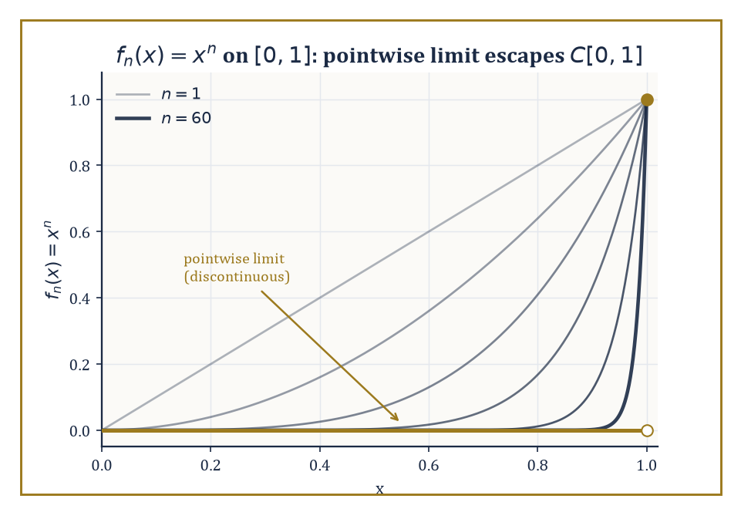
Same sequence xⁿ, two topologies, two verdicts: pointwise it collapses to a jump at x=1; uniformly it never converges at all.
This is a genuinely double burden. Linear algebra only ever asked you to respect addition and scalar multiplication; here you must respect those and continuity simultaneously, and in infinite dimensions the two do not automatically get along.
A linear map between finite-dimensional spaces is always continuous — you may never have been told this because it never needed saying — but a linear map between infinite-dimensional spaces can be about as discontinuous as it likes, unless you go out of your way to forbid it.
Abstract example — Why the topology is not optional. Take the space C[0,1] of continuous functions on [0,1] and the sequence
fₙ(x) = xⁿ
Under pointwise convergence, this sequence behaves as follows:
fₙ(x) → 0 for every x in [0,1), and fₙ(1) = 1 for every n
So the pointwise limit is the function that is 0 on [0,1) and jumps to 1 at x = 1 — a function that is not continuous, and so does not even live in C[0,1].
Under the uniform (sup-norm) topology, the verdict is different again:
sup₀≤x≤1 |fₙ(x) − 0| = 1 for every n
(the supremum is approached as x → 1⁻), so fₙ does not converge to 0 uniformly either — consistent with the fact that a uniform limit of continuous functions must itself be continuous, and the pointwise limit above manifestly isn't.
Same sequence, same set of functions, two different topologies, two different (and both entirely correct) answers to 'does this converge, and to what?' That ambiguity, made precise rather than argued about in a pub, is the entire reason the subject exists.
A quick terminological note before we go further: 'operator' and 'functional' name the same kind of object — a linear map respecting the topology — but convention reserves 'functional' for the special case where the output is a scalar (the target is just the field ℝ or ℂ), while 'operator' covers the general case, including when the output is itself a function.
Every functional is an operator; not every operator is a functional.
Abstract example — The same rule, legal in one space and meaningless in another. On C[0,1] with the sup norm, consider the evaluation functional
δ₁(f) = f(1)
This is perfectly bounded:
|δ₁(f)| = |f(1)| ≤ ‖f‖_∞
so ‖δ₁‖ ≤ 1, and testing on f ≡ 1 shows
‖δ₁‖ = 1 exactly
But the identical rule 'evaluate at x = 1' does not even make sense as a functional on L²[0,1], because elements of L² are equivalence classes of functions agreeing almost everywhere, and altering a function's value at the single point x = 1 leaves its equivalence class completely unchanged — pointwise evaluation isn't merely unbounded on L², it fails to be well-defined there in the first place.
Which functionals exist at all, not just which ones happen to be continuous, depends on which space and topology you have chosen.
The classical examples are the ones you will meet in every corner of analysis: C(K), the continuous functions on a compact set K, with the sup norm; the Lᵖ(μ) spaces of functions whose p-th power is integrable against a measure μ; Hilbert spaces of square-integrable functions; and Sobolev spaces, which additionally track a function's derivatives.
These arise from wildly different problems — approximation theory, integral equations, quantum mechanics, elasticity — yet share enough structural DNA that a single abstract theory, developed once, answers questions in all of them simultaneously.
That is the entire economic case for abstraction: prove the Hahn–Banach theorem once, and never have to re-derive it separately for continuous functions, square-integrable functions, and sequences that happen to be absolutely summable.
Numeric example — A first citizen of the dual space. Define L : C[0,1] → ℝ by
L(f) = ∫₀¹ f(x) dx
On f(x) = x², we get
L(f) = ∫₀¹ x² dx = 1/3
On f(x) = 3x − 2, we get
L(f) = [3x²/2 − 2x]₀¹ = 3/2 − 2 = −1/2
Linearity is immediate from linearity of the integral:
L(af + bg) = aL(f) + bL(g)
for any scalars a, b. Boundedness follows from
|L(f)| = |∫₀¹ f(x) dx| ≤ ∫₀¹ |f(x)| dx ≤ ‖f‖∞
(the sup norm), so L is a bounded linear functional with operator norm ‖L‖ ≤ 1; testing against f ≡ 1 gives
L(f) = 1 = ‖f‖∞
so in fact ‖L‖ = 1 exactly. This unassuming object — 'integrate the function' — is the simplest nontrivial element of the dual space C[0,1]*, and it is worth remembering once Room 35.3 makes duality the star of the show.
The name 'functional analysis' comes from 'functional': a function whose own domain is a space of functions, returning an ordinary number.
The archetype predates the abstract theory by two centuries — the calculus of variations, which asks questions of the form 'which path minimizes this quantity,' is exactly the theory of functionals and their critical points, and it is where the whole subject's instincts were first trained.
Numeric example — A functional from the calculus of variations. The length functional assigns to a path y on [0,1] the number
L[y] = ∫₀¹ √(1 + y′(x)²) dx
Take y(x) = 2x, the straight line from (0,0) to (1,2): y′(x) = 2 constant, so
L[y] = ∫₀¹ √(1+4) dx = √5 ≈ 2.236
— and indeed the straight-line distance from (0,0) to (1,2) is
√(1² + 2²) = √5
exactly as it should be, since a straight line's arc length is just its endpoint distance. L assigns one real number to an entire function; making that assignment continuous, and asking which functions minimize or maximize it, is the calculus of variations, and it is the historical seed from which the whole abstract apparatus of this storey eventually grew.
Functional analysis is therefore both a subject with its own theorems and machinery, and simultaneously the common grammar in which the rest of modern analysis is written — differential equations, harmonic analysis, probability, and quantum theory all eventually say what they mean in the vocabulary this storey builds.

Room 35.2: Banach Spaces and Hilbert Spaces
Completeness: The One Thing You Actually Cannot Do Without
A Banach space is a normed vector space that is complete: every Cauchy sequence — one whose terms eventually get and stay arbitrarily close to each other — actually converges to a limit that lives in the space.
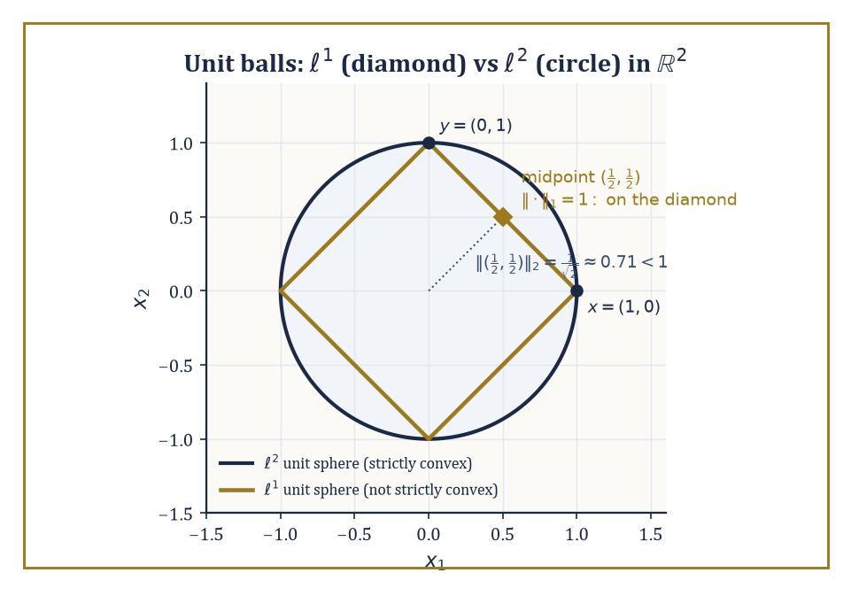
The ℓ¹ diamond lets a whole edge sit on the unit sphere; the ℓ² circle bows a midpoint strictly inside — one figure, two verdicts on strict convexity.
This sounds like a technicality until you notice how much depends on it: the contraction-mapping theorem, the inverse-function theorem, and essentially every existence proof that runs 'construct an approximating sequence, then take the limit' silently assumes that the limit exists somewhere you're allowed to look for it. Without completeness, you can build a sequence that homes in on a target and then discover the target was never in your space to begin with.
Numeric example — What incompleteness feels like. Work inside ℚ, the rationals, with the ordinary absolute value as norm. Let x₁ = 1, x₂ = 1.4, x₃ = 1.41, x₄ = 1.414, x₅ = 1.4142, … , the successive decimal truncations of √2.
This sequence is Cauchy: |xₙ − xₘ| shrinks below any prescribed tolerance once n and m are large enough, since the terms agree on more and more decimal digits, for instance:
|x₄ − x₅| = |1.414 − 1.4142| = 0.0002
Yet the sequence has no limit inside ℚ, because its only possible limit is √2, and √2 is irrational. ℚ is a perfectly respectable normed vector space over itself; it is simply not complete, and this single defect is why we do analysis in ℝ rather than ℚ. Banach spaces are the higher-dimensional refusal to repeat that mistake.
The working examples are C(K) (continuous functions on a compact set K, sup norm), Lᵖ(μ) (functions with ∫|f|ᵖ dμ < ∞, norm ‖f‖ₚ = (∫|f|ᵖ dμ)^(1/p)), and the sequence spaces ℓᵖ, consisting of infinite sequences x = (x₁, x₂, x₃, …) with ‖x‖ₚ = (Σₖ|xₖ|ᵖ)^(1/p) < ∞.
All three families are complete — this is a genuine theorem in each case, not a triviality — and all three reduce, when the underlying set is finite, to the familiar finite-dimensional normed spaces you already know.
Numeric example — A norm computed in ℓ². Let x = (1, 1/2, 1/4, 1/8, …), i.e. xₖ = (1/2)^(k−1) for k = 1, 2, 3, …. Then:
‖x‖₂² = Σₖ₌₁^∞ (1/2^(k−1))² = Σₖ₌₁^∞ 1/4^(k−1)
This is a geometric series with ratio 1/4, summing to:
1/(1 − 1/4) = 4/3
So:
‖x‖₂ = √(4/3) = 2/√3 ≈ 1.1547
The sequence is a perfectly good vector in ℓ², despite having infinitely many nonzero coordinates — this is the point of the space: it is exactly the sequences for which such a sum converges at all.
A Hilbert space is a Banach space whose norm arises from an inner product ⟨·,·⟩ via:
‖x‖ = √⟨x,x⟩
The extra structure buys you angles, orthogonality, and orthonormal bases, and makes Hilbert spaces the most geometrically forgiving of the infinite-dimensional spaces.
The Riesz representation theorem says that every continuous linear functional f on a Hilbert space H has the form:
f(x) = ⟨x, y⟩
for a unique vector y ∈ H — the dual space, mysterious in general Banach spaces, collapses back into a copy of H itself. Every separable infinite-dimensional Hilbert space is isomorphic to every other one (they are all secretly ℓ²); the actual content of Hilbert space theory lies not in the spaces but in the operators that act on them, which is where Rooms 35.6 and 35.7 are headed.
Numeric example — Riesz representation, finite-dimensional dress rehearsal. Take H = ℝ³ with the usual dot product, and the linear functional f(x,y,z) = 2x − y + 3z. Riesz representation (which in finite dimensions is just 'every linear functional is dotting with some fixed vector') says:
f(v) = v · w for w = (2, −1, 3)
Check the three basis vectors:
f(1,0,0) = 2 = (1,0,0)·w
f(0,1,0) = −1 = (0,1,0)·w
f(0,0,1) = 3 = (0,0,1)·w
and linearity does the rest. The infinite-dimensional statement is the same idea with the dot product replaced by an integral: a bounded functional on L²[0,1] such as
f(h) = ∫₀¹ h(x)g(x) dx
for fixed g ∈ L² is represented by that same g, and Riesz's theorem is the guarantee that every bounded functional on L² arises this way — there are no bounded functionals on a Hilbert space that aren't secretly 'take the inner product with something.'
Not every Banach space is secretly a Hilbert space in disguise; whether a given norm comes from an inner product at all is decided by a single algebraic identity, the parallelogram law:
‖x+y‖² + ‖x−y‖² = 2‖x‖² + 2‖y‖² for every x, y
A norm satisfies this identity if and only if it arises from an inner product, so the law is a genuine litmus test, not just a curiosity left over from parallelograms in the plane.
Numeric example — ℓ¹ fails the parallelogram law. Work in ℓ¹ restricted to two coordinates, with x = (1,0), y = (0,1). Then x+y = (1,1), with:
‖x+y‖₁ = 1+1 = 2
and x−y = (1,−1), with:
‖x−y‖₁ = 1+1 = 2
The left side of the parallelogram law is:
‖x+y‖² + ‖x−y‖² = 4 + 4 = 8
The right side is:
2‖x‖₁² + 2‖y‖₁² = 2(1) + 2(1) = 4
Since 8 ≠ 4, the law fails outright — confirming, on two vectors you could check by hand, that the ℓ¹ norm does not come from any inner product, so ℓ¹ can never be a Hilbert space, however you might otherwise try to dress it up.
The shape of the unit ball matters more than it has any right to. A space is strictly convex if the line segment joining two distinct points of the unit sphere never touches the sphere except at its endpoints; this controls whether nearest-point projections onto convex sets are unique, and it quietly underwrites the uniqueness of best approximations and the good behaviour of weakly convergent minimizing sequences in optimization.
Numeric example — ℓ¹ fails to be strictly convex; ℓ² succeeds. In ℓ¹ (restricting to two coordinates for clarity), take x = (1,0) and y = (0,1); both have ‖x‖₁ = ‖y‖₁ = 1. Their midpoint is (1/2, 1/2), with:
‖(1/2,1/2)‖₁ = 1/2 + 1/2 = 1
— the same norm as the endpoints. The entire segment between x and y sits on the unit sphere; strict convexity fails outright, and with it, uniqueness of nearest points.
Contrast ℓ² (equivalently ℝ² with the Euclidean norm): ‖x‖₂ = ‖y‖₂ = 1 still, but the midpoint has:
‖(1/2,1/2)‖₂ = √(1/4+1/4) = √(1/2) ≈ 0.7071 < 1
strictly inside the ball. ℓ² is strictly convex; ℓ¹ is not — a small numerical fact with large downstream consequences for how well-posed approximation problems are in each space.

Room 35.3: Linear Operators and Duality
Matrices, All Grown Up and Slightly Feral
A bounded linear operator T : X → Y between normed spaces is a linear map for which the following holds for some constant C and every x:
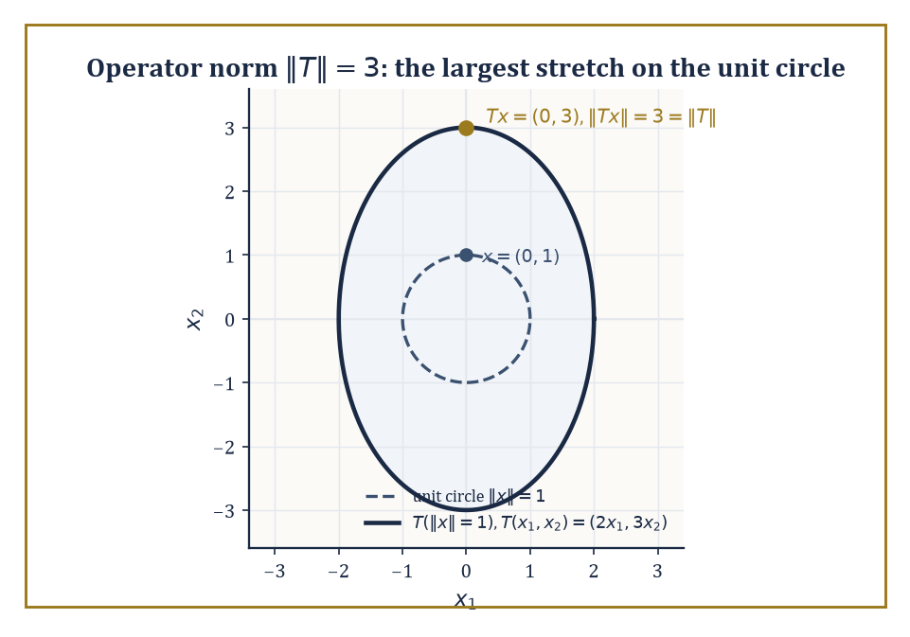
T stretches the unit circle into an ellipse, and the operator norm is caught in the act at the one point that gets stretched the most.
‖Tx‖ ≤ C‖x‖
The smallest such C is the operator norm, measuring the worst-case stretching T can inflict:
‖T‖ = sup{‖Tx‖ : ‖x‖ ≤ 1}
In finite dimensions, every linear map is automatically bounded — this is one of those facts nobody mentions precisely because it is always true there. In infinite dimensions it is not automatic at all, and Room 35.8 will introduce operators (differentiation, chiefly) that are unbounded and have to be handled with real care.
Numeric example — Operator norm of a diagonal map. Let T : ℝ² → ℝ² be defined by:
T(x₁,x₂) = (2x₁, 3x₂)
with the Euclidean norm on both copies of ℝ². Then:
‖Tx‖² = 4x₁² + 9x₂²
and we maximize this subject to:
‖x‖² = x₁² + x₂² = 1
Since 9 > 4, the maximum is achieved by putting all the weight on x₂: x₁ = 0, x₂ = 1 gives:
‖Tx‖² = 9, so ‖Tx‖ = 3
No other unit vector does better (any mixture only trades a coefficient-9 contribution for a coefficient-4 one). So ‖T‖ = 3, the larger of the two diagonal entries — the operator norm of a diagonal matrix is exactly its largest entry in absolute value, i.e. its largest singular value, a fact that will resurface, dressed up, when we discuss eigenvalues of compact operators.
The dual space X* is the space of all bounded linear functionals on X; it is always a Banach space, even when X itself is not complete (a pleasant and slightly surprising bonus). Applying the dual construction twice gives the bidual X**, and there is always a natural embedding J : X → X** defined by:
J(x)(f) = f(x) for f ∈ X*
X is called reflexive when J is not just injective (which is automatic, courtesy of Hahn–Banach) but actually onto — when X** contains nothing more than a relabelled copy of X.
Abstract example — ℓ¹ is not reflexive, and it is ℓ^∞'s fault. It is a genuine theorem that:
(ℓ¹)* ≅ ℓ^∞
Every bounded functional on ℓ¹ has the form
φ(x) = Σₖ xₖyₖ
for a unique bounded sequence y ∈ ℓ^∞, with ‖φ‖ = ‖y‖_∞. So far this looks exactly like the finite-dimensional story.
The asymmetry appears one step later: (ℓ^∞)* is emphatically not ℓ¹. It is a much larger and stranger space, containing functionals — generalized limits called Banach limits among them — that assign a sensible 'limit' to every bounded sequence, including ones like (1,0,1,0,1,0,…) that have no ordinary limit, and that cannot be written as Σ xₖyₖ for any y ∈ ℓ¹.
Consequence: the natural embedding of ℓ¹ into (ℓ¹)** = (ℓ^∞)* misses almost everything; ℓ¹ is the standard example of a Banach space that is decidedly not reflexive, and the mismatch traces directly back to the lopsided relationship between ℓ¹ and ℓ^∞.
The adjoint of a bounded operator T : X → Y is the operator T* : Y* → X* defined by:
(T*g)(x) = g(Tx)
For T an ordinary matrix with the standard dot products, T* is literally the transpose, so nothing new has happened yet. What is new is the spectrum:
σ(T) = {λ ∈ ℂ : T − λI is not invertible}
This generalizes the set of eigenvalues, but the word 'generalizes' is doing real work — for bounded operators on complex Banach spaces the spectrum is always nonempty and compact, a genuinely infinite-dimensional theorem with no honest finite-dimensional analogue (it is also precisely why complex scalars, not real ones, are compulsory here: a 90° rotation of ℝ² has no real eigenvalue at all, yet as a complex-linear map it has two, ±i).
Abstract example — The shift operator: a spectrum with no eigenvalues in it. Define the right shift S on ℓ²(ℕ) by:
S(x₁, x₂, x₃, …) = (0, x₁, x₂, …)
It is an isometry (‖Sx‖ = ‖x‖ exactly, since shifting doesn't change the sum of squares), hence ‖S‖ = 1. It is injective (Sx = 0 forces every xₖ = 0), but not surjective — nothing maps to (1,0,0,…), since that would require a coordinate 'before the first one.'
Try to solve Sx = λx coordinate by coordinate: the equations read:
0 = λx₁, x₁ = λx₂, x₂ = λx₃, …
For λ ≠ 0 this forces x₁ = 0, then x₂ = 0, and so on — the only solution is x = 0, so S has no eigenvalues whatsoever; the point spectrum is empty. And yet the full spectrum σ(S) is the entire closed unit disc:
{λ : |λ| ≤ 1}
every one of those scalars still makes S − λI fail to be invertible, just not via a kernel, the mechanism finite-dimensional habit expects. (Its adjoint, the left shift S*, is far more obliging: every λ with |λ| < 1 genuinely is an eigenvalue of S*.) This is the standard moment where 'spectrum equals eigenvalues' quietly stops being true, sometime around when the dimension count left ℕ behind.
The same 'second dual is bigger' pattern recurs throughout the subject, and it is worth seeing it in one more costume. The space c₀ of sequences converging to zero has dual:
(c₀)* ≅ ℓ¹
and that space's own dual is:
(ℓ¹)* ≅ ℓ^∞
so c₀'s bidual is ℓ^∞, which strictly contains c₀ (the constant sequence (1,1,1,…) is bounded but does not converge to zero, so it lies in ℓ^∞ but never in c₀). c₀ is therefore not reflexive either, for exactly the structural reason ℓ¹ was not: somewhere in the chain of duals, ℓ^∞ shows up and refuses to shrink back down.
Numeric example — The bidual gap for c₀, made concrete. Take the constant sequence:
w = (1,1,1,…)
As an element of ℓ^∞ = (c₀)**, ‖w‖_∞ = 1, so it certainly lives in the bidual. But w does not converge to zero, so w ∉ c₀ — and under the natural embedding J, J(x) is just x relabelled, so no x ∈ c₀ could possibly produce w. The natural embedding J : c₀ → c₀** therefore misses w entirely: c₀** is strictly larger than J(c₀), and c₀ is not reflexive, exhibited on a single sequence you can write down without any theory at all.
Duality is what lets us pair spaces of functions against spaces of measures or distributions, and it is the machine that produces weak formulations of differential equations: instead of demanding that a candidate solution satisfy an equation pointwise, we demand only that it satisfy the equation when tested — paired via duality — against every member of a suitable space of test functions.
Rooms 35.8 and 35.9 will lean on exactly this idea.

Room 35.4: The Fundamental Theorems
Three Theorems and a Quiet Funeral for Your Remaining Intuitions
The Hahn–Banach theorem says that a bounded linear functional defined on a subspace M of X can always be extended to the whole of X without increasing its norm. Two consequences make this the true foundation stone of the subject. First, dual spaces are never trivially small — for any nonzero x₀ ∈ X there is a functional f with
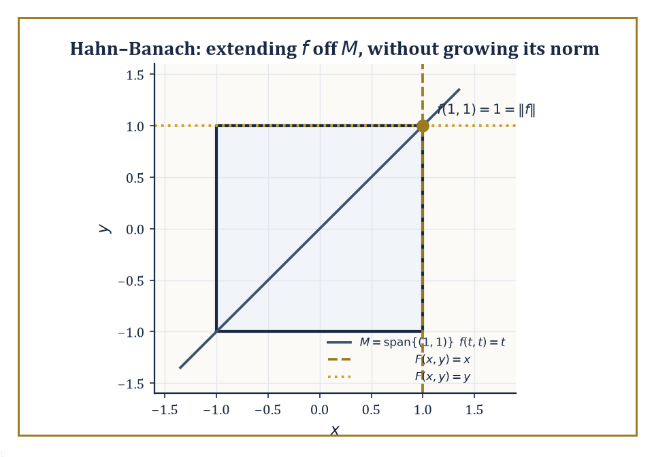
In the sup-norm square, f's norm-1 verdict on the diagonal M extends two different ways — F(x,y)=x and F(x,y)=y both hug the same corner without ever growing past it.
f(x₀) = ‖x₀‖, ‖f‖ = 1
so functionals genuinely 'see' every vector. Second, in its geometric form, the theorem says that two disjoint convex sets can always be separated by a hyperplane, i.e. by the level set of some continuous linear functional. Everything downstream in duality theory eventually cites this fact, directly or indirectly.
Numeric example — An extension, worked in full. Let X = ℝ² with the sup norm, and let M = span{(1,1)}, the diagonal line.
‖(x,y)‖_∞ = max(|x|,|y|)
Define f on M by
f(t,t) = t for (t,t) ∈ M
Since |f(t,t)| = |t| = ‖(t,t)‖_∞, the norm of f on M is exactly 1. Hahn–Banach guarantees a norm-1 extension F to all of ℝ²; here is one:
F(x,y) = x
Check it agrees with f on M:
F(t,t) = t
Check its norm: for ‖(x,y)‖_∞ ≤ 1 we have |x| ≤ 1, so ‖F‖ ≤ 1, with equality at (1,0); so ‖F‖ = 1, exactly matching ‖f‖. Note the extension is not unique — F(x,y) = y works equally well, since
F(t,t) = t, ‖F‖ = 1
by the same argument. And so does every convex combination
F_s(x,y) = sx + (1−s)y for s ∈ [0,1]
F_s(t,t) = st + (1−s)t = t
|F_s(x,y)| ≤ s|x| + (1−s)|y| ≤ max(|x|,|y|), with equality attainable, so ‖F_s‖ = 1 throughout
An entire one-parameter family of equally valid extensions — Hahn–Banach guarantees existence, never uniqueness.
The open-mapping theorem says a surjective bounded operator between Banach spaces sends open sets to open sets — it cannot squash the target space down onto some thin, degenerate image.
The closed-graph theorem says that if the graph {(x, Tx)} of a linear operator T is closed as a subset of X × Y, then T is automatically bounded — you never have to verify continuity by hand once closedness of the graph is established, which in practice is often the easier thing to check.
The uniform-boundedness principle (Banach–Steinhaus) says that a family of bounded operators that is pointwise bounded — sup over the family of ‖Tₙx‖ is finite for each fixed x — is automatically uniformly bounded: sup over the family of the operator norms ‖Tₙ‖ is finite too.
Together these three are the workhorses that make linear functional analysis into a subject with theorems, rather than a subject with only definitions.
Abstract example — Banach–Steinhaus, run in reverse. Consider the coordinate functionals φₙ : ℓ² → ℝ given by
φₙ(x) = n·xₙ
Each is bounded, with
‖φₙ‖ = n
exactly (achieved at the standard basis vector eₙ, since ‖eₙ‖ = 1 and φₙ(eₙ) = n). Since ‖φₙ‖ = n → ∞, this family is not uniformly bounded.
Banach–Steinhaus, read contrapositively, then guarantees that pointwise boundedness must fail somewhere too: there exists some x ∈ ℓ² for which the numbers φₙ(x) = n·xₙ form an unbounded sequence.
This is worth pausing on, because it is not obvious how to exhibit such an x by hand — the tempting test vector
x = (1/n)ₙ
gives
φₙ(x) = 1 for every n
perfectly bounded, precisely because that particular x was too well-behaved to expose the problem. The theorem's entire value is that it proves such a badly-behaved x must exist somewhere in the space without needing to hand you a formula for one; constructing one explicitly is a real (if standard) exercise in choosing an ever-sparser subsequence of coordinates. This is the flavour of every Baire-category argument: an existence proof by contradiction, not a set of assembly instructions.
It is worth being precise about why the closed-graph theorem does not contradict Room 35.8's later claim that differentiation is unbounded: the theorem requires the operator to be defined on the whole of a Banach space, not merely a subspace.
Differentiation is only densely defined — on the subspace of differentiable functions, not the whole of L² — and that missing 'whole space' hypothesis is exactly the loophole through which unbounded operators escape the theorem's grip.
Abstract example — A graph that is not closed, and why that is fine. Restrict d/dx to polynomials sitting inside L²[0,1], and suppose a sequence of polynomials pₙ converges in L² to some limit f, while their derivatives pₙ′ converge in L² to some limit g.
If the graph of d/dx (restricted to polynomials) were closed, this would force f to be differentiable with
f′ = g
It need not be: f can fail to be classically differentiable while still being weakly differentiable with weak derivative g — precisely the Sobolev-space phenomenon of Room 35.8.
So the graph of d/dx on this too-small domain is not closed, no contradiction with the closed-graph theorem arises (its domain was never the whole space to begin with), and the honest fix is to enlarge the domain to W^{1,2}[0,1], on which differentiation, suitably interpreted, is closed after all.
All three theorems rest on the Baire category theorem — a complete metric space cannot be written as a countable union of nowhere-dense sets — and this is the first genuine load-bearing use of completeness in the whole storey. Room 35.2's insistence on completeness was not decorative; here is the payoff.

Room 35.5: Weak Topologies and Reflexivity
Convergence, Now with Adjustable Standards
The weak topology on a Banach space X is the coarsest topology under which every continuous linear functional in X* remains continuous — coarser than the norm topology, so it is easier for a sequence to converge weakly than to converge in norm. Weak convergence xₙ ⇀ x means that
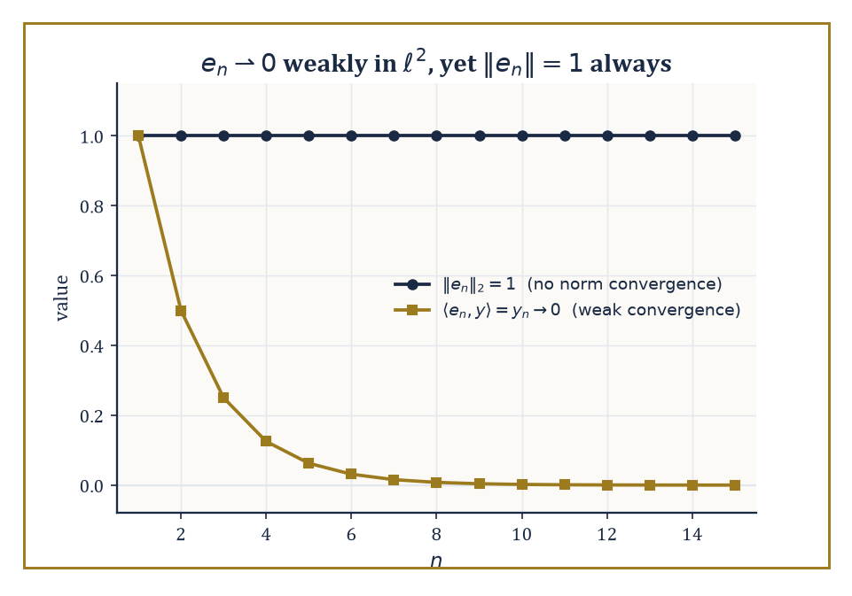
eₙ never budges in norm, yet every honest pairing against it dies down to zero — the two faces of weak convergence, plotted side by side.
f(xₙ) → f(x) for every f ∈ X*
a much gentler requirement than norm convergence, which demands
‖xₙ − x‖ → 0
This gentleness is exactly why weak convergence is useful: sequences that refuse to converge in norm often converge weakly perfectly well.
Numeric example — Weak convergence without norm convergence. In ℓ², let eₙ be the standard basis vector with a 1 in position n and 0 elsewhere. For any fixed y = (y₁, y₂, y₃, …) ∈ ℓ²,
⟨eₙ, y⟩ = yₙ
Because Σₖ yₖ² converges (that is what y ∈ ℓ² means), the individual terms yₖ must tend to 0 as k → ∞ — a convergent series always has terms tending to zero. So
⟨eₙ, y⟩ = yₙ → 0 for every y ∈ ℓ²
which is precisely the statement eₙ ⇀ 0 weakly. Yet
‖eₙ‖₂ = √(1²) = 1
for every single n, so
‖eₙ − 0‖ = 1
never shrinks — no norm convergence at all. The sequence marches weakly to the origin while staying permanently a unit distance away from it in the strong sense.
A useful corollary of Banach–Steinhaus (Room 35.4) is that every weakly convergent sequence is automatically bounded in norm — weak convergence, however gentle a demand, still cannot let a sequence run off to infinity. The eₙ example obeys this trivially, since ‖eₙ‖ = 1 throughout.
The corollary earns its keep in reverse: a sequence like gₙ = n·eₙ has
‖gₙ‖ = n → ∞
so it cannot converge weakly to anything at all, however innocuous some individual pairings ⟨gₙ, y⟩ might look for a well-chosen y. Unbounded norm is an automatic disqualification from weak convergence, no further checking required.
Numeric example — Unbounded norm disqualifies weak convergence outright. Let gₙ = n·eₙ in ℓ², so
‖gₙ‖₂ = n for every n
Suppose, for contradiction, that gₙ ⇀ g weakly for some g ∈ ℓ²; the boundedness corollary above would then force (‖gₙ‖) to be a bounded sequence. But
‖gₙ‖ = n → ∞
which is not bounded — contradiction. So gₙ cannot converge weakly to anything at all, full stop, regardless of how any individual pairing ⟨gₙ,y⟩ might behave for a particular y ∈ ℓ²; unboundedness alone settles the matter before a single pairing is computed.
On a dual space X*, there is an even coarser topology available: the weak* topology, the coarsest topology making every evaluation map f ↦ f(x) (for fixed x ∈ X) continuous.
Alaoglu's theorem is the payoff: the closed unit ball of X* is always weak*-compact, with no completeness or reflexivity assumption on X required at all — a compactness statement that holds essentially for free, in stark contrast to how hard-won compactness is everywhere else in infinite dimensions.
Abstract example — Alaoglu in action. Take X = ℓ¹, so X* = ℓ^∞ (Room 35.3). Let φₙ = eₙ, viewed as an element of ℓ^∞ acting by
φₙ(x) = xₙ for x ∈ ℓ¹
Each φₙ has
‖φₙ‖_∞ = 1
so the whole sequence sits inside the closed unit ball of ℓ^∞, which Alaoglu guarantees is weak*-compact. Does it actually converge weak*? For any fixed x ∈ ℓ¹,
φₙ(x) = xₙ → 0
because Σₖ|xₖ| < ∞ forces the terms xₖ to vanish in the limit — so φₙ → 0 in the weak* topology, even though ‖φₙ‖_∞ = 1 for every n and there is no norm convergence whatsoever. It is the exact mirror image of the previous example, one level up in the duality tower.
Reflexive spaces — Hilbert spaces, and Lᵖ for 1 < p < ∞ — enjoy the best of both worlds: their closed unit balls are weakly compact (a theorem of Kakutani), and the Eberlein–Šmulian theorem then tells us that for these spaces weak compactness and weak sequential compactness coincide, so every bounded sequence has a weakly convergent subsequence.
This is the natural habitat for variational arguments: build a minimizing sequence, use boundedness to extract a weakly convergent subsequence, then show the quantity you care about behaves well under weak limits.
Non-reflexive spaces (L¹, C(K), L^∞) offer no such guarantee and demand craftier tools.
Abstract example — ℓ¹ again: this time, failing to be reflexive on purpose. ℓ¹ has an almost paradoxical property called the Schur property: in ℓ¹, weak convergence of a sequence actually implies norm convergence — the two notions that are supposed to be miles apart elsewhere collapse together here.
Since (eₙ) does not converge in norm —
‖eₙ − eₘ‖₁ = 2 for any n ≠ m
so it isn't even Cauchy — the Schur property forbids it from converging weakly either — meaning (eₙ), a perfectly bounded sequence sitting in the closed unit ball of ℓ¹, has no weakly convergent subsequence at all.
The closed unit ball of ℓ¹ therefore fails to be weakly compact, and by Kakutani's characterization, ℓ¹ is not reflexive — the same conclusion Room 35.3 reached via the ℓ^∞ duality mismatch, now reached by an entirely different route.
This is why weak convergence, not strong convergence, is so often the mode of convergence in which minimizing sequences of variational problems actually live: strong convergence is frequently too much to ask for, but weak convergence, in a reflexive space, is available almost for free.
This gentler style of convergence has one further consequence worth flagging before Room 35.6: compact operators, whatever else they do, always turn weakly convergent sequences into norm-convergent ones.
If xₙ ⇀ x weakly and K is compact, then
Kxₙ → Kx in norm
compactness is precisely strong enough to repair, on the far side of the operator, the very gap between weak and strong convergence that the ambient space could not close on its own.
This is often the actual mechanism by which compactness gets used in practice: build a weakly convergent minimizing sequence using reflexivity, then apply a compact operator to upgrade that convergence to something strong enough to survive being plugged into a nonlinear expression.

Room 35.6: Compact Operators and the Fredholm Alternative
Where Infinite Dimensions Grudgingly Behave Like Matrices Again
A compact operator K : X → Y maps bounded sets to precompact sets — sets whose closure is compact — which is a genuinely strong condition in infinite dimensions, since the unit ball itself is never compact there.
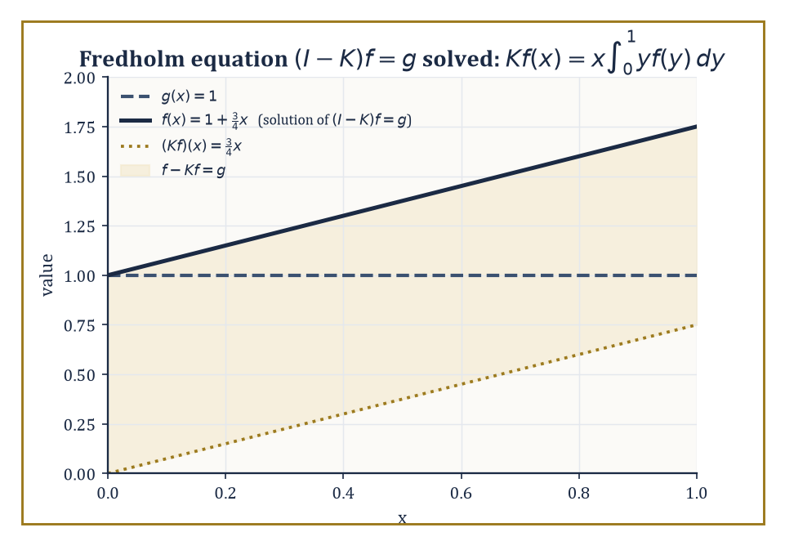
The exact worked case g≡1: solving (I−K)f=g by hand hands back the straight line f(x)=1+¾x, and the shaded strip is the gap K quietly closes.
Finite-rank operators (those with finite-dimensional range) are automatically compact, and so is any operator that is a uniform limit of finite-rank operators; the classic working examples are integral operators with continuous or square-integrable kernels.
Compact operators are, in a precise sense, the infinite-dimensional objects that still remember how to act like finite matrices.
It is worth seeing directly why finite rank forces compactness, since everything else in this room builds on it.
If K has rank r, its entire range is a fixed r-dimensional subspace, and any bounded sequence of outputs (Kxₙ) is then a bounded sequence confined to that finite-dimensional subspace — where Bolzano–Weierstrass, alive and well in finite dimensions, guarantees a convergent subsequence.
Compactness of finite-rank operators is thus nothing but ordinary Bolzano–Weierstrass, smuggled into infinite dimensions through a finite-dimensional side door.
Numeric example — A rank-one integral operator and its eigenvalue. Define K on L²[0,1] by the following rule.
(Kf)(x) = x·∫₀¹ y f(y) dy
This is manifestly rank one (every output is a scalar multiple of the function x), hence compact. To find an eigenvalue, guess f(x) = x itself:
(Kf)(x) = x·∫₀¹ y·y dy = x·∫₀¹ y² dy = x·(1/3) = (1/3)x
So Kf = (1/3)f exactly:
Kf = (1/3)f
meaning f(x) = x is an eigenfunction with eigenvalue λ = 1/3. Because K has rank one, every function orthogonal to x (in the L² inner product) is annihilated by K, giving the eigenvalue 0 with infinite multiplicity.
So the full eigenvalue list is:
{1/3, 0, 0, 0, …}
a single nonzero eigenvalue and an infinite pile of zeros, exactly the pattern the Fredholm theory below predicts for compact operators in general.
Numeric example — Compactness of K, verified from the definition. Take any bounded sequence fₙ in L²[0,1] with ‖fₙ‖ ≤ 1, and apply the K defined above:
Kfₙ = cₙ·x, where cₙ = ∫₀¹ y fₙ(y) dy
By the Cauchy–Schwarz inequality:
|cₙ| ≤ ‖y‖_{L²}·‖fₙ‖_{L²} ≤ (1/√3)·1 = 1/√3
since:
‖y‖²_{L²} = ∫₀¹y² dy = 1/3
So (cₙ) is a bounded sequence of real numbers, and by ordinary Bolzano–Weierstrass on ℝ it has a convergent subsequence cₙₖ → c. Then:
Kfₙₖ = cₙₖ·x → c·x
in L² norm, since:
‖cₙₖx − cx‖ = |cₙₖ − c|·‖x‖ → 0
A bounded input sequence produced an output sequence with a convergent subsequence, exactly as the definition of compactness demands — worked by hand rather than cited from a theorem.
The Fredholm alternative for a compact operator K states that I − K is invertible if and only if it is injective, and that when it fails to be injective, the kernel and the cokernel are finite-dimensional and of equal dimension.
Either the equation
(I − K)f = g
has a unique solution for every g, or the homogeneous equation
(I − K)f = 0
has finitely many independent solutions and g must satisfy finitely many compatibility conditions to be solvable at all — there is no messier third option, which is precisely the finite-dimensional-flavoured good behaviour that makes compact operators so valuable.
Numeric example — Solving (I − K)f = g explicitly. Using the same K as above, solve for a given g:
f(x) − x∫₀¹ y f(y) dy = g(x)
Since K's only nonzero eigenvalue is 1/3 ≠ 1, the Fredholm alternative guarantees I − K is invertible; here is the solution formula.
Write c = ∫₀¹ y f(y) dy (an unknown constant), so:
f(x) = g(x) + cx
Substitute back into the definition of c:
c = ∫₀¹ y(g(y) + cy) dy = G + c·∫₀¹ y² dy = G + c/3, where G := ∫₀¹ y g(y) dy
Solving:
c − c/3 = G, so (2/3)c = G, giving c = (3/2)G
Hence:
f(x) = g(x) + (3/2)G·x
Test it with g(x) = 1 (the constant function):
G = ∫₀¹ y·1 dy = 1/2, so c = (3/2)(1/2) = 3/4, giving f(x) = 1 + (3/4)x
Verify directly:
∫₀¹ y f(y) dy = ∫₀¹ y(1 + (3/4)y) dy = 1/2 + (3/4)(1/3) = 1/2 + 1/4 = 3/4, so (Kf)(x) = (3/4)x, and f(x) − (Kf)(x) = 1 + (3/4)x − (3/4)x = 1 = g(x)
Confirmed.
The Fredholm alternative is precious precisely because, for a general bounded operator on an infinite-dimensional space, injectivity and surjectivity can come apart completely — recall the shift operator S from Room 35.3, injective but not surjective, with no notion of 'invertible' rescued by either property alone.
What the alternative promises is that once attention narrows to operators of the shape I − K with K compact, that reassuring finite-dimensional reflex — injective if and only if surjective — is restored exactly.
Compactness is the specific ingredient that drags the operator back within reach of finite-dimensional intuition, which is exactly why it is worth caring about so much.
More generally, the spectrum of a compact operator consists entirely of eigenvalues of finite multiplicity, and these eigenvalues can accumulate only at zero — zero itself may or may not be an eigenvalue, but it is always the sole possible accumulation point.
This is the infinite-dimensional discipline that keeps compact operators tractable: however many eigenvalues there are, they cannot pile up anywhere interesting, only quietly dwindle toward the origin, like most academic ambitions.

Room 35.7: Spectral Theory of Compact Self-Adjoint Operators
Diagonalization, Rescued from the Wreckage
A self-adjoint compact operator on a Hilbert space admits a full orthonormal basis of eigenvectors, and the eigenvalues are all real and tend to zero. Self-adjoint means it satisfies the following relation for all x, y:
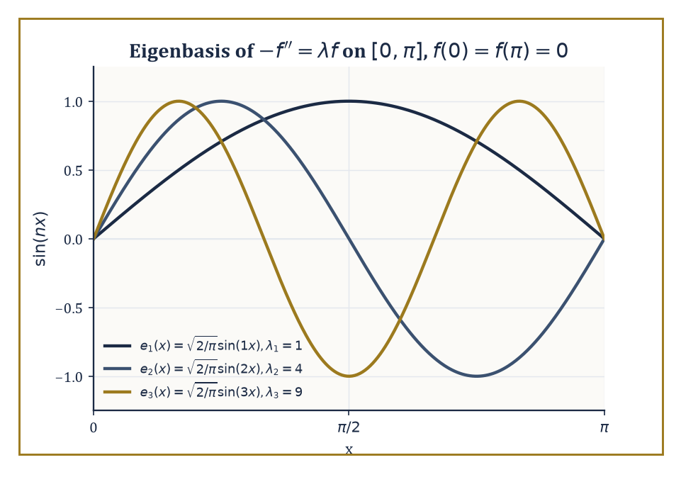
The first three eigenfunctions of −f″=λf on [0,π] — the ordinary Fourier sine basis, caught in the act of being an eigenbasis.
⟨Kx,y⟩ = ⟨x,Ky⟩
This is the spectral theorem for compact self-adjoint operators, and it is nothing less than complete diagonalization, transported wholesale into infinite dimensions — after Room 35.6's parade of things that go wrong in infinite dimensions, it is worth savouring one thing that goes exactly right.
Compact normal operators (which commute with their own adjoint but need not be self-adjoint) enjoy the same result with complex eigenvalues instead of real ones.
Numeric example — Diagonalizing the rank-one operator from Room 35.6. The kernel k(x,y) = xy defining K in Room 35.6 is symmetric, which makes K self-adjoint on L²[0,1].
k(x,y) = xy = k(y,x)
We already found the eigenfunction f(x) = x with eigenvalue 1/3; normalizing it gives the unit eigenvector e₁(x) = √3·x.
‖x‖² = ∫₀¹ x² dx = 1/3, so ‖x‖ = 1/√3
e₁(x) = √3·x, with ‖e₁‖² = 3·∫₀¹x²dx = 3·(1/3) = 1 as required
Every function orthogonal to x contributes eigenvalue 0, so the full list of eigenvalues, arranged in decreasing size, is (1/3, 0, 0, 0, …) — real, as promised, and trivially 'tending to zero' since after the first term they are already there.
Abstract example — Why compact self-adjoint eigenvalues must be real. Suppose Kx = λx for some nonzero x, with K self-adjoint (over ℂ, the inner product is conjugate-linear in the second slot):
Kx = λx, and ⟨Kx,y⟩ = ⟨x,Ky⟩ for all x,y
Then:
⟨Kx,x⟩ = ⟨λx,x⟩ = λ‖x‖²
While self-adjointness also gives ⟨Kx,x⟩ = ⟨x,Kx⟩, which is the conjugate of ⟨Kx,x⟩ — forcing ⟨Kx,x⟩ to be a real number:
⟨Kx,x⟩ = ⟨x,Kx⟩ = conjugate of ⟨Kx,x⟩
Since ‖x‖² is a positive real number, λ must itself be real:
λ = ⟨Kx,x⟩/‖x‖²
No genuinely complex eigenvalue can survive contact with self-adjointness, which is exactly why physicists insist that quantum-mechanical observables be represented by self-adjoint operators: it is self-adjointness alone that guarantees every possible measurement outcome comes out a real number rather than a complex one.
The toy kernel above was deliberately simple; the motivating examples historically were Sturm–Liouville problems — second-order differential operators on an interval, subject to boundary conditions, whose eigenfunctions turn out to be exactly the special functions (Legendre polynomials, Bessel functions, ordinary Fourier sines and cosines) that keep appearing throughout applied mathematics.
Numeric example — The classical Fourier sine basis as an eigenbasis. Consider the following boundary value problem on [0,π] with Dirichlet boundary conditions f(0) = f(π) = 0:
−f″(x) = λf(x)
Try f(x) = sin(nx) for a positive integer n:
f″(x) = −n²sin(nx), so −f″(x) = n²sin(nx) = n²f(x)
This is an eigenfunction with eigenvalue λₙ = n², for every n = 1, 2, 3, …. These eigenfunctions are pairwise orthogonal on [0,π]: for instance, taking n=1, m=2:
∫₀^π sin(x)sin(2x) dx = ∫₀^π sin(x)·2sin(x)cos(x) dx = 2∫₀^π sin²(x)cos(x) dx = 2[sin³(x)/3]₀^π = 2(0 − 0)/3 = 0
The same pattern of cancellation holds for every n ≠ m. Normalized, √(2/π)·sin(nx) forms a complete orthonormal eigenbasis for this operator — which is exactly the abstract spectral theorem's conclusion, realized concretely as the ordinary Fourier sine series you may already have met while solving the heat equation on a rod with fixed-temperature ends.
This theorem is the rigorous, abstract backbone of every eigenfunction expansion you have ever used or will use: solving Sturm–Liouville problems, diagonalizing integral equations, and separating variables for the classical PDEs (heat, wave, Laplace) all secretly invoke exactly this result.
The Rayleigh quotient characterizes the eigenvalues variationally:
R(f) = ⟨Kf,f⟩ / ⟨f,f⟩
The largest eigenvalue is the maximum of R over all nonzero f, and this is the starting point for essentially every numerical eigenvalue algorithm in practical use, because maximizing or minimizing a ratio of quadratic forms is something computers are extremely good at.
Numeric example — Checking the Rayleigh quotient at the eigenvector. Using K and f(x) = x as before:
⟨Kf,f⟩ = ⟨(1/3)x, x⟩ = (1/3)‖x‖² = (1/3)(1/3) = 1/9, and ⟨f,f⟩ = ‖x‖² = 1/3
R(f) = (1/9)/(1/3) = 1/3
This is exactly the eigenvalue we found directly — confirming, on a genuinely computable example, that the Rayleigh quotient evaluated at an eigenvector always returns the corresponding eigenvalue, and (since K's largest eigenvalue is 1/3 and every other eigenvalue is 0) that this f in fact maximizes R over all of L²[0,1].
The min-max principle sharpens the Rayleigh quotient from a description of the largest eigenvalue into a recipe for every eigenvalue in turn: the k-th eigenvalue is obtained by optimizing the Rayleigh quotient over the subspace orthogonal to all the eigenfunctions already found, one rung of the ladder at a time.
Numeric example — Checking the second rung of the ladder. Continuing the Sturm–Liouville example, check the second eigenvalue against its own Rayleigh quotient. Take f(x) = sin(2x), orthogonal to the first eigenfunction sin(x) by the same cancellation computed earlier.
−f″(x) = 4sin(2x) = 4f(x), so ⟨−f″,f⟩ = 4⟨f,f⟩ = 4∫₀^π sin²(2x) dx
Using sin²θ = (1−cos2θ)/2:
∫₀^π sin²(2x) dx = ∫₀^π (1 − cos4x)/2 dx = π/2 − [sin(4x)/8]₀^π = π/2
(the bracket vanishes at both endpoints). So:
⟨−f″,f⟩ = 4·(π/2) = 2π, and ⟨f,f⟩ = π/2, giving R(f) = 2π / (π/2) = 4 = 2²
This is exactly λ₂, the second rung of the ladder λₙ = n² = 1, 4, 9, 16, …, each one recoverable from its own eigenfunction exactly as the min-max principle promises.
Extending this machinery to bounded self-adjoint operators, and further still to unbounded self-adjoint operators via the spectral measure, is the technical foundation of the functional calculus — the ability to make sense of expressions like √T or e^{iTt} for an operator T — and hence of quantum mechanics itself, where observables are self-adjoint operators and the spectral theorem is precisely what tells you which measurement outcomes are possible.

Room 35.8: Unbounded Operators and Sobolev Spaces
Differentiation Refuses to Be Tamed, So We Negotiate Instead
Many of the operators analysts actually care about — differential operators chief among them — are unbounded: no constant C makes the following hold for every f in the space.
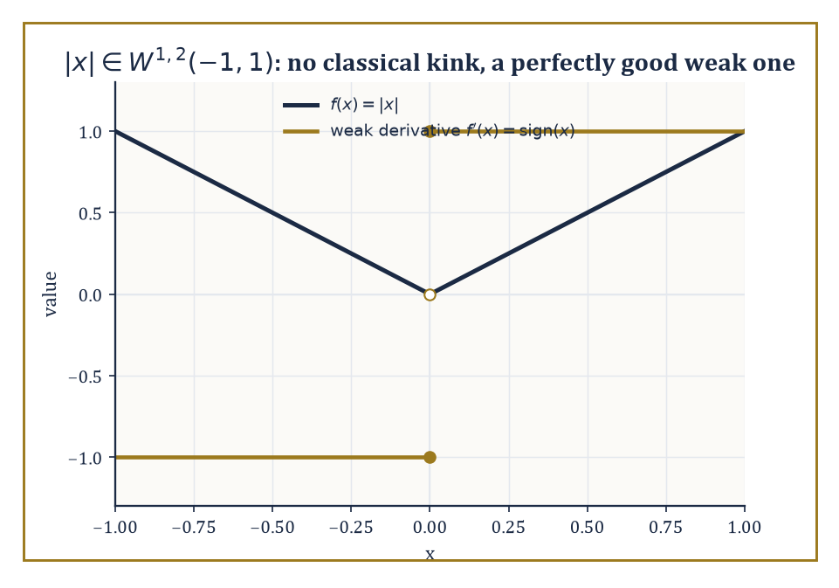
|x| has a kink no classical derivative can survive, but sign(x) is standing by as its perfectly respectable weak derivative.
‖Tf‖ ≤ C‖f‖
Rather than pretending otherwise, we study them as densely defined operators (defined only on a dense subspace, the 'domain,' rather than the whole space), equipped with the graph norm ‖f‖² + ‖Tf‖².
The crucial properties become closedness of the graph and, where applicable, self-adjointness — precisely the properties the closed-graph theorem of Room 35.4 was quietly rehearsing us for.
Numeric example — Differentiation is genuinely unbounded. On L²[0,1], let fₙ be the function defined below.
fₙ(x) = sin(nπx)
Compute ‖fₙ‖².
∫₀¹ sin²(nπx) dx = ∫₀¹ (1 − cos(2nπx))/2 dx = 1/2 − [sin(2nπx)/(4nπ)]₀¹ = 1/2
The boundary term vanishes since sin(2nπ) = sin(0) = 0.
‖fₙ‖ = 1/√2
This is the same for every n. Now differentiate.
fₙ′(x) = nπ cos(nπx)
By the identical computation:
‖fₙ′‖² = n²π² · (1/2)
‖fₙ′‖ = nπ/√2
The ratio of these norms diverges.
‖fₙ′‖/‖fₙ‖ = nπ → ∞ as n → ∞
No single constant C can bound the following uniformly.
‖fₙ′‖ ≤ C‖fₙ‖
So d/dx is unbounded on L²[0,1], exactly as advertised.
Self-adjointness for an unbounded operator is subtler than for a bounded one, precisely because the domain now matters.
An operator T is symmetric if the following holds for f, g in its domain.
⟨Tf,g⟩ = ⟨f,Tg⟩
But self-adjointness demands more: the domain of the adjoint T* must coincide exactly with the domain of T itself, not merely contain it.
An operator can be symmetric without being self-adjoint, and the gap between the two is where a surprising amount of mathematical physics actually lives — in questions of whether a given quantum-mechanical Hamiltonian admits a unique self-adjoint extension at all, and what happens to the physics if it admits several.
Abstract example — Symmetric but not self-adjoint: momentum on an interval. Let T be defined by Tf = −if′, acting on L²[0,1], with domain the functions f that are differentiable, have f′ ∈ L²[0,1], and satisfy f(0) = f(1) = 0.
Integration by parts gives the following.
⟨Tf,g⟩ − ⟨f,Tg⟩ = −i[f(x)g̅(x)]₀¹ = −i(f(1)g̅(1) − f(0)g̅(0)) = 0
This holds for every f in this domain and every g in the same domain, since both boundary terms vanish outright — so T is symmetric.
But the adjoint T* turns out to be defined on the larger domain of all f with f′ ∈ L²[0,1] and no boundary condition imposed whatsoever, because the boundary terms above only ever needed f to vanish at the ends, never g: the domain of T* strictly contains the domain of T, so T is symmetric without being self-adjoint.
Repairing this — choosing exactly which boundary condition to impose, such as the one below, for a fixed phase θ — is precisely the business of finding self-adjoint extensions.
f(1) = e^{iθ}f(0)
Different choices of θ describe genuinely different physical particles confined to the interval.
Sobolev spaces W^{k,p} consist of functions whose weak derivatives up to order k lie in Lᵖ — 'weak derivative' meaning a derivative defined not pointwise but by how the function behaves when integrated against test functions, which is precisely how you extend differentiation to functions that flatly refuse to be classically differentiable everywhere.
W^{k,p} is a Banach space (a Hilbert space when p = 2), and it is the natural home for weak formulations of elliptic PDEs — a sort of halfway house for functions that cannot quite produce a classical derivative but are perfectly willing to behave themselves under an integral sign.
Numeric example — The weak derivative of |x|, checked against a test function. The claim is that the weak derivative of f(x) = |x| on (−1,1) is sign(x), even though |x| is not classically differentiable at 0.
The defining property to check is the following, for every smooth φ vanishing at ±1.
∫₋₁¹ |x| φ′(x) dx = −∫₋₁¹ sign(x) φ(x) dx
Take φ(x) = (1+x)²(1−x), chosen so φ(1) = 0, φ(−1) = 0, φ(0) = 1.
φ(x) = (1+x)²(1−x) = 1 + x − x² − x³
φ′(x) = −3x² − 2x + 1
Compute the left side.
∫₋₁¹ |x|(−3x² − 2x + 1) dx
Split by parity — |x|·(−3x²) = −3|x|³ and |x|·1 = |x| are even, while |x|·(−2x) = −2x|x| is odd and integrates to 0 over (−1,1) — leaving the following.
2∫₀¹(−3x³ + x) dx = 2[−3x⁴/4 + x²/2]₀¹ = 2(−3/4 + 1/2) = 2(−1/4) = −1/2
Now compute the right side.
−∫₋₁¹ sign(x)φ(x) dx = −[∫₀¹φ dx − ∫₋₁⁰φ dx]
With φ(x) = −x³ − x² + x + 1:
∫₀¹φ dx = [−x⁴/4 − x³/3 + x²/2 + x]₀¹ = −1/4 − 1/3 + 1/2 + 1 = 11/12
∫₋₁⁰φ dx = 0 − (−1/4 + 1/3 + 1/2 − 1) = 0 − (−5/12) = 5/12
So the right side is:
−[11/12 − 5/12] = −6/12 = −1/2
Both sides equal −1/2: the identity checks out on a genuine, non-symmetric test function, confirming sign(x) really is the weak derivative of |x|.
Sobolev embedding theorems trade differentiability for integrability: enough weak derivatives in Lᵖ buys you continuity, or Hölder continuity, or membership in a better Lᵍ, depending on the dimension and the relationship between k, p, and the dimension of the underlying domain.
The Rellich–Kondrachov theorem upgrades some of these embeddings from merely continuous to compact, which is the single fact that converts existence proofs for elliptic PDEs into direct applications of either the Fredholm alternative or the direct method in the calculus of variations.
Numeric example — A compact embedding, watched in real time. Let fₙ be given below, on [0,1].
fₙ(x) = sin(nπx)/n
By the computation two examples ago:
‖fₙ‖_{L²} = (1/n)(1/√2) → 0
Differentiating:
fₙ′(x) = π cos(nπx)
‖fₙ′‖_{L²} = π/√2
This is constant in n. Hence:
‖fₙ‖²_{W^{1,2}} = ‖fₙ‖² + ‖fₙ′‖² = 1/(2n²) + π²/2
This is bounded uniformly in n (it converges to π²/2): the sequence (fₙ) is bounded in the Sobolev space W^{1,2}(0,1).
In one dimension, functions in W^{1,2} are automatically Hölder-continuous, and bounded Sobolev sets are equicontinuous and uniformly bounded — precisely the hypotheses of the Arzelà–Ascoli theorem, which is the concrete mechanism behind Rellich–Kondrachov in this setting.
And indeed fₙ → 0 uniformly on [0,1], since the following holds for every x.
|fₙ(x)| ≤ 1/n → 0
Boundedness in the stronger Sobolev norm has bought us genuine uniform convergence of a subsequence (here, the whole sequence), not merely a weak limit.

Room 35.9: Looking Ahead: From Functional Analysis to Operator Algebras, Distributions, and PDEs
The Tower Keeps Building on What You Just Learned to Trust
We have now assembled the core of functional analysis: Banach and Hilbert spaces, bounded and unbounded operators, duality, the three fundamental theorems, weak topologies, compact operators, the spectral theorem, and Sobolev spaces.
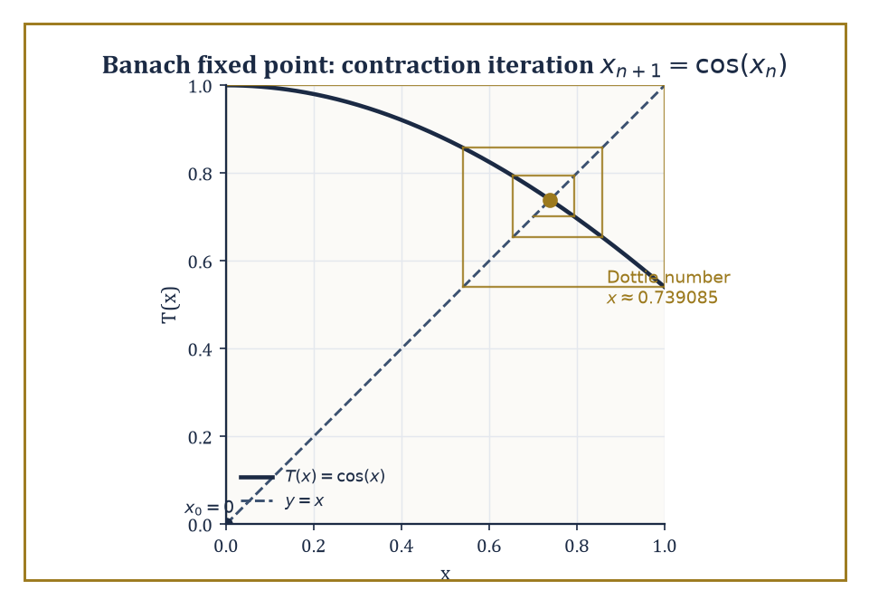
The cobweb of x₀=0 under T(x)=cos(x), spiraling obediently into the Dottie number — completeness and a contraction doing all the work by themselves.
It is worth noticing what these tools bought us collectively — a genuine, working replacement for finite-dimensional linear algebra, rigid enough that the fundamental theorems constrain what operators can possibly do, and generous enough (via the spectral theorem) that a great many concrete problems still reduce to diagonalization in the end.
One direction these tools open onto is operator algebras: collections of bounded operators on a Hilbert space, closed under addition, multiplication, and taking adjoints, and complete in an appropriate norm.
C*-algebras are the abstraction of 'algebras of operators that behave like B(H), the bounded operators on Hilbert space,' characterized by the deceptively simple identity:
‖a*a‖ = ‖a‖²
for every element a.
Numeric example — The C*-identity, checked on a 2×2 matrix. Let A = [[0,1],[0,0]] act on ℂ² — a nilpotent matrix:
A² = 0
Its adjoint A* (conjugate transpose, here just the transpose since entries are real) is:
A* = [[0,0],[1,0]]
Multiplying — the (2,2) entry is 1·1 = 1, and every other entry vanishes on inspection — gives:
A*A = [[0,0],[0,1]]
This matrix is diagonal with eigenvalues 0 and 1, and since it is positive semidefinite, its operator norm equals its largest eigenvalue:
‖A*A‖ = 1
Separately, the singular values of A are the square roots of the eigenvalues of A*A, namely 0 and 1, so:
‖A‖ = 1 and ‖A‖² = 1
Indeed:
‖A*A‖ = 1 = ‖A‖²
The C*-identity holds, on the smallest interesting non-self-adjoint example available.
Von Neumann algebras push the C*-algebra idea further, closing not merely in the operator norm but in the weaker weak-operator topology that Room 35.5 introduced — a shift that lets them classify entire 'types' of infinite-dimensional behaviour (type I, II, and III factors) with no finite-dimensional analogue whatsoever.
Anyone who enjoyed Storey 34's tensor algebras will recognize the family resemblance: an operator algebra is, in spirit, what happens when a tensor algebra's multiplication table is allowed to interact with a genuine infinite-dimensional topology instead of politely stopping at finite rank.
Abstract example — A type I factor you already know. The algebra Mₙ(ℂ) of all n×n complex matrices, acting on H = ℂⁿ, is itself a von Neumann algebra: on a finite-dimensional space every operator topology worth naming coincides, so Mₙ(ℂ) is automatically closed in all of them, and it is already closed under taking adjoints.
It is also its own double commutant — the operators commuting with everything that commutes with Mₙ(ℂ) are (by Schur's lemma) just the scalar multiples of the identity, and the operators commuting with those scalars are, in turn, all of Mₙ(ℂ) again — which is exactly the algebraic definition a von Neumann algebra must satisfy.
Such finite matrix algebras, and B(H) itself for infinite-dimensional H, are precisely the 'type I' factors: the tame, essentially matrix-flavoured end of the classification.
Types II and III appear only once you build algebras — typically from infinite discrete groups — with no matching decomposition into anything as simple as matrices on a fixed Hilbert space, which is exactly why nothing in finite dimensions could have introduced them first.
A second direction is the theory of distributions — objects like the Dirac delta that are not functions at all, but are defined entirely by how they act on smooth test functions.
Riding alongside them is Fourier analysis conducted on tempered distributions, which extends the Fourier transform far beyond the functions for which the defining integral literally converges.
Numeric example — The derivative of a jump is a spike. Let H be the Heaviside step function restricted to (−1,1), defined by:
H(x) = 0 for −1 < x < 0, H(x) = 1 for 0 ≤ x < 1
As in the |x| example above, take a test function φ vanishing at the endpoints:
φ(x) = (1−x²)², so φ(0) = 1, φ(1) = φ(−1) = 0
The distributional derivative is defined by ⟨H′,φ⟩ := −⟨H,φ′⟩, which computes as:
⟨H′,φ⟩ = −∫₋₁¹ H(x)φ′(x) dx = −∫₀¹ φ′(x) dx = −[φ(1) − φ(0)] = −[0 − 1] = 1
Meanwhile, by the very definition of the Dirac delta:
⟨δ,φ⟩ := φ(0) = 1
The two agree — on this concrete test function, and by the identical argument on any test function whatsoever — confirming the famous fact that the distributional derivative of the Heaviside step function is the Dirac delta: differentiating a jump of height 1 produces an infinitely concentrated spike of total mass 1.
A third direction, nonlinear functional analysis, extends fixed-point theorems, monotone-operator theory, and degree theory from the linear operators of this storey to genuinely nonlinear maps.
It is the abstract engine behind nonlinear PDEs and variational inequalities, where the Fredholm alternative's clean dichotomy no longer applies and existence has to be fought for by other means.
Numeric example — A contraction, iterated by hand. The Banach fixed-point theorem says a contraction on a complete space has a unique fixed point, reachable by simple iteration. Take T(x) = cos(x) on [0,1]; since:
|T′(x)| = |sin(x)| ≤ sin(1) ≈ 0.8415 < 1
throughout [0,1], T is a genuine contraction there. Starting from x₀ = 0, the iteration proceeds:
x₁ = cos(0) = 1
x₂ = cos(1) ≈ 0.5403
x₃ = cos(0.5403) ≈ 0.8576
x₄ = cos(0.8576) ≈ 0.6543
x₅ = cos(0.6543) ≈ 0.7935
x₆ = cos(0.7935) ≈ 0.7014
The sequence is visibly homing in, if a little reluctantly, on the unique solution of x = cos(x), the so-called Dottie number, approximately 0.739085.
No cleverness required, just the completeness of [0,1] and the contraction property doing all the work, exactly as the theorem promises.
Lax–Milgram's theorem makes a fitting capstone for the whole storey: it takes a bounded, coercive bilinear form on a Hilbert space — the weak formulation of an elliptic PDE, living naturally in a Sobolev space — and produces, via nothing more exotic than Riesz representation applied cleverly, a unique weak solution.
Room 35.2's geometric Hilbert-space theorem, Room 35.3's duality, and Room 35.8's Sobolev spaces are all cashed in together to solve a genuine differential equation, without ever writing down a classical solution formula at all.
The deeper lesson of the whole storey is this: infinite-dimensional linear algebra, once equipped with the right topology, turns out to be both far more powerful and far more rigid than its finite-dimensional ancestor.
The fundamental theorems constrain what an operator is even allowed to do; the spectral theorem then recovers, for the well-behaved operators, a genuine form of diagonalization — and it is exactly this combination of rigidity and payoff that makes so many concrete problems in analysis solvable at all.
Functional analysis is the linear algebra of the spaces in which analysis actually happens — Hilbert space for quantum mechanics, Sobolev spaces for elliptic PDEs, the weak topology for the calculus of variations, the spectrum for every eigenvalue problem too large to write down as a matrix. Everything downstream of this storey — operator algebras, distributions, nonlinear PDEs — is this same toolkit, pointed at a slightly different target.
Notice, though, what has been quietly borrowed without payment throughout: every ∫ sign in every Lᵖ space, every weak derivative, every 'almost everywhere' has been leaning on an integral and a notion of measure that this storey never actually defined. We have been doing analysis on the Lebesgue integral's credit for thirty-five storeys now, and the bill is about to arrive.
The next storey pays it: measure theory builds the rigorous notion of size, integral, and 'almost everywhere' that functional analysis has been assuming was already sitting downstairs the whole time. It is, in its own way, the more honest storey — less geometry, more bookkeeping — but the bookkeeping is exactly what makes every Lᵖ space in this one legitimate rather than merely convenient.
We came in with linear algebra done in infinite dimensions; we leave with a rigid, powerful, occasionally counterintuitive theory that constrains operators, diagonalizes the well-behaved ones, and quietly underwrites most of modern analysis. The tower continues upward, and it is, as ever, still standing on rather less than you'd like — which, at this altitude, counts as good news.

Storey 36: Measure Theory
Length, Area, Volume, and the Art of Integrating Almost Everywhere
A few floors below, we spent an entire storey admiring Banach spaces and Hilbert spaces, and among the exhibits we let pass without much comment were the L^p spaces — those handsome, complete, infinite-dimensional creatures that made functional analysis feel so solid. We treated them the way one treats a well-turned-out dinner guest: pleasant company, obviously well-bred, no need to ask about the family. It is now time to ask about the family. Where do L^p spaces actually come from? What, precisely, is being integrated, and with respect to what? The honest answer is that they are built out of measure theory, and if we do not go back and build that foundation properly, we shall spend the rest of the Tower's climb standing on a floor we never actually poured.
The proximate cause of all this is an embarrassment that the Riemann integral of school and first-year-university fame cannot survive. Take the function that is 1 at every rational number and 0 at every irrational number, restricted to the interval [0,1]. Every subinterval of [0,1], no matter how short, contains both rationals and irrationals — densely, insistently, no matter how you chop the interval up. So on every subinterval the function's supremum is 1 and its infimum is 0, for every partition you could ever choose. The upper Riemann sum is permanently 1; the lower Riemann sum is permanently 0. They never meet, so the Riemann integral simply refuses to exist. And yet the rationals in [0,1] are a countable set — a thin, scattered, essentially negligible thing next to the uncountable irrationals — and any sane notion of size ought to declare that thinness worth precisely nothing. Calculus, for all its triumphs, has no vocabulary for saying so.
Measure theory supplies that vocabulary. The programme of this storey is to build, from the ground up, a rigorous notion of the size of a set — a measure — robust enough to survive countable operations (unions, limits, the works), and then to build an integral on top of it, the Lebesgue integral, that reduces to the familiar Riemann integral whenever the Riemann integral already made sense, and that keeps working long after the Riemann integral has thrown up its hands. Along the way we will meet σ-algebras (the permissible collections of measurable sets), measures themselves, Carathéodory's extension procedure, Lebesgue measure on Euclidean space, measurable functions, the Lebesgue integral, the great convergence theorems that are the entire point of the exercise, product measures and Fubini's theorem, and finally L^p spaces and the Radon–Nikodym theorem — at which point we will have quietly gone back and issued those well-bred dinner guests their birth certificates.
A confession, before we start climbing: measure theory is the room in the Tower where analysis finally makes its peace with the infinite and, just as importantly, with the negligible. Sets of measure zero can be uncountable, can be topologically enormous, can look for all the world like they matter — and the theory will cheerfully tell you to ignore them anyway, because they never affect an integral. Learning to say “yes, but that only happens off a set of measure zero” with a straight face is both a technical skill and something closer to a philosophical disposition. Riemann taught us to integrate continuous functions. We are about to learn to integrate almost every function that analysis has ever produced — “almost every” doing quite a lot of quiet, load-bearing work in that sentence. Let's measure.

Room 36.1: What Measure Theory Actually Is
In Which Length Grows Up and Gets a Proper Job
At its heart, measure theory does one thing: it assigns to sets a non-negative number — their size — in a way that is systematic enough to support an entire theory of integration built on top of it. This sounds almost too modest to deserve its own storey of the Tower, until you try to make it precise and discover that the obvious candidate, the Riemann integral's implicit notion of size (intervals have length, and everything else is approximated by intervals), simply cannot cope with sets like the rationals.
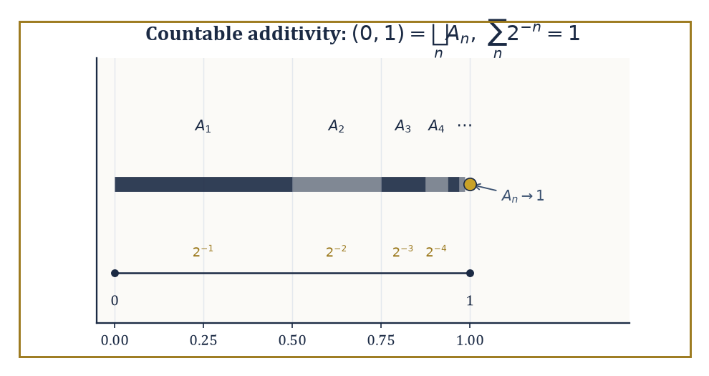
The interval (0,1) split into countably many shrinking pieces A_n = (1−2^{-(n-1)}, 1−2^{-n}), whose lengths 2^{-n} sum, with countable additivity's blessing, to exactly 1.
We saw this in the opening pages: the indicator function of the rationals on [0,1] has no Riemann integral, because upper and lower sums never converge to a common value, regardless of how finely you partition. Intuitively the rationals in [0,1] ought to have size zero — they are countable, after all, an infinitesimal smattering of points in a continuum — but Riemann's machinery has no way to say this, because it only ever measures things by covering them crudely with finitely many intervals.
Numeric example — Worked example — where Riemann gives up. Let f(x) = 1 if x is rational and 0 if x is irrational, for x ∈ [0,1] (the Dirichlet function). Take any partition 0 = x₀ < x₁ < ... < x_n = 1. On each subinterval [x_{i-1}, x_i], however small, both rationals and irrationals are dense (between any two distinct reals there sit infinitely many of each), so sup f = 1 and inf f = 0 on that subinterval regardless of i or n.
U = Σᵢ (1)(x_i − x_{i-1}) = 1 for every partition
L = Σᵢ (0)(x_i − x_{i-1}) = 0 for every partition
Since U = 1 ≠ 0 = L always, no amount of refining the partition closes the gap, and the Riemann integral of f over [0,1] does not exist. We will return to this exact function in Room 36.5, where measure theory dispatches it in one line.
What a measure needs, to do better, is countable additivity: if A₁, A₂, A₃, ... are pairwise disjoint sets, then the measure of their union must equal the sum of their individual measures — and this has to hold even when there are infinitely many of them.
μ(⋃ₙ Aₙ) = Σₙ μ(Aₙ)
Merely finite additivity (the same statement, but only for finitely many disjoint sets at a time) is a much weaker and much less useful demand; analysis is fundamentally the study of limiting processes, and limiting processes are countable operations, so a notion of size that only respects finite unions will betray you the moment you try to pass to a limit under an integral sign, which is precisely the operation the rest of this storey exists to justify.
(Set functions that are only finitely additive can behave in genuinely deranged ways on unmeasurable pieces — the Banach–Tarski paradox, in which a ball is chopped into finitely many pieces and reassembled into two balls of the same size, lives in exactly this gap. Countable additivity, tenure committees please note, is what keeps geometry from falling apart.)
Numeric example — Worked example — countable additivity in action. Partition the interval (0,1) into the countably many pieces Aₙ = (1 − 2^{-(n-1)}, 1 − 2^{-n}) for n = 1, 2, 3, .... So A₁ = (0, 1/2), A₂ = (1/2, 3/4), A₃ = (3/4, 7/8), A₄ = (7/8, 15/16), and so on — each interval picking up exactly where the last left off, shrinking geometrically as it marches toward 1.
The ordinary length of Aₙ is 2^{-n}. These sets are pairwise disjoint and their union is (0,1) (minus the countably many boundary points, which we can ignore since single points have length zero — a fact we prove properly in Room 36.3). Countable additivity demands that the length of (0,1) equal the following sum.
Σₙ₌₁^∞ 2^{-n} = 1/2 + 1/4 + 1/8 + ... = 1
The infinite sum and the geometric picture agree — which is reassuring, since if they had not agreed, this whole storey would be considerably shorter and considerably more embarrassing.
Lebesgue measure on Euclidean space ℝⁿ is the construction that does the job properly: it extends the familiar notions of length (n = 1), area (n = 2), and volume (n = 3 and beyond) to a genuinely enormous class of sets — vastly larger than “finite unions of rectangles” — while keeping two properties that any self-respecting notion of size must have: translation invariance (sliding a set around does not change its size) and countable additivity.
The Lebesgue integral, built from this measure in Room 36.5, extends the Riemann integral in the strongest sense possible: whenever a function is Riemann integrable, it is also Lebesgue integrable, and the two integrals agree exactly. The Lebesgue integral simply integrates a great many more functions besides, and — this is the real selling point — it interacts vastly better with limits, as the convergence theorems of Room 36.6 will demonstrate at length.
Numeric example — Worked example — agreement on a continuous function. Take f(x) = x² on [0,1], a perfectly civilised continuous function. The Riemann integral is the familiar one.
∫₀¹ x² dx = [x³/3]₀¹ = 1/3
The Lebesgue integral of the same function over the same interval, constructed by an entirely different route (approximating f from below by simple functions, as Room 36.5 will show step by step), also evaluates to exactly 1/3. This is not a coincidence or a lucky special case: it is a theorem — Lebesgue integration agrees with Riemann integration on every function for which Riemann's theory already gives an answer. The new theory does not contradict the old one; it simply keeps working after the old one has given up, as it will for the Dirichlet function above.
This is why measure theory is not a specialist detour but the load-bearing language beneath most of modern analysis. Probability theory is measure theory in which the total measure of the whole space is normalised to 1 (a random variable is a measurable function, an expectation is an integral).
Ergodic theory studies transformations that preserve a measure. Harmonic analysis and the theory of partial differential equations lean on Lebesgue integration and its convergence theorems at every turn, because the functions that show up as solutions to real equations are very rarely as polite as continuous functions with compact support. We are, in short, about to learn the grammar that the rest of the Tower has been quietly assuming we already knew.
Numeric example — Worked example — probability as measure, expectation as integral. Take Ω = {1,2,3,4,5,6} (the outcomes of one die) equipped with the probability measure μ({k}) = 1/6 for each k, and let X: Ω → ℝ be the identity map X(ω) = ω — the measurable function that reports the number shown, i.e. the random variable. Its expectation is, by the definition promised above, nothing more than an integral against μ.
E[X] = ∫_Ω X dμ = Σ_{k=1}^{6} k · μ({k}) = (1+2+3+4+5+6) · (1/6) = 21/6 = 3.5
This is exactly the schoolroom answer for the expected value of a fair die, arrived at without a single new idea beyond “integrate a simple function” — which is the entire content of the claim that probability theory is measure theory wearing a different hat.

Room 36.2: Algebras, σ-Algebras, and Measures
Bureaucracy for Sets, and Why the Countable Version Is the One That Matters
Before we can define a measure, we need to agree on which sets are allowed to have a measure at all — it turns out (Room 36.3 will supply the villain) that not every subset of ℝ can be assigned a sensible size, so we need a well-behaved collection of permissible sets to work with.
An algebra of sets on a space X is a collection 𝒜 of subsets of X that contains X itself and is closed under complements and finite unions (and hence, by De Morgan's laws, under finite intersections too — closure under complements turns unions into intersections and back for free).
A σ-algebra strengthens this to closure under countable unions and complements, which — again by De Morgan — gives closure under countable intersections as well.
Every σ-algebra is an algebra; the reverse need not hold, and the gap between them is exactly the gap that makes σ-algebras the correct home for measures, since measures need to behave well under countably infinite operations, as Room 36.1 insisted.
Abstract example — Worked example — a finite algebra. Let X = {1, 2, 3, 4}, and let 𝒜 be the following collection of subsets:
𝒜 = {∅, {1,2}, {3,4}, X}
Check the axioms directly. First, X ∈ 𝒜 by inspection. Next, check complements: the complement of {1,2} in X is {3,4}, which is in 𝒜; the complement of {3,4} is {1,2}, also in 𝒜; and the complement of ∅ is X, and vice versa. Now check unions:
{1,2} ∪ {3,4} = X ∈ 𝒜
and any union involving ∅ or X reproduces an existing member. So 𝒜 is closed under complements and finite unions — it is an algebra. Because X is finite, there are only finitely many subsets to worry about in the first place, so “closed under finite unions” and “closed under countable unions” coincide here, and 𝒜 is automatically a σ-algebra too. The interesting distinction between algebras and σ-algebras only bites on infinite spaces, which is exactly the next example.
Abstract example — Worked example — an algebra that is not a σ-algebra. On X = ℝ, let 𝒜 be the collection of all finite unions of intervals of the forms (a,b], (−∞,b], and (a,∞), together with ∅ and ℝ. One can check (it is a standard, if slightly tedious, exercise) that 𝒜 is closed under complements and finite unions, so it is an algebra.
Now consider the rational numbers ℚ. Each singleton {q} can be written as the degenerate interval [q,q], and ℚ is a countable union of such singletons:
ℚ = ⋃_{q∈ℚ} {q}
But ℚ is dense in ℝ and its complement (the irrationals) is also dense, so ℚ cannot be written as any finite union of intervals of the allowed forms — no finite union of intervals is simultaneously dense and has a dense complement. Hence ℚ ∉ 𝒜, even though it is a countable union of members of 𝒜.
This is precisely the failure that σ-algebras are built to repair: the σ-algebra generated by 𝒜 (the smallest σ-algebra containing it) does contain ℚ, and in fact turns out to be the Borel σ-algebra, generated by the open sets of ℝ — the σ-algebra on which essentially all of classical analysis is conducted.
Its completion with respect to Lebesgue measure, formed by throwing in every subset of every Borel null set, is the Lebesgue σ-algebra, and it is strictly larger still (Room 36.3).
A measure on a measurable space (X, Σ) — Σ being a σ-algebra on X — is a function μ: Σ → [0, ∞] satisfying the following: first,
μ(∅) = 0
and second, countable additivity:
μ(⋃ₙ Aₙ) = Σₙ μ(Aₙ)
for any countable collection of pairwise disjoint sets Aₙ ∈ Σ. That is the entire definition; everything else is special cases and consequences.
A measure is finite if μ(X) < ∞; it is σ-finite if X can be written as a countable union of sets each of finite measure (a weaker, extremely common condition that Lebesgue measure on ℝ satisfies without being finite itself); and it is a probability measure if μ(X) = 1 exactly, the special case that underlies the whole of probability theory.
Numeric example — Worked example — three flavours of measure. Three flavours of measure illustrate the definitions in action, starting with counting measure on ℕ, defined by:
μ(A) = the number of elements of A (and μ(A) = ∞ if A is infinite)
For example:
μ({2,4,6}) = 3
μ(evens) = μ(odds) = ∞
μ(ℕ) = μ(evens) + μ(odds) = ∞ + ∞ = ∞
This is consistent with countable additivity in the extended arithmetic where ∞ absorbs everything. This measure is neither finite nor σ-finite in any useful sense on all of ℕ viewed as one block, though it is σ-finite if you slice ℕ into finite pieces like {1}, {2}, {3}, ....
Second, Lebesgue measure on ℝ has:
μ(ℝ) = ∞
so it is not finite. But ℝ can be written as an increasing union of bounded intervals:
ℝ = ⋃ₙ₌₁^∞ [−n, n]
and each of those intervals has finite measure:
μ([−n,n]) = 2n < ∞
for every n, so Lebesgue measure is σ-finite.
Third, the uniform (probability) measure on [0,1] is defined by:
μ(A) = the Lebesgue measure of A ∩ [0,1]
Here:
μ([0,1]) = 1
exactly, making it a genuine probability measure — the mathematical model of picking a real number uniformly at random from the unit interval.
One recurring technical headache is proving that two measures agree everywhere on a σ-algebra when you can only check that they agree on some smaller, more manageable generating collection — say, on all intervals, when you actually want equality on every Borel set.
Dynkin's π-λ theorem is the standard tool: if a collection of sets is a π-system (closed under finite intersections) and two finite measures agree on that π-system and on the whole space, then they agree on the entire σ-algebra generated by the π-system.
The monotone class theorem is a close cousin, phrased in terms of classes of sets closed under increasing unions and decreasing intersections, and is used for exactly the same purpose.
Both theorems exist because directly verifying countable additivity by hand on an arbitrary σ-algebra is usually hopeless; checking a simpler generating family and then invoking one of these theorems to extend the result is the standard workaround, and you will see it deployed constantly for the rest of your mathematical life.
Abstract example — Worked example — why cumulative distribution functions determine measures. Suppose μ and ν are two probability measures on the Borel σ-algebra of ℝ, and suppose they agree on every interval of the form (−∞, x] for x ∈ ℝ — that is, they have the same cumulative distribution function.
The collection {(−∞,x] : x ∈ ℝ} is a π-system, since:
(−∞,x] ∩ (−∞,y] = (−∞, min(x,y)]
another set of the same form. This π-system generates the Borel σ-algebra (every open interval, hence every open set, can be built from countably many such half-lines by unions, complements, and intersections).
Both μ and ν are finite (indeed, both give the whole space measure 1), and they agree on the π-system by hypothesis.
Dynkin's π-λ theorem then hands us, for free, that μ and ν agree on the entire Borel σ-algebra — not merely on half-lines, but on every Borel set whatsoever.
This single argument is the rigorous justification for a fact used constantly and casually throughout probability theory: a distribution function determines its probability measure completely.

Room 36.3: Outer Measure and Lebesgue Measure
Building Size From the Outside In, and Meeting the One Set That Refuses to Play
The construction of Lebesgue measure begins not with measurable sets but with every set — literally every subset of ℝⁿ, measurable or not — via a device called outer measure. The Lebesgue outer measure m*(A) of a set A ⊆ ℝⁿ is defined by covering A with a countable collection of rectangles (or cubes; either works) and taking the infimum, over all such coverings, of the total volume of the covering rectangles:
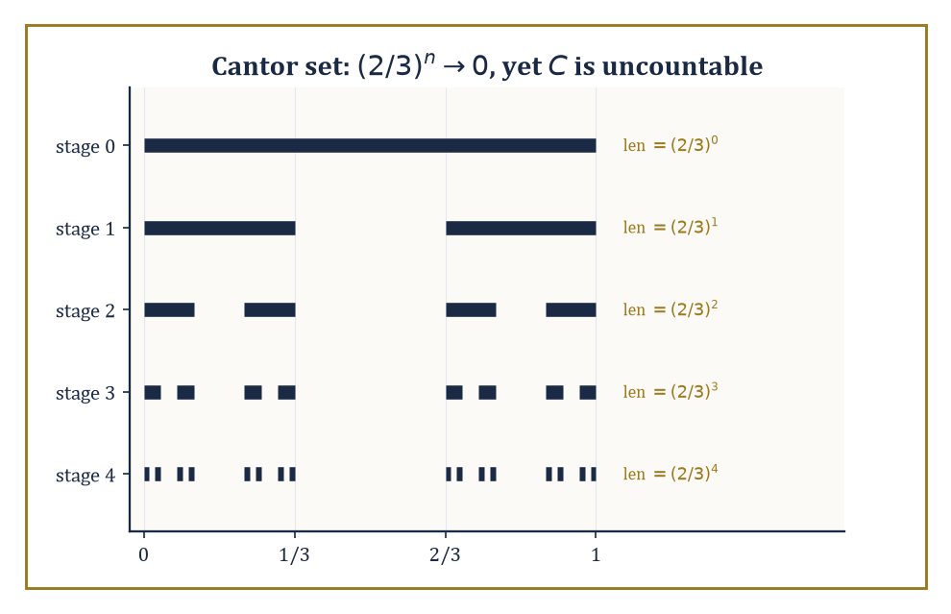
Five stages of deleting middle thirds: the remaining length shrinks geometrically to zero, yet what survives in the limit is an uncountable set — measure zero and cardinality of the continuum, comfortably at once.
m*(A) = inf { Σₖ vol(Rₖ) : A ⊆ ⋃ₖ Rₖ, each Rₖ a rectangle }
This is defined for absolutely every set, which is the whole appeal — no measurability hypothesis is needed to ask “how small a covering can I manage?” The catch is that outer measure is only countably subadditive in general rather than additive:
m*(⋃ₙ Aₙ) ≤ Σₙ m*(Aₙ)
It can under-count the true size of a union when the pieces overlap in a pathological, non-measurable way. Carathéodory's criterion is the fix: declare a set E measurable if it splits every test set A ⊆ ℝⁿ additively, meaning
m*(A) = m*(A ∩ E) + m*(A ∩ Eᶜ)
for every A. The sets satisfying this criterion form a σ-algebra, and outer measure restricted to that σ-algebra is, at last, a genuine countably additive measure — Lebesgue measure.
Numeric example — Worked example — a finite set has outer measure zero. Let A = {0, 1, 2} ⊆ ℝ. Fix any ε > 0. Cover each point with an open interval of length ε/3:
cover 0 with (−ε/6, ε/6), cover 1 with (1 − ε/6, 1 + ε/6), cover 2 with (2 − ε/6, 2 + ε/6)
Each interval has length ε/3, and there are three of them, so this is a valid countable (here, finite) covering of A with total length
ε/3 + ε/3 + ε/3 = ε
Hence m*(A) ≤ ε. Since ε > 0 was arbitrary and outer measure is non-negative,
m*(A) = 0
The same argument, run over a countable enumeration with intervals of length ε/2ⁿ around the n-th point, shows that every countable set has Lebesgue outer measure zero — which is exactly the fact that rescues the Dirichlet function of Room 36.1 in Room 36.5.
The Carathéodory-measurable sets include every Borel set — every open set, closed set, countable union or intersection thereof, and so on — plus a great deal more besides (the completion process of Room 36.2 throws in every subset of every null set).
What they do not include is everything: there exist subsets of ℝ that are not Lebesgue measurable at all, and constructing one genuinely requires the axiom of choice. The classical example is the Vitali set, and its existence is the theorem that keeps set theorists and analysts on permanently polite but wary terms — rather like two departments sharing a photocopier.
Abstract example — Worked example — the Vitali set is not measurable. Define an equivalence relation on [0,1) by x ~ y iff x − y ∈ ℚ. This partitions [0,1) into uncountably many equivalence classes, each of which is countable. Using the axiom of choice, form a set V by picking exactly one representative from each class.
Let q₁, q₂, q₃, ... enumerate the rationals in [−1,1], and set
Vₙ = { v + qₙ (mod 1-ish, i.e. taken within [−1,2)) : v ∈ V }
i.e. each Vₙ is V translated by qₙ. Two facts, both provable directly from the construction: the Vₙ are pairwise disjoint (if Vᵢ and Vⱼ shared a point, two representatives of V would differ by a rational, contradicting the “exactly one representative per class” choice), and their union covers [0,1) while staying inside [−1,2) (every x ∈ [0,1) is equivalent to its class's representative v ∈ V, so x = v + q for some rational q with |q| ≤ 1).
Now suppose, for contradiction, that Lebesgue measure could be defined on every subset of ℝ, consistently with translation invariance and countable additivity. Translation invariance forces
m(Vₙ) = m(V)
for every n. Countable additivity applied to the disjoint union then gives
1 ≤ m([0,1)) ≤ m(⋃ₙ Vₙ) = Σₙ m(Vₙ) ≤ m([−1,2)) = 3
If m(V) = 0, the sum is 0, contradicting the lower bound of 1. If m(V) = c > 0, the sum is a countably infinite total of a fixed positive number, which is ∞, contradicting the upper bound of 3. Either way, contradiction — so V cannot be assigned a Lebesgue measure consistent with the axioms.
This is why measurability is a genuine restriction and not merely bureaucratic caution: some sets really do have to be left out in the cold, and the axiom of choice is exactly what is needed to manufacture one.
Lebesgue measure, restricted to the measurable sets, has exactly the properties one would hope for: it is translation-invariant, meaning
m(A + x) = m(A)
for every set A and every vector x. It is also regular (the measure of any measurable set can be approximated from outside by open sets and from inside by compact sets), and it is the unique measure on the Borel σ-algebra assigning to every rectangle its ordinary geometric volume and behaving translation-invariantly.
In particular it recovers length, area, and volume exactly where those concepts already made sense — none of this is glamorous, it is precisely the boring, well-behaved measure you were using without a second thought in your first calculus course, now finally issued its credentials in writing.
Numeric example — Worked example — measuring a rectangle. In ℝ², the rectangle R = [0,2] × [0,3] has Lebesgue measure equal to its ordinary area:
m(R) = (2 − 0) × (3 − 0) = 6
This is definitional at the covering-by-rectangles stage of the construction (a single rectangle covers itself with total volume exactly its own volume, so the outer measure of a rectangle is trivially at most its own volume; the matching lower bound, that no cheaper covering exists, is the geometric content of the construction). Translation invariance then tells us, for free and without recomputation, that the shifted rectangle [5,7] × [10,13] also has measure exactly 6.
A set of measure zero — a null set — need not be small in any other sense. It can be infinite; it can even be uncountable, which is the single most counter-intuitive fact in this entire storey and worth sitting with for a moment.
The Cantor set is the standard demonstration: uncountable, closed, containing no interval whatsoever, and yet Lebesgue measure zero.
Numeric example — Worked example — the Cantor set has measure zero. Build the Cantor set C by starting with [0,1] and repeatedly deleting the open middle third of every remaining interval.
Stage 0: [0,1], total remaining length 1. Stage 1: remove (1/3, 2/3), leaving [0,1/3] ∪ [2/3,1], total remaining length
1 − 1/3 = 2/3
Stage 2: remove the middle third of each of those two intervals, two removed pieces each of length 1/9, leaving total length
2/3 − 2/9 = 4/9 = (2/3)²
By induction, after n stages the remaining set has total length exactly (2/3)ⁿ (at each stage, every surviving interval loses its middle third, multiplying total remaining length by 2/3). The Cantor set C is the intersection of all these stages, so
m(C) ≤ (2/3)ⁿ
for every n, and since (2/3)ⁿ → 0 as n → ∞,
m(C) = 0
Yet C is uncountable: each point of C corresponds to an infinite sequence of “left third” / “right third” choices at every stage, giving a bijection with the set of infinite binary sequences {0,1}^ℕ, which has the cardinality of the continuum. So C has as many points as [0,1] itself, and yet takes up none of its length.
Two functions that agree everywhere except on a set like C — or any null set — will be given, in Room 36.5 onward, exactly the same integral: they are identified, treated as the same object “almost everywhere,” which is the conceptual shift this entire storey keeps promising and is now finally in a position to deliver.

Room 36.4: Measurable Functions
The Minimum Standard of Behaviour Required Before Integration Is Even Discussed
A function f: X → ℝ (or into the extended reals, allowing ±∞) between measurable spaces is measurable if the pre-image of every open set is a measurable set — equivalently, if f⁻¹((a, ∞)) is measurable for every real a, a considerably more checkable condition in practice.
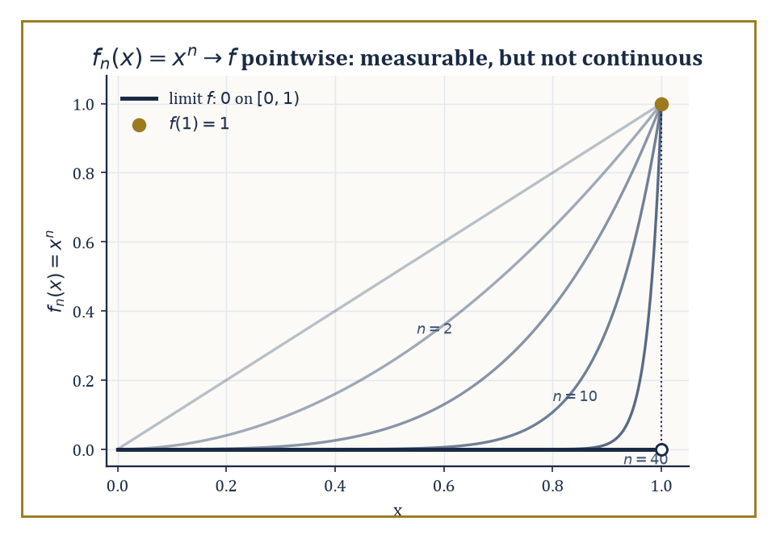
The continuous curves f_n(x)=x^n pile up, pointwise, into a limit with a genuine jump at x=1 — proof that measurability survives a limit far more graciously than continuity ever does.
f⁻¹((a, ∞)) is measurable for every real a
Measurability is a purely set-theoretic requirement, weaker than continuity, and it is the minimum amount of regularity a function needs before an integral can even be attempted, because the whole strategy of the Lebesgue integral (coming in Room 36.5) is to measure the sets on which f takes various values, and that only makes sense if those sets are, in fact, measurable. Think of measurability as the bouncer on the door of the integral: it asks precisely one question on the way in, and afterwards could not care less how badly the function behaves once admitted.
Numeric example — Worked example — checking measurability directly. Let f(x) = x² on ℝ with the Borel σ-algebra. To check measurability it suffices to check that f⁻¹((a,∞)) is Borel for every a. Take a = 4.
f⁻¹((4,∞)) = {x ∈ ℝ : x² > 4} = {x : x > 2 or x < −2} = (−∞,−2) ∪ (2,∞)
This is a union of two open intervals — manifestly Borel (in fact open). The same style of computation works for every a (for a ≥ 0 you get two half-lines symmetric about 0; for a < 0 you get all of ℝ), so f is measurable.
This is no accident: every continuous function is automatically Borel measurable, because the pre-image of an open set under a continuous function is open, hence Borel, by definition of continuity — measurability is a strictly weaker demand than continuity, and continuous functions clear it without even trying. The Dirichlet function of Room 36.1, despite being nowhere continuous, is also measurable: its pre-images are only ever ∅, ℚ, the irrationals, or ℝ, and ℚ is a countable union of singletons, hence Borel.
Measurability is remarkably robust under limits, which is precisely the property continuity lacks and precisely the property that makes measure theory the right setting for analysis. If f₁, f₂, f₃, ... are all measurable and fₙ(x) → f(x) for every x (a pointwise limit), then f itself is automatically measurable — no extra hypothesis required. Continuous functions offer no such guarantee: a pointwise limit of continuous functions can be wildly discontinuous.
Numeric example — Worked example — a discontinuous pointwise limit that is still measurable. Let fₙ(x) = xⁿ on [0,1], each one a perfectly continuous (hence measurable) function. For 0 ≤ x < 1, xⁿ → 0 as n → ∞ (a number strictly between 0 and 1, raised to higher and higher powers, shrinks to 0). For x = 1, xⁿ = 1 for every n, so the limit there is 1.
f(x) = 0 for x ∈ [0,1) and f(1) = 1
This is a function with a genuine jump discontinuity at x = 1, not continuous at all. Measurability nonetheless survives the limiting process intact: f is the indicator function of the single point {1} (up to the value elsewhere being 0), and {1} is a Borel set, so f is measurable. This is the general pattern: continuity is fragile under limits, measurability is not, which is exactly why measure theory rather than continuity is the right load-bearing concept for a theory of integration that needs to survive limiting operations.
Simple functions — finite linear combinations of indicator functions of measurable sets — are the scaffolding used to build the Lebesgue integral in the next room.
s(x) = Σᵢ₌₁ᵏ cᵢ · 1_{Aᵢ}(x), for measurable sets Aᵢ and real constants cᵢ
Every non-negative measurable function f can be approximated from below by an increasing sequence of simple functions sₙ ↑ f, obtained by chopping the range of f into finer and finer horizontal slabs (rather than the vertical slabs of Riemann's approach — this swap of vertical for horizontal is, in a real sense, the entire conceptual innovation of the Lebesgue integral).
Numeric example — Worked example — approximating from below with a simple function. Let f(x) = x² on [0,2]. Build a simple function at dyadic resolution n = 2 (i.e. slabs of height 1/4): for each x, let sₙ(x) = k/4 where k/4 ≤ f(x) < (k+1)/4. Evaluate at x = 1.3: f(1.3) = 1.69. We need the integer k with k ≤ 6.76 < k+1, so k = 6.
6/4 = 1.5 ≤ 1.69 < 1.75 = 7/4
So sₙ(1.3) = 1.5, and indeed 1.5 ≤ 1.69 as required — the simple function sits below f at this point, as it must everywhere by construction. As n increases (finer horizontal slabs, e.g. width 1/8, then 1/16, ...), sₙ(1.3) climbs toward 1.69 from below: at resolution 1/8 the relevant k satisfies k/8 ≤ 1.69, giving k = 13.
sₙ(1.3) = 13/8 = 1.625
This is already closer, and is the general mechanism by which sup over all simple functions below f recovers f exactly.
The arithmetic of measurable functions behaves exactly as one would hope: sums, products, and quotients (wherever the denominator is non-zero) of measurable functions are measurable. The key trick — worth seeing once, because it recurs constantly — is that a strict inequality like f(x) + g(x) > a can be re-expressed using a countable index set even though the real line itself is uncountable, and countability is exactly what a σ-algebra can absorb.
Abstract example — Worked example — sums of measurable functions are measurable. Let f and g be measurable. Fix a ∈ ℝ. Claim:
{x : f(x) + g(x) > a} = ⋃_{q ∈ ℚ} ( {x : f(x) > q} ∩ {x : g(x) > a − q} )
Proof of the claim: if f(x) + g(x) > a, then f(x) > a − g(x), and by density of the rationals there is some rational q strictly between a − g(x) and f(x), giving f(x) > q and g(x) > a − q simultaneously — so x lies in the right-hand union. Conversely if x lies in the union for some rational q, then f(x) > q and g(x) > a − q, and adding these gives f(x) + g(x) > a directly.
The right-hand side is a countable union (indexed by ℚ, which is countable) of intersections of two measurable sets, hence measurable, since σ-algebras are closed under exactly these operations. So {f + g > a} is measurable for every a, which is precisely the definition of f + g being measurable. The same style of argument — replacing an uncountable search with a countable, dense substitute — handles products and quotients too.
Finally, the essential supremum and essential infimum are the measure-theoretically correct replacements for the ordinary supremum and infimum: they ignore what happens on sets of measure zero, exactly as the whole theory has been promising. Formally, ess sup f is the smallest bound that f respects almost everywhere, permitting arbitrarily bad behaviour on a negligible set:
ess sup f = inf { M : μ({x : f(x) > M}) = 0 }
Numeric example — Worked example — essential supremum ignores a single bad point. Let f(x) = 5 for every x ∈ [0,1] except f(0) = 100. The ordinary supremum is sup f = 100, dictated entirely by the single outlier at x = 0. But {x : f(x) > 5} = {0}, and μ({0}) = 0 (a single point is a null set, as shown in Room 36.3).
So M = 5 already satisfies μ({f > M}) = 0, while any M < 5 gives {f > M} = [0,1] (measure 1, not zero, since f = 5 > M everywhere else). Hence ess sup f = 5, not 100 — the essential supremum correctly reports that f is “really” bounded by 5, with the one misbehaving point at x = 0 rightly discounted as invisible to measure. This is the essential-supremum version of the identification-up-to-null-sets philosophy that will govern every integral computed from Room 36.5 onward.

Room 36.5: The Lebesgue Integral
Slicing the Range Instead of the Domain, Which Is Cleverer Than It Sounds
The construction proceeds in three deliberate stages, each one leaning on the last. Stage one: for a non-negative simple function s(x), written as a sum over disjoint measurable sets Aᵢ with non-negative constants cᵢ,
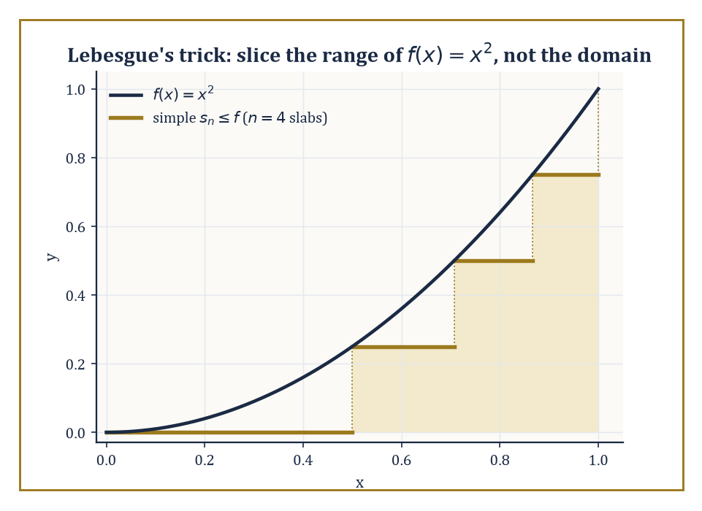
Four horizontal slabs approximate f(x)=x² from below — Lebesgue's entire innovation rendered as a staircase hugging the curve from underneath, rather than Riemann's vertical strips.
s(x) = Σᵢ cᵢ · 1_{Aᵢ}(x) (Aᵢ disjoint measurable sets, cᵢ ≥ 0)
define the integral directly as the natural linear combination of measures:
∫s dμ = Σᵢ cᵢ · μ(Aᵢ)
There is no approximation here — this is simply the definition, chosen because it is the only sensible one (a rectangle of height c standing over a set of measure m should contribute c · m to the total).
Numeric example — Worked example — integrating a simple function directly. Let s(x) = 2 · 1_{[0,1]}(x) + 5 · 1_{(1,3]}(x) on ℝ with Lebesgue measure. This is a simple function taking value 2 on [0,1], value 5 on (1,3], and value 0 elsewhere. By the definition above,
∫s dμ = 2 · μ([0,1]) + 5 · μ((1,3]) = 2 · 1 + 5 · 2 = 2 + 10 = 12
Geometrically this is exactly the sum of the areas of two rectangles — a 1-wide, 2-tall rectangle contributing area 2, and a 2-wide, 5-tall rectangle contributing area 10 — which is precisely what the definition was designed to capture, and matches ordinary geometric intuition exactly.
Stage two: for an arbitrary non-negative measurable function f, define
∫f dμ = sup { ∫s dμ : s simple, 0 ≤ s ≤ f }
the supremum of the integrals of every simple function lying below f. This is where the “slice the range, not the domain” philosophy pays off: rather than partitioning the x-axis as Riemann does, we partition the y-axis into horizontal strips, ask how much of the domain lands in each strip (a measure question, always well-posed for a measurable function), and sum up height times measure. Because this only ever asks “how big is this set,” never “how does f behave locally,” it survives functions far too wild for Riemann's vertical strips to handle.
Numeric example — Worked example — recovering a familiar integral by slicing the range. Take f(x) = x² on [0,1], for which we already know the answer should be 1/3 (Room 36.1). Build a simple function from below using n = 4 equal horizontal slabs, i.e. take the partition of [0,1] into [0, 0.25), [0.25, 0.5), [0.5, 0.75), [0.75, 1], and on each piece use the infimum of x² (which, since x² is increasing on [0,1], is its value at the left endpoint):
infimum values: 0², 0.25², 0.5², 0.75² = 0, 0.0625, 0.25, 0.5625
The resulting simple function's integral is (length 0.25 on each piece) × (sum of these infima):
0.25 × (0 + 0.0625 + 0.25 + 0.5625) = 0.25 × 0.875 = 0.21875
This lies below the true value 1/3 ≈ 0.3333, as it must (it's built from an under-approximation). Refining to n = 100 or n = 10000 equal slabs pushes this lower sum arbitrarily close to 1/3; the supremum over all such simple functions is exactly 1/3, matching the Riemann answer, confirming that the two theories agree here as promised.
Stage three: for a general (not necessarily non-negative) measurable function f, split it into its positive and negative parts,
f⁺(x) = max(f(x), 0) and f⁻(x) = max(−f(x), 0)
so that f = f⁺ − f⁻ and both pieces are non-negative and measurable. Define
∫f dμ = ∫f⁺ dμ − ∫f⁻ dμ
and call f integrable precisely when both pieces on the right have finite integral (so that the subtraction is not the meaningless ∞ − ∞).
Numeric example — Worked example — splitting into positive and negative parts. Let f(x) = x on [−1,1]. Then f⁺(x) = x for x ≥ 0 and 0 for x < 0; f⁻(x) = −x for x ≤ 0 and 0 for x > 0. Compute ∫f⁺:
∫f⁺ = ∫₀¹ x dx = [x²/2]₀¹ = 1/2
Compute ∫f⁻: by the mirror-image computation over [−1,0], this is also 1/2 (∫₀¹ x dx again, after the substitution x → −x). Both pieces are finite, so f is integrable, and
∫f dμ = 1/2 − 1/2 = 0
This matches exactly the direct computation that ordinary calculus would give:
∫₋₁¹ x dx = [x²/2]₋₁¹ = 1/2 − 1/2 = 0
The three-stage machine reduces, on a function this tame, to nothing more exotic than what you already knew.
The Lebesgue integral agrees with the Riemann integral on every function where the latter is defined, but it defines an integral for a great deal more. The Dirichlet function of Room 36.1, which broke the Riemann integral outright, is dispatched instantly: its integral is 0, because the set on which it takes the value 1 (the rationals) has measure zero, and a measurable function that is 0 almost everywhere integrates to 0.
Numeric example — Worked example — resolving the Dirichlet function at last. Let f(x) = 1_ℚ(x) on [0,1], the indicator function of the rationals. As a simple function (it takes only two values, 1 and 0), its Lebesgue integral is, by the stage-one definition,
∫f dμ = 1 · μ(ℚ ∩ [0,1]) + 0 · μ((ℚ ∩ [0,1])ᶜ)
Since ℚ ∩ [0,1] is countable, it has Lebesgue measure zero (Room 36.3's worked example on finite and countable sets). So
∫f dμ = 1 · 0 + 0 · 1 = 0
The function that defeated Riemann integration entirely is integrated in one line by Lebesgue's machinery, and the answer — 0 — is exactly the value intuition demanded back in Room 36.1: the rationals are too thin to contribute anything.
One further subtlety deserves a mention before we move on: absolute integrability (∫|f| dμ < ∞, equivalently both f⁺ and f⁻ having finite integral) is what guarantees that a series of functions can be integrated term by term without the answer depending on the order in which the terms are summed. This mirrors, exactly, a fact about numerical series that most readers will already have met.
Abstract example — Worked example — why absolute integrability matters. The alternating harmonic series
1 − 1/2 + 1/3 − 1/4 + ... = ln 2
converges, but only conditionally: it is not absolutely convergent, because Σ 1/n diverges. The Riemann rearrangement theorem states that a conditionally convergent series can be rearranged to converge to any target value whatsoever, or even to diverge, purely by reordering its terms — the sum is not an intrinsic property of the collection of terms unless absolute convergence holds. Precisely the same phenomenon threatens integration of a series of functions Σ fₙ: without absolute integrability,
∫Σ|fₙ| dμ < ∞
the value of ∫(Σ fₙ) dμ can depend on how the sum is organised or on the order limits are taken, and interchanging Σ and ∫ becomes illegitimate. Absolute integrability is the safety rail; the convergence theorems of the next room are, in large part, precise statements of exactly when that rail is available.
Finally, the integral inherits the good behaviour one would expect of any respectable notion of total accumulated size: it is linear,
∫(af + bg) dμ = a∫f dμ + b∫g dμ (for integrable f, g and constants a, b)
it is monotone,
f ≤ g everywhere ⟹ ∫f dμ ≤ ∫g dμ
and it is countably additive over disjoint domains of integration — the integral over a countable disjoint union of measurable sets is the sum of the integrals over each piece, the same countable-additivity backbone that started this whole storey now showing up one level higher, in the integral itself rather than merely in the measure beneath it.
Numeric example — Worked example — linearity of the integral confirmed directly. Let f(x) = x and g(x) = 1 on [0,1], and take a = 2, b = 3, so af + bg is the function 2x + 3. Direct computation:
∫₀¹ (2x+3) dx = [x² + 3x]₀¹ = (1+3) − 0 = 4
Via linearity instead:
a∫f dμ + b∫g dμ = 2·∫₀¹ x dx + 3·∫₀¹ 1 dx = 2·(1/2) + 3·(1) = 1 + 3 = 4
Both routes give 4, confirming linearity on this pair. And since 2x+3 ≥ 3 > 0 = the zero function everywhere on [0,1], monotonicity gives
∫(2x+3) dμ ≥ ∫0 dμ = 0
which the computed value of 4 duly satisfies — no surprises, which is rather the point of a theorem like this one.

Room 36.6: Convergence Theorems
The Actual Point of the Whole Exercise
Everything in the previous five rooms exists in service of this one. The single biggest practical advantage of the Lebesgue integral over the Riemann integral is that it comes with theorems licensing the interchange of limits and integrals, under hypotheses mild enough to be useful constantly, rather than so restrictive as to be a curiosity.
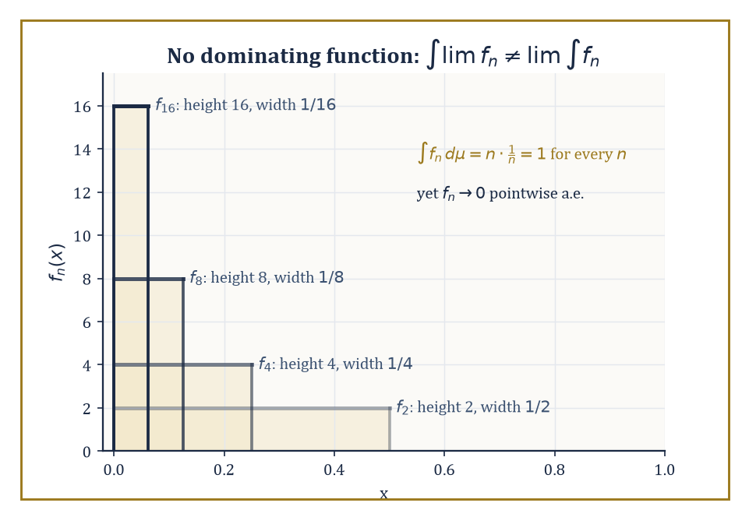
Spikes f_n = n·1_{(0,1/n)} all carry integral exactly 1 while collapsing pointwise to 0 — the standard portrait of a sequence with no integrable function large enough to dominate it.
lim ∫fₙ = ∫lim fₙ
The monotone convergence theorem (MCT) is the first and simplest: if 0 ≤ f₁ ≤ f₂ ≤ f₃ ≤ ... is an increasing sequence of non-negative measurable functions converging pointwise to f, then ∫fₙ dμ → ∫f dμ, even when both sides are infinite.
Numeric example — Worked example — monotone convergence in action. Let f(x) = x^{-1/2} on (0,1], which blows up near 0 but is still integrable there — a standard improper-Riemann-integral fact.
∫₀¹ x^{-1/2} dx = [2√x]₀¹ = 2
Define fₙ(x) = min(x^{-1/2}, n), a truncation that caps the function at height n; each fₙ is bounded and increases pointwise to f as n grows (the cap gets less and less restrictive). The crossover point where x^{-1/2} = n is x = 1/n², so fₙ(x) = n for x ≤ 1/n² and fₙ(x) = x^{-1/2} for x > 1/n². Compute directly:
∫₀¹ fₙ dx = ∫₀^{1/n²} n dx + ∫_{1/n²}^1 x^{-1/2} dx = n · (1/n²) + [2√x]_{1/n²}^{1} = 1/n + (2 − 2 · (1/n)) = 1/n + 2 − 2/n = 2 − 1/n
As n → ∞, 2 − 1/n → 2, exactly matching ∫₀¹ x^{-1/2} dx = 2 computed directly. MCT guarantees this convergence in advance, without needing the explicit closed form at all — a considerable saving of effort for less obliging functions.
Fatou's lemma weakens the hypotheses further, dropping the monotonicity requirement entirely, but pays for it by weakening the conclusion from equality to an inequality: for any sequence of non-negative measurable functions fₙ,
∫(liminf fₙ) dμ ≤ liminf ∫fₙ dμ
Mass is allowed to “escape” in the limit — the integral of the limit can be strictly smaller than the limiting behaviour of the integrals — but it can never mysteriously appear from nowhere.
Numeric example — Worked example — Fatou's lemma with strict inequality (the moving bump). Let fₙ(x) = 1_{[n, n+1]}(x) on ℝ — a bump of height 1 and width 1, marching off to infinity as n increases. For any fixed x ∈ ℝ, eventually n > x, so fₙ(x) = 0 for all sufficiently large n; hence liminf fₙ(x) = 0 for every single x, and
∫(liminf fₙ) dμ = ∫0 dμ = 0
Meanwhile ∫fₙ dμ = μ([n,n+1]) = 1 for every n, so liminf ∫fₙ dμ = liminf(1) = 1. Fatou's lemma asserts
0 ≤ 1
which is true but very far from equality — the bump's mass never actually vanishes, it just marches off toward infinity where no fixed point of the domain ever sees it again. This is the standard cautionary example for why Fatou gives an inequality, not an equation, and it is worth keeping in your back pocket every time a limit interchange looks suspiciously convenient.
The dominated convergence theorem (DCT) is the workhorse of the three: if fₙ → f pointwise (almost everywhere is enough) and there is a single integrable function g with |fₙ(x)| ≤ g(x) for all n and (almost) all x, then ∫fₙ dμ → ∫f dμ exactly.
The dominating function g is the crucial extra ingredient Fatou's lemma lacked, and it is precisely what rules out mass escaping to infinity, as it did in the moving-bump example above (no integrable g can dominate a bump of fixed height that keeps sliding rightward forever, since it would have to be at least 1 on all of [n, n+1] for every n, forcing ∫g = ∞).
Numeric example — Worked example — dominated convergence resolving a limit cleanly. Let fₙ(x) = xⁿ on [0,1] — the same sequence used in Room 36.4. We already established the pointwise limit: f(x) = 0 for x ∈ [0,1) and f(1) = 1, which equals 0 almost everywhere (the single point x = 1 is a null set).
Take g(x) = 1, the constant function, which is integrable on [0,1] since μ([0,1]) = 1 < ∞; and indeed
|fₙ(x)| = xⁿ ≤ 1 = g(x)
for every x ∈ [0,1] and every n, so the domination hypothesis holds cleanly. DCT then guarantees
∫₀¹ fₙ dx → ∫₀¹ f dx = 0
Checking directly:
∫₀¹ xⁿ dx = 1/(n+1)
and indeed 1/(n+1) → 0 as n → ∞. The theorem's conclusion and the direct computation agree exactly, as they must.
It is instructive — and, frankly, rather satisfying — to see domination fail and watch the theorem's conclusion fail right along with it, since this confirms the hypothesis was doing real work rather than sitting there for decoration.
Numeric example — Worked example — no dominating function, and the limit genuinely fails. Let fₙ(x) = n · 1_{(0, 1/n)}(x) on (0,1) — a spike of height n over a shrinking interval of width 1/n. Compute
∫fₙ dμ = n · μ((0,1/n)) = n · (1/n) = 1
for every single n, a constant sequence of integrals, all equal to 1. Meanwhile, for any fixed x ∈ (0,1), once n exceeds 1/x we have 1/n < x, so fₙ(x) = 0 for all sufficiently large n; hence fₙ → 0 pointwise almost everywhere (everywhere except the single null point x = 0). So ∫fₙ dμ = 1 for every n, but
∫(lim fₙ) dμ = ∫0 dμ = 0
the limits do not interchange,
∫lim fₙ ≠ lim ∫fₙ
What went wrong is precisely the missing dominating function: the pointwise supremum of the fₙ near x behaves roughly like 1/x, which is not integrable near 0 (∫₀¹ (1/x) dx diverges), so no single integrable g can bound every fₙ at once, and DCT's hypothesis genuinely fails rather than merely being inconvenient to check. This family of examples is also the standard illustration of a lack of uniform integrability, the refinement of these ideas that governs convergence in L¹ precisely, via Vitali's convergence theorem.
Finally, it is worth knowing explicitly that pointwise almost-everywhere convergence, convergence in measure, and convergence in Lᵖ are genuinely different notions, related by a network of implications rather than a single equivalence — a fact analysts rely on daily and beginners routinely mix up.
Convergence in measure means fₙ → f in measure whenever, for every ε > 0,
μ({x : |fₙ(x) − f(x)| > ε}) → 0
Abstract example — Worked example — convergence in measure without pointwise convergence anywhere. Build the “typewriter sequence”: sweep across [0,1) with intervals of width 1/2 (the intervals [0,1/2) and [1/2,1)), then with intervals of width 1/4 (four of them, sweeping left to right), then width 1/8 (eight of them), and so on, letting fₙ be the indicator function of the n-th interval in this ever-refining, ever-restarting sweep.
As n increases through a full sweep at resolution 1/2ᵏ,
∫fₙ dμ = 1/2ᵏ
and since every value of n eventually forces k → ∞,
∫fₙ dμ → 0
so fₙ → 0 both in L¹ and in measure. But fix any single point x ∈ [0,1): at every resolution level k, x falls inside exactly one of the 2ᵏ sweeping intervals, so fₙ(x) = 1 for that one n at level k and 0 for the other 2ᵏ − 1 values of n at that level. As the sweep proceeds through infinitely many levels, fₙ(x) takes the value 1 infinitely often and the value 0 infinitely often, for every single x — so the sequence fₙ(x) does not converge at any point whatsoever, despite converging beautifully in L¹ and in measure.
This is the standard counterexample showing convergence in measure (and in Lᵖ) is strictly weaker than pointwise almost-everywhere convergence — the two notions overlap but neither implies the other outright, and the precise map of which implications do hold (a subsequence of an Lᵖ-convergent sequence always has an almost-everywhere convergent subsequence, for instance) is standard analytic furniture worth memorising once and for all.

Room 36.7: Product Measures and Fubini's Theorem
Changing the Order of Integration Without Getting Sued
Given two measure spaces (X, Σ_X, μ) and (Y, Σ_Y, ν), the product σ-algebra Σ_X ⊗ Σ_Y on X × Y is generated by the measurable rectangles A × B (A ∈ Σ_X, B ∈ Σ_Y), and there is a unique product measure μ × ν on this σ-algebra characterised by its values on rectangles:
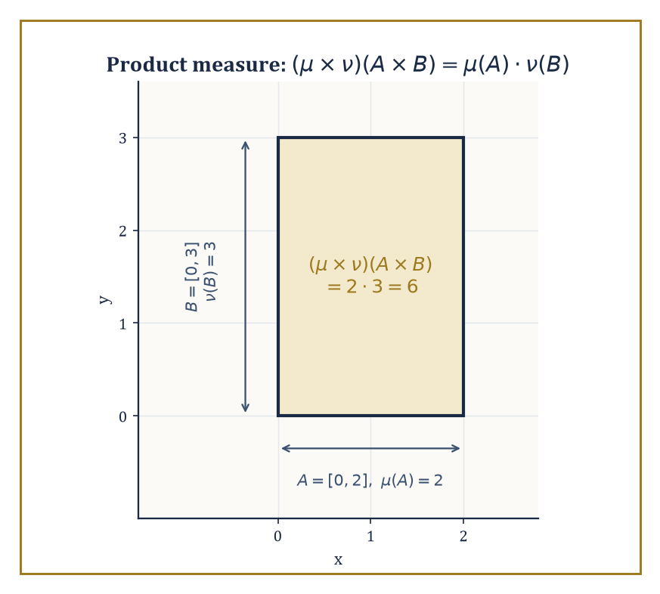
The measurable rectangle [0,2]×[0,3]: product measure turns out to be nothing more mysterious than the ordinary area you already knew how to compute.
(μ × ν)(A × B) = μ(A) · ν(B)
This is the abstract machinery underlying every double integral you have ever computed, and Lebesgue measure on ℝ² is nothing more exotic than the product of Lebesgue measure on ℝ with itself — either a satisfying piece of economy or faintly disappointing, depending on how much you were hoping the plane had been hiding from you.
Numeric example — Worked example — a product measure recovers ordinary area. Take X = Y = ℝ with Lebesgue measure μ = ν, and consider the rectangle R = [0,2] × [0,3] in the product space. By the defining property of the product measure:
(μ × ν)(R) = μ([0,2]) · ν([0,3]) = 2 · 3 = 6
— exactly the ordinary area computed directly in Room 36.3. The product-measure construction and the earlier direct construction of Lebesgue measure on ℝ² are not merely consistent; they are, once the dust settles, the identical object, which is a small but reassuring coherence check on the whole theory.
Fubini's theorem is the payoff: if f is integrable on the product space (X × Y, μ × ν) — meaning ∫∫|f| d(μ×ν) < ∞ — then the double integral can be computed as an iterated integral in either order, and both orders give the same answer:
∫_X (∫_Y f(x,y) dν(y)) dμ(x) = ∫_Y (∫_X f(x,y) dμ(x)) dν(y) = ∫∫ f d(μ×ν)
This is the rigorous justification for the “just swap the order of dx and dy” manoeuvre that every calculus student performs on instinct and very few are ever told requires a hypothesis.
Numeric example — Worked example — Fubini's theorem confirmed directly. Let f(x,y) = xy on [0,1] × [0,1], a bounded continuous function on a finite-measure space, hence certainly integrable. Compute one order:
∫₀¹ (∫₀¹ xy dy) dx
The inner integral, treating x as a constant, is:
∫₀¹ xy dy = x · [y²/2]₀¹ = x/2
Then:
∫₀¹ (x/2) dx = (1/2) · [x²/2]₀¹ = (1/2)(1/2) = 1/4
Now the other order:
∫₀¹ (∫₀¹ xy dx) dy
by the exact same computation with the roles of x and y swapped (the integrand is symmetric in x and y), also gives 1/4. Both orders agree, exactly as Fubini's theorem promises.
Tonelli's theorem is Fubini's more permissive sibling: it drops the integrability hypothesis entirely, at the cost of requiring f to be non-negative (rather than merely measurable of either sign), and concludes that the iterated integrals are equal — possibly both infinite, but never disagreeing with each other. Tonelli is what you reach for first when you are not yet sure whether f is integrable at all, since checking non-negativity is usually far easier than checking ∫∫|f| < ∞ directly, and once Tonelli confirms the two iterated integrals agree and are finite, integrability follows and Fubini applies to the genuine (possibly signed) function you actually wanted.
Numeric example — Worked example — Tonelli with an infinite answer. Let f(x,y) = 1 on the first quadrant [0,∞) × [0,∞), certainly non-negative.
Compute one order of the iterated integral; the inner integral ∫₀^∞ 1 dy diverges to ∞ for every fixed x, so the outer integral is also infinite:
∫₀^∞ (∫₀^∞ 1 dy) dx = ∫₀^∞ ∞ dx = ∞
The other order gives the identical answer, ∞, by the same computation with x and y swapped. Tonelli's theorem guarantees this agreement in advance — both orders equal ∞ — even though the function is nowhere close to being integrable in the finite sense (∫∫f d(μ×ν) = ∞, so Fubini's actual hypothesis fails, but Tonelli never needed it to).
That the integrability (or non-negativity) hypothesis is not mere legal throat-clearing is demonstrated by a genuinely famous counter-example, in which the two iterated integrals of a perfectly innocent-looking function disagree outright.
Numeric example — Worked example — a function where order of integration genuinely matters. Let f(x,y) = (x² − y²) / (x² + y²)² on (0,1) × (0,1). One can check, by differentiating, that y/(x²+y²) is an antiderivative of f with respect to y:
∂/∂y [ y/(x² + y²) ] = [(x²+y²) − y·2y] / (x²+y²)² = (x² − y²)/(x²+y²)² = f(x,y)
Hence:
∫₀¹ f(x,y) dy = [y/(x²+y²)]_{y=0}^{y=1} = 1/(x²+1) − 0 = 1/(1+x²)
Integrating this over x:
∫₀¹ 1/(1+x²) dx = [arctan x]₀¹ = arctan(1) − arctan(0) = π/4 − 0 = π/4
So one iterated integral equals π/4. For the other order, note f is antisymmetric under swapping its arguments:
f(x,y) = −f(y,x)
(swap x and y in the formula and the numerator flips sign while the denominator does not). By the identical computation with the roles relabelled:
∫₀¹ f(x,y) dx = −1/(1+y²)
∫₀¹ (−1/(1+y²)) dy = −π/4
So the two iterated integrals are π/4 and −π/4 — genuinely different numbers, not a computational slip. The resolution is that f is not integrable on the whole square in the ∫∫|f| < ∞ sense (the singularity at the origin is too severe once you stop letting positive and negative parts cancel each other), so neither Fubini nor Tonelli's hypotheses are met, and the theorem simply does not apply — which is exactly why a hypothesis was needed in the first place.
Infinite products of measure spaces extend this machinery to countably many factors at once, and are the rigorous foundation for two constructions that show up constantly further up the Tower: an infinite sequence of independent random variables (each coordinate its own probability space, the whole sequence living on the infinite product) and infinite-dimensional Gaussian measures used in stochastic analysis. The product measure on a countable product is again characterised by its values on “cylinder sets” — sets determined by constraints on only finitely many coordinates at a time.
Numeric example — Worked example — an infinite product measure for coin flips. Model an infinite sequence of fair coin flips as the product space {0,1}^ℕ, with each factor carrying the Bernoulli(1/2) measure (P(0) = P(1) = 1/2). The product measure assigns to the cylinder set “first three flips equal 1, 0, 1, remaining flips unconstrained” the following probability:
(1/2)(1/2)(1/2) = 1/8
— exactly matching the elementary probability calculation you would do without any measure theory at all. What the product-measure machinery buys you, beyond confirming a calculation you already trusted, is a rigorous single measure defined consistently on the σ-algebra generated by all such cylinder sets — including events depending on infinitely many coordinates at once, such as “the long-run frequency of heads equals 1/2,” which no finite calculation could ever pin down but which the infinite product measure handles without difficulty, and which is precisely the content of the strong law of large numbers waiting further up the Tower.

Room 36.8: L^p Spaces and the Radon–Nikodym Theorem
In Which the Dinner Guests From the Opening Finally Receive Their Papers
The space Lᵖ(X, μ), for 1 ≤ p < ∞, consists of all measurable functions f with
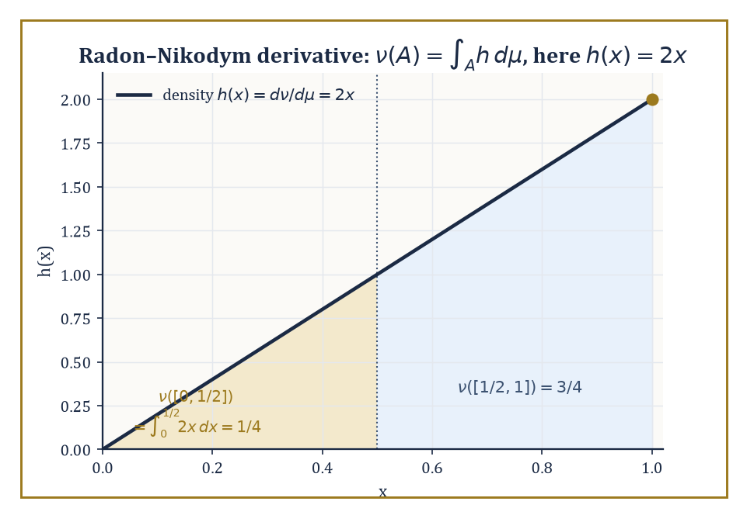
The density h(x)=2x weights the upper half of [0,1] three times as heavily as the lower half — ν([0,½])=¼ against ν([½,1])=¾, read straight off the areas under the line.
∫|f|ᵖ dμ < ∞
(strictly, equivalence classes of such functions under “equal almost everywhere,” which is where Room 36.3's philosophy of ignoring null sets finally becomes load-bearing rather than merely reassuring), equipped with the following norm:
‖f‖_p = (∫|f|ᵖ dμ)^{1/p}
Under this norm, Lᵖ is a Banach space — complete, meaning every Cauchy sequence of functions actually converges to a function still in the space, a fact whose proof leans directly on the monotone and dominated convergence theorems of Room 36.6.
When p = 2, the norm comes from an inner product,
⟨f,g⟩ = ∫fg dμ
and L² is a Hilbert space — the exact object that anchored so much of the previous storey's discussion of orthogonality and projection, now finally built from first principles rather than taken on trust.
Numeric example — Worked example — three norms of the same function. Let f(x) = x on [0,1] with Lebesgue measure.
Compute ‖f‖₁:
‖f‖₁ = ∫₀¹ |x| dx = ∫₀¹ x dx = 1/2
Compute ‖f‖₂:
‖f‖₂ = (∫₀¹ x² dx)^{1/2} = (1/3)^{1/2} = 1/√3 ≈ 0.577
Compute ‖f‖_∞ (the essential supremum, Room 36.4's definition):
{x : |f(x)| > M} = (M, 1] for 0 ≤ M < 1
which has positive measure 1 − M whenever M < 1, and is empty (measure zero) once M ≥ 1; so
ess sup |f| = 1
Three different numbers — 0.5, 0.577, and 1 — from the same function, illustrating concretely that the Lᵖ norms genuinely measure different things (L¹ weights every value equally by its “mass,” L² penalises large values more heavily via the square, L^∞ cares only about the worst almost-everywhere behaviour) and are not merely notational variants of one idea.
Hölder's inequality states that
∫|fg| dμ ≤ ‖f‖_p · ‖g‖_q whenever 1/p + 1/q = 1
(p and q are called conjugate exponents) — this is the fundamental estimate relating a product of functions to the separate norms of the factors, and it specialises at p = q = 2 to the Cauchy–Schwarz inequality familiar from Hilbert space theory.
Minkowski's inequality states that
‖f + g‖_p ≤ ‖f‖_p + ‖g‖_p
This is the triangle inequality for the Lᵖ norm, and is in fact what makes ‖·‖_p a genuine norm in the first place rather than merely a suggestively-named quantity.
Numeric example — Worked example — checking Hölder and Minkowski on a concrete pair. Let f(x) = x and g(x) = 1 on [0,1], and take p = q = 2 (self-conjugate: 1/2 + 1/2 = 1).
For Hölder's inequality, compute:
∫₀¹ |f g| dx = ∫₀¹ x dx = 1/2
Meanwhile:
‖f‖₂ · ‖g‖₂ = (1/√3) · (∫₀¹ 1² dx)^{1/2} = (1/√3) · 1 = 1/√3 ≈ 0.577
Indeed 0.5 ≤ 0.577, confirming Hölder's inequality on this pair (not an equality here, since equality in Hölder requires f and g to be proportional, which x and 1 are not).
For Minkowski's inequality, compute:
‖f + g‖₂ = (∫₀¹ (x+1)² dx)^{1/2}
Expand:
∫₀¹ (x² + 2x + 1) dx = 1/3 + 1 + 1 = 1/3 + 2 = 7/3
‖f+g‖₂ = (7/3)^{1/2} ≈ 1.528
And:
‖f‖₂ + ‖g‖₂ = 1/√3 + 1 ≈ 0.577 + 1 = 1.577
Indeed 1.528 ≤ 1.577, confirming Minkowski's inequality holds strictly (not with equality, since equality in Minkowski at p = 2 requires f and g to be non-negative scalar multiples of one another).
For 1 ≤ p < ∞, the dual space (Lᵖ)* — the space of continuous linear functionals on Lᵖ — is identified with L^q, where q is the conjugate exponent of p; every continuous linear functional on Lᵖ takes the form
f ↦ ∫fg dμ
for a unique g ∈ L^q, and ‖g‖_q equals the operator norm of the functional it represents. This is the precise, constructive answer to the question the previous storey left dangling: what does the dual of an Lᵖ space actually look like?
Numeric example — Worked example — an explicit dual pairing. On L²[0,1] (self-dual, since q = 2 when p = 2), consider the linear functional
φ(f) = ∫₀¹ f(x) dx
This is represented, in the sense above, by g(x) = 1 (the constant function), since
φ(f) = ∫₀¹ f · 1 dx
matches the general form exactly. Compute:
‖g‖₂ = (∫₀¹ 1² dx)^{1/2} = 1
By Cauchy–Schwarz (Hölder at p=q=2),
|φ(f)| = |∫f·1| ≤ ‖f‖₂ ‖1‖₂ = ‖f‖₂
so the operator norm of φ is at most 1; and taking f = 1 itself gives
φ(1) = 1 = ‖1‖₂
so the bound is achieved and the operator norm equals exactly 1 — matching ‖g‖₂ = 1 precisely, as the duality theorem promises.
The Radon–Nikodym theorem addresses a different but related question: given two measures μ and ν on the same measurable space, when can ν be written as an integral against μ,
ν(A) = ∫_A h dμ
for some non-negative measurable function h? The answer is: precisely when ν is absolutely continuous with respect to μ (written ν ≪ μ, meaning μ(A) = 0 forces ν(A) = 0 for every measurable A) and μ is σ-finite.
The function h, when it exists, is unique up to a set of μ-measure zero, and is called the Radon–Nikodym derivative, written dν/dμ. This is the abstract, measure-theoretic form of the fundamental theorem of calculus — a “density” recovering a whole measure from a single function — and it is the theorem that produces conditional expectations in probability theory.
Numeric example — Worked example — a density and its Radon–Nikodym derivative. Let μ be Lebesgue measure on [0,1], and define ν(A) = ∫_A 2x dx for every measurable A ⊆ [0,1], i.e. ν is built directly from the density h(x) = 2x.
First check ν is itself a genuine probability measure:
ν([0,1]) = ∫₀¹ 2x dx = [x²]₀¹ = 1
so total mass is exactly 1. Compute a specific value:
ν([0, 1/2]) = ∫₀^{1/2} 2x dx = [x²]₀^{0.5} = 0.25
so under ν, the “probability” of landing in the lower half of [0,1] is only 1/4, not 1/2, reflecting that the density h(x) = 2x weights larger x-values more heavily.
By construction, ν ≪ μ (any set of Lebesgue measure zero contributes zero to ∫_A 2x dx as well, since the integral of any bounded function over a null set is zero), and the Radon–Nikodym derivative is, transparently,
dν/dμ = 2x
— the very function we started with. This example runs the theorem in the easy, constructive direction (building ν from a chosen h); the substance of the actual theorem is the harder converse direction, guaranteeing that whenever ν ≪ μ holds abstractly, some such h is guaranteed to exist, even when no explicit formula for it is available in advance.
Not every measure is absolutely continuous with respect to another, of course — some measures are concentrated entirely on a set the reference measure considers negligible, a phenomenon called mutual singularity.
The Lebesgue decomposition theorem says that any (σ-finite) measure ν splits uniquely into an absolutely continuous part and a singular part relative to a given reference measure μ:
ν = ν_ac + ν_sing, with ν_ac ≪ μ and ν_sing concentrated on some μ-null set
Abstract example — Worked example — decomposing a measure with an atom. Let μ be Lebesgue measure on ℝ, and let ν = δ₀ + (Lebesgue measure restricted to [0,1]), where δ₀ is the Dirac point mass at the origin, defined by δ₀(A) = 1 if 0 ∈ A and δ₀(A) = 0 otherwise.
The second summand, Lebesgue measure restricted to [0,1], is absolutely continuous with respect to μ, with density h(x) = 1_{[0,1]}(x) — this is the ν_ac piece.
The first summand, δ₀, is concentrated entirely on the single point {0}, and μ({0}) = 0 (a point is a null set, Room 36.3 again), so δ₀ is supported on a μ-null set while giving that set full mass — the textbook definition of singularity with respect to μ.
So the Lebesgue decomposition of ν with respect to μ is exactly:
ν_ac = Lebesgue measure on [0,1] (density 1_{[0,1]}), ν_sing = δ₀
and no other decomposition into an absolutely continuous piece and a singular piece is possible, by the uniqueness clause of the theorem. Point masses, and their more exotic cousins like measures concentrated on Cantor-set-like fractals, are the standard source of singular parts throughout analysis and probability alike.
We have now acquired the core machinery: σ-algebras and measures, outer measure and Carathéodory's extension, Lebesgue measure itself, measurable functions, the Lebesgue integral built in three careful stages, the convergence theorems that are the entire point of the enterprise, product measures and Fubini's theorem, and finally Lᵖ spaces and the Radon–Nikodym theorem — at which point those well-bred dinner guests from the opening pages received their birth certificates in full.
The tools built here open directly onto several of the Tower's remaining rooms, further up than we will climb today. Probability theory is measure theory with total mass normalised to 1, plus the extra structure of independence, conditional expectation (which the Radon–Nikodym theorem produces essentially for free), and martingales. The theory of distributions generalises measures and their densities into objects that can be differentiated arbitrarily many times, however wild the original measure. Geometric measure theory extends the whole apparatus to Hausdorff measures of fractional dimension, currents, and sets of finite perimeter — measuring things that are not quite curves and not quite regions but something usefully in between. Ergodic theory studies transformations that preserve a measure, watching what a system does to itself over infinite time. And the spectral theory of operators on Lᵖ spaces, together with Fourier analysis on groups, both lean on exactly the integration theory built in this storey to make sense of infinite-dimensional linear algebra in the first place.
The deeper lesson, if this storey has one, is that once sets can be measured and functions can be integrated with respect to that measurement, the whole of analysis acquires a flexibility the Riemann integral never had the infrastructure to provide. Pointwise statements give way to almost-everywhere statements; limits pass under integral signs on demand, given the right hypothesis; order of integration stops being sacred and becomes negotiable, given the right hypothesis; and a measure can be pulled apart into a density-bearing piece and a singular piece, given the right hypothesis. Nearly everything, it turns out, is “given the right hypothesis” — which is either the most honest sentence in this entire storey or the closest thing analysis has to a motto, and possibly both at once.
Ahead lies a rather different sort of room. The next storey sets aside limits, infinity, and null sets almost entirely and turns to Abstract Algebra: groups, rings, fields, the clean finite combinatorics of symmetry and structure, built without a single ε or δ in sight. After a storey spent making peace with the infinite and the negligible, there is something almost restful about a subject where every statement is exactly true, with no “almost” attached to it — though give it a few storeys, and even algebra will find its own version of infinity to worry about. The tower continues upward. We have learned to integrate almost everywhere.

Storey 37: Abstract Algebra
Groups, Rings, Fields, and the Art of Structure for Its Own Sake
The last storey spent its entire budget teaching you to measure sets so unruly that length, area, and volume needed to be reinvented from first principles just to survive contact with them; we built σ-algebras, we built countable additivity, we built an entire integral robust enough to survive functions with no right to be integrated at all. It was hard-won machinery, earned the slow way, one epsilon at a time. This storey asks you to set all of it down for a while and do something that feels, at first, suspiciously like a step backward: we are going to stop measuring things and start asking what an operation is.
Elementary algebra — the algebra of school, of solving for x — manipulates numbers according to rules everybody already half-knows by feel: addition is commutative, multiplication distributes over addition, every equation wants to be solved. Abstract algebra takes those rules, strips away the numbers they were originally attached to, and studies the rules themselves as objects of interest in their own right. It is, on first encounter, the moment many students report that mathematics has stopped being 'about things' and started being 'about symbols' — a complaint this narrator remembers filing personally, at approximately nineteen, in a cold lecture theatre, before it turned out to be entirely wrong.
The feeling passes, and here is why: the symbols are names for symmetries, for number systems, for the transformations that recur, disguised, throughout the rest of mathematics. A group is not an abstraction floating free of content — it is what the rotations of a square, the arithmetic of a clock, and the shuffles of a deck of cards all have secretly in common, once you stop looking at what they are and start looking at how they behave. This storey builds the vocabulary — groups, rings, fields, modules, extensions, and the beginnings of Galois theory — keeping a concrete example within arm's reach at every step, because an abstraction with no example nearby is just a rumour.
Let's abstract.

Room 37.1: What Abstract Algebra Actually Is
In Which We Stop Caring What the Symbols Stand For
An algebraic structure is a set equipped with one or more operations — rules for combining elements to produce new elements — that are required to satisfy a short list of axioms: rules about how the operation must behave, not what the elements themselves are. This is the entire trick of the subject, and it is worth sitting with for a moment before we race off into groups and rings.
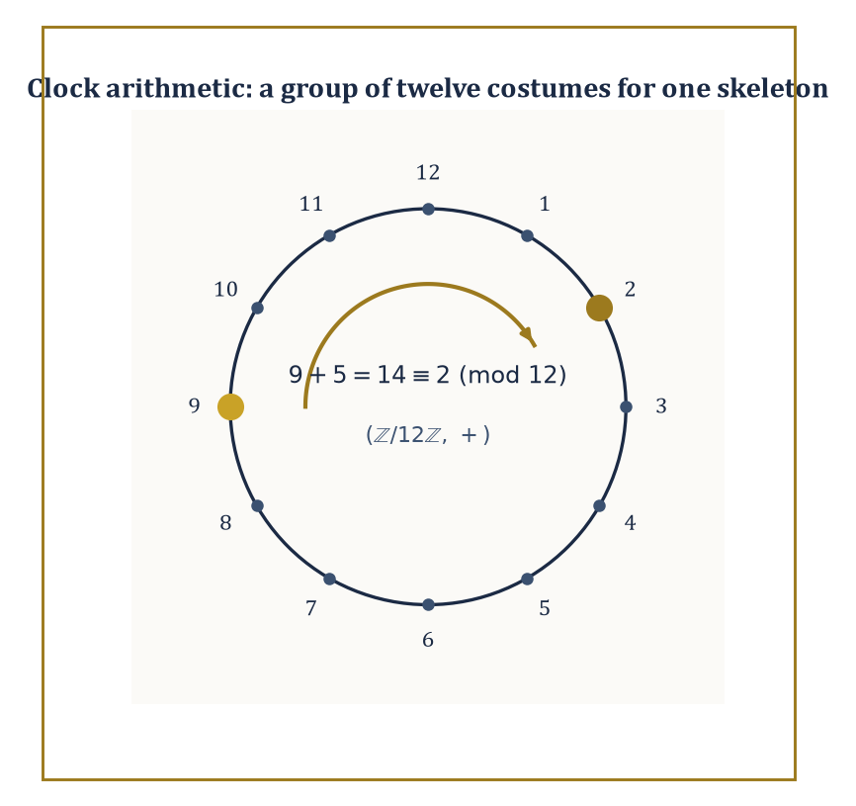
Nine o'clock plus five hours is two o'clock — the same three-line checklist that governs the integers, wearing a wristwatch.
Elementary algebra asks: what is x, given that
2x + 3 = 7
Abstract algebra asks a different, stranger question: forget what x is — what can we say about any system in which an operation like '+' exists and behaves the way addition behaves? The moment you stop asking about the elements and start asking about the operation, you have crossed into abstract algebra, and there is, alas, no crossing back to innocence.
Abstract example — Two systems, one skeleton. Consider two sets side by side: the integers ℤ = {…,-2,-1,0,1,2,…} under addition, and the set ℕ = {0,1,2,3,…} under addition.
Both have an operation that is associative in either set,
(a+b)+c = a+(b+c)
and both have an identity element, 0,
a+0 = a
But only ℤ has inverses: for every a ∈ ℤ there is -a ∈ ℤ with
a+(-a) = 0
so that 5 has a partner -5 undoing it. In ℕ, 5 has no partner at all — there is no natural number n with
5+n = 0
So (ℤ,+) satisfies all the axioms we are about to call a 'group', while (ℕ,+) fails on inverses alone and is merely what algebraists call a monoid. Nothing about the elements changed between the two examples — 0,1,2,3,… sit inside both sets — what changed is which operation-axioms the whole package satisfies. That is the entire content of the definition of a group, stated in advance: it is a checklist, and ℕ fails item three.
The point of isolating these axioms is that wildly different concrete objects can satisfy exactly the same checklist, and any theorem proved from the checklist alone — using nothing but 'associative, identity, inverses' — then applies to all of them simultaneously, without having to be reproved each time in a new costume. This is not a minor convenience; it is the entire reason the subject exists. A theorem about 'groups' is a theorem about integer addition, about the symmetries of a square, about the arithmetic of a twelve-hour clock, and about the shuffles of a deck of cards, all at once, because all four are secretly instances of the same three-line definition.
Abstract example — Same axioms, different costumes. The symmetries of a square — the eight ways to pick the square up and put it back down so it still looks like a square (four rotations by 0°, 90°, 180°, 270°, and four reflections) — form a group of eight elements under 'do one symmetry, then another'.
The hours on a clock face, {0,1,2,…,11}, form a group of twelve elements under addition-then-wraparound — 9 o'clock plus 5 hours is 2 o'clock:
9+5 = 14 ≡ 2 mod 12
These two groups have nothing whatsoever to do with each other as objects — one is geometric, one is arithmetic, and they don't even have the same number of elements (8 versus 12). Yet Lagrange's theorem, which we meet properly in Room 37.2, applies word-for-word to both, because both satisfy the group axioms. This is what it means to say abstract algebra studies the operation rather than the objects: the theorem doesn't know or care whether it's talking about a square or a clock.
Once a class of structures is defined, the natural next question is: when are two of them 'the same'? Not identical as sets — that's usually too strong to be useful — but the same in every way the operation can detect.
A map that preserves the operation is called a homomorphism; one that is also a perfect one-to-one correspondence is an isomorphism, and structures related by an isomorphism are, for every algebraic purpose, indistinguishable. Homomorphisms, isomorphisms, subobjects (substructures sitting inside a bigger one), and quotient objects (structures built by deliberately forgetting some distinctions) are the four nouns in which the rest of this storey is written; get comfortable with them now, because they will not be explained again from scratch.
Numeric example — Spotting a disguise. Take (ℤ/2ℤ, +), the set {0,1} with addition mod 2 (so 1+1=0), and take ({1,-1}, ×), the two square roots of 1 under ordinary multiplication. These look like different objects — one is 'clock arithmetic with two hours', the other is 'signs under multiplication' — but map 0 to 1 and 1 to -1:
0 ↦ 1, 1 ↦ -1
Check that this preserves the operation. First, 0+0=0 should correspond to 1×1=1:
0+0=0 and 1×1=1
Indeed 0↦1 and 1↦1, so it checks out. Next, 1+1=0 should correspond to (-1)×(-1)=1:
1+1=0 and (-1)×(-1)=1
This checks out too, since 0↦1 on both sides. Finally, 0+1=1 should correspond to 1×(-1)=-1:
0+1=1 and 1×(-1)=-1
This also checks out, since 1↦-1. Every sum on the left matches a product on the right under this dictionary, and the map is a bijection (two elements to two elements, none missed, none doubled), so it is an isomorphism. Algebraically, 'clock arithmetic mod 2' and 'multiplying signs' are the same group wearing two different hats.
Abstract algebra is therefore two subjects wearing one name: a pure subject with its own internal architecture and aesthetic — some of the deepest and strangest theorems in all of mathematics live here — and simultaneously the load-bearing structural language underneath geometry, number theory, and a fair portion of theoretical physics. We spend this storey building the checklist items in order of increasing richness: groups (one operation), rings (two operations), fields (two operations, one of them invertible), and beyond.

Room 37.2: Groups and Homomorphisms
Addition, Symmetry, and Rubik's Cube, Unified by Spite
A group is a set G together with a binary operation ∗ (a rule assigning to each ordered pair a,b ∈ G a third element a∗b ∈ G) satisfying three axioms.
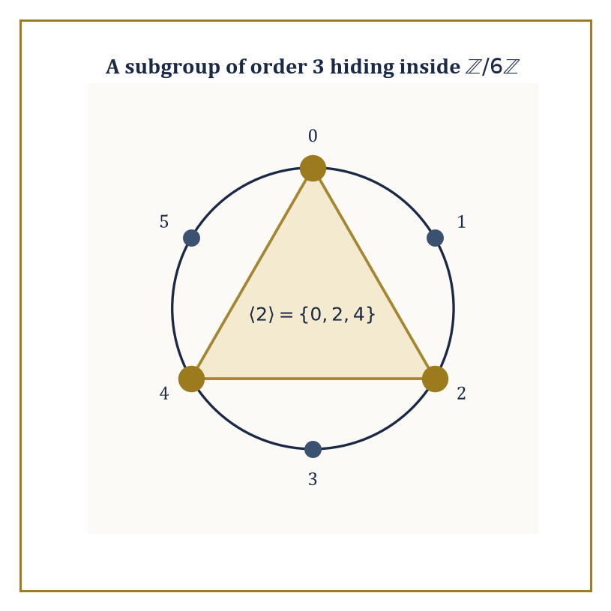
The element 2 doesn't generate all of ℤ/6ℤ — it generates exactly the golden triangle, a subgroup of order 3, precisely because 3 divides 6.
First, associativity, so that a long chain of combinations needs no brackets, for all a,b,c:
(a∗b)∗c = a∗(b∗c)
Second, an identity element e ∈ G exists, for every a:
e∗a = a∗e = a
Third, inverses: for every a ∈ G there exists a⁻¹ ∈ G with:
a∗a⁻¹ = a⁻¹∗a = e
Nothing else is required — no commutativity, no finiteness, no numbers of any kind.
When the operation also commutes for all a,b —
a∗b = b∗a
— the group is called abelian, in honour of Niels Henrik Abel, who died young, poor, and two days before a letter arrived offering him a professorship; mathematics does have a sense of humour, and it is not always a kind one.
The integers under addition, the nonzero real numbers under multiplication, invertible n×n matrices under matrix multiplication (called GLₙ), and the permutations of n objects under composition (called Sₙ) are the four examples you should keep permanently on the shelf.
Numeric example — The smallest genuinely non-abelian group. Let G = S₃, the six ways to permute three labelled objects {1,2,3}: e (do nothing), the three transpositions (12), (13), (23) (swap a pair, fix the third), and the two 3-cycles (123), (132) (send 1→2→3→1, or the reverse).
Composition is 'do the second permutation after the first', reading right to left as functions usually are.
Check non-abelian-ness directly: apply (12) then (13) to the point 1. First (12) sends 1↦2, then (13) sends 2↦2 (it only touches 1 and 3), so the composite sends 1↦2.
Now the other order: apply (13) then (12) to 1: (13) sends 1↦3, then (12) sends 3↦3, so this composite sends 1↦3.
Since one composite sends 1↦2 and the other sends 1↦3, the two composites are different permutations.
So S₃ is a group of order 6 in which order matters — the smallest group where commutativity genuinely fails, which is why every account of the subject, this storey included, reaches for it first.
A homomorphism φ: G → H between groups is a map satisfying, for all a,b, the following — it turns the operation in G into the operation in H, faithfully, even if it forgets other information:
φ(a∗b) = φ(a)∘φ(b)
Two subsets fall out of any homomorphism for free: the kernel, the elements crushed down to the identity —
ker φ = {a ∈ G : φ(a) = e_H}
— and the image, everything actually hit —
im φ = {φ(a) : a ∈ G}
Both are automatically subgroups (of G and H respectively) — the kernel because if φ(a)=φ(b)=e then φ(a∗b⁻¹)=e too, and the image because homomorphisms preserve the group operation by definition.
The first isomorphism theorem then says that quotienting G by exactly the stuff the map kills gives you back, faithfully and isomorphically, exactly what the map hit:
G / ker φ ≅ im φ
It is the algebraic version of 'divide out the redundancy and what's left is the honest content' — a sentiment that also describes most academic committee meetings, minus the isomorphism.
Numeric example — Reduction mod 5. Let φ: ℤ → ℤ/5ℤ send each integer to its remainder on division by 5, so that:
φ(7)=2, φ(-3)=2 (since -3 = -1·5+2), φ(20)=0
This is a homomorphism from (ℤ,+) to (ℤ/5ℤ,+): check that φ(7+13) and φ(7)+φ(13) agree.
φ(7+13)=φ(20)=0
φ(7)+φ(13)=2+3=5≡0 mod 5
They agree, as they must for any pair, since remainders add correctly mod 5 by construction.
The kernel is:
ker φ = {n ∈ ℤ : n ≡ 0 mod 5} = 5ℤ = {…,-10,-5,0,5,10,…}
and the image is all of ℤ/5ℤ (every remainder is hit):
im φ = ℤ/5ℤ = {0,1,2,3,4}
The first isomorphism theorem predicts:
ℤ/5ℤ ≅ ℤ/5ℤ
which is admittedly not the most thrilling instance on record, but it is honest, and it is exactly the mechanism by which 'clock arithmetic' is defined as a quotient of the integers in the first place.
A group is cyclic if it is generated by a single element g — that is, every element equals gⁿ (or, written additively, ng) for some integer n.
Cyclic groups are the atoms of abelian group theory: ℤ itself is cyclic (generated by 1), and ℤ/nℤ is the finite cyclic group of order n (generated by 1, wrapping around after n steps).
Every cyclic group is abelian, trivially:
gᵐ∗gⁿ = g^(m+n) = gⁿ∗gᵐ
though the converse fails badly — plenty of abelian groups need more than one generator.
Numeric example — A subgroup hiding inside a clock. In ℤ/6ℤ = {0,1,2,3,4,5} under addition mod 6, the element 1 generates the whole group (1,2,3,4,5,0,… by repeated addition — all six elements).
But the element 2 generates only a part of it:
2, 2+2=4, 4+2=6≡0
and then it repeats, giving:
⟨2⟩ = {0,2,4}
a cyclic subgroup of order 3 sitting inside the cyclic group of order 6, generated by an element that is not itself a generator of the whole thing. Note 3 divides 6, exactly as Lagrange's theorem (next) demands.
Lagrange's theorem states that if G is a finite group and H ≤ G is a subgroup, then the order (element-count) of H divides the order of G.
The proof is a counting argument — G splits into disjoint cosets of H, all of the same size |H|, so |G| is a whole-number multiple of |H| — and we will do that counting properly in Room 37.3.
For now, treat it as the first hard constraint the theory hands you: it doesn't tell you which subgroups exist, but it rules out most of the numbers a hopeful subgroup-order might have wanted to be.
Numeric example — What Lagrange forbids. S₃ has order 6, whose divisors are 1, 2, 3, 6. Lagrange's theorem says every subgroup of S₃ must have one of these four orders — and indeed S₃ has representatives of all four.
The trivial subgroup has order 1, and three subgroups of order 2 are generated by each transposition, for example:
⟨(12)⟩={e,(12)}
there is a subgroup of order 3:
A₃=⟨(123)⟩={e,(123),(132)}
and S₃ itself has order 6.
What Lagrange's theorem forbids is a subgroup of order 4 or 5 — no such subgroup exists, and now you know why without having to search for one: 4 and 5 don't divide 6, so the search was always doomed.
That is the theorem's real power — not telling you what's there, but saving you the trouble of looking for what provably isn't.

Room 37.3: Group Actions, Cosets, and Quotient Groups
Groups Doing Things to Sets, and the Bookkeeping That Follows
A group action of G on a set X is a homomorphism from G into Sym(X), the group of all permutations of X — equivalently, a rule assigning to each g ∈ G a way of moving the points of X around, written g·x, such that the following hold for all g,h ∈ G and x ∈ X:
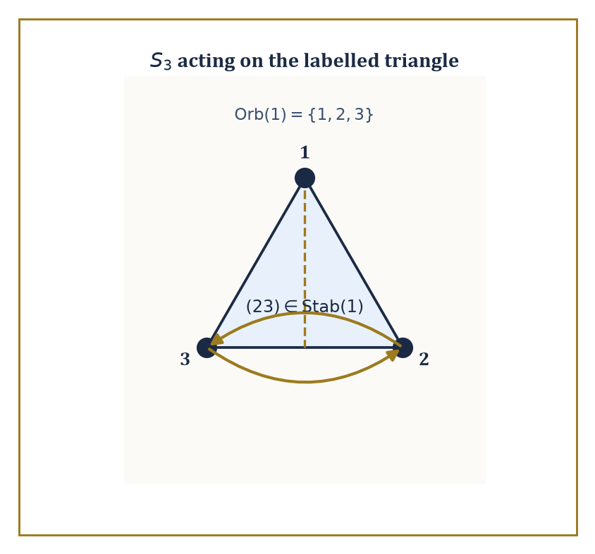
The reflection (23) is the one symmetry that leaves vertex 1 exactly where it found it — everything Stab(1) means, drawn as a single fold of the triangle.
e·x = x
(gh)·x = g·(h·x)
This is the formal machinery behind the informal idea of a group 'acting on' or 'symmetrizing' something: the rotation group of a cube acts on the cube's eight corners, the permutation group Sₙ acts on {1,…,n} by definition, and a group can even act on itself, by left multiplication or by conjugation, tricks that turn out to be surprisingly powerful.
Numeric example — S₃ moving three points. S₃ acts on X = {1,2,3} in the obvious way: the permutation (12) sends 1↦2, 2↦1, 3↦3.
Check the action axiom on a composite by applying (13) first then (12) to the point 1.
(13) sends 1↦3
(12) sends 3↦3 (untouched)
So the composite (12)·((13)·1) sends 1 to 3.
This matches exactly what you get by first computing the single permutation (12)∘(13) and applying it to 1 directly, because the group action axiom (gh)·x = g·(h·x) is really just associativity of function composition wearing a trench coat — composition of permutations is function composition, and function composition is always associative, so the axiom is automatic rather than something that needs separate verification each time.
For a point x ∈ X, its orbit is the set of everywhere x can be moved to:
Orb(x) = {g·x : g ∈ G}
Its stabilizer is the set of elements that leave x fixed in place:
Stab(x) = {g ∈ G : g·x = x}
The stabilizer is always a subgroup of G (if g and h both fix x, so does gh, and so does g⁻¹). The orbit-stabilizer theorem ties the two together:
|Orb(x)| · |Stab(x)| = |G|
Intuitively, the group's elements get sorted into |Orb(x)| bins, one per point the orbit reaches, and each bin has exactly |Stab(x)| elements in it (the ones that send x to that particular point) — so multiplying bins by bin-size recovers the whole group.
Numeric example — Counting orbit and stabilizer in S₃. Take the natural action of S₃ on X={1,2,3} and fix the point x=1. The orbit of 1 is everywhere 1 can be sent: (12) sends it to 2, (13) sends it to 3, e sends it to 1 — every point in X is reachable, so:
Orb(1) = {1,2,3}, size 3
The stabilizer of 1 is every permutation fixing 1 in place: e certainly does, and the only transposition not touching 1 is (23), which does too, so:
Stab(1) = {e,(23)}, size 2
The orbit-stabilizer theorem predicts:
|Orb(1)|·|Stab(1)| = 3×2 = 6 = |S₃|
Correct, and this is no coincidence — it is a theorem, not a lucky count.
For a subgroup H ≤ G, a left coset is a set for some fixed g ∈ G:
gH = {gh : h ∈ H}
The left cosets partition G into equal-sized pieces (each of size |H|), which is exactly the counting argument behind Lagrange's theorem promised in the last room. Right cosets Hg are defined the same way but need not agree with left cosets in general. When they do agree for every g — that is, when gH = Hg for all g ∈ G — the subgroup H is called normal, written H ⊴ G, and the set of cosets G/H then inherits a perfectly well-defined group operation, making G/H the quotient group:
(aH)(bH) = (ab)H
Without normality, this multiplication rule is ambiguous — different representatives of the same coset would give different answers — so normality is not a nicety, it is the precise condition under which 'dividing a group by a subgroup' is even meaningful.
Numeric example — Building ℤ/nℤ, and a quotient inside S₃. The cosets of the subgroup nℤ inside (ℤ,+) are the n residue classes mod n:
0+nℤ, 1+nℤ, …, (n-1)+nℤ
Since ℤ is abelian, every subgroup is automatically normal, so ℤ/nℤ is always a legitimate quotient group; this is, in fact, the official construction of clock arithmetic. For a non-abelian example, take H = A₃ = {e,(123),(132)} inside S₃. A₃ has index 2 (only two cosets: A₃ itself, and everything else), for example:
(12)A₃ = {(12),(13),(23)}
Any subgroup of index 2 is automatically normal — left and right cosets are forced to coincide because there are only two of them and one is always H itself, so the other (everything else) is forced to match on both sides. The quotient S₃/A₃ has exactly two elements, so:
S₃/A₃ ≅ ℤ/2ℤ
This is the unique group of order 2.
A simple group is one with no normal subgroups other than the trivial subgroup {e} and itself — it cannot be broken apart into a quotient in any nontrivial way, making it, in a precise sense, an atom of group theory.
Every finite group can be built up from simple groups via a chain of extensions (a composition series), rather as every integer factors into primes, and classifying the finite simple groups — completed, after decades of collective effort spanning tens of thousands of journal pages and more than one mathematician's entire career, in the closing years of the twentieth century — is one of the largest proofs in the history of the subject. Nobody has read all of it. This is not a joke; it is simply true, and it is a fact the field has made an uneasy peace with.
Abstract example — The smallest non-abelian simple group. A₅, the even permutations of five objects, has order 60 (half of 5!=120) and is simple: it has no normal subgroups except {e} and itself.
This is the smallest non-abelian simple group, and its simplicity is precisely the algebraic fact behind the impossibility of solving the general quintic equation by radicals — a connection we will make precise in Room 37.8.
Contrast this with A₃ from the previous example: A₃ has order 3, which is prime, so by Lagrange its only subgroups are {e} and itself — every group of prime order is automatically simple (and cyclic, and abelian), for the boring reason that there's no room for anything else to divide it.
A₅ is the first interesting simple group precisely because its order, 60, has plenty of divisors, and yet none of the corresponding subgroups happens to be normal.

Room 37.4: Rings, Ideals, and Quotient Rings
Two Operations Are Twice the Fun and Considerably More Than Twice the Bookkeeping
A ring is a set R with two operations, usually called addition and multiplication, such that (R,+) is an abelian group, multiplication is associative, and multiplication distributes over addition on both sides:
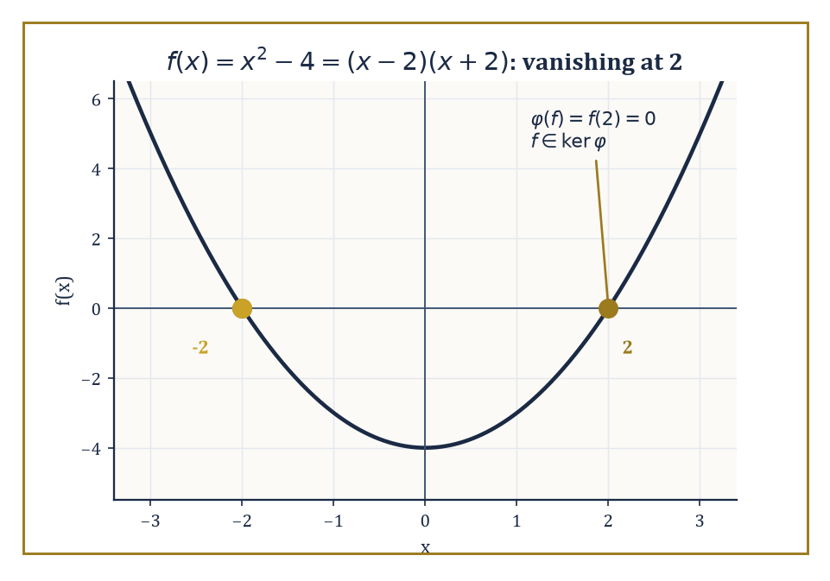
x²-4 lands in the kernel of 'evaluate at 2' for the most literal reason possible: its graph passes right through the point.
a(b+c) = ab+ac
(a+b)c = ac+bc
That is the bare minimum; a commutative ring additionally requires ab=ba for all a,b, and a ring with identity requires a multiplicative identity 1 with 1·a = a·1 = a.
Most rings anyone actually cares about — the integers, polynomial rings, rings of continuous functions — are commutative rings with identity, and we will quietly assume both from here on unless said otherwise.
The point of the two-operation package is that it captures, all at once, the integers, polynomials, matrices, and functions: wildly different objects, unified by satisfying the same eight-or-so axioms.
Numeric example — Distributivity, checked by hand. In the ring of integers, verify a(b+c)=ab+ac with a=3, b=4, c=5.
Left side: 3×(4+5) = 3×9 = 27
Right side: (3×4)+(3×5) = 12+15 = 27
They agree, as the axiom demands — and this is not a coincidence to be checked case by case, it is a fact about the integers that follows from how multiplication is built out of repeated addition, but the axiomatic approach simply assumes it as a starting rule so that the same proof technique transfers unchanged to polynomial rings, matrix rings, and any other ring anyone constructs tomorrow.
An ideal I ⊆ R is a subset that is a subgroup under addition and additionally absorbs multiplication: for every r ∈ R and every i ∈ I, both ri and ir land back in I.
This absorption property is what makes ideals the right notion of 'substructure to quotient by' in ring theory, playing the role that normal subgroups played for groups — you cannot quotient a ring by an arbitrary subring and expect the multiplication to survive the process, but an ideal is built precisely so that it does.
Numeric example — 3ℤ absorbs everything you throw at it. Let I = 3ℤ = {…,-6,-3,0,3,6,9,…}, the multiples of 3, inside R = ℤ.
Take an arbitrary ring element, say r=7, and an arbitrary element of I, say i=6=3×2.
7×6=42=3×14
This is indeed a multiple of 3, hence back in I.
This will hold no matter which multiple of 3 you pick and no matter which integer you multiply it by —
r·(3k) = 3(rk)
a multiple of 3 by construction — which is exactly the absorption property, verified in general by one line of algebra rather than infinitely many separate checks.
Given an ideal I ⊴ R, the quotient ring R/I consists of the cosets a+I with addition and multiplication defined coset-wise; the absorption property is exactly what makes multiplication well-defined on cosets (try to check this fails for a mere subring and you'll see why ideals earn their keep).
A prime ideal P is one where ab ∈ P forces a ∈ P or b ∈ P — the ideal-theoretic generalization of a prime number being unable to divide a product without dividing one of the factors — and the quotient R/P by a prime ideal is always an integral domain (no zero divisors).
A maximal ideal M is one properly contained in no ideal except R itself, and the quotient R/M by a maximal ideal is always a field.
Every maximal ideal is prime (fields are automatically domains), but the converse can fail.
Numeric example — 5 is prime, 6 is not, and their quotients know it. Compare ℤ/5ℤ and ℤ/6ℤ. In ℤ/6ℤ, take 2 and 3: neither is 0, but
2×3=6≡0 mod 6
— a genuine zero divisor, because the ideal (6) is not prime (6 is composite, 6=2×3, and neither factor lies in (6) alone). So ℤ/6ℤ is not even an integral domain, let alone a field.
Now ℤ/5ℤ = {0,1,2,3,4}: since 5 is prime, (5) is a maximal ideal, so ℤ/5ℤ must be a field — every nonzero element has a multiplicative inverse.
Check this for 2: we need x with 2x≡1 mod 5. Try x=3:
2×3=6≡1 mod 5
Yes —
2⁻¹=3 in ℤ/5ℤ
This is the entire content of the fact that ℤ/pℤ is a field exactly when p is prime, seen from the ideal-theoretic side rather than the elementary-number-theory side.
A ring homomorphism φ: R → S preserves both operations:
φ(a+b)=φ(a)+φ(b)
φ(ab)=φ(a)φ(b)
and, if both rings have 1, usually φ(1)=1 by convention.
Exactly as with groups, the kernel is an ideal (not merely a subring — this is precisely why 'ideal' had to be invented as a separate concept from 'subring'), the image is a subring, and the first isomorphism theorem reads
R/ker φ ≅ im φ
word for word the group statement with 'subgroup' upgraded to 'ideal'.
Numeric example — Evaluating a polynomial at x=2. Let φ: ℝ[x] → ℝ be evaluation at 2,
φ(f) = f(2)
This is a ring homomorphism:
φ(f+g)=f(2)+g(2)=φ(f)+φ(g)
φ(fg)=f(2)g(2)=φ(f)φ(g)
both immediate from how polynomial addition and multiplication are defined pointwise.
The kernel is every polynomial vanishing at 2 — for instance f(x)=x²-4 satisfies
f(2)=4-4=0
so f ∈ ker φ, and indeed x²-4 factors as (x-2)(x+2), visibly a multiple of (x-2).
In fact ker φ = (x-2), because a real polynomial vanishes at 2 exactly when (x-2) divides it (the factor theorem, from a much earlier storey, making a guest appearance).
The image is all of ℝ, since every real number is f(2) for the constant polynomial f=that number.
So the first isomorphism theorem gives
ℝ[x]/(x-2) ≅ ℝ
dividing out 'everything that vanishes at 2' leaves you with exactly the value at 2, which is a satisfyingly literal reading of what a quotient is supposed to mean.

Room 37.5: Factorization in Integral Domains
Where Unique Factorization Turns Out to Be a Privilege, Not a Right
An integral domain is a commutative ring with identity 1≠0 and no zero divisors:
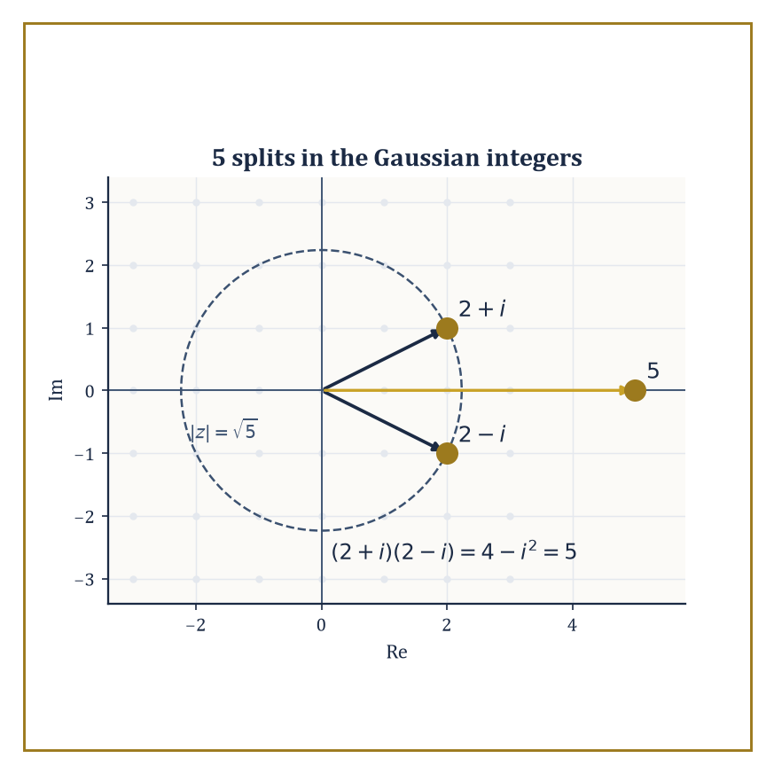
5 looks stubbornly prime from the real line, but step into the complex plane and it visibly splits into 2+i and its mirror image.
ab=0 forces a=0 or b=0
This single extra condition is what lets you 'cancel' in equations — if ab=ac and a≠0, then
a(b-c)=0
and since a≠0 the no-zero-divisors condition forces b-c=0, i.e. b=c — a manipulation every school pupil performs on instinct and no domain-theorist performs without first checking the ring qualifies.
Numeric example — Cancellation succeeds and fails. In ℤ/5ℤ, take the two products below.
2×3=6≡1 (mod 5)
2×4=8≡3 (mod 5)
These are different, consistent with cancellation being valid there (2 is nonzero, and ℤ/5ℤ is a domain, being a field). But in ℤ/6ℤ, take:
2×2=4 (mod 6)
2×5=10≡4 (mod 6)
the same product, yet 2≠5. Cancelling the 2 would wrongly conclude 2=5. The reason cancellation fails is exactly the zero-divisor problem from Room 37.4:
2×3≡0 (mod 6)
so ℤ/6ℤ is not a domain, and the cancellation law — which secretly relies on being able to divide the equation a(b-c)=0 down to b-c=0 — simply has no right to hold there.
A unique factorization domain (UFD) is an integral domain in which every nonzero non-unit factors into irreducibles, and that factorization is unique up to order and multiplication by units (invertible elements) — this is the abstract version of the fundamental theorem of arithmetic.
A Euclidean domain is one equipped with a division algorithm: a size function (a 'norm') letting you divide with remainder, the remainder strictly smaller than the divisor, exactly as with long division of integers.
Every Euclidean domain is automatically a principal ideal domain (PID, meaning every ideal is generated by a single element) — repeated division produces a generator via the same argument as the Euclidean algorithm for gcds — and every PID is automatically a UFD. So the implications run:
Euclidean ⟹ PID ⟹ UFD
three increasingly weaker guarantees of good factorization behaviour, and the interesting mathematics tends to live in rings that satisfy one implication but not its converse.
Numeric example — The Euclidean algorithm, the mechanism underneath it all. In ℤ, find gcd(17,5) by repeated division with remainder.
17 = 3×5 + 2
5 = 2×2 + 1
2 = 2×1 + 0
The remainder hits zero, so the algorithm halts and the last nonzero remainder, 1, is gcd(17,5). This is the division algorithm that makes ℤ a Euclidean domain (with the 'size' function being ordinary absolute value), and the same mechanical procedure — divide, take the remainder, repeat until it hits zero — is what makes ℝ[x] and ℤ[i] (below) Euclidean too, just with a different notion of 'size' each time (degree for polynomials, norm for Gaussian integers).
The Gaussian integers ℤ[i] = {a+bi : a,b ∈ ℤ} form a Euclidean domain under the norm:
N(a+bi)=a²+b²
which is multiplicative,
N(zw)=N(z)N(w)
and lets you divide with a remainder of strictly smaller norm. Unique factorization then explains something that looks, from inside ordinary arithmetic, faintly magical: certain ordinary prime numbers stop being prime once you're allowed complex integer factors.
Numeric example — 5 stops being prime in ℤ[i]. Compute the product of the two Gaussian-integer factors of 5.
(2+i)(2-i) = 2×2 + 2×(-i) + i×2 + i×(-i) = 4 - 2i + 2i - i² = 4 - (-1) = 5
So 5, stubbornly prime in ℤ, factors as (2+i)(2-i) in ℤ[i]. Both factors are irreducible in ℤ[i]: their norms are
N(2+i)=4+1=5, N(2-i)=4+1=5
and 5 is prime in ℤ, so neither factor can be broken down further (a further factorization would need norms multiplying to 5, and 5=5×1 is the only way, forcing one factor to be a unit). This phenomenon — an ordinary prime 'splitting' into two Gaussian-integer primes — is precisely governed by whether the prime is congruent to 1 mod 4 (5≡1 mod 4, and it splits) or 3 mod 4 (which stay prime, e.g. 3, 7, 11), a fact first understood by Fermat and one of the founding observations of algebraic number theory.
Not every ring of algebraic integers is so well-behaved. In ℤ[√-5] = {a+b√-5 : a,b ∈ ℤ}, unique factorization simply breaks.
The standard demonstration is worth working through slowly, because it is the example that historically convinced number theorists they needed an entirely new invariant — the ideal class group — to repair the damage.
Numeric example — Two genuinely different factorizations of 6. In ℤ[√-5], compute two different-looking factorizations of the same number.
2×3 = 6
(1+√-5)(1-√-5) = 1² - (√-5)² = 1 - (-5) = 1+5 = 6
Using the norm:
N(a+b√-5)=a²+5b²
we get:
N(2)=4, N(3)=9, N(1+√-5)=1+5=6, N(1-√-5)=6
None of 2, 3, 1+√-5, 1-√-5 can be broken down further: the norm form a²+5b² never equals 2 or 3 for integers a,b (checking small cases: for b=0 it gives perfect squares 0,1,4,9,…; for b=±1 it gives a²+5, i.e. 5,6,9,14,…; neither list contains 2 or 3), so no element of ℤ[√-5] has norm 2 or 3, which rules out any nontrivial factorization of 2, 3, or the two norm-6 elements.
So 6 = 2×3 = (1+√-5)(1-√-5) are two factorizations into irreducibles that are not merely rearrangements of each other by units (the only units in ℤ[√-5] are ±1) — genuine, unrepairable non-uniqueness. This single broken equation is the crack that opens onto the entire theory of ideal class groups, invented by Kummer and Dedekind specifically to patch it.
Deciding by hand whether a specific polynomial is irreducible would be hopeless without shortcuts, and Eisenstein's criterion is the most useful one available. Consider a polynomial with integer coefficients:
f(x) = aₙxⁿ + … + a₁x + a₀
If there is a prime p dividing every coefficient except the leading one, with p² not dividing the constant term a₀, then f is irreducible over ℚ.
Gauss's lemma underlies why: it says a polynomial with integer coefficients that factors over ℚ already factors over ℤ, so it suffices to rule out integer factorizations, and Eisenstein's condition does exactly that by a clean argument mod p.
Numeric example — x³-2 is irreducible, by Eisenstein. Take:
f(x)=x³-2
with coefficients (1,0,0,-2) for x³,x²,x,constant. Choose p=2. Does 2 divide every coefficient except the leading 1? The coefficients to check are 0, 0, and -2 — 2 divides 0 (trivially) and 2 divides -2 — yes, all three. Does 2²=4 divide the constant term -2? No, 4 does not divide -2.
Both conditions of Eisenstein's criterion are met, so x³-2 is irreducible over ℚ — it has no rational root and does not factor into a linear times a quadratic with rational coefficients. This one fact is the entire reason ∛2 generates a genuine degree-3 field extension of ℚ, a claim we will need and verify from a different angle in Room 37.7.

Room 37.6: Modules over Rings
Vector Spaces That Lost Their Field and Gained a Ring Instead
A module M over a ring R is an abelian group (M,+) equipped with a scalar multiplication R×M→M satisfying the same wish-list of axioms as a vector space, except that R is merely a ring, not necessarily a field.
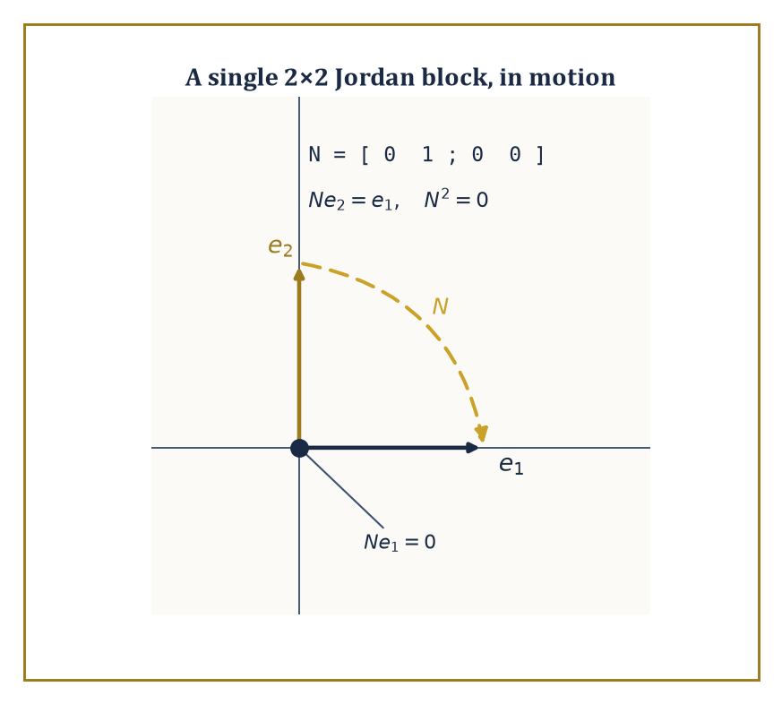
N pushes e2 down onto e1 and e1 down onto nothing — one step from an eigenbasis, which is precisely why a Jordan block is needed at all.
r(m+n) = rm + rn
(r+s)m = rm + sm
(rs)m = r(sm)
1m = m
This one relaxation changes everything: vector spaces over a field are extremely well-behaved (every vector space has a basis, every subspace has a complement), while modules over a general ring can be badly behaved in ways that turn out to be exactly the interesting phenomena of number theory and topology in algebraic disguise.
Numeric example — The clock as a module over the integers. Every abelian group is automatically a ℤ-module in a forced, unique way: n·m means 'add m to itself n times' (and (-n)·m means do that to -m). Take M=ℤ/6ℤ as a ℤ-module, and compute the scalar action of 4 on the element [2].
4·[2] = [2]+[2]+[2]+[2] = [8] = [2]
(since 8 mod 6 = 2.) Note this module has no basis in the vector-space sense — there is no element [k] such that every element of ℤ/6ℤ is an integer multiple of [k] in a unique way, because, e.g.,
[3]+[3] = [0]
a genuine 'linear' relation with no analogue over a field. This failure of the free-basis property is precisely what distinguishes a general ℤ-module (an abelian group) from a ℤ-vector space (which doesn't exist, since ℤ isn't a field).
A free module is one that does have a basis — Rⁿ, with basis given by the standard 'unit vectors', is the model example, behaving exactly like a vector space of dimension n even though R is only a ring.
A sequence of modules and homomorphisms is exact at B if the image of the incoming map equals the kernel of the outgoing map:
⋯ → A → B → C → ⋯
A short exact sequence
0 → A → B → C → 0
packages up the statement 'A sits inside B as a submodule, and B/A is isomorphic to C' into a single compact diagram, and it is the workhorse notation of homological algebra.
Worked example — A short exact sequence you can hold in your hand. Take the short exact sequence
0 → ℤ →(×2) ℤ → ℤ/2ℤ → 0
where the first map is multiplication by 2 and the second is reduction mod 2. Exactness at the first ℤ (injectivity of ×2) is immediate:
2a=2b forces a=b in ℤ
Exactness at ℤ/2ℤ (surjectivity of the reduction map) is immediate too: every residue class 0 or 1 is hit. The interesting check is exactness in the middle: is the image of 'multiply by 2' exactly the kernel of 'reduce mod 2'? The image of ×2 is the even integers,
2ℤ = {…,-4,-2,0,2,4,…}
The kernel of reduction mod 2 is also exactly the even integers — an integer reduces to 0 mod 2 precisely when it's even. Image equals kernel, so the sequence is exact at the middle term too, and the whole diagram is a short exact sequence: 'the even integers sit inside ℤ, and ℤ modulo the evens is ℤ/2ℤ' — an entirely unsurprising fact, now wearing the standard notation you will meet again in every homological argument from here to the end of the Tower.
The structure theorem for finitely generated modules over a PID is the crown result of this room: every such module decomposes as a direct sum of a free part and finitely many cyclic torsion pieces R/(pᵢ^kᵢ) for primes pᵢ of R.
Specialize R=ℤ and you get the classification of finite abelian groups — every finite abelian group is a direct sum of cyclic groups of prime-power order, uniquely, up to reordering.
Specialize R=K[x] for a field K and the module 'a vector space with a chosen linear operator T acting on it' and you recover the rational canonical form and the Jordan canonical form of a matrix, both from the same single theorem.
Numeric example — Every abelian group of order 12, listed exhaustively. Factor 12.
12 = 2²×3
The structure theorem says a finite abelian group of order 12 is determined by how the exponent 2 (on the prime 2) is split into a sum, combined with the prime-3 part.
The exponent 2 splits as 2 (one piece) or 1+1 (two pieces) — those are the only two partitions of 2 — giving cyclic factor ℤ/4ℤ or ℤ/2ℤ⊕ℤ/2ℤ for the 2-part, always paired with ℤ/3ℤ for the 3-part (3 being prime, no further splitting possible).
That yields exactly two abelian groups of order 12 up to isomorphism: ℤ/4ℤ⊕ℤ/3ℤ, which collapses (since gcd(4,3)=1) to the single cyclic group ℤ/12ℤ by the Chinese remainder theorem, and ℤ/2ℤ⊕ℤ/2ℤ⊕ℤ/3ℤ, which collapses to ℤ/2ℤ⊕ℤ/6ℤ (again using gcd(2,3)=1 to merge the second ℤ/2ℤ with ℤ/3ℤ into ℤ/6ℤ).
So: exactly two abelian groups of order 12, ℤ/12ℤ and ℤ/2ℤ⊕ℤ/6ℤ, and the structure theorem is what guarantees there are no others hiding anywhere.
The same theorem, run over R=ℂ[x] with M a finite-dimensional complex vector space acted on by a linear operator T (so that x acts as T), delivers the Jordan canonical form: every such M decomposes into cyclic pieces ℂ[x]/((x-λ)^k), each one a 'Jordan block'.
A Jordan block is a matrix that is λ down the diagonal, 1 along the superdiagonal, and 0 everywhere else — the closest a non-diagonalizable operator can get to being diagonal.
Numeric example — A 2×2 Jordan block, made concrete. Consider the matrix
N = [[0,1],[0,0]]
N cannot be diagonalized: its only eigenvalue is 0 (the characteristic polynomial is λ², double root at 0), but Nv=0 only for v in the 1-dimensional space spanned by (1,0) — there is no second, independent eigenvector to build a full eigenbasis from.
N is nonetheless the simplest possible non-diagonal matrix in a precise sense: it is nilpotent —
N² = 0 (the zero matrix)
computed directly by matrix multiplication — and a single Jordan block for eigenvalue 0. As a module over ℂ[x], this is exactly ℂ[x]/(x²) — the module where x acts as N — and it is indecomposable: unlike ℤ/6ℤ (which splits as ℤ/2⊕ℤ/3), ℂ[x]/(x²) cannot be broken into smaller cyclic pieces, precisely because x² is a prime-power (2²) rather than a product of distinct primes.
Modules that are not free still deserve measurement, and homological algebra supplies the instruments: Ext and Tor are functors that measure, respectively, the failure of a module to split off as a direct summand and the failure of tensor products to behave as simply as they do for vector spaces.
Projective modules (direct summands of free ones) and injective modules (their dual notion) are the well-behaved building blocks the theory is built from.
We will not compute an Ext group in this storey — that machinery is better appreciated once category theory, immediately ahead of us, has supplied the vocabulary of functors properly — but it is worth knowing the words exist, since 'Ext' and 'Tor' will recur like old acquaintances throughout the upper storeys of this Tower.

Room 37.7: Field Extensions
Building Bigger Number Systems by Politely Insisting a Root Exists
A field extension K ⊆ L is simply a field L containing a smaller field K as a subfield; the whole of L can then be regarded as a vector space over K (add elements of L as usual, scale by elements of K), and its dimension as such a vector space is the degree, written [L:K].
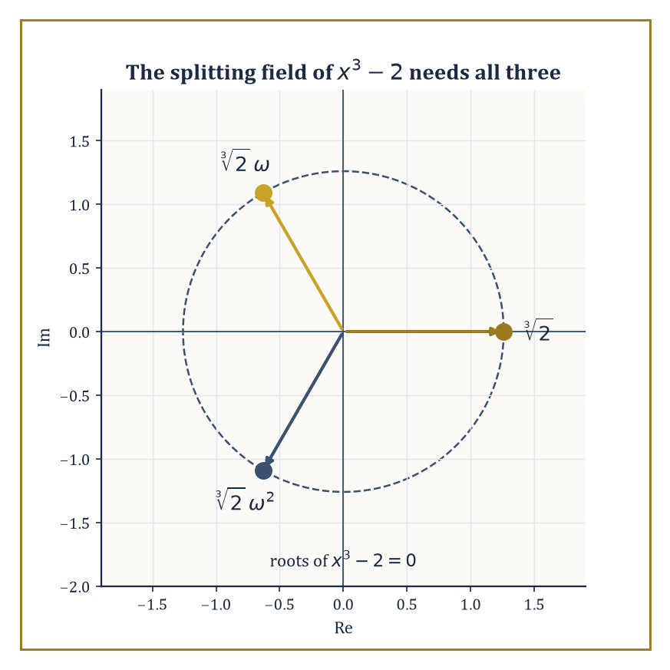
ℚ(∛2) alone catches only one of these three roots — the splitting field has to reach for the other two, out in the complex plane, at a cost of degree 6.
When [L:K] is finite, L is called a finite extension of K; when every element of L satisfies some nonzero polynomial with coefficients in K, L is called an algebraic extension. Finite extensions are always algebraic (a standard argument using the pigeonhole principle on powers of an element inside a finite-dimensional space), though the converse can fail for infinite extensions.
Numeric example — [ℚ(√2):ℚ] = 2, basis and all. Let L=ℚ(√2)={a+b√2 : a,b∈ℚ}, the smallest field containing ℚ and √2. As a ℚ-vector space, L is spanned by {1,√2}: every element is a ℚ-linear combination of these two, by definition of the set.
Are they independent? If a+b√2=0 with a,b∈ℚ and b≠0, then
√2=-a/b
a rational number — but √2 is irrational (a fact from a much earlier storey, provable by the classic infinite-descent argument on parity), contradiction. So {1,√2} is a basis, [ℚ(√2):ℚ]=2, and multiplication behaves exactly as you'd hope:
(2+3√2)(1-√2) = 2-2√2+3√2-3×2 = 2+√2-6 = -4+√2
still of the form a+b√2, confirming L is closed under multiplication as a field extension must be.
Given an irreducible polynomial p(x) over K, adjoining a root α produces the simple extension
K(α) = K[x]/(p(x))
and [K(α):K] equals the degree of p — the minimal polynomial of α, the unique monic irreducible polynomial over K that α satisfies. This is the standard machine for building new fields to order: name the property you want a new element to have (namely, being a root of a specific irreducible polynomial), and the quotient construction manufactures a field in which that property holds, with no further questions asked about what α 'really is'.
Numeric example — Building ℚ(∛2) to order. We showed in Room 37.5 (via Eisenstein with p=2) that x³-2 is irreducible over ℚ. So K(α)=ℚ[x]/(x³-2), where α is the class of x, is a genuine field, of degree [ℚ(∛2):ℚ]=3, with basis {1,α,α²} where α³=2 by construction.
Concretely, α behaves exactly like the real cube root of 2:
(1+α)(1-α+α²) = 1-α+α²+α-α²+α³ = 1+α³ = 1+2 = 3
using α³=2 at the last step — you never need to know that α 'is' 1.259921… to compute correctly inside the field; the single defining relation α³=2 suffices for every algebraic manipulation.
A splitting field of a polynomial f over K is the smallest extension of K in which f factors completely into linear factors — it contains every root of f, and nothing algebraically superfluous besides. Splitting fields always exist and are unique up to isomorphism, by repeatedly adjoining roots one irreducible factor at a time.
An algebraic closure K̄ of K is a field containing a root of every nonzero polynomial over K (and every polynomial over K̄ itself); it exists for any field K (a fact that genuinely requires Zorn's lemma — the axiom of choice in disguise — once K is infinite) and, like splitting fields, is unique up to isomorphism.
Numeric example — Two splitting fields, one small and one not. The polynomial x²+1 has no real root, but over L=ℝ(i)=ℂ it factors completely:
x²+1=(x-i)(x+i)
Since ℂ already contains both roots, [ℂ:ℝ]=2 is the splitting field, and in fact ℂ is algebraically closed (the fundamental theorem of algebra, from a much earlier storey) — it is its own algebraic closure.
Contrast this with x³-2: its three roots are ∛2 (real), ∛2ω, and ∛2ω² (both complex), where ω=e^(2πi/3) is a primitive cube root of unity satisfying ω²+ω+1=0. The splitting field must contain ∛2 (degree 3 over ℚ) and ω (degree 2 over ℚ(∛2), since ω is not real but ∛2 generates only a real field), so by the tower law below,
[ℚ(∛2,ω):ℚ] = 3×2 = 6
considerably roomier than the degree-3 field ℚ(∛2) alone, which contains only one of the three roots.
For a tower of fields K ⊆ M ⊆ L, degrees multiply:
[L:K] = [L:M]·[M:K]
The proof is a basis-combination argument — if {mᵢ} is a basis for M over K and {ℓⱼ} a basis for L over M, then {mᵢℓⱼ} is a basis for L over K — and the multiplicativity is what turns field extension degrees into a powerful divisibility constraint, exactly analogous to Lagrange's theorem for groups.
Numeric example — The tower law, brick by brick. Build the tower ℚ ⊆ ℚ(√2) ⊆ ℚ(√2,√3). We know [ℚ(√2):ℚ]=2. For the next step, is √3 already inside ℚ(√2)? Suppose √3=a+b√2 for some a,b∈ℚ; squaring gives
3=a²+2b²+2ab√2
Since 3 and a²+2b² are rational and √2 is irrational, the coefficient of √2 must vanish: 2ab=0, so a=0 or b=0. If b=0, then a²=3, impossible for rational a. If a=0, then 2b²=3, i.e. b²=3/2, also impossible for rational b. So √3 ∉ ℚ(√2), meaning x²-3 stays irreducible over ℚ(√2), giving [ℚ(√2,√3):ℚ(√2)]=2.
The tower law then gives
[ℚ(√2,√3):ℚ] = 2×2 = 4
with basis {1,√2,√3,√6} — and indeed one can check this whole degree-4 field is generated by the single element √2+√3 alone (its minimal polynomial over ℚ turns out to be x⁴-10x²+1, degree 4, matching), an instance of the primitive element theorem that we state here without proof and will not need again until it resurfaces, transfigured, in Room 37.8's fundamental theorem.

Room 37.8: Introduction to Galois Theory
In Which Symmetry Groups Reveal Exactly Which Equations Can Be Solved
For a field extension L/K, the Galois group Gal(L/K) consists of all field automorphisms of L that fix every element of K — bijective maps L→L preserving addition and multiplication, doing nothing whatsoever to K itself, but potentially permuting the elements of L that lie outside K.
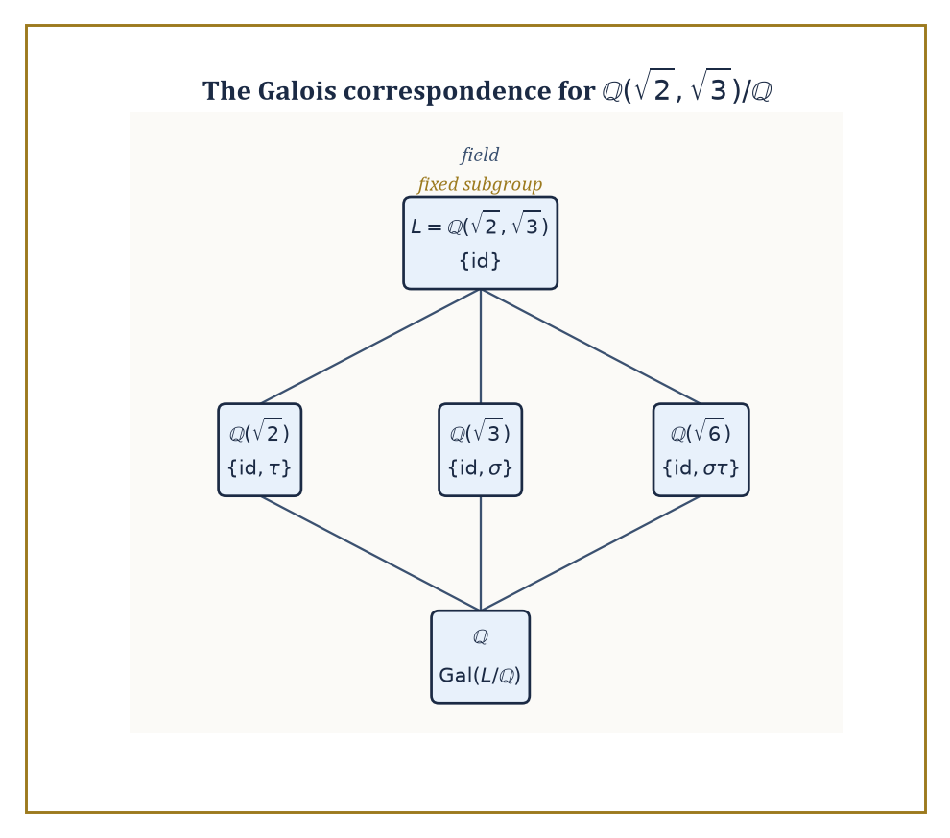
Bigger field, smaller subgroup: the lattice of intermediate fields and the lattice of subgroups mirror each other exactly, one node per node.
When L/K is a finite Galois extension (meaning: normal, so L contains all roots of every irreducible polynomial over K that has one root in L, and separable, meaning no irreducible polynomial involved has repeated roots — automatic in characteristic zero, so ignore this clause unless you're working over a finite field), the Galois group has order exactly [L:K], and the fundamental theorem of Galois theory sets up a perfect order-reversing correspondence: subgroups of Gal(L/K) correspond exactly to intermediate fields K⊆M⊆L, with bigger subgroups corresponding to smaller fields and vice versa.
Numeric example — The Galois group of ℚ(√2)/ℚ, found by hand. An automorphism σ of ℚ(√2) fixing ℚ is determined entirely by where it sends √2, because every element is a+b√2 with a,b∈ℚ fixed by σ. Since σ must preserve the relation (√2)²=2, we need
σ(√2)²=σ(2)=2
so σ(√2)=±√2 — only two possibilities. Both actually work: the identity (σ(√2)=√2), and the 'conjugation' map σ(a+b√2)=a-b√2. Check the second is a genuine homomorphism, starting from the fact that
(1+√2)(2+√2)=2+√2+2√2+2=4+3√2
so
σ((1+√2)(2+√2)) = σ(4+3√2) = 4-3√2
Separately,
σ(1+√2)σ(2+√2) = (1-√2)(2-√2) = 2-√2-2√2+2 = 4-3√2
They agree — σ really does preserve multiplication. So Gal(ℚ(√2)/ℚ) = {id, σ}, a group of order 2, matching [ℚ(√2):ℚ]=2 exactly as the theorem promises.
The fundamental theorem is best appreciated by watching the correspondence in a case with more than one intermediate field to find, so that the 'bijection' part of the claim has some actual content to demonstrate rather than being vacuously true.
Numeric example — Four automorphisms, three intermediate fields, one Klein four-group. Take L=ℚ(√2,√3), with [L:ℚ]=4 as computed in Room 37.7. An automorphism fixing ℚ must send √2 to ±√2 and, independently, √3 to ±√3 (each is a root of its own minimal polynomial, x²-2 and x²-3 respectively, and roots must go to roots), giving four candidate automorphisms: id (√2↦√2, √3↦√3), σ (√2↦-√2, √3↦√3), τ (√2↦√2, √3↦-√3), and στ (√2↦-√2, √3↦-√3).
All four are genuine automorphisms, so Gal(L/ℚ) has exactly 4 elements, matching [L:ℚ]=4. Every non-identity element here squares to the identity (σ²: √2↦-√2↦√2, back to start), so the group is the Klein four-group ℤ/2ℤ×ℤ/2ℤ, not cyclic ℤ/4ℤ.
It has exactly three subgroups of order 2: {id,σ}, {id,τ}, {id,στ}. The fundamental theorem predicts three intermediate fields, and there they are: {id,σ} fixes exactly the elements unmoved by σ, which is ℚ(√3) (σ negates √2 but fixes √3); {id,τ} fixes ℚ(√2); and {id,στ} fixes ℚ(√6) — check: στ sends
√6=√2·√3 ↦ (-√2)(-√3)=√6
unmoved, so √6 is indeed fixed by στ, giving the third intermediate field. Three subgroups, three intermediate fields, matched up exactly as promised, and not one of them found by guesswork.
The single most famous application of this machinery is negative: it explains why there is no formula, built from addition, subtraction, multiplication, division, and root-extraction, that solves the general polynomial equation of degree five (or higher) in terms of its coefficients — in flat contradiction to the quadratic, cubic, and quartic formulas that had been known, with increasing difficulty, since the Renaissance.
Solvability of an equation by radicals corresponds, under Galois's dictionary, to solvability of its Galois group — a purely group-theoretic property meaning the group can be broken down by a chain of normal subgroups with abelian quotients at every stage, mirroring the successive 'take a root' operations a radical formula performs.
Abstract example — Why S₅ refuses to cooperate. The Galois group of a 'general' degree-5 polynomial (one with algebraically independent, generic coefficients) is the full symmetric group S₅, of order 120. Consider its composition series:
S₅ ⊳ A₅ ⊳ {e}
where A₅ (order 60) is normal in S₅ with quotient S₅/A₅ ≅ ℤ/2ℤ, perfectly abelian and fine. The trouble is the next step down: A₅ itself, as noted in Room 37.3, is simple — it has no normal subgroup at all except {e} and itself, so the composition series cannot be refined any further, and its only composition factor is A₅ itself, which is non-abelian.
A solvable group is required to have every composition factor abelian, and A₅ is not, so S₅ is not a solvable group. By Galois's correspondence, this single group-theoretic fact — that A₅ is simple and non-abelian — is the entire, complete reason no radical formula for the general quintic can exist.
Abel proved this by other means in 1824; Galois's contribution, arriving shortly after and costing him his life in a duel at twenty, was to explain why it was true and to hand every future equation, in every degree, a definitive yes-or-no test.
Galois theory is often called the crown of classical algebra, and it earns the title twice over: as a complete, satisfying resolution to a two-hundred-year-old open problem, and as the prototype for a pattern that recurs throughout later mathematics — a correspondence between geometric or algebraic objects and groups of symmetries that classify them completely.
Every 'Galois correspondence' encountered in later storeys, in covering space theory, in algebraic geometry's étale fundamental group, in the deepest reaches of number theory's Langlands programme, is this same idea wearing yet another costume.

Room 37.9: Looking Ahead: From Abstract Algebra to Algebraic Geometry, Number Theory, and Representation Theory
Where the Structure We Just Built Goes to Work
We have, over the last eight rooms, assembled the core vocabulary of abstract algebra: groups (one operation, symmetry made precise), rings (two operations, arithmetic made general), fields (division added back in), modules (linear algebra freed from requiring a field), field extensions (building new number systems to order), and Galois theory (the symmetry group that decides which equations can be solved). It has been, by any honest reckoning, a great deal of checklist-checking and coset-counting for what looks, from a distance, like a fairly short list of axioms. The payoff is that this short list now unlocks a genuinely enormous amount of further mathematics, essentially for free.
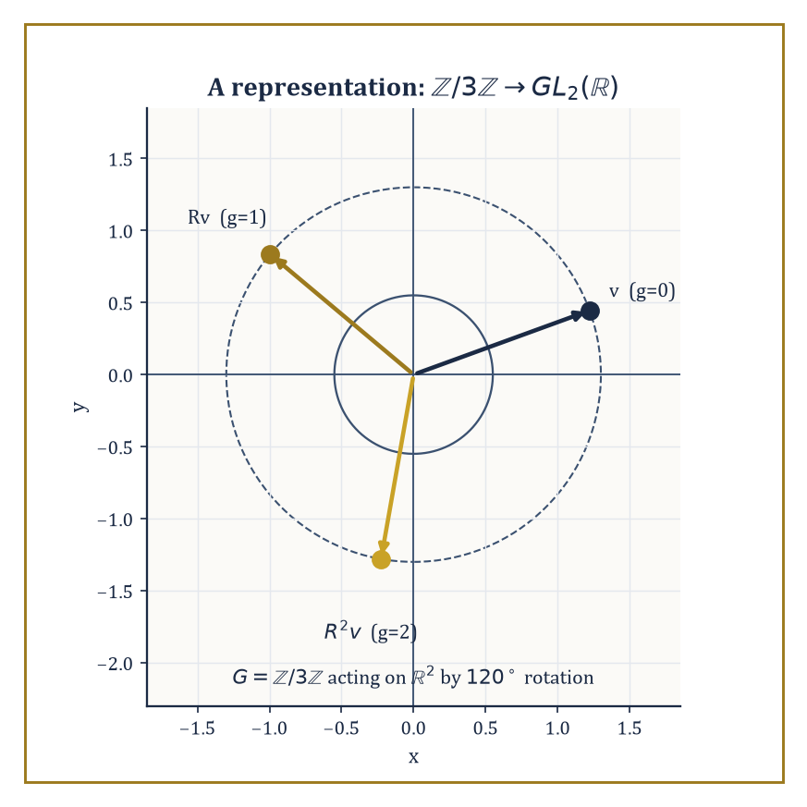
The abstract group ℤ/3ℤ, made concrete: three applications of a 120° rotation return a vector exactly to where it started.
Algebraic number theory takes the rings of integers inside number fields — generalizations of the Gaussian integers ℤ[i] and the ℤ[√-5] whose broken factorization caused so much trouble in Room 37.5 — and studies them via ideals rather than elements precisely because element-factorization can fail. The ideal class group measures exactly how badly unique factorization fails (it is trivial precisely when the ring is a UFD), and Dedekind zeta functions package arithmetic information about these rings into analytic objects, generalizing the Riemann zeta function this Tower has not yet met but will.
Abstract example — The ring of integers as a bridge to geometry. Consider the ring R, defined as the quotient
R=ℝ[x,y]/(x²+y²-1)
Its elements are polynomial functions on the unit circle — any polynomial identity involving x²+y² is simplified using the relation
x²+y²=1
R is precisely the ring of coordinate functions of the circle as an algebraic variety — the point set
{(x,y)∈ℝ² : x²+y²=1}
and the ring R determine each other completely, a correspondence formalized as 'Spec' in algebraic geometry. This is the same move as ℤ ↔ 'the ring of integer-valued arithmetic' generalized one dimension up: instead of a ring encoding number-theoretic data, it encodes geometric data. The entire modern subject of algebraic geometry is the systematic working-out of exactly how much of a geometric shape can be recovered purely from its ring of functions — commutative algebra, unglamorously, turns out to be the technical engine underneath essentially all of it.
Representation theory studies groups not in the abstract but acting concretely on vector spaces — a representation of G is a homomorphism G → GL(V) for some vector space V, which turns every abstract group into a group of matrices and every abstract question into a question of linear algebra, at the cost of having to classify all the different ways a given group can act. It is, in a sense, the reverse move to everything else in this storey: rather than stripping numbers away to find the bare operation, representation theory takes the bare operation and hands it back a vector space to act on, chosen so as to make the group's structure as visible as possible.
Numeric example — Rotating the plane by a third of a turn. Let G be the cyclic group of order three, represented on V=ℝ² by sending the generator 1 to the rotation matrix R, rotation by 120°:
G = ℤ/3ℤ = {0,1,2}
R = [[cos 120°, -sin 120°],[sin 120°, cos 120°]] = [[-1/2, -√3/2],[√3/2, -1/2]]
Check this respects the group structure: 1+1=2 in G should correspond to R² (rotating twice). Rotating by 120° twice is rotating by 240°, and indeed:
R² = [[cos 240°, -sin 240°],[sin 240°, cos 240°]] = [[-1/2, √3/2],[-√3/2,-1/2]]
Matrix multiplication of R by itself confirms this (the computation is routine trigonometric bookkeeping and comes out exactly to the 240° matrix). And 1+1+1=0 in G should correspond to R³ = identity — three rotations of 120° bring you back to the start, i.e. a full 360° turn, exactly as required.
This tiny example already displays the whole point of the subject: the abstract cyclic group of order 3 has been made concrete as a specific, visualizable, matrix-multiplying symmetry of the plane, and every question about ℤ/3ℤ's structure can now be answered by looking at rotations instead of by manipulating residues mod 3.
And underlying every construction in this storey — homomorphism, kernel, quotient, universal property — sits a pattern that category theory, immediately ahead of us in Storey 38, finally gives a name and a grammar of its own: objects, arrows between them, and the diagrams that must commute. Where this storey asked 'what structures satisfy these axioms', the next asks the question one level up: 'what do groups, rings, fields, and even topological spaces have in common as categories, regardless of which axioms define their objects internally' — the abstraction of the abstraction, and, mercifully, very nearly the last one this Tower will ask of you before the view starts paying for the climb.
The deeper lesson of this storey is not any single theorem but the method itself: isolate the formal properties that make a familiar manipulation work, forget everything else about the objects involved, and discover that the resulting skeleton organizes vast, unrelated-looking tracts of mathematics under one roof. Number theory, geometry, and symmetry turn out to be speaking the same underlying language far more often than their surface vocabularies let on, and the fact that a rotation matrix, a residue class, and a coset can all be instances of the same three-line definition is not a curiosity to be filed away — it is, quietly, the central discovery of everything we have done since Room 37.1.
Abstract algebra is the study of structure itself — not the structure of any one system, but the shared skeleton underneath many. Groups gave us symmetry with the numbers washed off; rings and fields gave us arithmetic generalized past recognition; Galois theory gave us a group that decides, definitively, which equations can and cannot be solved by the algebra your school teacher trusted implicitly. The classification of finite simple groups, the structure theorem for modules, and the impossibility of the quintic formula are not three unrelated facts — they are three consequences of the same handful of axioms, taken seriously and followed all the way to the end.
We have learned, over this storey, to study operations without numbers attached — and the tower continues upward regardless, indifferent to how comfortable we've grown.
The next storey takes the compression one notch further. Category theory looks back at everything built here — groups and their homomorphisms, rings and their homomorphisms, vector spaces and their linear maps — and notices that 'a collection of objects and the structure-preserving maps between them' is itself a pattern worth naming, regardless of what the objects or the maps happen to be internally. It is the abstraction of abstraction, and by the time we reach it, this storey's groups, rings, and fields will have quietly become mere examples of something even more general — which is, incidentally, exactly the trick this storey just finished performing on ordinary arithmetic.

